TABLE S1 Summary of longitude, latitude, mean annual temperature (MAT), and mean annual precipitation (MAP) at sampling plots.

Plot Name | longitude (°) | latitude (°) | MAT (℃) | MAP (mm)
MP1 | 123 | 44.5 | 5.10 | 373
MP2 | 121 | 44.5 | 5.80 | 320
MP3 | 120 | 45.1 | 3.72 | 320
MP4 | 118 | 44.7 | 0.56 | 336
MP5 | 116 | 44.2 | 1.17 | 262
MP6 | 116 | 43.5 | 0.16 | 321
MP7 | 117 | 44.5 | 1.96 | 287
MP8 | 114 | 44.0 | 0.10 | 234
MP9 | 113 | 43.8 | 2.47 | 177
MP10 | 112 | 43.6 | 3.69 | 140
LP1 | 113 | 36.2 | 11.8 | 469
LP2 | 112 | 35.9 | 9.96 | 492
LP3 | 111 | 35.9 | 10.6 | 471
LP4 | 110 | 36.0 | 10.7 | 444
LP5 | 109 | 36.7 | 9.50 | 415
LP6 | 107 | 36.9 | 7.46 | 365
LP7 | 107 | 37.5 | 5.23 | 329
LP8 | 105 | 37.4 | 5.87 | 266
LP9 | 104 | 37.4 | 7.56 | 194
LP10 | 104 | 37.4 | 7.71 | 179
TP1 | 95.4 | 31.4 | 0.41 | 516
TP2 | 93.5 | 31.8 | -1.50 | 447
TP3 | 92.0 | 31.6 | -4.37 | 417
TP4 | 90.7 | 31.3 | -6.76 | 439
TP5 | 89.7 | 31.5 | -3.06 | 369
TP6 | 87.8 | 31.8 | -2.57 | 324
TP7 | 85.8 | 31.9 | -3.77 | 313
TP8 | 83.3 | 32.4 | -3.90 | 264
TP9 | 81.2 | 32.3 | -3.49 | 242
TP10 | 80.1 | 32.4 | -1.27 | 159

TABLE S2 Summary of environmental factors (soil environment, plant properties, climate) in three transects.

 | MP |  |  | LP |  |  | TP
 | MG | TG | DS | MG | TG | DS | MG | TG | DS
soil environment
pH | 8.18±0.14 | 7.59±0.05 | 7.95±0.02 | 8.05±0.02 | 8.09±0.02 | 8.23±0.12 | 6.92±0.07 | 8.16±0.03 | 8.23±0.04
SOC (%) | 1.30±0.18 | 1.81±0.05 | 0.61±0.07 | 1.21±0.05 | 0.75±0.04 | 0.48±0.03 | 5.10±0.30 | 0.81±0.04 | 0.41±0.04
TN (%) | 0.13±0.02 | 0.19±0.01 | 0.06±0.01 | 0.14±0.01 | 0.09±0.01 | 0.06±0.01 | 0.42±0.02 | 0.09±0.02 | 0.05±0.01
NH₄⁺ (mg/kg) | 1.16±0.08 | 2.18±0.24 | 0.58±0.04 | 2.03±0.13 | 2.16±0.28 | 1.32±0.11 | 4.00±0.22 | 1.11±0.07 | 1.40±0.21
NO₃⁻(mg/kg) | 23.4±1.37 | 35.3±3.33 | 14.3±1.97 | 9.14±2.13 | 14.6±2.89 | 6.34±0.88 | 39.6±4.57 | 19.6±2.08 | 4.31±1.37
AP (mg/kg) | 2.85±0.20 | 4.99±0.20 | 3.28±0.27 | 2.61±0.21 | 1.98±0.12 | 4.25±0.41 | 3.24±0.39 | 2.10±0.22 | 3.99±0.18
WC % | 0.16±0.01 | 0.12±0.01 | 0.07±0.01 | 0.13±0.01 | 0.09±0.01 | 0.04±0.02 | 0.33±0.03 | 0.13±0.01 | 0.06±0.01
EC (us/cm) | 771±35.2 | 204±13.1 | 246±21.4 | 215±6.36 | 313±67.4 | 277±48.4 | 238±34.0 | 560±141 | 410±99.1
plant properties
PS | 1.55±0.12 | 1.42±0.05 | 1.34±0.07 | 1.48±0.09 | 1.58±0.06 | 1.36±0.08 | 1.65±0.13 | 1.42±0.04 | 0.91±0.09
PB(g/m²) | 125±7.40 | 56.6±5.04 | 22.3±2.31 | 155.4±20.0 | 101±8.23 | 74.2±9.87 | 95.0±9.45 | 53.0±7.87 | 25.4±2.04
RWD (kg/m²) | 0.30±0.01 | 0.54±0.05 | 0.12±0.01 | 0.46±0.01 | 0.27±0.02 | 0.21±0.01 | 1.49±0.10 | 0.27±0.01 | 0.33±0.03
RD (mm) | 0.54±0.01 | 0.52±0.01 | 0.56±0.01 | 0.52±0.01 | 0.49±0.01 | 0.51±0.02 | 0.60±0.02 | 0.47±0.01 | 0.60±0.01
climate
MAT (℃) | 4.87±0.18 | 0.96±0.12 | 2.09±0.30 | 10.82±0.16 | 8.23±0.37 | 7.04±0.17 | -1.82±0.40 | -4.04±0.29 | -2.89±0.24
MAP (mm) | 338±5.14 | 301±5.08 | 184±7.89 | 478±2.11 | 388±7.87 | 213±7.78 | 460±8.45 | 361±8.74 | 222±9.20
AI | 27.3±0.46 | 33.3±0.85 | 19.1±1.33 | 27.6±0.32 | 25.5±0.06 | 15.2±0.72 | 70.5±2.68 | 84.8±7.97 | 39.5±2.61
Notes. SOC: soil organic carbon; TN: total nitrogen; NH₄⁺: ammonium-nitrogen; NO₃⁻: nitrate-nitrogen; AP: available phosphorus; WC: water content; EC: electrical conductivity; PS: plant Shannon index; PB: plant biomass; RDW: root dry weight; RD: root diameter; MAT: mean annul temperature; MAP: mean annul precipitation; and AI: arid index.

TABLE S3 Results of PERMANOVA test for bacterial communities among transects and habitat types.

Community |  | Bray-curtis
 |  | F | R²
MP - LP |  | 19.1 | 0.107**
MP - TP |  | 13.0 | 0.076**
LP - TP |  | 11.8 | 0.069**
MP | MG - TG | 6.55 | 0.110**
 | MG - DS | 9.58 | 0.172**
 | TG - DS | 19.6 | 0.266**
LP | MG - TG | 6.15 | 0.102**
 | MG - DS | 17.5 | 0.275**
 | TG - DS | 14.3 | 0.208**
TP | MG - TG | 21.2 | 0.281**
 | MG - DS | 26.0 | 0.361**
 | TG - DS | 11.5 | 0.175**
Notes. *P < 0.05; **P < 0.01. MP: Inner Mongolia Plateau; LP: Loess Plateau; TP: Tibet Plateau; MG: Meadow grassland; TG: Typical grassland; DS Desert steppe.

TABLE S4 The proportion of different ecological processes based on β-nearest taxon index (βNTI).

 | MP | LP | TP | MP |  |  | LP |  |  | TP
 |  |  |  | MG | TG | DS | MG | TG | DS | MG | TG | DS
Heterogeneous selection | 4.65 | 8.67 | 4.24 | 7.97 | 1.09 | 0.00 | 0.20 | 11.7 | 7.66 | 0.00 | 3.26 | 0.00
Homogeneous selection | 53.9 | 27.5 | 41.5 | 36.2 | 47.8 | 75.7 | 67.3 | 23.2 | 41.1 | 38.0 | 47.1 | 38.4
Dispersal limitation | 34.4 | 50.6 | 48.9 | 50.7 | 17.8 | 16.7 | 11.9 | 33.9 | 31.7 | 35.5 | 40.2 | 49.6
Homogeneous dispersal | 0.98 | 0.35 | 0.51 | 0.72 | 3.26 | 0.72 | 2.42 | 0.20 | 2.42 | 6.16 | 0.36 | 0.72
Drift | 6.08 | 12.9 | 4.94 | 4.35 | 30.1 | 6.88 | 18.2 | 31.1 | 17.1 | 20.3 | 9.06 | 11.2
Notes. MP: Inner Mongolia Plateau; LP: Loess Plateau; TP: Tibet Plateau; MG: Meadow grassland; TG: Typical grassland; DS Desert steppe.

TABLE S5 Mantel tests of environmental variables against the relative importance of homogeneous selection and dispersal limitation in shaping soil bacterial communities.

 | Homogeneous selection |  |  |  | Dispersal limitation
 | Total | MP | LP | TP | Total | MP | LP | TP
AP | 0.001** | 0.015** | 0.000 | 0.012** | 0.007** | 0.021** | 0.044** | 0.010**
AI | 0.013** | 0.109** | 0.018** | 0.001 | 0.029** | 0.222** | 0.189** | 0.027**
EC | 0.074** | 0.001 | 0.002* | 0.154** | 0.033** | 0.013** | 0.001 | 0.089**
MAP | 0.042** | 0.149** | 0.042** | 0.154** | 0.096** | 0.312** | 0.314** | 0.277**
MAT | 0.042** | 0.011** | 0.017** | 0.001 | 0.089** | 0.078** | 0.153** | 0.040**
NH₄⁺ | 0.015** | 0.023** | 0.000 | 0.082** | 0.019** | 0.055** | 0.013** | 0.117**
NO₃⁻ | 0.014** | 0.001 | 0.001 | 0.102** | 0.024** | 0.012** | 0.010** | 0.094**
pH | 0.125** | 0.002* | 0.011** | 0.263** | 0.060** | 0.037** | 0.002* | 0.229**
PB | 0.005** | 0.000 | 0.002* | 0.022** | 0.012** | 0.041** | 0.005* | 0.025**
PS | 0.002** | 0.001 | 0.001 | 0.011** | 0.005** | 0.009** | 0.003* | 0.038**
RDW | 0.041** | 0.001 | 0.022** | 0.185** | 0.021** | 0.048** | 0.143** | 0.166**
RD | 0.000** | 0.055** | 0.000 | 0.000 | 0.008** | 0.141** | 0.024** | 0.060**
SOC | 0.064** | 0.122** | 0.014** | 0.196** | 0.045** | 0.291** | 0.121** | 0.194**
TN | 0.065** | 0.119** | 0.009** | 0.213** | 0.058** | 0.291** | 0.123** | 0.221**
WC | 0.058** | 0.002* | 0.032** | 0.140** | 0.027** | 0.018** | 0.043** | 0.103**
Notes. *P < 0.05; **P < 0.01. AP: available phosphorus; AI: arid index; EC: electroconductibility; MAT: mean annul temperature; MAP: mean annul precipitation; NH₄⁺: ammonium-nitrogen; NO₃⁻: nitrate-nitrogen; PB: plant biomass; PS: plant Shannon index; RDW: root dry weight; RD: root diameter; SOC: soil organic carbon; TN: total nitrogen; and WC: water content. The optimal predictor was bolded.

TABLE S6 The relative abundance of each bin and interpretation for homogeneous selection process among transects and habitat types.

 |  |  |  |  |  | MP |  |  | LP |  |  | TP
 | RA | MP | LP | TP | MG | TG | DS | MG | TG | DS | MG | TG | DS
bin1 | 0.006 | 0.006 | 0.006 | 0.002 | 0.007 | 0.004 | 0.007 | 0.006 | 0.007 | 0.005 | 0.000 | 0.004 | 0.004
bin2 | 0.016 | 0.004 | 0.003 | 0.002 | 0.003 | 0.002 | 0.009 | 0.005 | 0.003 | 0.002 | 0.000 | 0.003 | 0.001
bin3 | 0.004 | 0.058 | 0.040 | 0.044 | 0.055 | 0.071 | 0.044 | 0.039 | 0.049 | 0.028 | 0.075 | 0.037 | 0.023
bin4 | 0.02 | 0.016 | 0.016 | 0.014 | 0.016 | 0.015 | 0.020 | 0.015 | 0.017 | 0.019 | 0.009 | 0.018 | 0.015
bin5 | 0.01 | 0.000 | 0.000 | 0.001 | 0.000 | 0.000 | 0.001 | 0.000 | 0.000 | 0.000 | 0.000 | 0.000 | 0.009
bin6 | 0.012 | 0.001 | 0.003 | 0.000 | 0.003 | 0.000 | 0.000 | 0.005 | 0.002 | 0.008 | 0.000 | 0.001 | 0.000
bin7 | 0.01 | 0.020 | 0.015 | 0.009 | 0.020 | 0.019 | 0.020 | 0.011 | 0.017 | 0.017 | 0.001 | 0.012 | 0.016
bin8 | 0.026 | 0.007 | 0.004 | 0.006 | 0.007 | 0.026 | 0.000 | 0.011 | 0.003 | 0.000 | 0.032 | 0.000 | 0.005
bin9 | 0.005 | 0.015 | 0.013 | 0.016 | 0.013 | 0.018 | 0.011 | 0.013 | 0.018 | 0.008 | 0.008 | 0.029 | 0.006
bin10 | 0.006 | 0.003 | 0.000 | 0.003 | 0.003 | 0.002 | 0.003 | 0.000 | 0.000 | 0.000 | 0.004 | 0.005 | 0.000
bin11 | 0.005 | 0.001 | 0.001 | 0.001 | 0.001 | 0.001 | 0.000 | 0.000 | 0.001 | 0.001 | 0.002 | 0.000 | 0.000
bin12 | 0.01 | 0.001 | 0.000 | 0.004 | 0.002 | 0.000 | 0.000 | 0.000 | 0.000 | 0.000 | 0.000 | 0.005 | 0.008
bin13 | 0.033 | 0.002 | 0.000 | 0.003 | 0.000 | 0.003 | 0.001 | 0.000 | 0.000 | 0.000 | 0.004 | 0.005 | 0.000
bin14 | 0.015 | 0.006 | 0.018 | 0.008 | 0.006 | 0.006 | 0.004 | 0.020 | 0.014 | 0.021 | 0.005 | 0.007 | 0.015
bin15 | 0.016 | 0.000 | 0.000 | 0.000 | 0.000 | 0.000 | 0.000 | 0.000 | 0.000 | 0.000 | 0.000 | 0.000 | 0.001
bin16 | 0.074 | 0.000 | 0.007 | 0.002 | 0.003 | 0.000 | 0.000 | 0.001 | 0.007 | 0.013 | 0.000 | 0.005 | 0.002
bin17 | 0.114 | 0.002 | 0.003 | 0.001 | 0.001 | 0.001 | 0.004 | 0.003 | 0.002 | 0.002 | 0.000 | 0.001 | 0.002
bin18 | 0.012 | 0.000 | 0.002 | 0.001 | 0.002 | 0.000 | 0.000 | 0.001 | 0.002 | 0.003 | 0.000 | 0.001 | 0.002
bin19 | 0.004 | 0.002 | 0.001 | 0.000 | 0.002 | 0.003 | 0.001 | 0.000 | 0.000 | 0.002 | 0.001 | 0.000 | 0.000
bin20 | 0.009 | 0.000 | 0.000 | 0.000 | 0.000 | 0.000 | 0.000 | 0.000 | 0.000 | 0.004 | 0.000 | 0.000 | 0.000
bin21 | 0.01 | 0.018 | 0.010 | 0.014 | 0.011 | 0.030 | 0.010 | 0.007 | 0.009 | 0.010 | 0.032 | 0.009 | 0.005
bin22 | 0.021 | 0.001 | 0.024 | 0.002 | 0.001 | 0.004 | 0.000 | 0.005 | 0.021 | 0.047 | 0.003 | 0.003 | 0.000
bin23 | 0.05 | 0.070 | 0.090 | 0.061 | 0.065 | 0.073 | 0.071 | 0.109 | 0.107 | 0.050 | 0.062 | 0.070 | 0.049
bin24 | 0.016 | 0.122 | 0.105 | 0.115 | 0.118 | 0.143 | 0.096 | 0.124 | 0.121 | 0.064 | 0.154 | 0.124 | 0.062
bin25 | 0.021 | 0.011 | 0.012 | 0.009 | 0.013 | 0.008 | 0.011 | 0.016 | 0.017 | 0.002 | 0.013 | 0.012 | 0.002
bin26 | 0.018 | 0.000 | 0.002 | 0.000 | 0.000 | 0.000 | 0.000 | 0.002 | 0.001 | 0.005 | 0.000 | 0.000 | 0.001
bin27 | 0.02 | 0.000 | 0.001 | 0.001 | 0.000 | 0.000 | 0.000 | 0.000 | 0.000 | 0.007 | 0.001 | 0.000 | 0.004
bin28 | 0.013 | 0.006 | 0.001 | 0.007 | 0.003 | 0.008 | 0.007 | 0.000 | 0.005 | 0.000 | 0.010 | 0.006 | 0.005
bin29 | 0.017 | 0.006 | 0.001 | 0.000 | 0.004 | 0.007 | 0.006 | 0.001 | 0.000 | 0.001 | 0.000 | 0.000 | 0.000
bin30 | 0.068 | 0.014 | 0.015 | 0.016 | 0.011 | 0.014 | 0.018 | 0.013 | 0.018 | 0.015 | 0.022 | 0.012 | 0.015
bin31 | 0.039 | 0.016 | 0.018 | 0.020 | 0.014 | 0.015 | 0.021 | 0.011 | 0.014 | 0.033 | 0.004 | 0.020 | 0.041
bin32 | 0.061 | 0.001 | 0.006 | 0.004 | 0.000 | 0.002 | 0.000 | 0.002 | 0.002 | 0.014 | 0.005 | 0.000 | 0.019
bin33 | 0.021 | 0.013 | 0.005 | 0.000 | 0.008 | 0.019 | 0.008 | 0.001 | 0.000 | 0.026 | 0.001 | 0.000 | 0.003
bin34 | 0.112 | 0.005 | 0.003 | 0.006 | 0.004 | 0.007 | 0.002 | 0.006 | 0.008 | 0.000 | 0.010 | 0.011 | 0.006
bin35 | 0.017 | 0.019 | 0.004 | 0.012 | 0.013 | 0.026 | 0.013 | 0.005 | 0.006 | 0.002 | 0.019 | 0.011 | 0.007
bin36 | 0.016 | 0.050 | 0.045 | 0.030 | 0.060 | 0.075 | 0.017 | 0.049 | 0.052 | 0.029 | 0.063 | 0.040 | 0.016
bin37 | 0.052 | 0.014 | 0.021 | 0.030 | 0.001 | 0.009 | 0.032 | 0.004 | 0.005 | 0.044 | 0.002 | 0.029 | 0.051
bin38 | 0.022 | 0.000 | 0.000 | 0.000 | 0.000 | 0.000 | 0.000 | 0.000 | 0.000 | 0.000 | 0.000 | 0.000 | 0.000
Notes. MP: Inner Mongolia Plateau; LP: Loess Plateau; TP: Tibet Plateau; MG: Meadow grassland; TG: Typical grassland; DS: Desert steppe.

TABLE S7 The interpretation of each bin for dispersal limitation process among transects and habitat types.

 |  |  |  |  | MP |  |  | LP |  |  | TP
 | MP | LP | TP | MG | TG | DS | MG | TG | DS | MG | TG | DS
bin1 | 0.001 | 0.000 | 0.003 | 0.001 | 0.002 | 0.000 | 0.000 | 0.000 | 0.000 | 0.007 | 0.001 | 0.000
bin2 | 0.004 | 0.008 | 0.007 | 0.005 | 0.002 | 0.002 | 0.002 | 0.007 | 0.010 | 0.000 | 0.010 | 0.007
bin3 | 0.000 | 0.000 | 0.005 | 0.000 | 0.000 | 0.000 | 0.000 | 0.000 | 0.000 | 0.000 | 0.013 | 0.000
bin4 | 0.004 | 0.005 | 0.007 | 0.010 | 0.001 | 0.001 | 0.007 | 0.004 | 0.001 | 0.013 | 0.006 | 0.000
bin5 | 0.098 | 0.112 | 0.075 | 0.090 | 0.055 | 0.159 | 0.146 | 0.088 | 0.106 | 0.015 | 0.092 | 0.130
bin6 | 0.017 | 0.015 | 0.010 | 0.023 | 0.018 | 0.005 | 0.017 | 0.016 | 0.006 | 0.015 | 0.007 | 0.005
bin7 | 0.000 | 0.000 | 0.003 | 0.000 | 0.000 | 0.000 | 0.000 | 0.000 | 0.000 | 0.006 | 0.000 | 0.000
bin8 | 0.047 | 0.034 | 0.050 | 0.053 | 0.040 | 0.022 | 0.030 | 0.047 | 0.003 | 0.056 | 0.052 | 0.015
bin9 | 0.009 | 0.004 | 0.004 | 0.027 | 0.000 | 0.004 | 0.000 | 0.001 | 0.010 | 0.006 | 0.000 | 0.007
bin10 | 0.014 | 0.016 | 0.010 | 0.016 | 0.012 | 0.014 | 0.019 | 0.017 | 0.010 | 0.010 | 0.009 | 0.009
bin11 | 0.003 | 0.005 | 0.002 | 0.004 | 0.003 | 0.003 | 0.007 | 0.006 | 0.003 | 0.002 | 0.001 | 0.001
bin12 | 0.021 | 0.016 | 0.017 | 0.018 | 0.022 | 0.022 | 0.020 | 0.013 | 0.016 | 0.004 | 0.017 | 0.021
bin13 | 0.005 | 0.010 | 0.005 | 0.003 | 0.003 | 0.009 | 0.013 | 0.011 | 0.007 | 0.000 | 0.006 | 0.008
bin14 | 0.001 | 0.000 | 0.002 | 0.000 | 0.000 | 0.001 | 0.001 | 0.000 | 0.000 | 0.001 | 0.003 | 0.001
bin15 | 0.006 | 0.012 | 0.010 | 0.002 | 0.007 | 0.008 | 0.015 | 0.012 | 0.008 | 0.006 | 0.009 | 0.014
bin16 | 0.019 | 0.021 | 0.025 | 0.019 | 0.012 | 0.020 | 0.028 | 0.020 | 0.010 | 0.031 | 0.023 | 0.016
bin17 | 0.003 | 0.001 | 0.004 | 0.011 | 0.000 | 0.000 | 0.000 | 0.001 | 0.004 | 0.000 | 0.004 | 0.008
bin18 | 0.005 | 0.004 | 0.003 | 0.013 | 0.000 | 0.001 | 0.001 | 0.002 | 0.008 | 0.000 | 0.004 | 0.004
bin19 | 0.004 | 0.004 | 0.005 | 0.005 | 0.002 | 0.005 | 0.001 | 0.005 | 0.004 | 0.003 | 0.002 | 0.011
bin20 | 0.021 | 0.035 | 0.042 | 0.019 | 0.019 | 0.020 | 0.034 | 0.037 | 0.031 | 0.034 | 0.048 | 0.041
bin21 | 0.000 | 0.002 | 0.000 | 0.001 | 0.000 | 0.000 | 0.006 | 0.001 | 0.000 | 0.000 | 0.000 | 0.000
bin22 | 0.002 | 0.008 | 0.005 | 0.000 | 0.001 | 0.003 | 0.001 | 0.004 | 0.021 | 0.000 | 0.013 | 0.000
bin23 | 0.000 | 0.000 | 0.000 | 0.000 | 0.000 | 0.000 | 0.000 | 0.000 | 0.000 | 0.000 | 0.000 | 0.000
bin24 | 0.000 | 0.000 | 0.000 | 0.000 | 0.000 | 0.000 | 0.000 | 0.000 | 0.000 | 0.000 | 0.000 | 0.000
bin25 | 0.000 | 0.001 | 0.002 | 0.000 | 0.000 | 0.000 | 0.000 | 0.000 | 0.002 | 0.000 | 0.001 | 0.003
bin26 | 0.001 | 0.004 | 0.003 | 0.001 | 0.001 | 0.000 | 0.003 | 0.004 | 0.005 | 0.000 | 0.001 | 0.007
bin27 | 0.002 | 0.005 | 0.005 | 0.001 | 0.000 | 0.005 | 0.005 | 0.007 | 0.011 | 0.000 | 0.004 | 0.017
bin28 | 0.004 | 0.006 | 0.003 | 0.005 | 0.002 | 0.004 | 0.007 | 0.007 | 0.001 | 0.000 | 0.004 | 0.004
bin29 | 0.017 | 0.013 | 0.021 | 0.013 | 0.013 | 0.023 | 0.004 | 0.008 | 0.018 | 0.008 | 0.013 | 0.040
bin30 | 0.001 | 0.002 | 0.000 | 0.002 | 0.000 | 0.000 | 0.001 | 0.000 | 0.005 | 0.000 | 0.001 | 0.000
bin31 | 0.000 | 0.004 | 0.005 | 0.000 | 0.000 | 0.000 | 0.002 | 0.007 | 0.000 | 0.004 | 0.004 | 0.001
bin32 | 0.005 | 0.011 | 0.011 | 0.006 | 0.005 | 0.002 | 0.011 | 0.008 | 0.012 | 0.011 | 0.006 | 0.004
bin33 | 0.009 | 0.011 | 0.017 | 0.008 | 0.001 | 0.022 | 0.007 | 0.004 | 0.012 | 0.004 | 0.015 | 0.028
bin34 | 0.005 | 0.010 | 0.008 | 0.005 | 0.001 | 0.011 | 0.008 | 0.001 | 0.020 | 0.000 | 0.001 | 0.015
bin35 | 0.003 | 0.009 | 0.003 | 0.005 | 0.000 | 0.008 | 0.005 | 0.009 | 0.012 | 0.003 | 0.001 | 0.005
bin36 | 0.026 | 0.013 | 0.038 | 0.026 | 0.011 | 0.030 | 0.008 | 0.010 | 0.021 | 0.002 | 0.030 | 0.048
bin37 | 0.026 | 0.010 | 0.013 | 0.034 | 0.040 | 0.002 | 0.023 | 0.014 | 0.000 | 0.051 | 0.001 | 0.001
bin38 | 0.068 | 0.041 | 0.052 | 0.056 | 0.062 | 0.085 | 0.040 | 0.033 | 0.071 | 0.017 | 0.058 | 0.088
Notes. MP: Inner Mongolia Plateau; LP: Loess Plateau; TP: Tibet Plateau; MG: Meadow grassland; TG: Typical grassland; DS: Desert steppe.

TABLE S8 Number and relative abundance of the dominant microbial groups among phylum.

The dominant microbial groups | Abundant taxa | Moderate taxa | Rare taxa
Group1
Acidobacteria | 42(0.065) | 202(0.061) | 516(0.045)
Actinobacteria | 21(0.012) | 176(0.046) | 394(0.038)
Bacteroidetes | 7(0.011) | 99(0.024) | 428(0.010)
Total | 70(0.088) | 477(0.131) | 1338(0.093)
Group2
Proteobacteria | 17(0.092) | 176(0.044) | 423(0.013)
Actinobacteria | 7(0.017) | 106(0.031) | 202(0.006)
Gemmatimonadetes | 8(0.015) | 40(0.010) | 225(0.005)
Acidobacteria | 2(0.002) | 33(0.009) | 96(0.003)
Nitrospirae |  | 36(0.008) | 63(0.002)
Total | 34(0.126) | 391(0.103) | 1009(0.029)

Captions for Supplementary Figures:
Fig. S1 The relative abundances of Acidobacteria, Actinobacteria, and Proteobacteria in three transects and grassland types. Low-case letters indicate significant differences based on LSD test between the transects and habitat types at P < 0.05. Error bars represent standard errors of the means.

Fig. S2 The relative abundance of bacterial in order level in three transects and grassland types

Fig. S3 Proportions of community pairs assembled by heterogeneous selection, drift, selection and SD (selection/dispersal limitation) in three transects and grassland types. Low-case letters indicate significant difference based on bootstrapping test between transects and habitat types at P < 0.05.

Fig. S4 Pie charts show the contribution of dominant bacterial taxa driven by ecological process in three transects and grassland types.

Fig S1

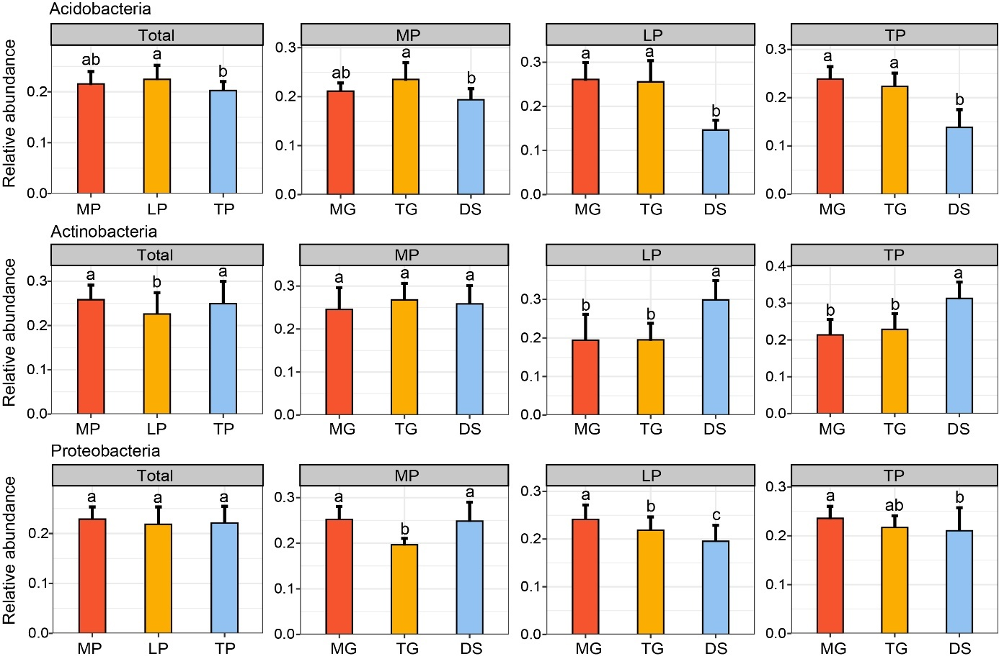

Fig S2
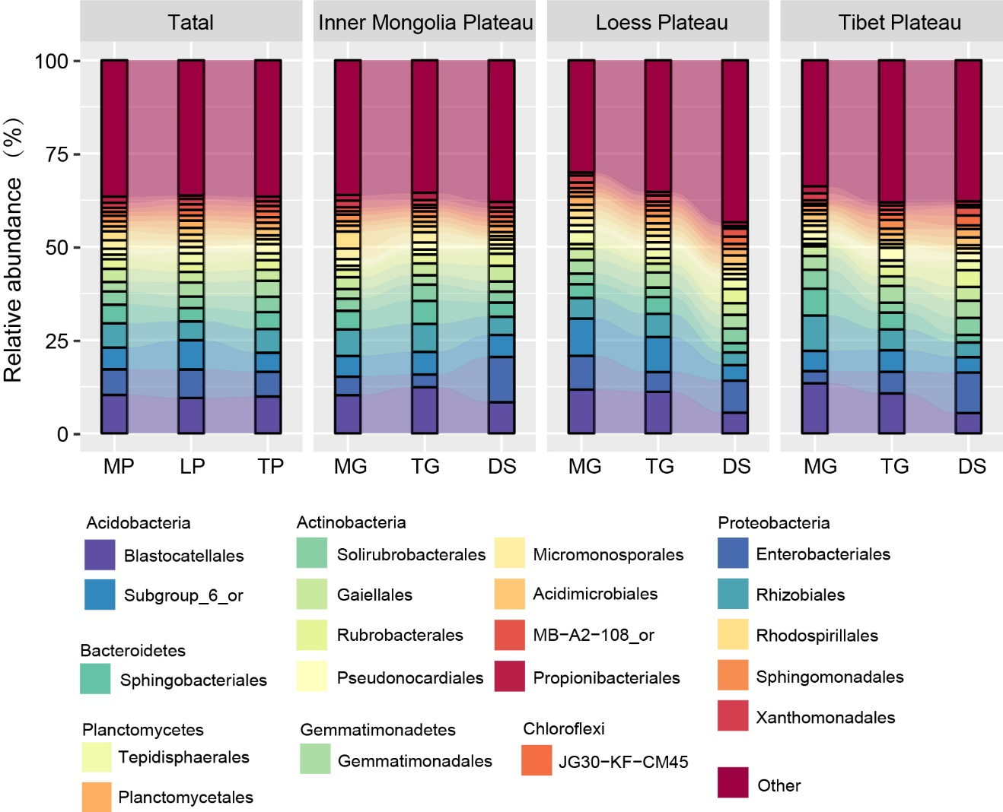

Fig S3
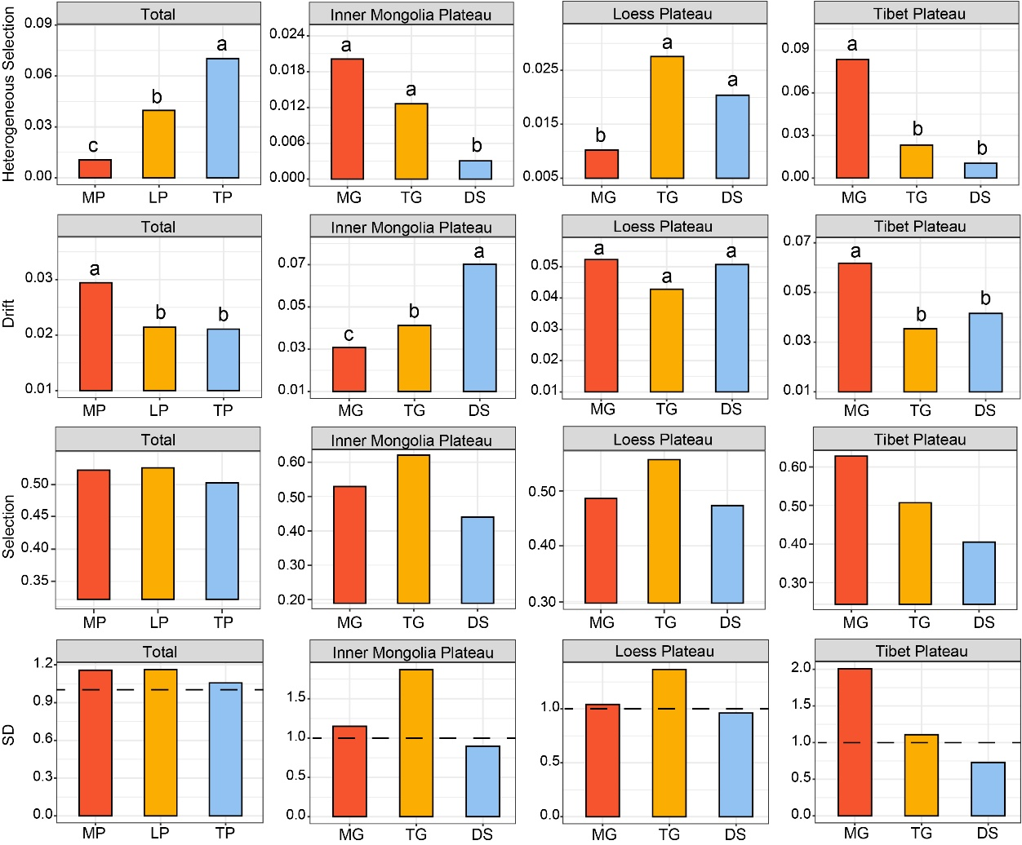

Fig S4
