Supplementary Materials

Table S1. N and W effects on environmental factors based on linear models.
Environmental factors | Control |  | Nª |  | W |  | NW |  | N versus control |  | W versus control |  | N × W  versus control
 | Average | SD | Average | SD | Average | SD | Average | SD | β^{b} | P | β | P | β | P
Soil T (℃) | 27.938 | 0.898 | 29.188 | 0.747 | 31.063 | 0.657 | 31.063 | 0.315 | 1.250 | 0.094 | 3.125 | 9.97E-06^{c} | -1.250 | 0.094
Water (%) | 20.708 | 1.468 | 22.810 | 1.277 | 20.248 | 1.098 | 20.813 | 1.634 | 2.103 | 0.078 | -0.460 | 0.101 | -1.538 | 0.288
pH | 5.825 | 0.141 | 5.793 | 0.163 | 5.805 | 0.085 | 5.860 | 0.221 | -0.033 | 0.891 | -0.020 | 0.772 | 0.088 | 0.595
Salinity | 0.815 | 0.061 | 0.834 | 0.056 | 0.814 | 0.149 | 0.896 | 0.046 | 0.019 | 0.274 | -0.001 | 0.501 | 0.064 | 0.484
TC (%) | 0.475 | 0.035 | 0.523 | 0.063 | 0.450 | 0.032 | 0.475 | 0.037 | 0.048 | 0.123 | -0.025 | 0.123 | -0.023 | 0.616
TN (%) | 0.048 | 0.005 | 0.050 | 0.000 | 0.048 | 0.005 | 0.048 | 0.005 | 0.002 | 0.574 | 0.000 | 0.574 | -0.002 | 0.574
TC/TN | 9.758 | 1.112 | 9.983 | 0.463 | 9.200 | 0.701 | 10.165 | 0.621 | 0.225 | 0.145 | -0.557 | 0.632 | 0.740 | 0.351
NO₂⁻ (μg·g⁻¹) | 0.010 | 0.027 | 0.013 | 0.018 | 0.001 | 0.014 | 0.003 | 0.015 | 0.004 | 0.777 | -0.009 | 0.359 | -0.001 | 0.941
NH₄⁺ (μg·g⁻¹) | 8.825 | 2.304 | 11.527 | 1.528 | 11.705 | 5.799 | 12.756 | 2.358 | 2.700 | 0.295 | 2.880 | 0.253 | -1.650 | 0.638
NO₃⁻ (μg·g⁻¹) | 0.911 | 0.054 | 1.051 | 0.272 | 1.008 | 0.051 | 1.057 | 0.217 | 0.143 | 0.305 | 0.100 | 0.565 | -0.095 | 0.602
NH₄⁺/ NO₃⁻ | 9.722 | 2.570 | 11.376 | 2.374 | 11.457 | 5.574 | 12.126 | 0.852 | 1.654 | 0.497 | 1.735 | 0.468 | -0.985 | 0.772
P (μg·g⁻¹) | 203.108 | 17.595 | 193.115 | 93.183 | 184.103 | 31.328 | 232.820 | 31.611 | -9.993 | 0.474 | -19.005 | 0.700 | 58.710 | 0.284
AGB (g·m⁻² ) | 141.834 | 22.305 | 159.447 | 27.451 | 121.448 | 21.967 | 128.345 | 16.906 | 17.612 | 0.297 | -20.387 | 0.041 | -10.715 | 0.642
BGB (g·m⁻² ) | 64.818 | 9.265 | 72.134 | 11.403 | 56.349 | 9.125 | 59.214 | 7.023 | 7.316 | 0.297 | -8.469 | 0.041 | -4.451 | 0.642
N₂O (mmol·m⁻²·h⁻¹) | 0.465 | 0.192 | 3.845 | 1.402 | 1.318 | 0.998 | 4.150 | 4.534 | 3.380 | 0.025 | 0.853 | 0.642 | -0.548 | 0.825
CH₄ (mmol·m⁻²·h⁻¹) | 0.303 | 0.319 | 0.098 | 0.188 | 0.860 | 1.017 | 0.278 | 0.362 | -0.205 | 0.193 | 0.558 | 0.221 | -0.378 | 0.521
CO₂ (mmol·m⁻²·h⁻¹) | 1.475 | 0.233 | 1.998 | 0.557 | 1.860 | 0.434 | 1.535 | 0.703 | 0.523 | 0.706 | 0.385 | 0.882 | -0.848 | 0.124
ªAbbreviations: N, nitrogen addition; W, Warming; NW, the dual treatment of N and W; N × W, the interactive effect of N and W; SD, standard deviation; T, temperature; TC, total carbon; TN, total nitrogen; P, phosphorus; AGB, aboveground biomass; BGB, belowground biomass.
^{b}All estimated effect sizes (β) are based on environmental factors.
^{c}Statistical significance is based on Wald type II F tests. Significant effects (P < 0.050) are shown in bold.
Table S2. N and W effects on microbial diversity and evenness indices based on linear models.

Treatment  effects |  | Bacteria |  |  |  |  |  | Fungi
 |  | Richness |  | Shannon | Simpson | Faith's  PD | Pielou's  evenness | Richness | Shannon | Simpson | Faith's  PD | Pielou's  evenness
Nª | β^{b} | 1.060 | 1.026 |  | 0.995 | 1.011 | 1.017 | -0.33 | 0.489 | 0.241 | 0.453 | 0.621
 | t | 1.997 | 2.025 |  | 1.877 | 1.627 | 2.014 | -0.558 | 0.831 | 0.381 | 0.908 | 1.033
 | P | 0.003^{c} | 0.002 |  | 0.003 | 0.023 | 0.002 | 0.076 | 0.249 | 0.21 | 0.154 | 0.347
W | β | -0.527 | -0.498 |  | -0.652 | -0.445 | -0.503 | -0.387 | 0.339 | 0.297 | -0.005 | 0.467
 | t | -0.992 | -0.982 |  | -1.228 | -0.716 | -0.996 | -0.654 | 0.576 | 0.469 | -0.010 | 0.775
 | P | 0.597 | 0.795 |  | 0.458 | 0.495 | 0.803 | 0.06 | 0.142 | 0.254 | 0.015 | 0.204
N × W | β | 0.646 | 0.805 |  | 0.727 | 0.272 | 0.823 | -0.963 | -1.988 | -1.67 | -1.979 | -2.076
 | t | 0.861 | 1.124 |  | 0.97 | 0.309 | 1.153 | -1.15 | -2.388 | -1.862 | -2.806 | -2.439
 | P | 0.406 | 0.283 |  | 0.351 | 0.763 | 0.272 | 0.273 | 0.034 | 0.087 | 0.016 | 0.031
ªAbbreviations: N, nitrogen addition; W, Warming; N × W, the interactive effect of N and W; PD, phylogenetic diversity.
^{b}All estimated effect sizes (β) are based on response variables.
^{c}Statistical significance is based on Wald type II F tests. Significant effects (P < 0.050) are shown in bold.

Table S3. N and W effects on abundant bacterial phyla (> 0.1%) and genera (> 0.3%) based on linear models.

Taxonomy | Name | Nª |  | W |  | N × W
 |  | β^{b} | P | β | P | β | P
Abundant phyla | Proteobacteria | -0.668 | 0.002^{c} | 0.481 | 0.541 | -1.388 | 0.062
 | Bacteroidetes | 1.127 | 0.205 | 0.296 | 0.768 | -0.898 | 0.392
 | Acidobacteria | -0.124 | 0.012 | -1.282 | 0.680 | 2.273 | 0.006
 | Firmicutes | 0.641 | 0.002 | -0.024 | 0.080 | 1.296 | 0.071
 | Actinobacteria | 0.717 | 0.002 | -0.207 | 0.220 | 1.273 | 0.080
 | Chloroflexi | -0.233 | 0.601 | -0.132 | 0.479 | 1.026 | 0.345
 | Planctomycetes | -0.128 | <0.001 | -0.649 | 0.029 | 2.466 | <0.001
 | Chlorobi | 0.776 | 0.540 | 0.066 | 0.483 | -0.892 | 0.412
 | Verrucomicrobia | 0.000 | 0.016 | -0.688 | 0.383 | 2.032 | 0.016
 | Cyanobacteria.Chloroplast | -0.068 | 0.877 | -0.102 | 0.925 | 0.311 | 0.784
 | Chlamydiae | -0.985 | 0.302 | -1.188 | 0.159 | 0.938 | 0.346
 | Gemmatimonadetes | 0.779 | 0.019 | -0.443 | 0.903 | 0.779 | 0.384
 | Spirochaetes | 0.208 | 0.649 | 0.830 | 0.489 | -0.908 | 0.406
 | Armatimonadetes | -0.241 | 0.007 | -1.360 | 0.730 | 2.500 | 0.002
 | Nitrospira | 0.636 | 0.168 | -0.726 | 0.204 | 0.151 | 0.878
 | WS3 | 0.725 | 0.041 | -0.682 | 0.425 | 0.618 | 0.507
 | Synergistetes | -1.024 | 0.369 | -1.058 | 0.336 | 1.118 | 0.283
 | BRC1 | 0.444 | 0.134 | 0.059 | 0.429 | 0.681 | 0.499
 | OD1 | 0.664 | 0.608 | -0.640 | 0.033 | -0.861 | 0.351
Abundant genera | Gp1 | -0.975 | 0.089 | -1.56 | 0.928 | 3.065 | <0.001
 | Bradyrhizobium | 0.937 | 0.002 | -0.251 | 0.555 | 0.934 | 0.213
 | Gp3 | 1.321 | 0.002 | -0.834 | 0.027 | 0.009 | 0.989
 | Conexibacter | 0.595 | 0.002 | -0.04 | 0.074 | 1.354 | 0.059
 | Gp16 | -0.721 | 0.439 | -0.695 | 0.408 | 2.147 | 0.031
 | Bacillus | 0.587 | 0.006 | 0.096 | 0.078 | 1.185 | 0.123
 | Spartobacteria_genera_incertae_sedis | 0.074 | 0.014 | -0.733 | 0.509 | 1.964 | 0.02
 | Gp7 | 1.238 | 0.005 | -0.272 | 0.702 | 0.234 | 0.772
 | Phenylobacterium | 0.79 | 0.004 | -0.915 | 0.302 | 1.041 | 0.181
 | Singulisphaera | -0.063 | <0.001 | -0.485 | 0.008 | 2.373 | <0.001
 | Pseudolabrys | 0.439 | 0.010 | -0.867 | 0.752 | 1.484 | 0.079
 | Gp6 | 0.126 | 0.009 | -0.977 | 0.975 | 1.976 | 0.017
 | Aciditerrimonas | -0.269 | 0.096 | -1.428 | 0.324 | 2.014 | 0.030
 | Burkholderia | 0.088 | 0.008 | -1.433 | 0.223 | 1.989 | 0.013
 | Ktedonobacter | -0.38 | 0.011 | -0.826 | 0.156 | 2.562 | 0.001
 | Gemmata | 0.194 | <0.001 | -0.362 | 0.017 | 2.072 | 0.001
 | Mycobacterium | 1.058 | <0.001 | 0.157 | 0.038 | 0.922 | 0.109
ªAbbreviations: N, nitrogen addition; W, Warming; N × W, the interactive effect of N and W.
^{b}All estimated effect sizes (β) are based on relative abundances of abundant bacterial phyla (> 0.1%) and genera (> 0.3%). The phyla and genera are listed in the decreasing order of relative abundances.
^{c}Statistical significance is based on Wald type II F tests. Significant effects (P < 0.050) are shown in bold.

Table S4. N and W effects on methanogenic, bacterial nitrifying, and denitrifying genera based on linear models.
Category | Name | Nª |  | W |  | N × W
 |  | β^{b} | P | β | P | β | P
Methanogenic genera | Methanoregula | 0.213 | 0.297 | 0.939 | 0.701 | -1.494 | 0.153
 | Methanocella | -0.261 | 0.675 | -0.365 | 0.547 | 0.052 | 0.963
 | Methanoculleus | -0.581 | 0.880 | -1.057 | 0.454 | 1.321 | 0.222
 | Methanospirillum | -0.993 | 0.059 | -0.199 | 0.684 | 0.000 | 1.000
 | Methanosarcina | -0.513 | 0.728 | -0.642 | 0.564 | 0.642 | 0.564
 | Methanosaeta | -0.783 | 0.044^{c} | 0.261 | 1.000 | -0.522 | 0.584
 | Methanolinea | 0.327 | 0.272 | 0.763 | 0.822 | -1.743 | 0.090
 | Methanobacterium | 0.348 | 0.510 | 0.696 | 0.199 | 0.000 | 1.000
 | Methanocorpusculum | 0.000 | 0.337 | 1.000 | 0.337 | -1.000 | 0.337
 | Methanosphaera | 0.000 | 0.143 | 1.379 | 0.143 | -1.379 | 0.143
 | Methanolacinia | 0.000 | 1.000 | -0.732 | 0.183 | 0.000 | 1.000
 | Methanobrevibacter | 1.000 | 0.337 | 0.000 | 0.337 | -1.000 | 0.337
 | Methanolobus | 1.000 | 0.337 | 0.000 | 0.337 | -1.000 | 0.337
 | Methanomicrobium | 1.000 | 0.337 | 0.000 | 0.337 | -1.000 | 0.337
Nitrifying genera | Nitrosospira | 0.715 | 0.441 | -0.328 | 0.232 | -0.621 | 0.552
 | Nitrospira | 0.641 | 0.181 | -0.733 | 0.181 | 0.092 | 0.926
 | Nitrosomonas | 0.152 | 0.704 | -0.087 | 0.417 | -0.718 | 0.511
 | Nitrobacter | 0.648 | 0.015 | -0.259 | 0.542 | 1.037 | 0.234
 | Nitrosococcus | 0.685 | 0.047 | -0.342 | 1.000 | 0.685 | 0.474
Denitrifying genera | Bradyrhizobium | 0.937 | 0.002 | -0.251 | 0.555 | 0.934 | 0.213
 | Bacillus | 0.587 | 0.006 | 0.096 | 0.078 | 1.185 | 0.123
 | Burkholderia | 0.088 | 0.008 | -1.433 | 0.223 | 1.989 | 0.013
 | Rhodoplanes | 1.525 | <0.001 | -0.254 | 0.691 | 0.280 | 0.628
 | Shewanella | 0.028 | 0.323 | 0.003 | 0.346 | 0.977 | 0.348
 | Rhodobacter | -0.372 | 0.246 | 0.301 | 0.947 | -0.530 | 0.621
 | Sphingomonas | 0.475 | 0.353 | 0.129 | 0.753 | 0.086 | 0.937
 | Pseudomonas | 0.176 | 0.329 | -0.527 | 0.754 | 0.717 | 0.508
 | Paenibacillus | 0.600 | 0.004 | -0.072 | 0.136 | 1.272 | 0.097
 | Thiobacillus | 0.940 | 0.163 | 0.940 | 0.163 | -0.470 | 0.629
 | Azoarcus | 0.996 | 0.050 | -0.398 | 0.424 | 0.028 | 0.976
 | Hyphomicrobium | 0.216 | 0.377 | 0.000 | 0.620 | 0.540 | 0.620
 | Mesorhizobium | 1.182 | 0.019 | -0.222 | 0.622 | 0.000 | 1.000
 | Cupriavidus | 0.766 | 0.939 | 0.153 | 0.265 | -1.455 | 0.164
 | Rhizobium | 1.214 | 0.448 | 0.773 | 0.913 | -1.656 | 0.119
 | Hydrogenophaga | 0.555 | 0.859 | -0.185 | 0.228 | -0.924 | 0.382
 | Comamonas | 0.206 | 0.241 | 0.000 | 0.427 | 0.826 | 0.427
 | Ralstonia | 0.841 | 0.191 | -0.280 | 0.422 | -0.280 | 0.786
 | Cytophaga | 0.000 | 0.870 | 0.000 | 0.870 | -0.187 | 0.870
 | Halomonas | 0.235 | 0.211 | 1.412 | 0.211 | -1.647 | 0.089
 | Massilia | 1.019 | 0.463 | 0.255 | 0.463 | -1.274 | 0.230
 | Arcobacter | 0.553 | 0.795 | -0.138 | 0.309 | -0.830 | 0.441
 | Marinobacter | 0.000 | 1.000 | 0.732 | 0.183 | 0.000 | 1.000
 | Flavobacterium | 0.000 | 0.786 | -0.307 | 0.786 | 0.307 | 0.786
 | Aeromonas | 1.000 | 0.337 | 0.000 | 0.337 | -1.000 | 0.337
 | Methylobacterium | 0.830 | 0.232 | -0.415 | 0.232 | -0.415 | 0.682
 | Thiomicrospira | 0.000 | 0.663 | 1.246 | 0.045 | -0.415 | 0.663
 | Kocuria | 0.620 | 0.073 | 0.000 | 0.525 | 0.620 | 0.525
 | Azospirillum | 0.000 | 1.000 | -0.732 | 0.183 | 0.000 | 1.000
 | Neisseria | 0.000 | 1.000 | 0.732 | 0.183 | 0.000 | 1.000
 | Thauera | -0.732 | 0.183 | 0.000 | 1.000 | 0.000 | 1.000
ªAbbreviations: N, nitrogen addition; W, Warming; N × W, the interactive effect of N and W.
^{b}All estimated effect sizes (β) are based on relative abundances of methanogenic, bacterial nitrifying, and denitrifying genera. The genera are listed in the decreasing order of relative abundances.
^{c}Statistical significance is based on Wald type II F tests. Significant effects (P < 0.050) are shown in bold.
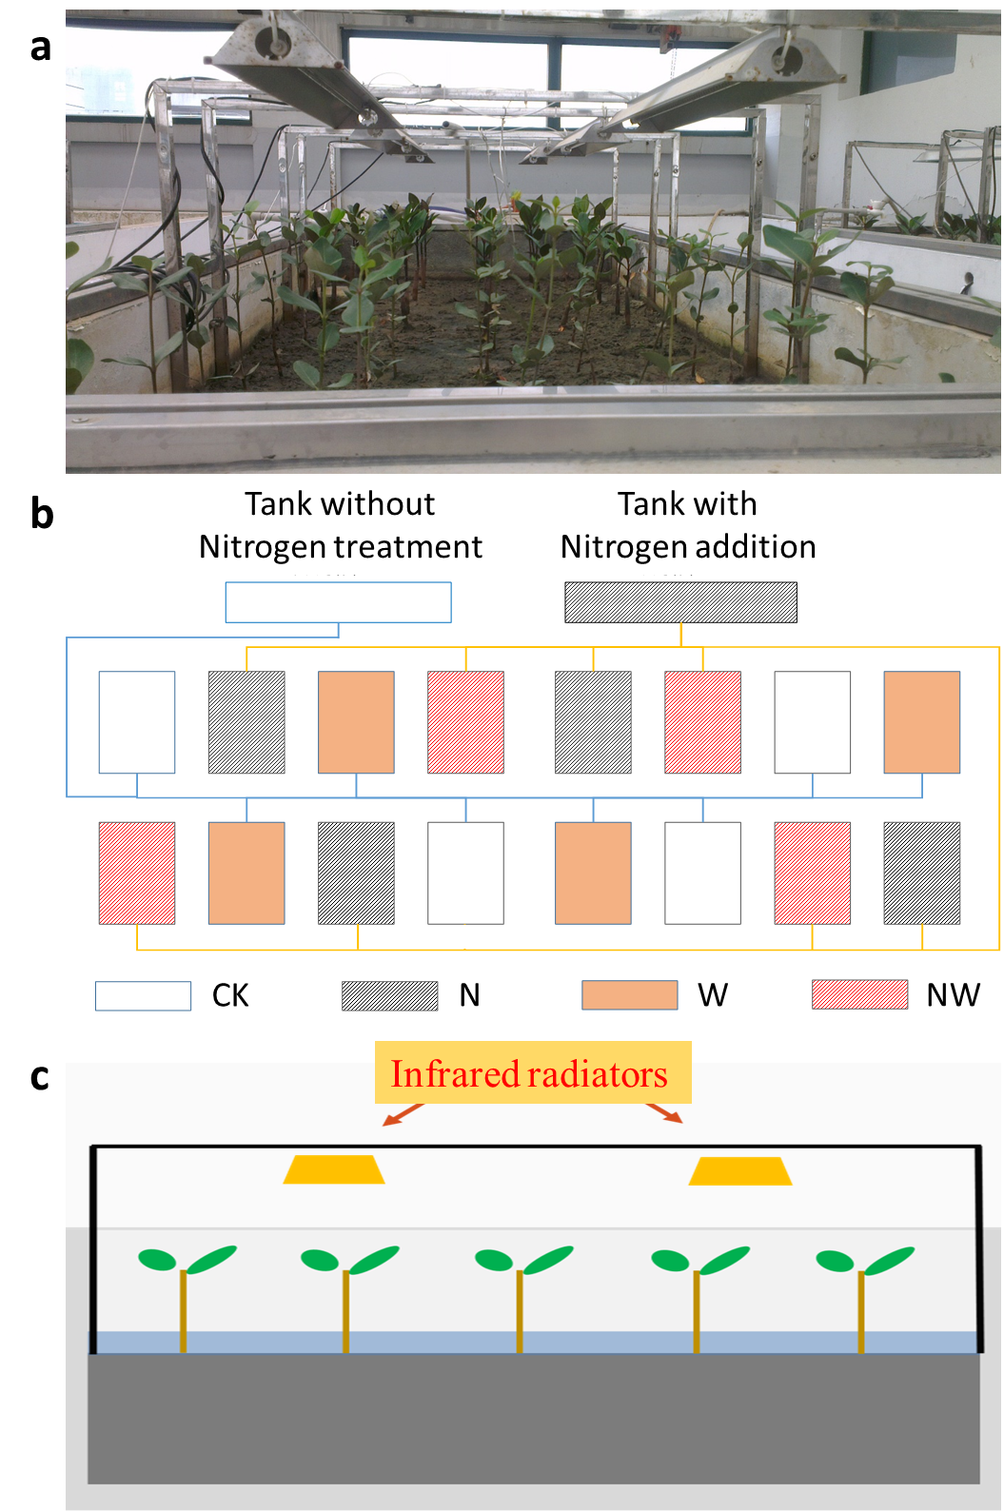
Fig. S1. (a) The photo of a laboratory-based plot, (b) A map showing the location distribution of experimental plots, and (c) A scheme showing the setup for the warming treatment. Abbreviations: CK, control; N, nitrogen addition; W, warming; NW, the dual treatment of N and W.

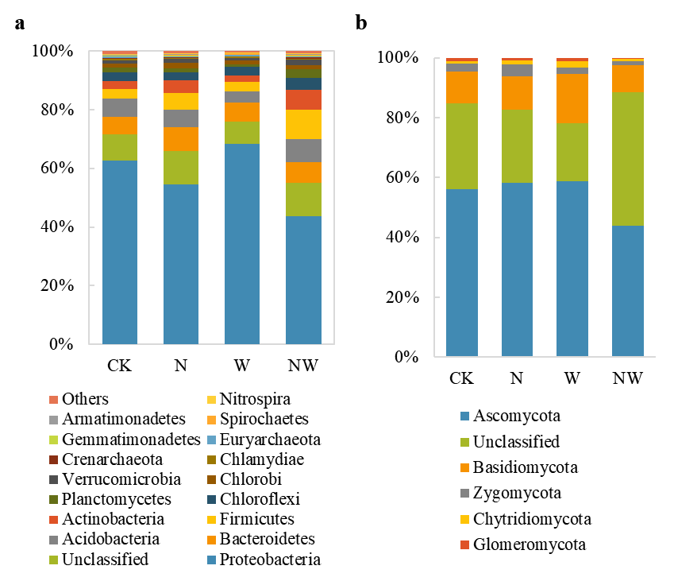
Fig. S2. Microbial community composition for (a) bacteria and (b) fungi.

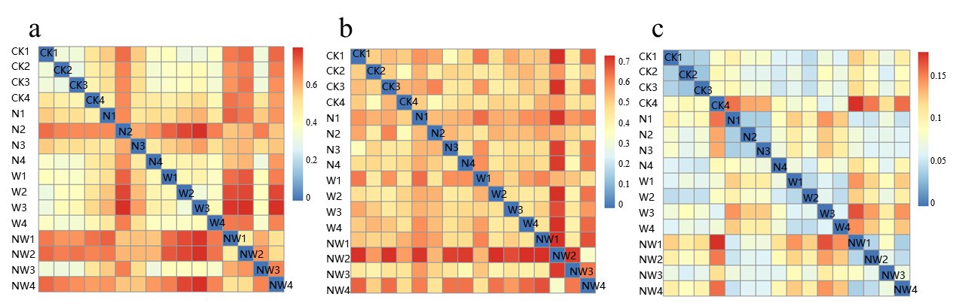
Fig. S3. The dissimilarity matrix for (a) 16S rRNA gene, (b) ITS, and (c) GeoChip data. The redder color represents a dissimilarity index close to 1, while the bluer color represents a dissimilarity index close to 0.

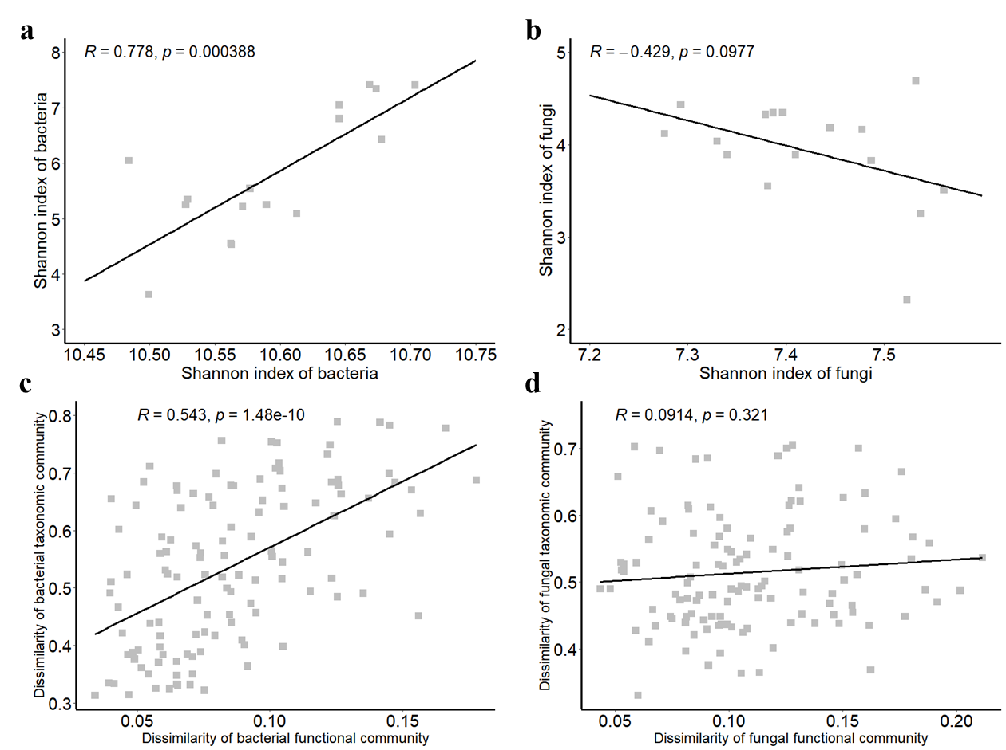

Fig. S4. Correlation between (a) bacterial taxonomic and functional α-diversities based on Shannon index, (b) fungal taxonomic and functional α-diversities based on Shannon index, (c) dissimilarity of bacterial taxomomic and functional community composition, and (d) dissimilarity of fungal taxomomic and functional community composition.

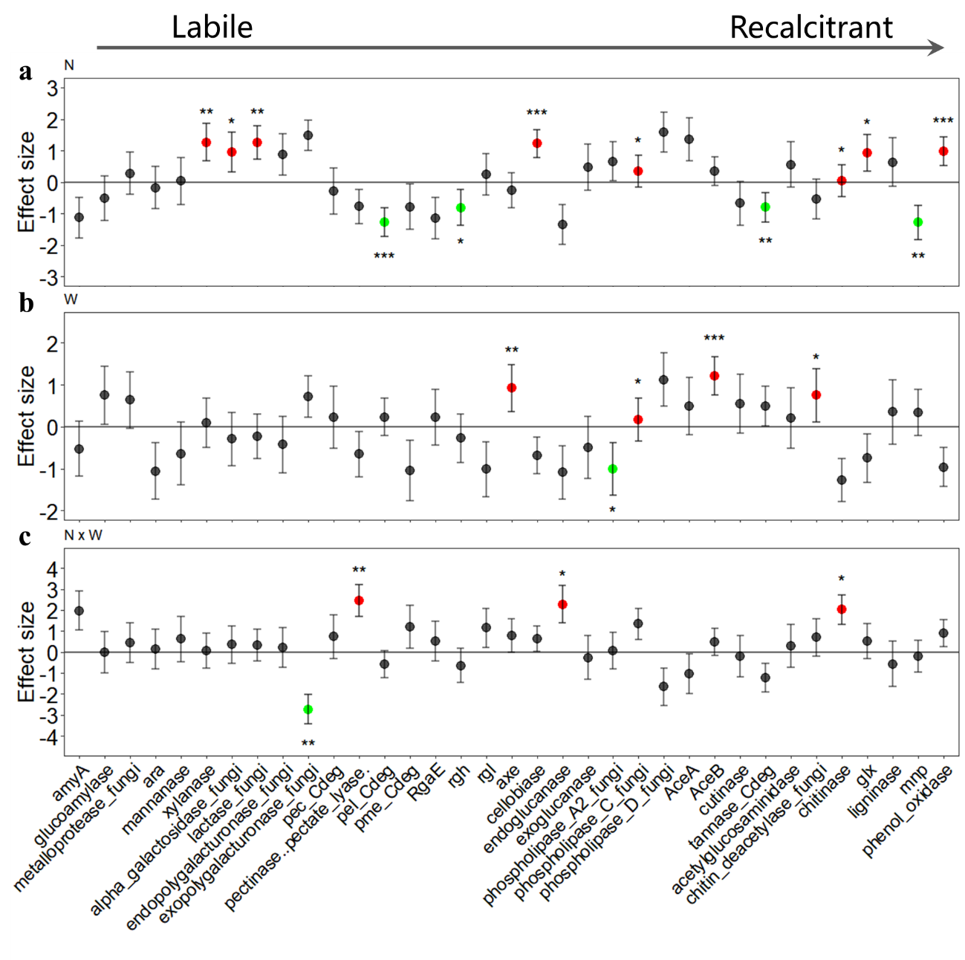
Fig. S5. Treatment effects on relative abundances of fungal carbon degradation genes based on linear models. a, N: nitrogen addition; b, W: warming; c, N × W: the interactive of N and W. Red color represents a significant increase in the relative abundance, while green color represents a significant decrease in the relative abundance. Black color represents insignificant changes. The statistical significance is based on F tests. Asterisks represent significant P-values: *, P < 0.050; **, P < 0.010; ***, P < 0.001. Error bars represent the standard errors of the estimated effect sizes.

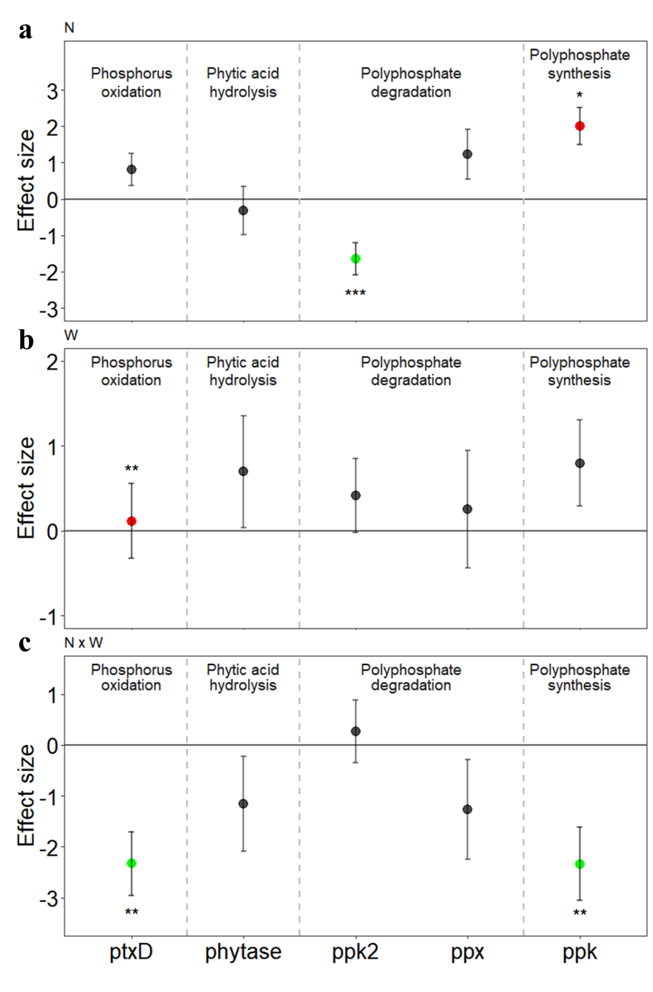
Fig. S6. Treatment effects on relative abundances of bacterial phosphorus cycling genes based on linear models. a, N: nitrogen addition; b, W: warming; c, N × W: the interactive of N and W. Red color represents a significant increase in the relative abundance, while green color represents a significant decrease in the relative abundance. Black color represents insignificant changes. The statistical significance is based on F tests. Asterisks represent significant P-values: *, P < 0.050; **, P < 0.010; ***, P < 0.001. Error bars represent the standard errors of the estimated effect sizes.

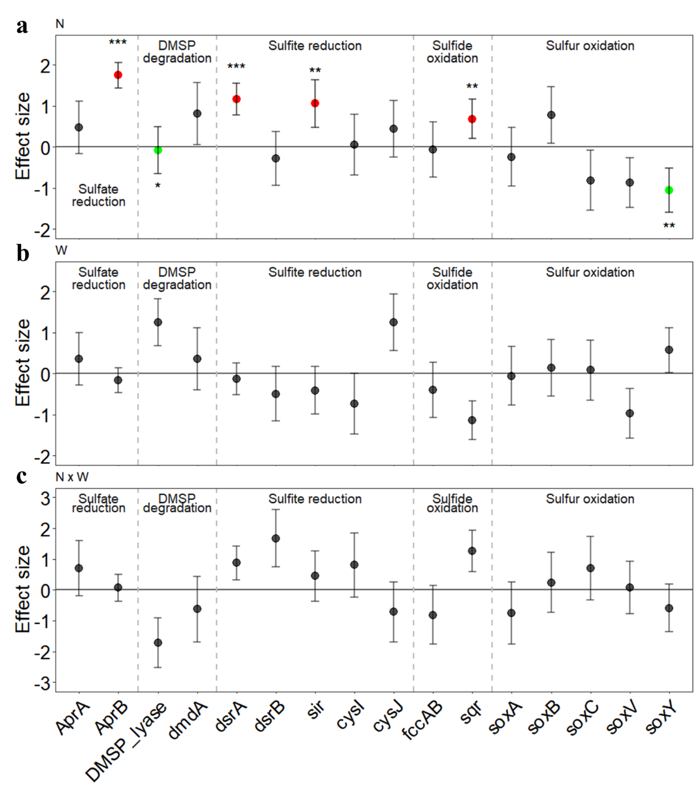
Fig. S7. Treatment effects on relative abundances of bacterial sulfur cycling genes based on linear models. a, N: nitrogen addition; b, W: warming; c, N × W: the interactive of N and W. Red color represents a significant increase in the relative abundance, while green color represents a significant decrease in the relative abundance. Black color represents insignificant changes. The statistical significance is based on F tests. Asterisks represent significant P-values: *, P < 0.050; **, P < 0.010; ***, P < 0.001. Error bars represent the standard errors of the estimated effect sizes.

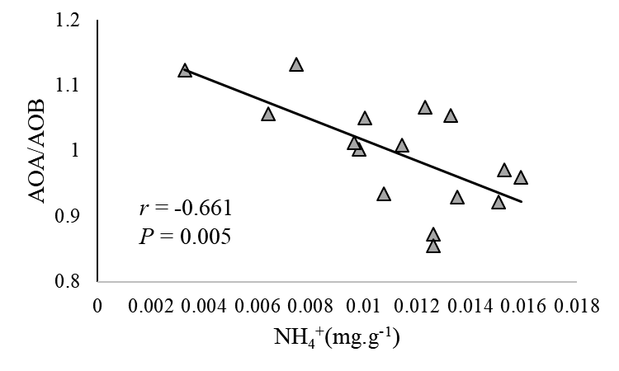
Fig. S8. Correlation between AOA/AOB and soil ammonium.

