Supplementary Information
Fig. S1 Soil samples sites across China eastern

Fig. S2 The predicted spatial distributions of soil microbial CO₂ fixation among forest (a), upland (b) and paddy (c) soils were mapped using ordinary kriging interpolation, and their associations with latitude for each ecosystem were estimated via linear least-squares regression analysis.
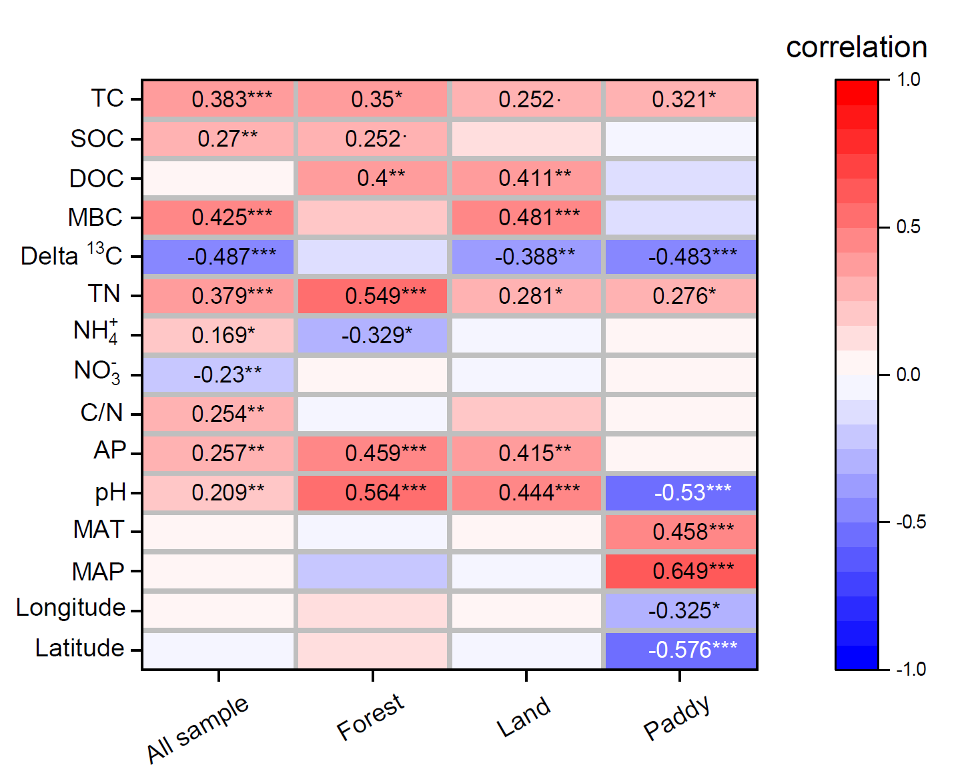
Fig. S3 Spearman correlation analysis showing the correlation of soil CO₂ fixation rates and soil environmental factors. TC, total carbon; SOC, soil organic carbon; DOC, dissolved organic carbon; MBC, microbial biomass carbon; TN, total nitrogen; NH₄⁺, ammonium; NO₃⁻, nitrate; C/N, ration of carbon to nitrogen; AP, Available phosphorus; MAT, mean annual temperature; MAP, mean annual precipitation. ***p<0.001, **p<0.01,*p<0.05, · p<0.1

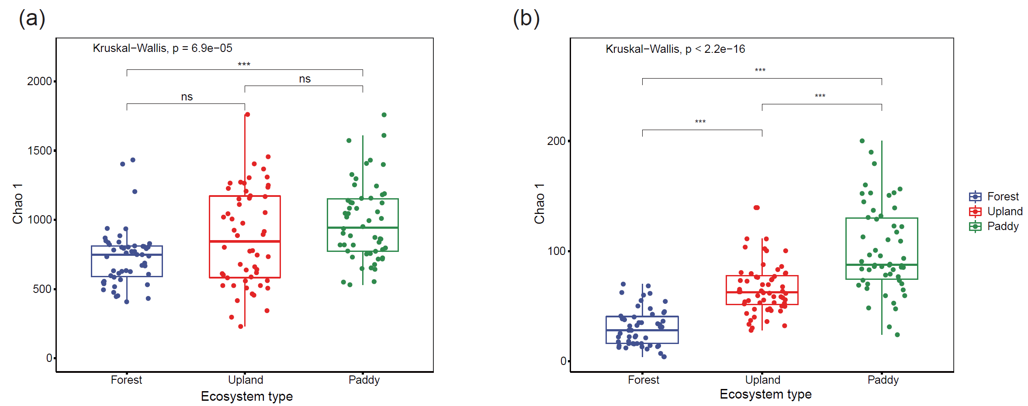

Fig.S4 α-diversity of cbbL-containing autotrophic bacteria and phototrophic protists in forest, upland and paddy soils. ***p<0.001, **p<0.01,*p<0.05, ns p >0.05

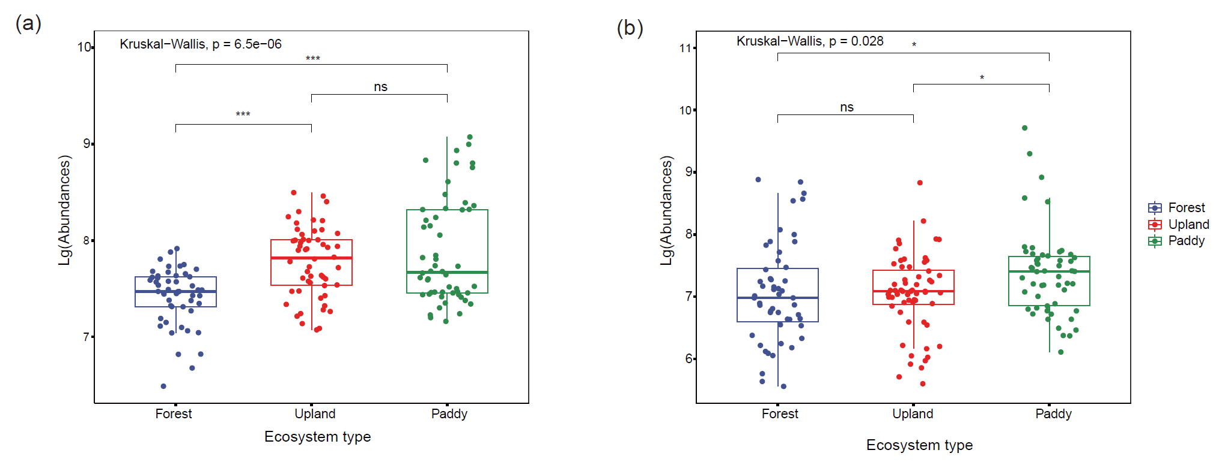

Fig. S5 The abundance of cbbL-containing autotrophic bacteria and phototrophic protists in forest, upland and paddy soils. ***p<0.001, **p<0.01,*p<0.05, ns p >0.05

Fig. S6 Bipartite networks display ecosystem-specific ASVs (indicators) in the cbbL-containing autotrophic bacterial and phototrophic protist communities. Circles represent autotrophic bacteria, and triangles represent phototrophic protist ASVs. Bacterial and protist ASVs are colored according to their family and class assignment, respectively.

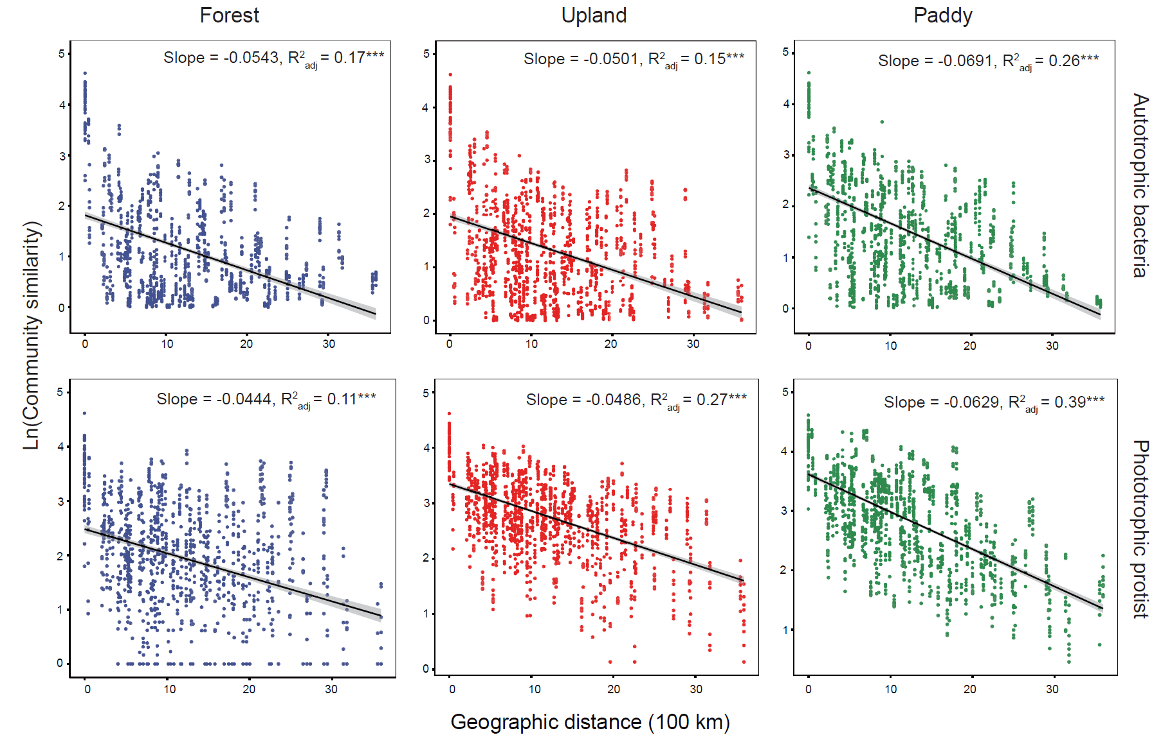
Fig. S7 Distance–decay patterns of autotrophic microbiota in the forest, upland and paddy environments. ***p<0.001

Fig.S8 Variation partitioning analysis (VPA) showing the effects of environmental and spatial factors on the autotrophic bacterial and phototropic protistan communities

Fig. S9 random forest model showing the importance of autotrophic family and phototrophic classes to CO₂ fixation in forest, upland and paddy.

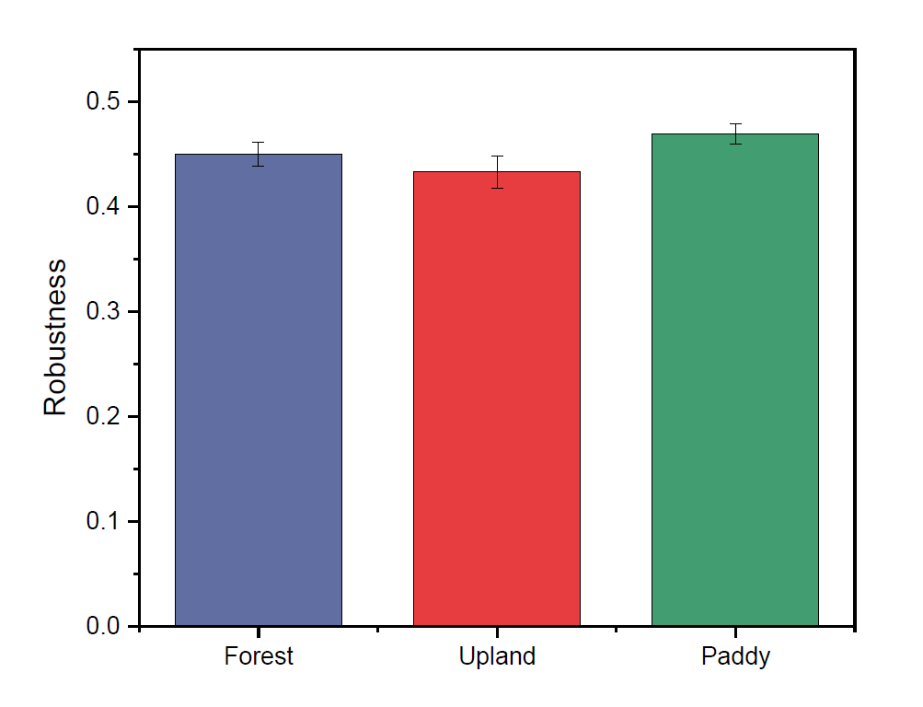

Fig. S10 Robustness measured as the proportion of taxa remained with 50% of the taxa randomly removed from each of the empirical networks.

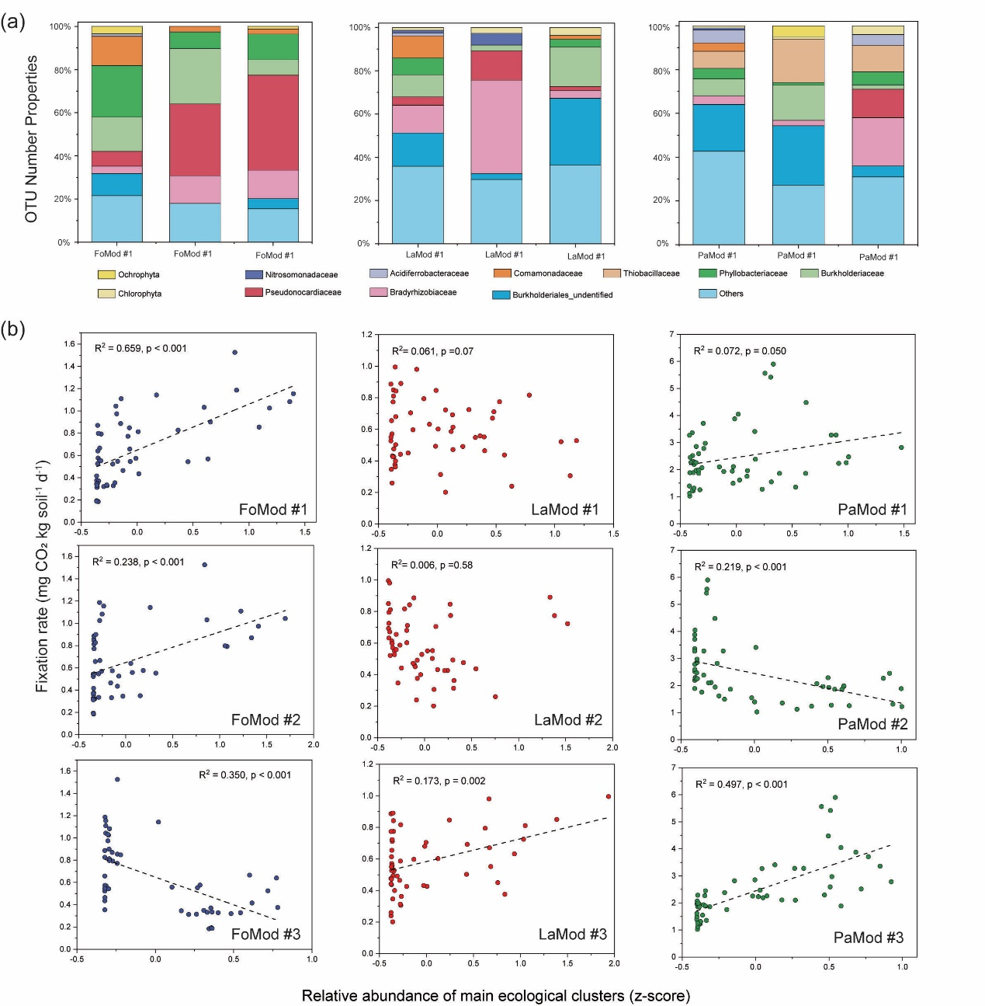

Fig. S11 (a) The number of dominant autotrophic bacterial and phototrophic protistan ASVs in the main ecological clusters for each ecosystem. (b) Regressions between the CO₂ fixation rates and the relative abundance of the main autotrophs ecological clusters.

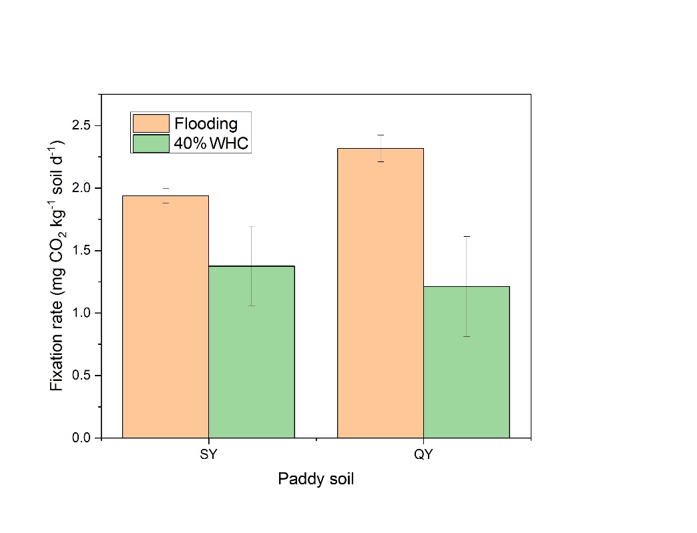
Fig. S12 parallel experiment showing the CO₂ fixation rates of paddy soils under flooding and well-drained conditions (40% WHC).

Table S1 Pairwise comparisons show PERMANOVA values for differences in microbial community composition between each land use. t-statistics values are shown for pairwise tests.

 | Bacteria |  |  | Protist
 | t statistic | P-value |  | t statistic | P-value
Forest versus Land | 3.636 | 0.001 |  | 6.459 | 0.001
Forest versus Paddy | 6.038 | 0.001 |  | 12.693 | 0.001
Land versus Paddy | 4.995 | 0.001 |  | 10.861 | 0.001

Table S2 Topological properties of networks obtained within each ecosystem type.

 | Forest | Land | Paddy
Total nodes | 238 | 200 | 308
Bacterial nodes | 232 | 190 | 296
Protist nodes | 6 | 10 | 12
Total links | 1066 | 777 | 2033
Bacterial-Bacterial links | 1039 | 747 | 1975
Protistan-Protistan links | 1 | 3 | 3
Bacterial-Protistan links | 26 | 27 | 55
Average path length | 5.37 | 5.92 | 4.36
Modularity | 0.059 | 0.1187 | 0.4667
Network diameter | 16 | 19 | 13
Average degree | 8.96 | 7.77 | 13.20

