**Supplemental Materials**

**Table S1.** Comparison of taxonomic and functional β-diversity between and within treatments

|  |  |  |  |  |  |
| --- | --- | --- | --- | --- | --- |
|  | Distance algorithm | Treatment | Distance | Std. | ANOVA |
| Taxonomic β-diversity | Bray | aN - aN* | 0.470 | 0.053 | b# |
| eN - aN | 0.490 | 0.060 | a |
| eN - eN | 0.456 | 0.040 | c |
| Sorensen  (unweighted bray) | aN - aN | 0.540 | 0.040 | b |
| eN - aN | 0.546 | 0.045 | a |
| eN - eN | 0.524 | 0.033 | c |
| Ruzicka  (weighted Jaccard) | aN - aN | 0.638 | 0.048 | b |
| eN - aN | 0.655 | 0.053 | a |
| eN - eN | 0.625 | 0.038 | c |
| Jaccard  (unweighted Jaccard) | aN - aN | 0.701 | 0.034 | a |
| eN - aN | 0.705 | 0.037 | a |
| eN - eN | 0.687 | 0.028 | b |
| Functional β-diversity | Bray | aN - aN | 0.242 | 0.084 | b |
| eN - aN | 0.262 | 0.083 | b |
| eN - eN | 0.270 | 0.086 | a |
| Sorensen  (unweighted bray) | aN - aN | 0.197 | 0.055 | b |
| eN - aN | 0.210 | 0.054 | b |
| eN - eN | 0.215 | 0.056 | a |
| Ruzicka  (weighted Jaccard) | aN - aN | 0.383 | 0.103 | b |
| eN - aN | 0.408 | 0.098 | b |
| eN - eN | 0.418 | 0.101 | a |
| Jaccard  (unweighted Jaccard) | aN - aN | 0.326 | 0.074 | b |
| eN - aN | 0.345 | 0.071 | b |
| eN - eN | 0.350 | 0.073 | a |

*aN: control samples; eN: N deposited samples.

#*P*-values were adjusted by Bonferroni correction, in which *P*-values were multiplied by the number of comparisons. Different alphabets mean significant differences.

**Table S2.** Effects of N deposition on microbial taxonomic and functional diversity, as assessed by Shannon index.

|  |  |  |  |
| --- | --- | --- | --- |
|  | Control samples | N deposited samples | *P*-value |
| Taxonomic diversity | 8.21 | 8.19 | 0.480 |
| Functional diversity | 10.42 | 10.36 | 0.200 |

**Table S3.** Significantly changedrepresentative OTUs calculated by difference analyses.

| OTU | Phylum | Genus | BaseMean | log2FoldChange | Adjust *P*§ |
| --- | --- | --- | --- | --- | --- |
| Increased OTU |  |  |  |  |  |
| OTU_59267 | *Proteobacteria* | *Pseudomonas* | 2.14 | 1.86 | 0.001 |
| OTU_541 | *Proteobacteria* | *Pseudomonas* | 0.81 | 1.77 | 0.016 |
| OTU_29947 | *Bacteroidetes* | *Ohtaekwangia* | 6.58 | 1.71 | 0.000 |
| OTU_23187 | *Bacteroidetes* | *Ohtaekwangia* | 3.74 | 1.70 | 0.049 |
| OTU_34480 | *Bacteroidetes* | *Ohtaekwangia* | 2.15 | 1.54 | 0.019 |
| OTU_17675 | *Bacteroidetes* | *Ohtaekwangia* | 1.93 | 1.34 | 0.027 |
| OTU_18113 | *Bacteroidetes* | *Ohtaekwangia* | 2.84 | 1.34 | 0.009 |
| OTU_85448 | *Bacteroidetes* | *Ohtaekwangia* | 5.06 | 1.30 | 0.001 |
| OTU_79487 | *Bacteroidetes* | *Ohtaekwangia* | 1.23 | 1.28 | 0.041 |
| OTU_25095 | *Bacteroidetes* | *Ohtaekwangia* | 1.08 | 1.27 | 0.038 |
| OTU_18853 | *Bacteroidetes* | *Ohtaekwangia* | 3.13 | 0.78 | 0.047 |
| OTU_41997 | *Bacteroidetes* | *Ohtaekwangia* | 11.32 | 0.74 | 0.019 |
| OTU_13142 | *Bacteroidetes* | *Ohtaekwangia* | 22.77 | 0.65 | 0.009 |
| OTU_19070 | *Bacteroidetes* | Unclassified | 1.67 | 1.03 | 0.034 |
| OTU_26226 | *Bacteroidetes* | *Fluviicola* | 0.84 | 1.28 | 0.049 |
| OTU_18080 | *Bacteroidetes* | Unclassified | 0.85 | 1.90 | 0.003 |
| OTU_106695 | *Bacteroidetes* | Unclassified | 1.70 | 1.80 | 0.003 |
| OTU_29992 | *Bacteroidetes* | *Flavobacterium* | 1.82 | 3.40 | 0.000 |
| OTU_11281 | *Bacteroidetes* | *Flavobacterium* | 1.39 | 2.98 | 0.000 |
| OTU_19061 | *Bacteroidetes* | *Flavobacterium* | 0.89 | 2.66 | 0.002 |
| OTU_48464 | *Bacteroidetes* | *Flavobacterium* | 0.93 | 1.94 | 0.019 |
| OTU_28836 | *Bacteroidetes* | *Flavobacterium* | 2.81 | 1.77 | 0.002 |
| OTU_84843 | *Bacteroidetes* | *Flavobacterium* | 3.03 | 1.70 | 0.016 |
| OTU_76917 | *Bacteroidetes* | *Flavobacterium* | 6.17 | 1.60 | 0.000 |
| OTU_126479 | *Bacteroidetes* | *Flavobacterium* | 0.92 | 1.54 | 0.020 |
| OTU_89477 | *Bacteroidetes* | *Flavobacterium* | 2.60 | 1.28 | 0.014 |
| OTU_19969 | *Bacteroidetes* | *Flavobacterium* | 1.99 | 1.13 | 0.025 |
| OTU_26206 | *Bacteroidetes* | *Flavobacterium* | 27.53 | 1.01 | 0.004 |
| OTU_129324 | *Bacteroidetes* | *Flavobacterium* | 5.95 | 0.99 | 0.004 |
| OTU_17095 | *Bacteroidetes* | *Flavobacterium* | 12.03 | 0.91 | 0.015 |
| OTU_16850 | *Bacteroidetes* | *Flavobacterium* | 18.79 | 0.59 | 0.016 |
| OTU_30355 | *Bacteroidetes* | Unclassified | 1.96 | 1.92 | 0.001 |
| OTU_88250 | *Bacteroidetes* | *Chitinophaga* | 0.87 | 2.37 | 0.000 |
| OTU_31009 | *Bacteroidetes* | *Ferruginibacter* | 3.53 | 3.00 | 0.000 |
| OTU_112311 | *Bacteroidetes* | *Ferruginibacter* | 4.95 | 1.50 | 0.000 |
| OTU_18079 | *Bacteroidetes* | *Ferruginibacter* | 2.41 | 1.46 | 0.009 |
| OTU_113080 | *Bacteroidetes* | *Ferruginibacter* | 2.30 | 1.44 | 0.001 |
| OTU_44662 | *Bacteroidetes* | *Ferruginibacter* | 6.16 | 1.30 | 0.000 |
| OTU_39127 | *Bacteroidetes* | *Ferruginibacter* | 1.28 | 1.23 | 0.016 |
| OTU_55603 | *Bacteroidetes* | *Ferruginibacter* | 2.65 | 0.90 | 0.027 |
| OTU_25973 | *Bacteroidetes* | *Ferruginibacter* | 4.39 | 0.80 | 0.039 |
| OTU_48613 | *Bacteroidetes* | *Ferruginibacter* | 17.27 | 0.78 | 0.002 |
| OTU_16990 | *Bacteroidetes* | *Flavitalea* | 7.21 | 1.14 | 0.018 |
| OTU_18074 | *Bacteroidetes* | *Niabella* | 3.05 | 1.33 | 0.023 |
| OTU_19334 | *Bacteroidetes* | *Niastella* | 12.33 | 1.27 | 0.000 |
| OTU_56646 | *Bacteroidetes* | *Sediminibacterium* | 6.48 | 0.71 | 0.007 |
| OTU_117823 | *Bacteroidetes* | *Segetibacter* | 5.12 | 0.86 | 0.009 |
| OTU_9280 | *Bacteroidetes* | *Terrimonas* | 4.27 | 2.52 | 0.000 |
| OTU_25305 | *Bacteroidetes* | *Terrimonas* | 2.57 | 1.53 | 0.000 |
| OTU_161598 | *Bacteroidetes* | *Terrimonas* | 1.71 | 1.50 | 0.020 |
| OTU_33709 | *Bacteroidetes* | *Terrimonas* | 3.52 | 0.96 | 0.001 |
| OTU_21521 | *Bacteroidetes* | *Terrimonas* | 12.61 | 0.88 | 0.045 |
| OTU_24513 | *Bacteroidetes* | Unclassified | 1.63 | 1.97 | 0.000 |
| OTU_34668 | *Bacteroidetes* | Unclassified | 4.23 | 1.95 | 0.000 |
| OTU_18296 | *Bacteroidetes* | Unclassified | 1.10 | 1.83 | 0.005 |
| OTU_85176 | *Bacteroidetes* | Unclassified | 1.06 | 1.81 | 0.012 |
| OTU_16931 | *Bacteroidetes* | Unclassified | 8.60 | 1.62 | 0.000 |
| OTU_22589 | *Bacteroidetes* | Unclassified | 6.03 | 1.58 | 0.002 |
| OTU_18742 | *Bacteroidetes* | Unclassified | 2.15 | 1.48 | 0.008 |
| OTU_89651 | *Bacteroidetes* | Unclassified | 9.82 | 1.35 | 0.001 |
| OTU_143142 | *Bacteroidetes* | Unclassified | 6.69 | 1.28 | 0.003 |
| OTU_73044 | *Bacteroidetes* | Unclassified | 3.38 | 1.21 | 0.001 |
| OTU_17204 | *Bacteroidetes* | Unclassified | 1.16 | 1.21 | 0.048 |
| OTU_18127 | *Bacteroidetes* | Unclassified | 2.01 | 1.19 | 0.021 |
| OTU_19091 | *Bacteroidetes* | Unclassified | 9.62 | 1.02 | 0.000 |
| OTU_19982 | *Bacteroidetes* | Unclassified | 2.51 | 0.92 | 0.028 |
| OTU_30812 | *Bacteroidetes* | Unclassified | 7.91 | 0.89 | 0.006 |
| OTU_72139 | *Bacteroidetes* | Unclassified | 8.73 | 0.79 | 0.005 |
| OTU_76350 | *Bacteroidetes* | Unclassified | 82.49 | 0.57 | 0.003 |
| OTU_105375 | *Bacteroidetes* | Unclassified | 24.08 | 0.50 | 0.003 |
| OTU_17090 | *Bacteroidetes* | *Adhaeribacter* | 6.94 | 1.36 | 0.001 |
| OTU_41270 | *Bacteroidetes* | *Adhaeribacter* | 18.89 | 0.74 | 0.001 |
| OTU_25503 | *Bacteroidetes* | *Adhaeribacter* | 10.99 | 0.67 | 0.045 |
| OTU_18230 | *Bacteroidetes* | *Cytophaga* | 11.27 | 1.39 | 0.001 |
| OTU_4372 | *Bacteroidetes* | *Sporocytophaga* | 0.80 | 1.37 | 0.039 |
| OTU_33961 | *Bacteroidetes* | *Cesiribacter* | 1.34 | 1.38 | 0.024 |
| OTU_76402 | *Bacteroidetes* | *Fabibacter* | 1.31 | 1.50 | 0.004 |
| OTU_18259 | *Bacteroidetes* | Unclassified | 2.99 | 1.07 | 0.023 |
| OTU_18321 | *Bacteroidetes* | *Pedobacter* | 1.06 | 1.93 | 0.001 |
| OTU_26812 | *Bacteroidetes* | Unclassified | 1.11 | 2.32 | 0.001 |
| OTU_21016 | *Bacteroidetes* | Unclassified | 5.24 | 3.03 | 0.000 |
| OTU_29297 | *Bacteroidetes* | Unclassified | 1.32 | 2.38 | 0.001 |
| OTU_40756 | *Bacteroidetes* | Unclassified | 1.15 | 1.16 | 0.025 |
| OTU_21809 | *Bacteroidetes* | Unclassified | 1.57 | 1.08 | 0.023 |
| OTU_62337 | *Bacteroidetes* | Unclassified | 11.29 | 0.95 | 0.038 |
| OTU_18471 | *Bacteroidetes* | Unclassified | 16.94 | 0.58 | 0.005 |
| OTU_119048 | *Bacteroidetes* | Unclassified | 1.38 | 3.08 | 0.000 |
| OTU_97392 | *Bacteroidetes* | Unclassified | 2.68 | 2.11 | 0.000 |
| OTU_19521 | *Bacteroidetes* | Unclassified | 1.13 | 1.78 | 0.003 |
| OTU_10064 | *Bacteroidetes* | Unclassified | 29.54 | 1.73 | 0.000 |
| OTU_19963 | *Bacteroidetes* | Unclassified | 1.62 | 1.66 | 0.003 |
| OTU_72001 | *Bacteroidetes* | Unclassified | 1.39 | 1.59 | 0.001 |
| OTU_100887 | *Bacteroidetes* | Unclassified | 1.60 | 1.53 | 0.004 |
| OTU_31229 | *Bacteroidetes* | Unclassified | 3.76 | 1.46 | 0.000 |
| OTU_46231 | *Bacteroidetes* | Unclassified | 2.33 | 1.22 | 0.001 |
| OTU_20516 | *Bacteroidetes* | Unclassified | 7.99 | 1.17 | 0.000 |
| OTU_33281 | *Bacteroidetes* | Unclassified | 10.66 | 1.02 | 0.000 |
| OTU_52833 | *Bacteroidetes* | Unclassified | 1.89 | 1.01 | 0.036 |
| OTU_21922 | *Bacteroidetes* | Unclassified | 2.21 | 1.01 | 0.029 |
| OTU_21989 | *Bacteroidetes* | Unclassified | 2.93 | 0.76 | 0.040 |
| OTU_74737 | *Bacteroidetes* | Unclassified | 16.57 | 0.58 | 0.048 |
| Decreased OTU |  |  |  |  |  |
| OTU_52819 | *Bacteroidetes* | *Ohtaekwangia* | 1.50 | -1.48 | 0.032 |
| OTU_42440 | *Bacteroidetes* | *Ohtaekwangia* | 7.80 | -0.51 | 0.049 |
| OTU_15251 | *Bacteroidetes* | Unclassified | 5.57 | -1.68 | 0.001 |
| OTU_17111 | *Bacteroidetes* | Unclassified | 4.15 | -0.92 | 0.012 |
| OTU_18664 | *Bacteroidetes* | *Flavisolibacter* | 3.76 | -1.22 | 0.000 |
| OTU_121490 | *Bacteroidetes* | *Flavitalea* | 5.84 | -1.28 | 0.001 |
| OTU_19791 | *Bacteroidetes* | *Hydrotalea* | 1.59 | -1.09 | 0.023 |
| OTU_17536 | *Bacteroidetes* | *Niastella* | 1.75 | -1.10 | 0.044 |
| OTU_105475 | *Bacteroidetes* | *Niastella* | 2.86 | -0.90 | 0.015 |
| OTU_136639 | *Bacteroidetes* | *Sediminibacterium* | 1.45 | -2.12 | 0.001 |
| OTU_37300 | *Bacteroidetes* | *Sediminibacterium* | 2.49 | -0.87 | 0.040 |
| OTU_30027 | *Bacteroidetes* | Unclassified | 1.75 | -1.44 | 0.004 |
| OTU_23626 | *Bacteroidetes* | Unclassified | 0.90 | -1.36 | 0.029 |
| OTU_42664 | *Bacteroidetes* | Unclassified | 1.39 | -1.27 | 0.016 |
| OTU_294 | *Bacteroidetes* | Unclassified | 2.24 | -1.04 | 0.020 |
| OTU_18642 | *Bacteroidetes* | Unclassified | 5.36 | -0.90 | 0.007 |
| OTU_22058 | *Bacteroidetes* | Unclassified | 3.29 | -0.79 | 0.024 |
| OTU_18654 | *Bacteroidetes* | Unclassified | 22.97 | -0.68 | 0.001 |
| OTU_27943 | *Bacteroidetes* | *Cytophaga* | 0.94 | -3.38 | 0.000 |
| OTU_19490 | *Bacteroidetes* | *Cytophaga* | 1.10 | -1.27 | 0.031 |
| OTU_4196 | *Bacteroidetes* | *Sporocytophaga* | 2.39 | -1.36 | 0.001 |
| OTU_43195 | *Bacteroidetes* | *Mucilaginibacter* | 1.05 | -1.48 | 0.020 |
| OTU_120 | *Bacteroidetes* | *Mucilaginibacter* | 1.16 | -1.45 | 0.010 |
| OTU_18163 | *Bacteroidetes* | Unclassified | 4.95 | -2.30 | 0.000 |
| OTU_21842 | *Bacteroidetes* | Unclassified | 3.88 | -0.84 | 0.014 |
| OTU_43427 | *Actinobacteria* | *Mycobacterium* | 0.92 | -1.27 | 0.041 |
| OTU_25203 | *Actinobacteria* | *Mycobacterium* | 1.11 | -1.24 | 0.022 |
| OTU_17016 | *Proteobacteria* | *Anaeromyxobacter* | 30.54 | -0.98 | 0.002 |
| OTU_111042 | *Proteobacteria* | *Anaeromyxobacter* | 2.15 | -0.93 | 0.045 |
| OTU_3076 | *Proteobacteria* | *Anaeromyxobacter* | 81.21 | -0.92 | 0.001 |
| OTU_43651 | *Proteobacteria* | *Anaeromyxobacter* | 17.69 | -0.41 | 0.047 |

§*P*-values were adjusted with the Benjamini and Hochberg correction method.**Table S4.** Topological properties of microbial functional gene networks

|  |  |  |
| --- | --- | --- |
| Network properties | Control samples | N deposited samples |
| Total nodes | 130 | 61 |
| Total links | 548 | 207 |
| Positive links (%) | 83 | 77 |
| Negative links (%) | 17 | 23 |
| R square of power-law | 0.91 | 0.75 |
| Modularity | 0.40 | 0.33 |
| Average degree (avgK) | 8.43 | 6.79 |
| Average clustering coefficient (avgCC) | 0.39 | 0.51 |
| Average path distance (GD) | 3.28 | 2.94 |
| Geodesic efficiency (E) | 0.37 | 0.43 |
| Harmonic geodesic distance (HD) | 2.68 | 2.31 |
| Maximal degree | 37 | 26 |
| Nodes with max degree | acetyl_CoA_carboxylase | cutinase |
| Centralization of degree (CD) | 0.23 | 0.33 |
| Maximal betweenness | 1178.31 | 337.05 |
| Nodes with max betweenness | nosZ | cutinase |
| Centralization of betweenness (CB) | 0.13 | 0.16 |
| Maximal stress centrality | 8182 | 1407 |
| Nodes with max stress centrality | nosZ | cutinase |
| Centralization of stress centrality (CS) | 0.88 | 0.67 |
| Maximal eigenvector centrality | 0.28 | 0.33 |
| Nodes with max eigenvector centrality | acetyl_CoA_carboxylase | cutinase |
| Centralization of eigenvector centrality (CE) | 0.23 | 0.25 |
| Density (D) | 0.07 | 0.11 |
| Transitivity (Trans) | 0.47 | 0.51 |
| Connectedness (Con) | 0.94 | 0.91 |
| Efficiency | 0.94 | 0.89 |

**Table S5.** Summary of soil and vegetation attributes in control and N deposited samples

|  |  |  |  |
| --- | --- | --- | --- |
| Environmental attributes | Control samples | N deposited samples | *P*-value |
| Soil attributes |  |  |  |
| Temperature (oC) | 16.13 (0.97)* | 15.55 (0.96) | **0.001**† |
| pH | 6.20 (0.18) | 6.34 (0.23) | **0.005** |
| Moisture Fraction (%) | 8.52 (2.01) | 8.35 (2.08) | 0.732 |
| NO3- (mg/L) | 79.7 (44.24) | 612 (337.67) | **0.001** |
| NH4+ (mg/L) | 666 (128) | 1001 (461) | 0.349 |
| TC (%)§ | 1.23 (0.19) | 1.39 (0.22) | **0.001** |
| TN (%) | 0.12 (0.01) | 0.13 (0.02) | **0.001** |
| Soil CO2 efflux (μmol m-2 s-1) | 5.04 (1.67) | 6.03 (2.13) | **0.019** |
| Vegetation attributes  (g/141cm-2) |  |  |  |
| AG | 2.22 (0.96) | 2.90 (1.71) | **0.050** |
| AF | 1.26 (0.78) | 3.97 (3.83) | **0.001** |
| PF | 0.54 (0.51) | 0.74 (0.41) | 0.429 |
| PG | 0.32 (0.02) | 0.38 (0.02) | 0.853 |
| Total aboveground biomass | 4.35 (1.34) | 7.99 (3.27) | **0.001** |
| Litter | 2.00 (1.24) | 2.69 (1.96) | 0.117 |
| Belowground biomass | 0.21 (0.15) | 0.16 (0.09) | 0.118 |

§Abbreviations**:** TC—total C; TN—total N; AG—annual grass biomass; AF—annual forb biomass; PF—perennial forb biomass; PG —perennial grass biomass.

†*P*-value means the main effect of N deposition calculated by ANOVA. Factors including experimental block, elevated CO2, warming, nitrate deposition, and enhanced precipitation were all considered in the ANOVA model. Significant (*P* < 0.050) values are shown in bold.

*The value in the bracket is the standard deviation.

**Table S6.** Mantel tests for correlations between a range of environmental attributes and quantitative measures of microbial community dissimilarity

|  |  |  |  |  |
| --- | --- | --- | --- | --- |
|  | Taxonomic | | Functional | |
|  | *r* | *P* | *r* | *P* |
| Soil attributes |  |  |  |  |
| Temperature (oC) | 0.002 | 0.46 | -0.035 | 0.74 |
| pH | 0.245 | **0.001**† | -0.128 | 0.99 |
| Moisture Fraction (%) | 0.052 | 0.20 | -0.075 | 0.88 |
| NO3- (mg/L) | 0.081 | 0.16 | 0.037 | 0.28 |
| NH4+ (mg/L) | -0.120 | 0.95 | -0.033 | 0.55 |
| TC (%)§ | 0.082 | 0.07 | 0.091 | 0.09 |
| TN (%) | 0.013 | 0.40 | 0.136 | 0.07 |
| Vegetation attributes |  |  |  |  |
| AG | 0.183 | **0.01** | -0.007 | 0.49 |
| AF | -0.023 | 0.57 | 0.019 | 0.36 |
| PF | -0.023 | 0.59 | 0.302 | **0.02** |
| PG | -0.064 | 0.74 | -0.054 | 0.68 |
| Aboveground biomass | 0.023 | 0.34 | 0.125 | 0.08 |
| Litter | 0.023 | 0.34 | 0.313 | **0.01** |
| Belowground biomass | 0.125 | 0.11 | -0.082 | 0.83 |

§Abbreviations: TC—total C; TN—total N; AG—annual grass biomass; AF—annual forb biomass; PF—perennial forb biomass; PG—perennial grass biomass.

†Significant (*P* < 0.050) correlations are shown in bold.

**Fig. S1** Comparison of the percentage change by N deposition for (a) microbial phyla; (b) N cycling genes; and (c) C cycling genes between using 32 and 4 samples as biological replicates.



**Fig. S2** The percentage change in relative abundances of microbial class induced by long-term N deposition. Asterisks indicate significant differences. *, *P* < 0.050; **, *P* < 0.010.

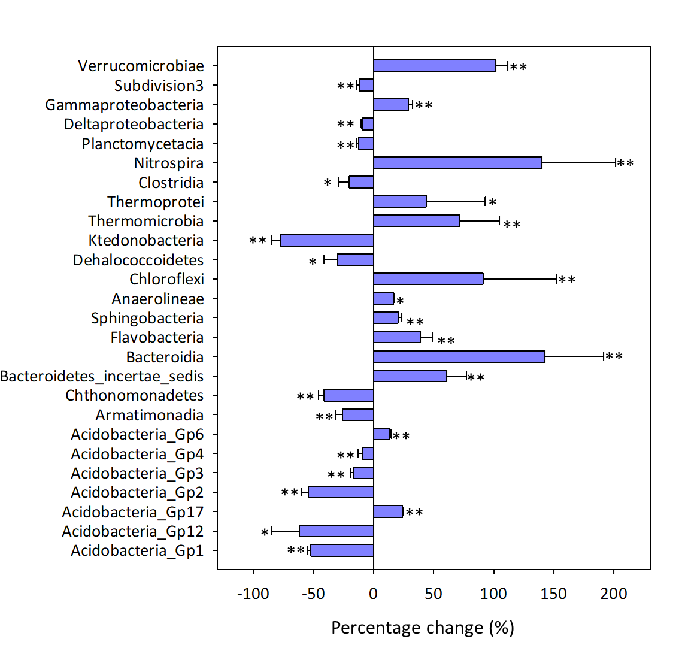

**Fig. S3** The percentage change in the relative abundance of major microbial genera induced by long-term N deposition treatment. All selected genera are significantly changed by N deposition treatment as calculated by the response ratio analysis.

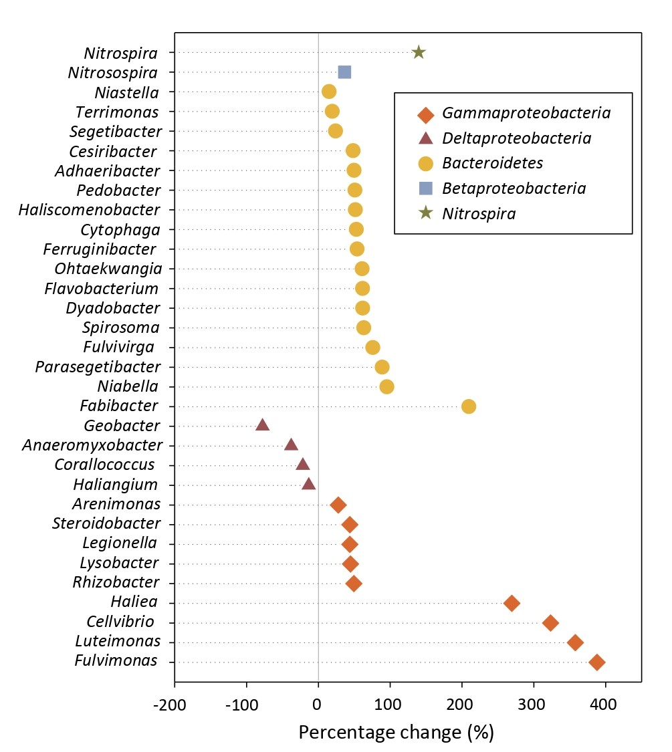

**Fig. S4** The percentage change in the relative abundance of genes associated with C fixation induced by N deposition, calculated as 100*(( mean value in N deposited samples/mean value in control samples) ‒ 1). Mean values and standard deviations are presented. Asterisks indicate significant differences. *, *P* < 0.050; **, *P* < 0.010. The numbers in the figure represent the pathways of C fixation. (i) 3-hydroxypropionate bicycle, (ii) Bacterial microcompartments, (iii) Calvin cycle, and (iv) Reductive tricarboxylic acid cycle.



**Fig. S5** The percentage change in the relative abundance of genes associated with methane and phosphorus cycling genes induced by N deposition, calculated as 100*((mean value in N deposited samples/mean value in control samples) ‒ 1). Mean values and standard deviations are presented. Asterisks indicate significant differences. *, *P* < 0.050; **, *P* < 0.010.

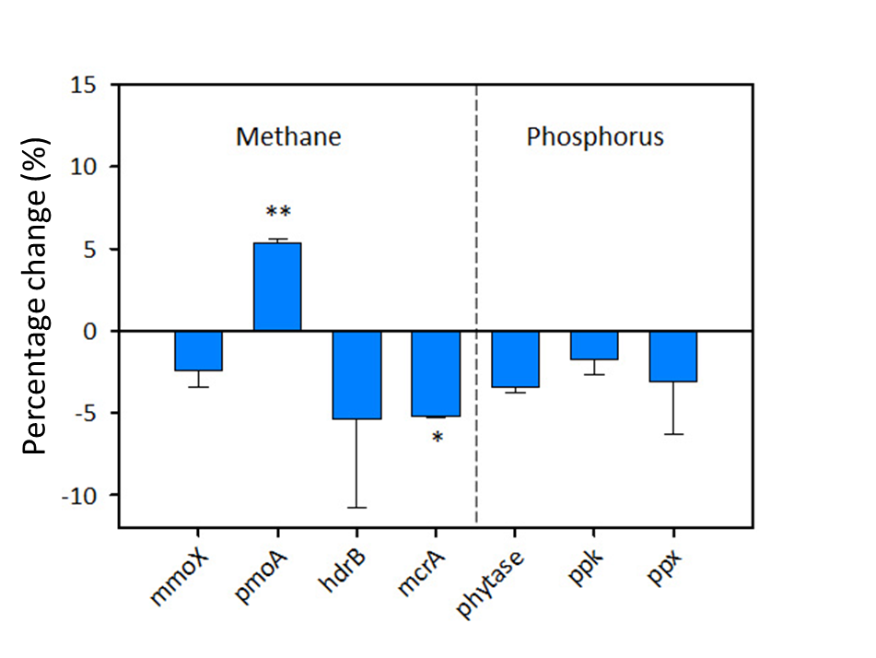

**Fig. S6** N deposition effects on *amoA* gene. The relative abundance of *amoA* is presented as the signal intensity difference between control and N deposited samples. Error bars represent standard errors. Blue bars represent genes derived from archaea (AOA), and pink bars represent genes derived from bacteria (AOB). Asterisks indicate significant differences. *, *P* < 0.050; **, *P* < 0.010.

