Supplementary tables
Supplementary Table S1. Demographic descriptive statistics of the subjects in the study
Parameter |  | Case(n=30) |  | Control(n=31)
 |  | Count | Percent | Count | Percent | Sig.
Age(years) | 20-30 | 15 | 50.00 | 16 | 51.60 | 0.620
 | 31-40 | 9 | 30.00 | 9 | 29.00
 | 41-50 | 4 | 16.67 | 6 | 19.40
 | >50 | 1 | 3.33 | 0 | 0.00
Marriage | Yes | 13 | 46.67 | 15 | 48.39 | 0.544
 | No | 15 | 50.00 | 13 | 41.94
 | Others | 1 | 3.33 | 3 | 9.68
Education | < BD | 25 | 86.67 | 26 | 83.87 | 0.646
 | ≥BD | 4 | 13.33 | 5 | 16.13
Smoking | Yes | 22 | 73.33 | 22 | 70.97 | 0.669
 | No | 7 | 26.67 | 9 | 29.03
Drinking | Yes | 16 | 53.33 | 16 | 51.61 | 0.783
 | No | 13 | 43.33 | 15 | 48.39
BMI | <18.5 | 1 | 3.33 | 3 | 9.70 | 0.452
 | 18.5-25 | 24 | 83.33 | 15 | 48.40
 | >25 | 4 | 16.67 | 13 | 41.90
Abbreviations: BD=Bachelor's degree; BMI=Body mass index, (body mass in kg)/ (height in meters)². Significance of differences was assessed by Chi-square tests.

Supplementary Table S2. Descriptive statistics of diet related parameters of all subjects
 |  | Case(n=30) |  | Control(n=31)
Parameter |  | Count | Percent | Count | Percent | Sig.
Meat | Yes | 20 | 66.67 | 13 | 41.94 | 0.425
 | No | 8 | 26.67 | 15 | 48.39
 | not known | 2 | 6.67 | 3 | 9.68
Yogurt | Yes | 22 | 73.33 | 25 | 80.65 | 0.808
 | No | 5 | 16.67 | 3 | 9.68
 | not known | 3 | 10.00 | 3 | 9.68
Fried food | Yes | 16 | 55.17 | 11 | 35.48 | 0.016
 | No | 11 | 37.93 | 18 | 58.06
 | not known | 2 | 6.90 | 2 | 6.45
High-fat food | Yes | 15 | 50.00 | 9 | 29.03 | 0.492
 | No | 13 | 43.33 | 20 | 64.52
 | not known | 2 | 6.67 | 2 | 6.45
Fast food | Yes | 12 | 40.00 | 17 | 54.84 | 0.077
 | No | 15 | 50.00 | 13 | 41.94
 | not known | 3 | 10.00 | 1 | 3.23
Spicy food | Yes | 19 | 63.33 | 14 | 45.16 | 0.086
 | No | 8 | 26.67 | 15 | 48.39
 | not known | 3 | 10.00 | 2 | 6.45
Vegetarian | Yes | 22 | 84.62 | 12 | 70.59 | 0.230
 | No | 3 | 11.54 | 5 | 29.41
 | not known | 1 | 3.85
Carnivorous | Yes | 20 | 80.00 | 13 | 76.47 | 0.209
 | No | 4 | 16.00 | 3 | 17.65
 | not known | 1 | 4.00 | 1 | 5.88
Balance | Yes | 1 | 3.85 | 3 | 17.65 | 0.300
 | No | 22 | 84.62 | 13 | 76.47
 | not known | 3 | 11.54 | 1 | 5.88
Eating patterns and food preference were recorded by a recall questionnaire of food intake in the last 4 weeks. Significant differences were assessed by Chi-square test.

Supplementary Table S3. Descriptive statistics of gut-related parameters for all subjects
 |  | Case (n=30) |  | Control (n=31)
Parameter |  | Count | Percent | Count | Percent | Sig.
Constipation | Yes | 9 | 30.00 | 13 | 41.90 | 0.354
 | No | 18 | 60.00 | 14 | 45.20
 | not known | 3 | 10.00 | 4 | 12.90
Diarrhea | Yes | 8 | 26.70 | 12 | 38.70 | 0.690
 | No | 21 | 70.00 | 19 | 61.30
 | not known | 1 | 3.33
BSST | Type 1 | 12 | 41.38 | 11 | 35.48 | 0.394
 | Type 2 | 2 | 6.90 | 3 | 9.68
 | Type 3 | 3 | 10.34 | 1 | 3.23
 | Type 5 | 6 | 20.69 | 4 | 12.90
 | Type 6 | 4 | 13.79 | 5 | 16.13
 | Type 7 | 2 | 6.90 | 7 | 22.58
Stool color | Black | 5 | 17.24 | 5 | 16.13 | 0.696
 | Red | 1 | 3.45 | 0 | 0.00
 | Tawny | 18 | 62.07 | 22 | 70.97
 | Golden | 5 | 17.24 | 4 | 12.90
BSST (Bristol stool scale types): type 1: separate hard lumps like nuts (hard to pass); type 2: sausage-shaped but lumpy; type 3: sausage-shaped but with cracks on surface; type 5: soft blobs with clear-cut edges (passed easily); type 6: fluffy pieces with edges, mushy; type 7: watery, no solid pieces. Chi-square test results.

Supplementary Table S4. Alpha diversity indices
 | Shannon | Simpson | chao1
Case | 3.15±0.20 | 0.93±0.02 | 1872.39±808.78
Control | 3.29±0.24 | 0.94±0.03 | 2852.88±1097.80
Sig. | 0.015 | 0.065 | 0.000
The diversity indices of two groups are shown as the mean±SD. Significance of differences was assessed by Mann Whitney U test.

Supplementary Table S5. Diversity indices of dissimilarity tests for two groups
 | ANOSIM | Sig. | MRPP | Sig. | adonis | Sig.
Case vs. Control | 0.13 | 0.003 | 0.47 | 0.003 | 0.08 | 0.004
Dissimilarity tests. Abbreviations: ANOSIM, analysis of similarity; MRPP, multiresponse permutation procedure; Adonis, nonparametric multivariate analysis of variance (MANOVA) with the adonis function.

Supplementary Table S6. Total genes detected and diversity indices of functional genes in each group
 | Genes detected | Shannon | Simpson
Case | 9434.74±1434.77 | 9.07±0.19 | 0.999877±0.000029
Control | 11304.20±2499.12 | 9.25±0.22 | 0.999897±0.000024
Sig. | 0.001 | 0.002 | 0.001
The diversity indices of two groups are shown as mean±SD (Standard Deviation). Significance of differences was assessed by Mann Whitney U test.

Supplementary Figures

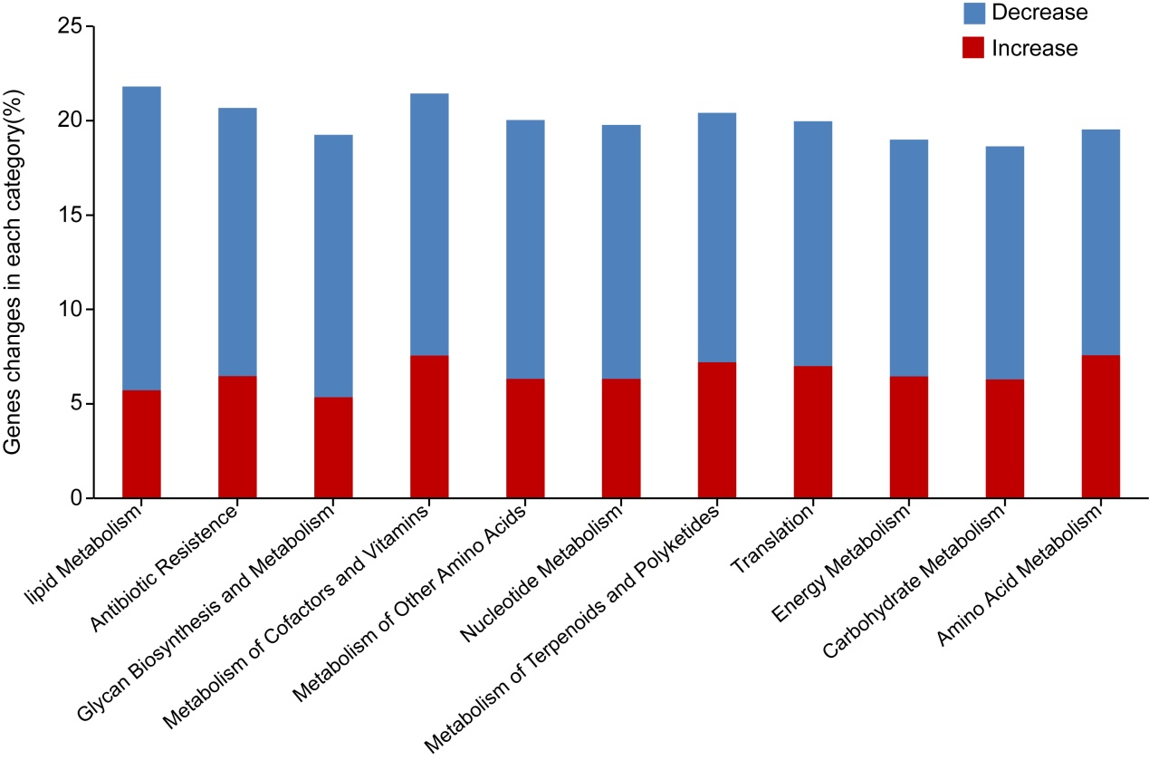
Supplementary Figure S1. Shifts of functional genes involved in key metabolic pathways in inmates. The numbers of genes that exhibited significant differences as assessed by the Mann-Whitney U test between the inmates (case) and control groups are presented as a percentage in each category.

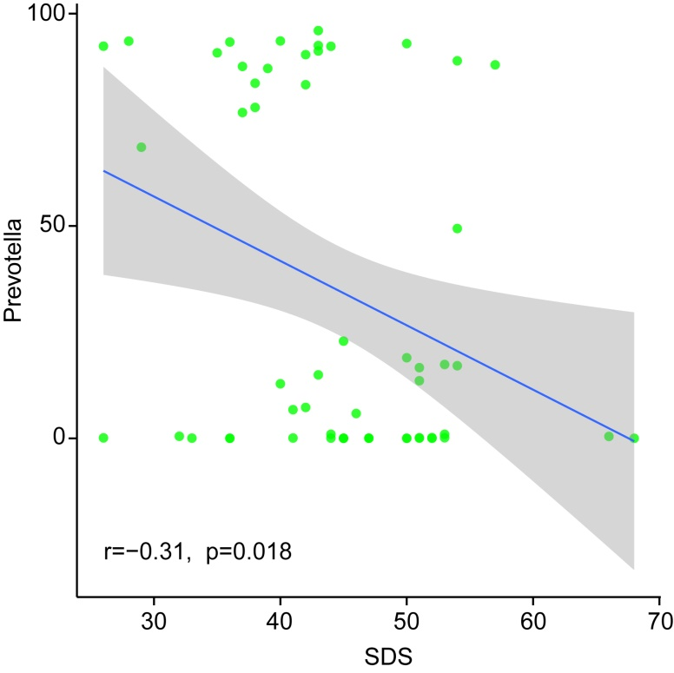
Supplementary Figure S2. Correlation between depression (SDS) and relative abundance of the genera Prevotella. The Spearman rank correlation (r) and probability (p) were used to evaluate statistical importance. SDS: Self-rating depression scale.

