Supplementary Materials

Supplementary Text
- Treatment effects on soil and plant variables in the 14th year of the experiment
Some variables were measured using soil samples collected in 2012, which was the 14th year of the experiment. Soil moisture significantly increased from 7.54% (31% of the maximum water holding capacity) in aP quadrants to 9.34% (44% of the maximum water holding capacity) in eP quadrants (p < .001, Table S1). Soil pH increased marginally significantly from 6.23 to 6.31 (p = .085). Soil nitrate (NO₃-N) significantly increased from 2.96 mg per g of soil in aP quadrants to 3.96 mg per g of soil in eP quadrants (p = .046). The average soil ammonium (NH₄-N) was 5.87 mg per g of soil in aP quadrants and 10.80 mg per g of soil in eP quadrants. However, due to large variations among aP and eP quadrants (CV values of 91.8%–172.0%), changes in NH₄-N were not statistically significant. Total aboveground biomass and the biomass of different functional groups (i.e., annual grass, annual forb, perennial grass, and perennial forb) did not significantly respond to the eP treatment. Litter biomass was marginally significantly decreased by 13.9% (p = .078). Belowground total root biomass was marginally significantly decreased by 27.9% (p =.065). This decrease was caused by a decrease in shallow root biomass (depth 0–15 cm, p = .079) but not deep root biomass (depth 15–30 cm).

- Treatment effects on microbial stress response genes
The relative abundance of glucose limitation gene bglP, which encodes β-glucoside permease, was increased by 12.5% (p = .044, Figure 2c). The relative abundance of oxygen limitation gene cydA, which encodes cytochrome d oxidase, was increased by 13.3% (p = .007). The relative abundances of phoB and phoA genes, which encode regulatory proteins involved in acquiring phosphate with high affinity in response to phosphate limitation, were increased by 5.1%–8.2% (p < .029). The relative abundance of oxidative stress gene katA, which encodes catalase, was increased by 7.2% (p = .005). The relative abundances of genes associated with general stress response (i.e., σ38) and heat shock (i.e., σ32 and grpE) were also increased by 5.5%–6.2% (p < .047) with the eP treatment.

- Treatment effects on microbial taxa
A total of 185 bacterial ASVs differed between eP and aP quadrants (p < .05 by Wald test after FDR correction, Data S5). Among them, 108 ASVs were increased by eP and thus could be classified as positive eP responders. Sixty of these ASVs belonged to the phylum Proteobacteria (39 ASVs in Gammaproteobacteria, 17 ASVs in Alphaproteobacteria, and 4 ASVs in Deltaproteobacteria), and 20 ASVs were classified in the phylum Bacterioidetes (Figure 3 & Data S5). In contrast, a total of 77 ASVs were decreased in relative abundance in response to eP and thus could be classified as negative eP responders. Among them, 31 ASVs belonged to the phylum Actinobacteria, including the genera Blastococcus, Geodermatophilus, Modestobacter, Angustibacter, Cellulomonas, Conexibacter, and Solirubrobacter (Figure 3 and Data S5).
A total of 89 fungal ASVs differed between eP and aP treatments (Data S6). Among them, 25 fungal ASVs were positive eP responders, of which 15 belonged to the class Sordariomycetes of Ascomycota. In contrast, 64 fungal ASVs were negative eP responders, of which 49 ASVs belonged to the phylum Ascomycota (16 ASVs in Eurotiomycetes, 15 ASVs in Dothideomycetes, 7 ASVs in Leotiomycetes, and 3 ASVs in Orbiliomycetes), and 10 ASVs belonged to the phylum Basidiomycota (Data S6). The relative abundance of Glomeromycota was also significantly decreased by eP (Data S3), indicating a reduction in mycorrhizal associations between fungi and plants.

- Environmental drivers of microbial community composition
The negative eP responders of bacteria were correlated with soil moisture, soil pH, shallow root biomass, total root biomass, and soil CO₂ efflux (Mantel’s r = 0.155–0.203, p < .009, Figure 5C). In contrast, the positive eP responders of bacteria were correlated with environmental variables to a lesser degree, with only marginal correlations. For fungi, the negative eP responders were correlated with deep root biomass (Mantel’s r = 0.166, p = .035), while the positive eP responders of fungi were correlated with soil moisture and soil CO₂ efflux (Mantel’s r = 0.149–0.187, p < .015).

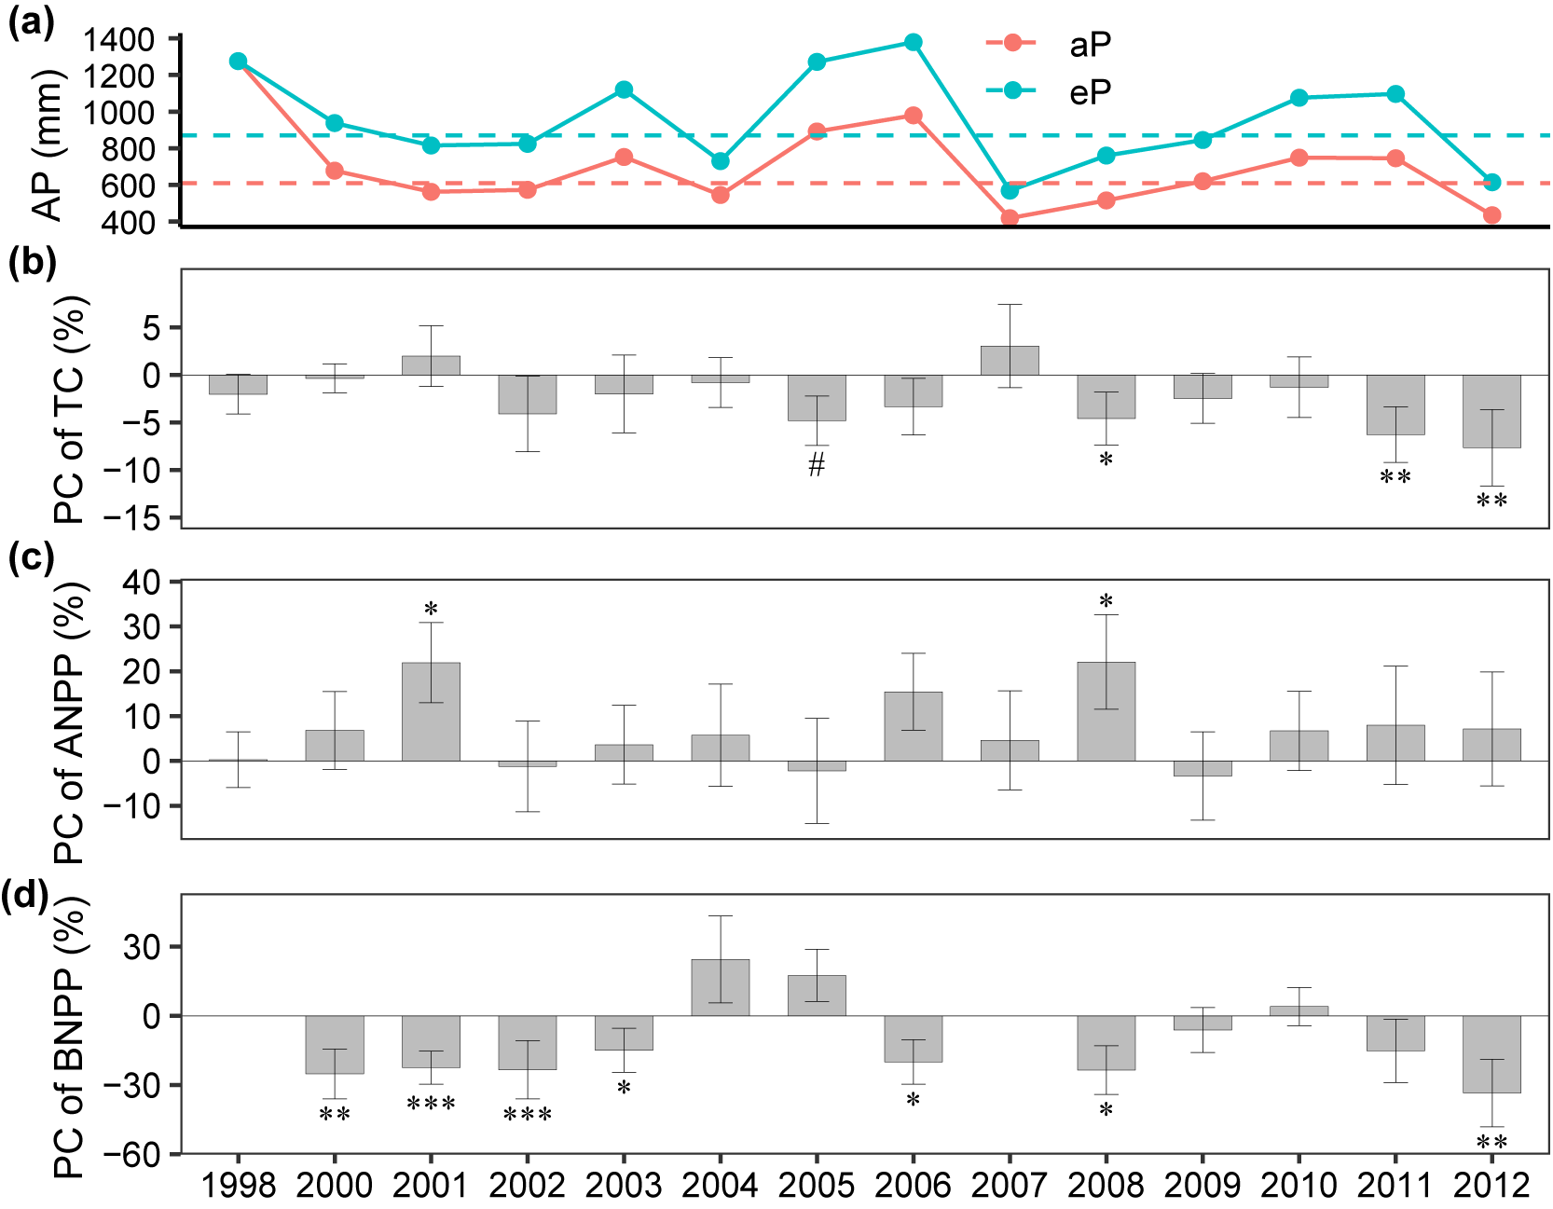

Figure S1.
The effects of the eP treatment on soil total C, ANPP, and BNPP in 1998 (Year 0) and from 2000 (Year 2) to 2012 (Year 14), compared to control plots receiving ambient precipitation (aP). (a), Annual precipitation in eP and aP quadrants. Dashed lines indicate average annual precipitation. (b), Percent changes of soil total C. The percent change represents the effect size calculated as follows: % effect = 100% × (eP - aP)/aP. (c), Percent changes of ANPP. (d), Percent changes of BNPP. The error bars represent standard error (n = 64 for data in 1998–2003, n = 48 for data in 2004–2011, and n = 32 for data in 2012). Statistical significance is indicated by *** for p < .001, ** for p < .010, * for p < .050, and # for p < .100.

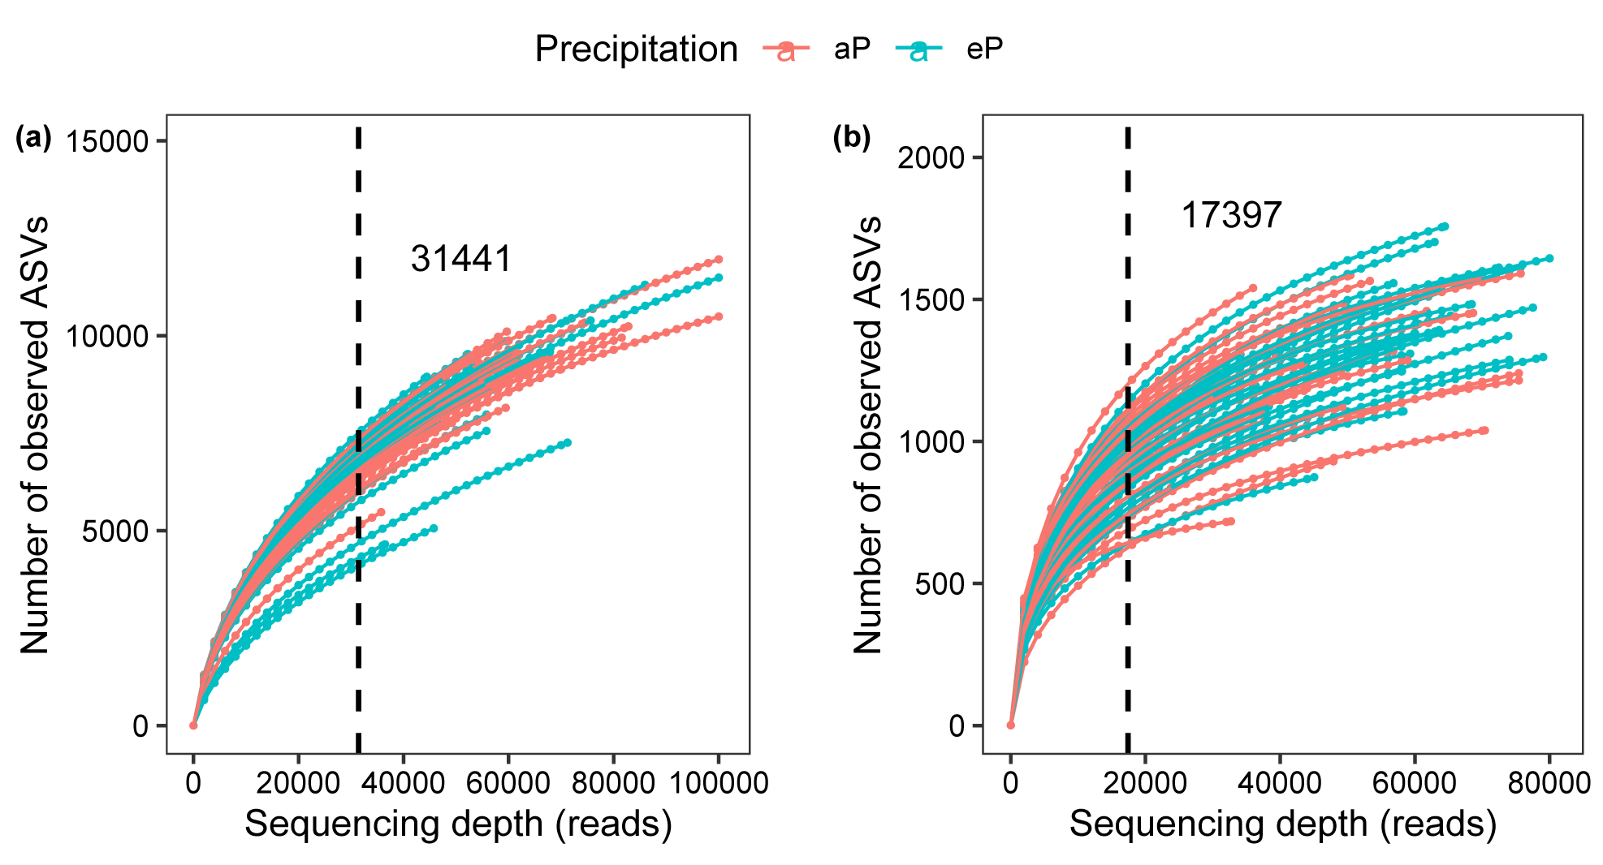

Figure S2.
Rarefaction curves of (a) 16S rRNA sequencing data and (b) ITS sequencing data. The vertical dashed lines represent the resampling depth.

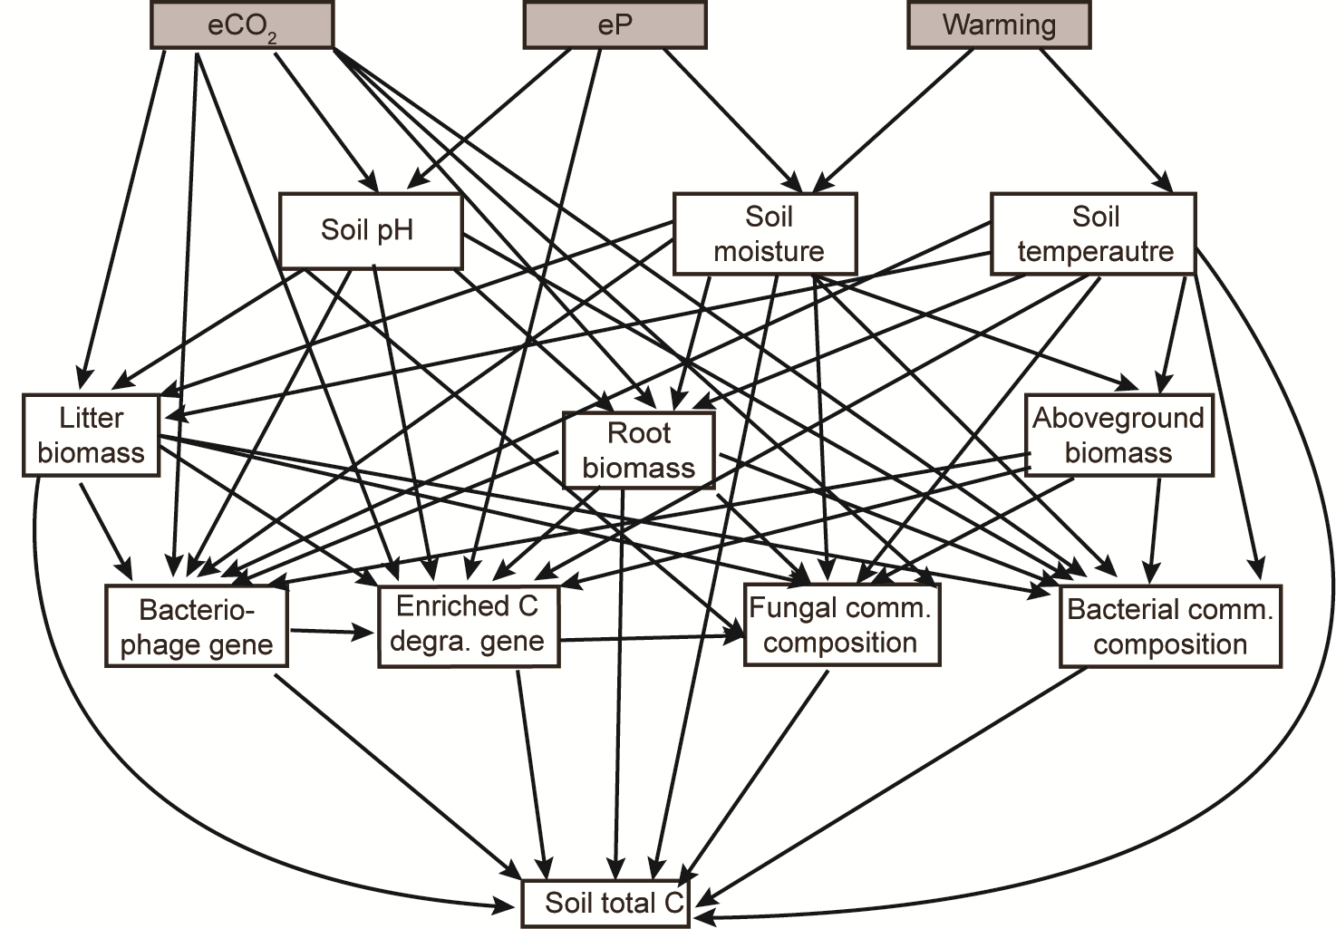

Figure S3.
The hypothesized conceptual model showing the influences of experiment treatments, environmental variables, and microbial profiles on soil total C. Enriched C degra. gene means relative abundances of increased C degradation genes shown in Fig. 2A, including those associated with the degradation of chitin and protein. Fungal comm. composition means fungal community composition. Bacterial comm. composition means bacterial community composition. As aboveground biomass contains four functional groups, including annual grass, annual forbs, perennial grass, and perennial forbs, we use the total aboveground biomass or biomass of each functional group in one regression to avoid collinearity. Similarly, root biomass is divided into shallow root biomass, fine root biomass, and deep root biomass, with shallow root and fine root not included in the same regression due to their collinearity.

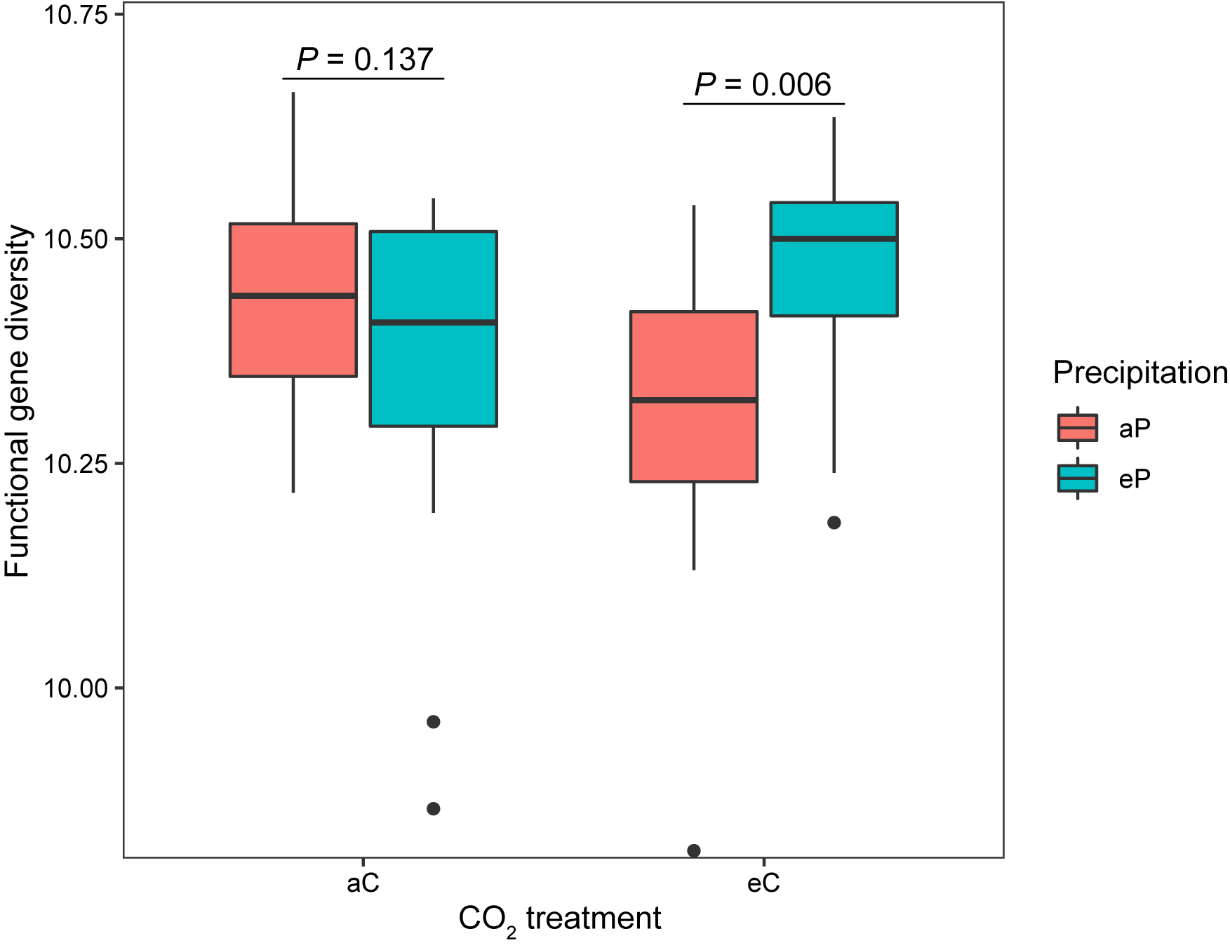

Figure S4.
The effects of the eP treatment on functional gene diversity under different CO₂ regimes. aC, ambient CO₂; eC, elevated CO₂.

(a)
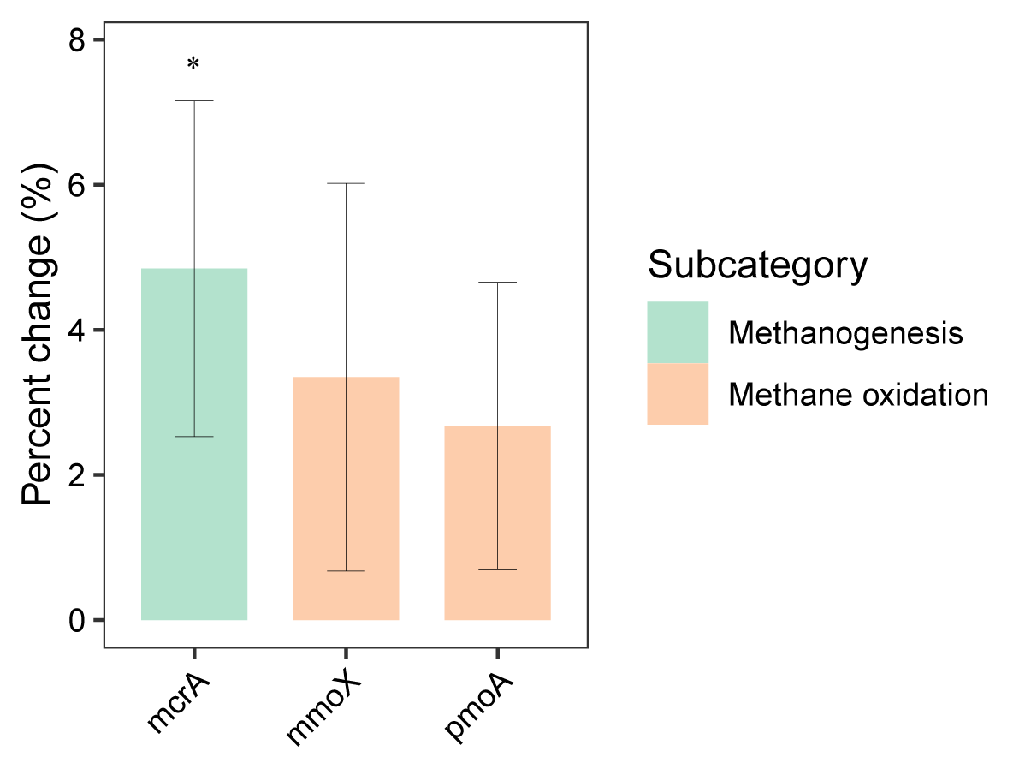
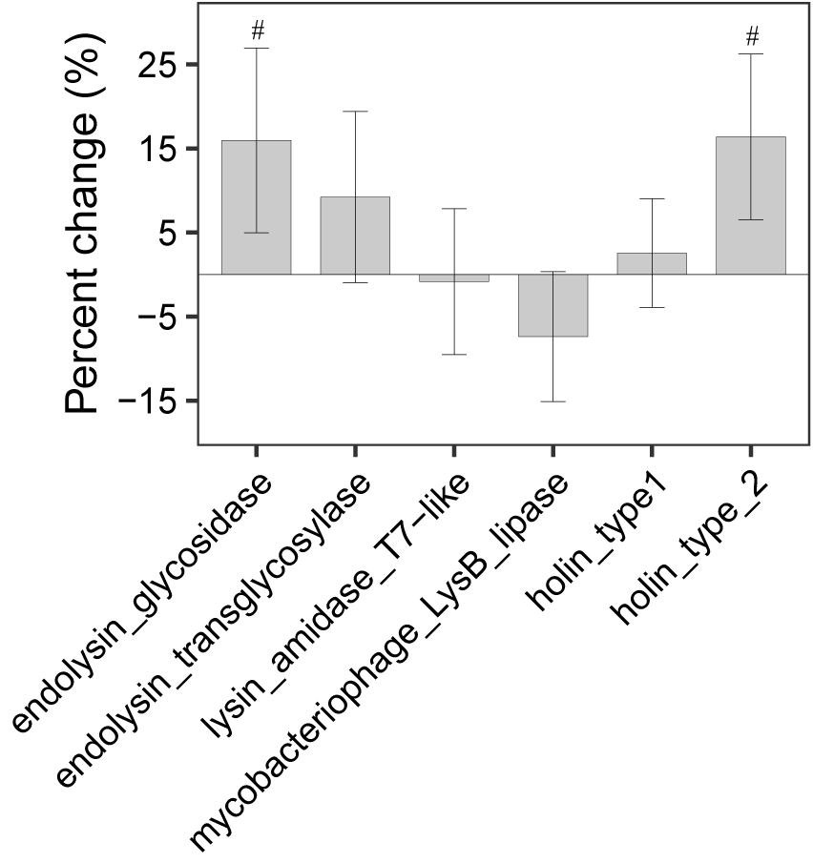
(b)

Figure S5.
The effects of the eP treatment on (a) methanogenesis and methane oxidation genes and (b) bacteriophage lysis genes. Percent changes represent the effect size of the relative abundance calculated as follows: % effect = 100% × (eP - aP)/aP. Statistical significance is indicated by * for p < .050 and # for p < .100.
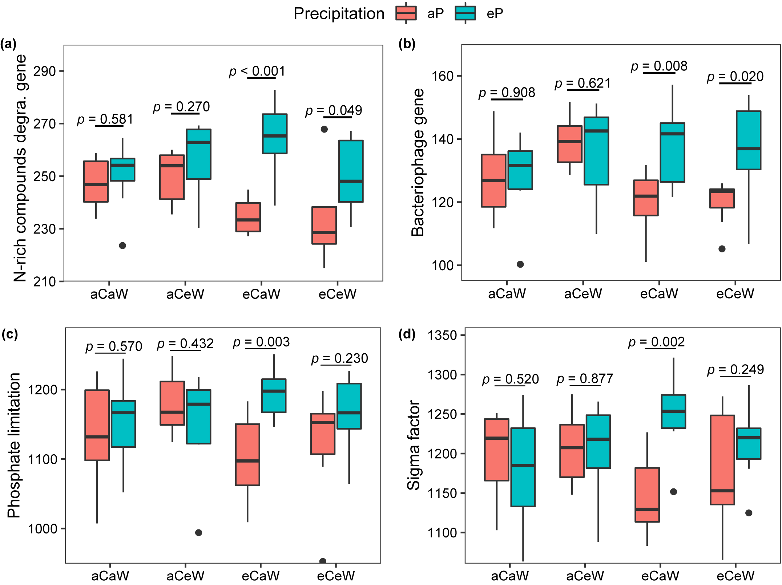

Figure S6.
The effects of the eP treatment on relative abundances of functional genes under different CO₂ and warming treatments. (a), N-rich compounds degradation genes, including those associated with degrading chitin and protein. (b) Bacteriophage genes. (c) Phosphate limitation genes. (d) Sigma factor genes. aC, ambient CO₂; eC, elevated CO₂; aW, ambient temperature; eW, warming.

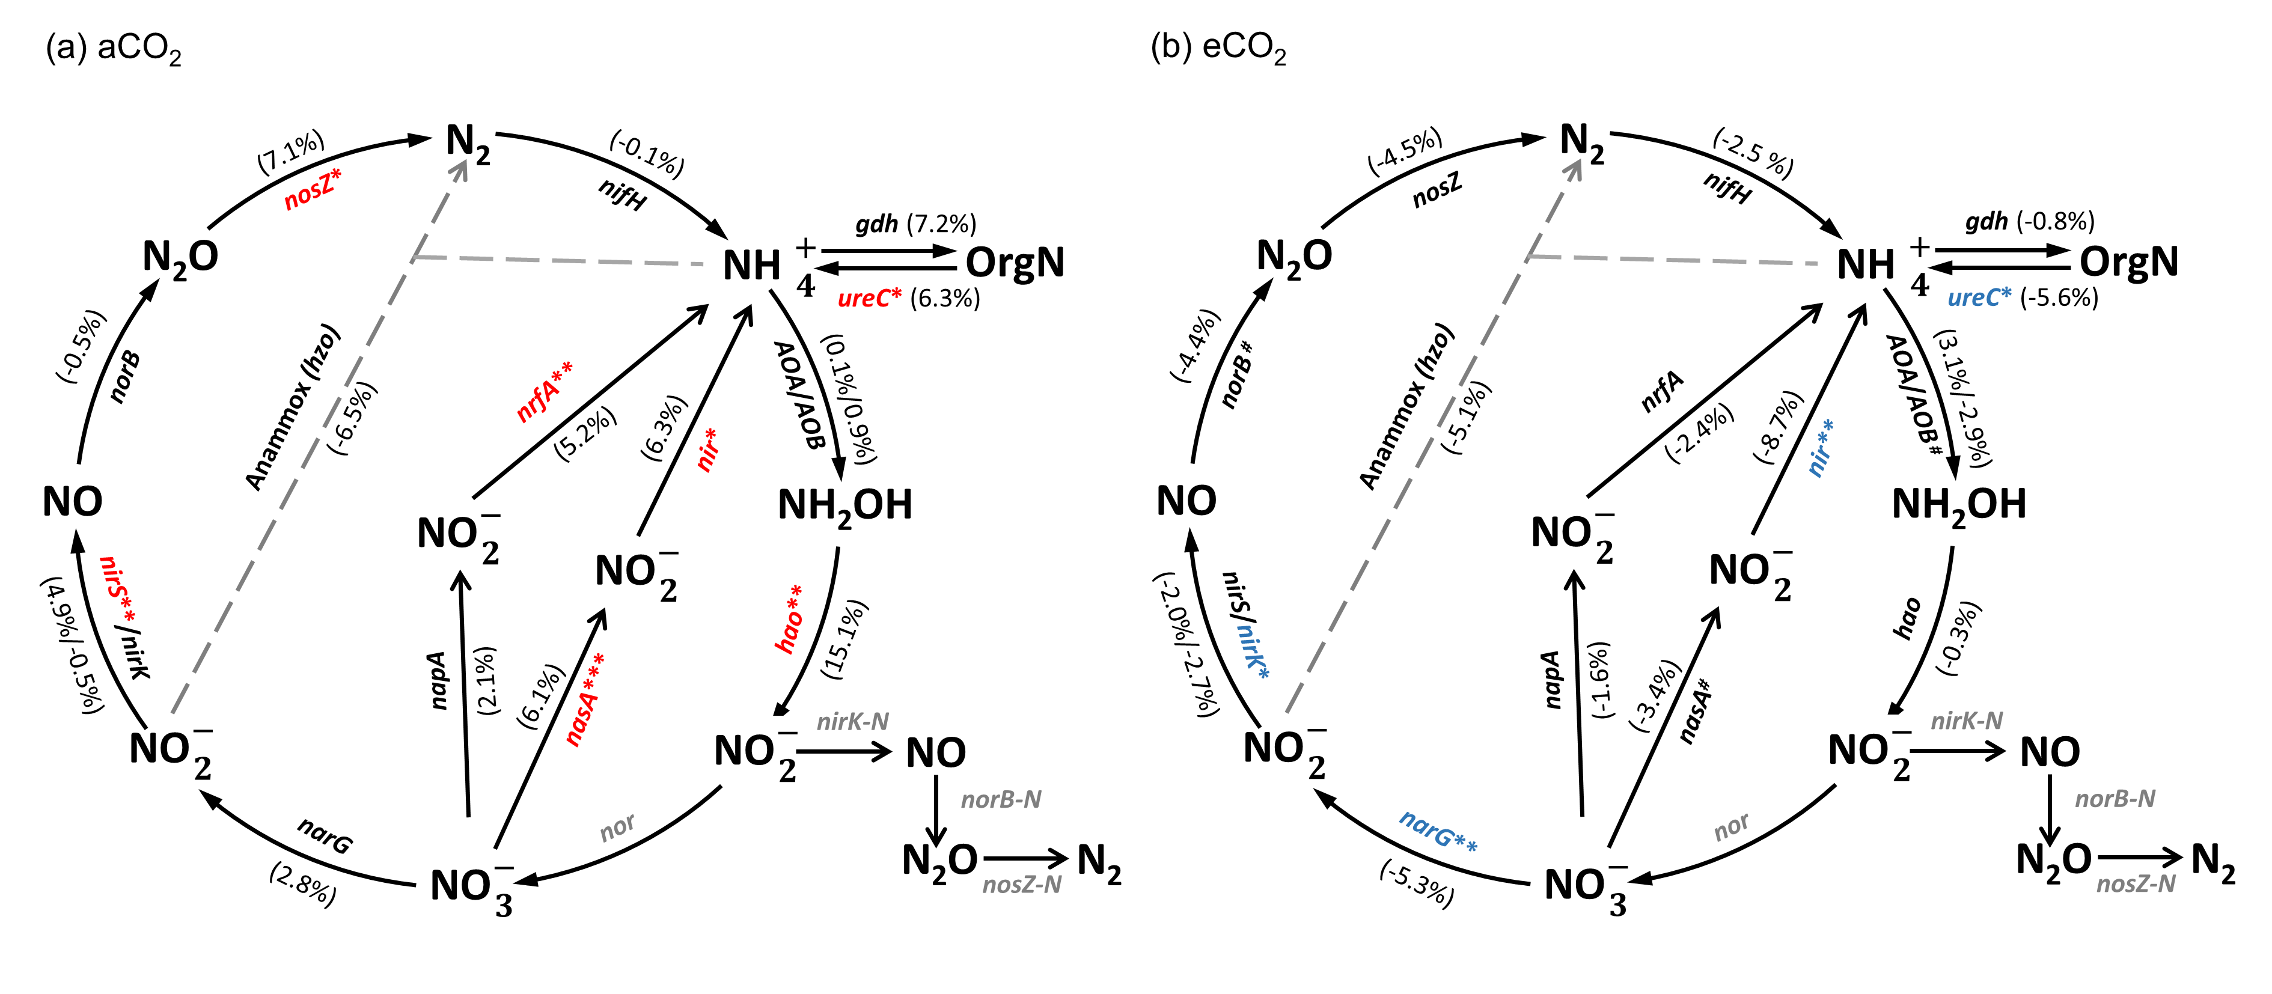

Figure S7.
The effects of the eP treatment on N cycling genes under (a) aCO₂ and (b) eCO₂. Red genes indicate those enriched by eP and blue genes indicate those decreased by eP (p < .050), while grey genes indicate those undetected by GeoChip. The percent change for each individual gene represents the effect size of the relative abundance calculated as follows: % effect = 100% × (eP - aP)/aP. Statistical significance is indicated by *** for p < .001, ** for p < .010, * for p < .050, and # for p < .100.

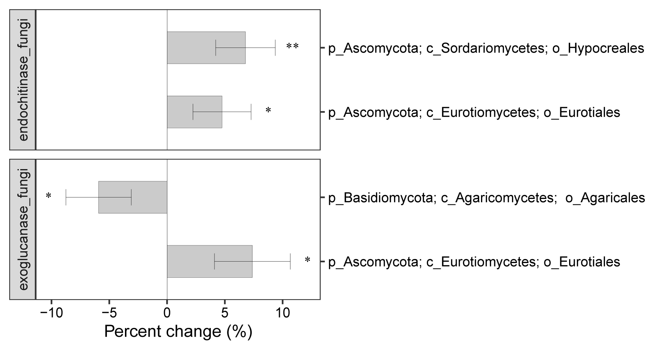

Figure S8.
The effects of the eP treatment on fungal genes encoding exoglucanase and endochitinase with different lineages. The percent change represents the effect size of the relative abundance calculated as follows: % effect = 100% × (eP - aP)/aP. Statistical significance is indicated by ** for p < .010 and * for p < .050.

Table S1.
The effects of eP on environmental variables measured for samples in 2012.
Environmental variables | aP | CV* (%) | eP | CV (%) | Effect† (%) | p-value
Soil moisture (%) | 7.540 | 26.2 | 9.337 | 17.3 | 23.8 | <0.001‡
Soil temperature (°C) | 15.89 | 6.7 | 15.79 | 5.8 | -0.7 | 0.402
Soil pH | 6.23 | 3.4 | 6.31 | 3.2 | 1.4 | 0.085
Annual grass (g m⁻²) | 232.6 | 68.4 | 204.8 | 44.1 | -11.9 | 0.882
Annual forb (g m⁻²) | 204.2 | 98.1 | 218.0 | 121.9 | 6.8 | 0.629
Perennial grass (g m⁻²) | 13.73 | 188.7 | 44.57 | 270.0 | 224.7 | 0.530
Perennial forb (g m⁻²) | 68.80 | 124.5 | 43.75 | 115.6 | -36.4 | 0.268
Aboveground biomass  (g m⁻²) | 454.7 | 49.9 | 482.7 | 49.3 | 6.2 | 0.566
Litter (g m⁻²) | 262.0 | 60.4 | 225.7 | 63.7 | -13.9 | 0.078
Fine root (g m⁻²) | 77.25 | 33.1 | 69.65 | 32.5 | -9.8 | 0.201
Shallow root (g m⁻²) | 139.5 | 99.0 | 92.50 | 76.2 | -33.7 | 0.079
Deep root (g m⁻²) | 24.94 | 99.4 | 25.96 | 132.3 | 4.1 | 0.956
Total root (g m⁻²) | 164.4 | 86.1 | 118.5 | 73.4 | -27.9 | 0.065
Soil total C (%) | 1.370 | 14.7 | 1.250 | 16.9 | -7.7 | 0.001
Soil total N (%) | 0.128 | 11.3 | 0.124 | 16.5 | -3.2 | 0.153
Soil C: N | 10.676 | 6.40 | 10.121 | 9.2 | -5.2 | 0.003
NH₄-N (mg·g⁻¹ soil) | 5.873 | 91.8 | 10.796 | 172.0 | 83.8 | 0.197
NO₃-N (mg·g⁻¹ soil) | 2.956 | 112.0 | 3.958 | 104.7 | 33.9 | 0.046
CO₂ efflux (µmol m⁻² s⁻¹) | 5.413 | 40.5 | 5.535 | 34.6 | 2.3 | 0.777
*CV: the coefficient of variation, which equals to the standard deviation divided by the mean.
†The effects of precipitation were calculated as: % effect = 100% × (eP - aP)/aP.
‡The p-value of the eP effect was determined by split-plot ANOVA. Significant effects are indicated in bold (p < .050).

Table S2.
Summary of p values for split-plot ANOVA results testing for the effects of treatments on soil total C, N, and NPP over 2–14 years of the experiment.
Period | Year 2–14 |  |  |  |  |  |  | Year 2–9 |  | Year 10–14
Treatments | Soil total C | Soil total N | C: N ratio | ANPP | BNPP | NPP |  | Soil total C |  | Soil total C
P* | 0.003† | 0.189 | 0.002 | 0.018 | <0.001 | 0.282 |  | 0.318 |  | <0.001
P × C | 0.948 | 0.927 | 0.992 | 0.485 | 0.235 | 0.620 |  | 0.785 |  | 0.549
P × W | 0.048 | 0.059 | 0.850 | 0.373 | 0.765 | 0.446 |  | 0.152 |  | 0.259
P × N | 0.188 | 0.236 | 0.842 | 0.283 | 0.242 | 0.814 |  | 0.216 |  | 0.832
P × Yr | 0.362 | 0.190 | 0.239 | 0.688 | 0.002 | 0.247 |  | 0.879 |  | 0.233
P × C × W | 0.446 | 0.378 | 0.706 | 0.378 | 0.021 | 0.037 |  | 0.570 |  | 0.008
P × C × N | 0.839 | 0.644 | 0.833 | 0.157 | 0.788 | 0.602 |  | 0.784 |  | 0.337
P × W × N | 0.133 | 0.047 | 0.319 | 0.266 | 0.882 | 0.325 |  | 0.174 |  | 0.779
P × C × Yr | 0.615 | 0.479 | 0.664 | 0.732 | 0.911 | 0.672 |  | 0.535 |  | 0.685
P × W × Yr | 0.315 | 0.129 | 0.477 | 0.078 | 0.556 | 0.366 |  | 0.018 |  | 0.805
P × N × Yr | 0.905 | 0.962 | 0.952 | 0.990 | 0.958 | 0.766 |  | 0.413 |  | 0.380
P × C × W × N | 0.935 | 0.889 | 0.959 | 0.332 | 0.605 | 0.250 |  | 0.945 |  | 0.939
P × C × W × Yr | 0.353 | 0.274 | 0.327 | 0.840 | 0.974 | 0.876 |  | 0.282 |  | 0.534
P × C × N × Yr | 0.955 | 0.988 | 0.563 | 0.315 | 0.596 | 0.586 |  | 0.885 |  | 0.226
P × W × N × Yr | 0.148 | 0.614 | 0.717 | 0.399 | 0.645 | 0.160 |  | 0.155 |  | 0.408
P × C × W × N × Yr | 0.720 | 0.955 | 0.746 | 0.992 | 0.396 | 0.966 |  | 0.610 |  | 0.239
*Treatments: P, precipitation; N, nitrogen deposition; C, CO₂; W, warming; Yr, Year.
†Significant (p < .050) effects are shown in bold.

Table S3.
Summary of p values for split-plot ANOVA results testing for the effects of treatments on environmental variables for samples in 2012.
Variables | P* | N | C | W | P × N | P × C | P × W | P × C × W | P × N × C | P × N × W | P × N × W × C
Soil moisture | <0.001† | 0.675 | 0.970 | 0.546 | 0.831 | 0.959 | 0.480 | 0.812 | 0.771 | 0.764 | 0.171
Soil temperature | 0.402 | <0.001 | 0.894 | <0.001 | 0.823 | 0.832 | 0.011 | 0.669 | 0.798 | 0.413 | 0.474
Soil pH | 0.085 | 0.006 | 0.085 | 0.627 | 0.109 | 0.679 | 0.977 | 0.833 | 0.884 | 0.080 | 0.396
Annual grass | 0.882 | 0.299 | 0.960 | 0.147 | 0.635 | 0.074 | 0.558 | 0.323 | 0.155 | 0.862 | 0.806
Annual forb | 0.629 | <0.001 | 0.835 | 0.797 | 0.626 | 0.371 | 0.430 | 0.067 | 0.710 | 0.326 | 0.534
Perennial grass | 0.530 | 0.025 | 0.435 | 0.450 | 0.108 | 0.845 | 0.224 | 0.856 | 0.587 | 0.821 | 0.660
Perennial forb | 0.268 | 0.086 | 0.669 | 0.028 | 0.154 | 0.794 | 0.183 | 0.567 | 0.215 | 0.671 | 0.605
Aboveground biomass | 0.566 | <0.001 | 0.519 | 0.164 | 0.354 | 0.698 | 0.111 | 0.736 | 0.670 | 0.135 | 0.731
Litter | 0.078 | 0.004 | 0.587 | 0.958 | 0.866 | 0.138 | 0.041 | 0.011 | 0.114 | 0.256 | 0.548
Shallow root | 0.079 | 0.152 | 0.355 | 0.784 | 0.540 | 0.794 | 0.052 | 0.335 | 0.314 | 0.080 | 0.938
Fine root | 0.201 | 0.511 | 0.150 | 0.852 | 0.619 | 0.474 | 0.131 | 0.151 | 0.592 | 0.110 | 0.834
Deep root | 0.956 | 0.022 | 0.887 | 0.279 | 0.891 | 0.186 | 0.607 | 0.214 | 0.320 | 0.026 | 0.979
Total root | 0.065 | 0.047 | 0.463 | 0.865 | 0.558 | 0.329 | 0.090 | 0.170 | 0.218 | 0.027 | 0.766
Soil total C | 0.001 | <0.001 | 0.265 | 0.383 | 0.304 | 0.794 | 0.824 | 0.005 | 0.977 | 0.197 | 0.282
Soil total N | 0.153 | <0.001 | 0.112 | 0.730 | 0.302 | 0.806 | 0.239 | 0.032 | 0.580 | 0.880 | 0.339
Soil C:N | 0.003 | 0.301 | 0.446 | 0.106 | 0.828 | 0.981 | 0.219 | 0.169 | 0.473 | 0.049 | 0.740
NH₄-N | 0.197 | 0.064 | 0.435 | 0.824 | 0.299 | 0.830 | 0.386 | 0.796 | 0.818 | 0.448 | 0.023
NO₃-N | 0.046 | <0.001 | 0.379 | 0.491 | 0.515 | 0.596 | 0.591 | 0.688 | 0.128 | 0.598 | 0.358
CO₂ efflux | 0.777 | 0.048 | 0.384 | 0.557 | 0.565 | 0.587 | 0.967 | 0.805 | 0.022 | 0.219 | 0.821
*Treatments: P, precipitation; N, nitrogen deposition; C, CO₂; W, warming.
†Significant (p < .050) effects are shown in bold.

Table S4.
Summary of split-plot PERMANOVA results testing for the effects of treatments on microbial functional and taxonomic compositions.
Treatments | Functional |  | Taxonomic-16S |  | Taxonomic-ITS
 | Pseudo-F | p value | Pseudo-F | p value | Pseudo-F | p value
P* | 2.022 | 0.050 | 2.916 | 0.001† | 2.310 | 0.001
P × C | 5.981 | 0.002 | 1.321 | 0.096 | 1.238 | 0.138
P × W | 1.842 | 0.094 | 1.342 | 0.081 | 1.147 | 0.234
P × N | 2.580 | 0.033 | 1.148 | 0.238 | 0.823 | 0.785
P × C × W | 2.183 | 0.048 | 1.206 | 0.176 | 1.246 | 0.137
P × N × C | 1.330 | 0.203 | 0.878 | 0.683 | 1.084 | 0.322
P × N × W | 1.659 | 0.113 | 1.237 | 0.149 | 0.866 | 0.722
P × N × W × C | 2.085 | 0.053 | 1.433 | 0.051 | 1.297 | 0.095
*Treatments: P, precipitation; N, nitrogen deposition; C, CO₂; W, warming.
†Significant (p < .050) effects are shown in bold.

Table S5.
Summary of split-plot ANOVA results testing for the effects of treatments on microbial functional and taxonomic diversity.
Treatments | Functional* |  | Taxonomic-16S |  | Taxonomic-ITS |  | Faith’s phylogenetic-16S |  | Faith’s phylogenetic-ITS
 | F value | p value | F value | p value | F value | p value | F value | p value | F value | p value
P† | 0.936 | 0.340 | 2.012 | 0.165 | 0.927 | 0.342 | 0.435 | 0.514 | 1.600 | 0.214
P × C | 10.638 | 0.002‡ | 0.245 | 0.624 | 0.007 | 0.936 | 0.914 | 0.345 | 0.253 | 0.618
P × W | 0.969 | 0.331 | 0.174 | 0.679 | 0.614 | 0.438 | 0.076 | 0.785 | 0.014 | 0.907
P × N | 3.232 | 0.081 | 0.706 | 0.406 | 3.273 | 0.079 | 0.211 | 0.649 | 0.851 | 0.363
P × C × W | 0.139 | 0.711 | 0.269 | 0.607 | 0.023 | 0.880 | 0.002 | 0.969 | 0.569 | 0.456
P × N × C | 0.019 | 0.891 | 0.027 | 0.871 | 0.151 | 0.700 | 0.122 | 0.729 | 0.315 | 0.578
P × N × W | 1.152 | 0.290 | 3.875 | 0.057 | 4.622 | 0.038 | 2.522 | 0.121 | 3.747 | 0.061
P × N × W × C | 1.938 | 0.172 | 1.585 | 0.216 | 0.184 | 0.671 | 1.493 | 0.230 | 0.244 | 0.624
*Functional and taxonomic alpha-diversities were calculated based on the Shannon index.
†Treatments: P, precipitation; N, nitrogen deposition; C, CO₂; W, warming.
‡Significant (p < .050) effects are shown in bold.

