**Supporting Information**

**Table S1.** The plot information of sampling sites located in the southeastern Tibetan plateau.

|  |  |  |  |  |  |  |  |
| --- | --- | --- | --- | --- | --- | --- | --- |
| Plot ID | Sampling date | Sampling time | Location | Latitude | Longitude | Elevation | Ecosystem type |
| L-1 | 2019.07.11 | 11:00 | Deqing, Yunnan Province | 28°16′5″ | 99°12′57″ | 2810 | Mixed forest |
| L-2 | 2019.07.13 | 11:25 | Changdu, Tibet Autonomous Region | 29°38′15″ | 98°8′22″ | 4245 | Alpine meadow |
| L-3 | 2019.07.14 | 11:00 | Changdu, Tibet Autonomous Region | 29°53′32″ | 96°40′46″ | 3900 | Alpine meadow |
| L-4 | 2019.07.14 | 13:00 | Changdu, Tibet Autonomous Region | 29°41′9″ | 96°43′37″ | 4420 | Alpine meadow |
| L-5 | 2019.07.17 | 11:30 | Linzhi, Tibet Autonomous Region | 29°19′24″ | 97°9′52″ | 3814 | Coniferous forest |
| L-6 | 2019.07.17 | 12:40 | Linzhi, Tibet Autonomous Region | 29°19′11″ | 97°10′44″ | 3655 | Coniferous forest |
| L-7 | 2019.07.17 | 14:30 | Linzhi, Tibet Autonomous Region | 29°7′5″ | 97°15′20″ | 3124 | Coniferous forest |
| L-8 | 2019.07.17 | 16:30 | Linzhi, Tibet Autonomous Region | 28°50′30″ | 97°29′21″ | 2629 | Mixed forest |
| L-9 | 2019.07.18 | 12:30 | Linzhi, Tibet Autonomous Region | 28°31′51″ | 98°22′42″ | 2013 | Dry-hot valley |
| L-10 | 2019.07.19 | 12:00 | Nujiang, Yunnan Province | 28°2′57″ | 98°35′32″ | 1563 | Mixed forest |
| L-11 | 2019.07.20 | 11:00 | Nujiang, Yunnan Province | 26°32′9″ | 98°53′51″ | 1090 | Evergreen forest |
| L-12 | 2019.07.20 | 14:20 | Nujiang, Yunnan Province | 25°58′5″ | 98°50′27″ | 853 | Evergreen forest |

**Table S2.** Correlations between Rs and diversity indices of the whole community and abundant phyla.

|  |  |  |  |  |  |  |  |  |  |
| --- | --- | --- | --- | --- | --- | --- | --- | --- | --- |
| Taxa | **Abundance** | **α-diversity** | | | |  | **β-diversity** | | |
| Richness | Shannon | 1/(Simpson) |  | Bray.Curtis | Jaccard | Sorensen | Morisita-Horn |
| Bacterial community | \ | 0.199 |  |  |  | 0.266 | 0.386 | 0.385 | 0.385 |
| Proteobacteria (27.4%) | 0.539 | 0.544 |  |  |  |  |  |  |  |
| Acidobacteria (24.7%) |  | 0.230 | 0.296 | 0.227 |  | 0.294 | 0.384 | 0.382 | 0.382 |
| Bacteroidetes (11.9%) |  |  |  | 0.197 |  | 0.332 | 0.370 | 0.371 | 0.371 |
| Actinobacteria (10.6%) | -0.337 | -0.418 | -0.301 |  |  | 0.316 | 0.419 | 0.416 | 0.416 |
| Planctomycetes (8.8%) |  |  | 0.227 |  |  | 0.391 | 0.339 | 0.340 | 0.340 |
| Chloroflexi (5.0%) | -0.259 | -0.244 |  |  |  | 0.342 | 0.366 | 0.371 | 0.371 |
| Gemmatimodetes (3.7%) | -0.443 | -0.415 |  |  |  | 0.341 | 0.507 | 0.504 | 0.504 |
| Verrucomicrobia (2.7%) |  |  | 0.280 | 0.295 |  | 0.210 | 0.232 | 0.233 | 0.233 |
| Cyanobacteria (0.9%) | -0.377 | -0.374 | -0.232 |  |  | 0.290 | 0.457 | 0.457 | 0.457 |
| Rokubacteria (0.8%) |  |  |  |  |  |  |  |  |  |
| Patescibacteria (0.6%) |  |  |  |  |  |  |  |  |  |
| Armatimodetes (0.6%) | -0.498 | -0.528 | -0.519 | -0.476 |  | 0.427 | 0.436 | 0.447 | 0.447 |
| Nitrospirae (0.5%) | -0.281 | -0.277 | -0.232 | -0.197 |  | 0.371 | 0.419 | 0.404 | 0.404 |
| Firmicutes (0.5%) |  | 0.285 | 0.310 | 0.238 |  |  |  |  |  |
| Latescibacteria (0.3%) | 0.219 | 0.302 | 0.334 | 0.340 |  |  |  |  |  |
| Elusimicrobia (0.2%) |  |  |  |  |  | 0.200 | 0.233 | 0.229 | 0.229 |
| Entotheonellaeota (0.2%) |  |  |  | -0.224 |  |  | 0.223 | 0.224 | 0.224 |
| FBP (0.1%) | -0.534 | -0.537 | -0.517 | -0.475 |  | 0.466 | 0.454 | 0.457 | 0.457 |
| Fungal community | \ | 0.234 |  |  |  | 0.274 | 0.374 | 0.375 | 0.375 |
| Ascomycota (49.0%) | -0.195 | 0.255 |  |  |  |  | 0.330 | 0.330 | 0.330 |
| Basidiomycota (26.4%) | 0.364 | 0.377 |  |  |  | 0.219 |  |  |  |
| Mortierellomycota (14.4%) |  | 0.207 |  |  |  |  |  |  |  |
| Chytridiomycota (0.6%) | -0.358 | -0.343 | . |  |  | 0.203 | 0.275 | 0.288 | 0.288 |

*Note*: Phyla with a relative abundance of > 0.1% are selected. The percentage in parentheses indicates the average of the relative abundance of each phylum. Only identified phyla after the taxonomic annotation and significant associations (P < 0.050) are shown.

**Table S3.** Explained variances (R2) of linear regression correlations between microbial diversity and Rs

|  |  |  |  |  |  |
| --- | --- | --- | --- | --- | --- |
| Taxonomic  resolutions | Bacterial communities | |  | Fungal communities | |
| α-diversity | β-diversity |  | α-diversity | β-diversity |
| ASV | 0.027* | 0.050** |  | 0.008 | 0.075*** |
| OTU | 0.016 | 0.032* |  | 0.021 | 0.062** |
| genus | 0.080** | 0.040* |  | 0.002 | 0.045** |
| family | 0.043* | 0.034* |  | 0.009 | 0.039* |
| order | 0.009 | 0.031* |  | 0.007 | 0.056** |
| class | -0.003 | 0.004 |  | -0.006 | 0.037* |
| phylum | 0.005 | 0.012 |  | 0.040* | 0.011 |

*Note*: Coefficients and R2 were evaluated by the linear fitting model. The significance level is labeled by: *, P < 0.050; **, P < 0.010; ***, P < 0.001.

**Table S4.** Partial Mantel test between Rs and microbial community composition after controlling environmental distance matrix

|  |  |  |  |  |  |
| --- | --- | --- | --- | --- | --- |
| Measurements | Bacterial community | |  | Fungal community | |
|  | Mantel *r* | P |  | Mantel *r* | P |
| Bray-Curtis distance | 0.084 | 0.015 |  | 0.085 | 0.026 |
| Sorensen distance | 0.081 | 0.008 |  | 0.063 | 0.039 |
| Components of β-diversity (Baselga, 2010) |  |  |  |  |  |
| -Turnover | 0.083 | 0.011 |  | 0.069 | 0.019 |
| -Nestedness | -0.008 | 0.585 |  | -0.041 | 0.91 |
| Components of β-diversity (Podani et al., 2013) |  |  |  |  |  |
| -Turnover | 0.080 | 0.015 |  | 0.066 | 0.012 |
| -Nestedness | 0.017 | 0.261 |  | -0.013 | 0.663 |

*Note*: The environmental distance matrix was calculated by Euclidean distances including the following factors: soil temperature, soil moisture, pH, soil organic carbon, total Nitrogen, NO3-, and NH4+.

**Table S5.** Modeling performance of SEM between Priori model and final model based on α-diversity or β-diversity

|  |  |  |  |  |
| --- | --- | --- | --- | --- |
|  | Bacterial diversity | | Fungal diversity | |
|  | α-diversity | β-diversity | α-diversity | β-diversity |
| ***Priori* model** |  |  |  |  |
| Number of parameters | 47 | 47 | 47 | 47 |
| Degrees of freedom | 3 | 3 | 3 | 3 |
| χ2 | 56.879 | 47.712 | 4.026 | 4.759 |
| P-value | 0.000 | 0.000 | 0.259 | 0.190 |
| CFI | 0.839 | 0.888 | 0.995 | 0.991 |
| TLI | -1.410 | -0.682 | 0.929 | 0.870 |
| AIC | 1638.506 | 1565.860 | 1703.339 | 1718.541 |
| RMSEA | 0.369 | 0.336 | 0.051 | 0.067 |
| **Final model** | |  |  |  |
| Number of parameters | 21 | 22 | 17 | 17 |
| Degrees of freedom | 17 | 12 | 7 | 10 |
| χ2 | 30.756 | 10.077 | 2.368 | 7.915 |
| P-value | 0.021 | 0.609 | 0.937 | 0.637 |
| CFI | 0.939 | 1.000 | 1.000 | 1.000 |
| TLI | 0.878 | 1.016 | 1.080 | 1.029 |
| AIC | 1306.813 | 1220.916 | 962.496 | 964.717 |
| RMSEA | 0.078 | 0.000 | 0.000 | 0.000 |

*Note*: CFI: comparative fit index; TLI: Tucker–Lewis index; AIC: Akaike information criterion; RMSEA: root mean square error of approximation.

**Table S6.** Standardized coefficients of edaphic properties linked to diversity measures and stochastic processes in SEMs based on α-diversity or β-diversity.

|  |  |  |  |  |
| --- | --- | --- | --- | --- |
|  | Bacterial diversity | | Fungal diversity | |
|  | α-diversity | β-diversity | α-diversity | β-diversity |
| **Links with microbial diversity** |  |  |  |  |
| NH4+ | -0.302** | -0.16 |  |  |
| NO3- |  | 0.197 |  |  |
| pH | 0.231** |  |  | 0.317** |
| Soil organic carbon |  | 0.194 | -0.449** | 0.512*** |
| Soil temperature | 0.466*** | 0.154 | 0.596*** | 0.141 |
| Total nitrogen | 0.634*** |  | 0.704*** |  |
| Soil moisture |  | 0.238** | 0.157* |  |
| **Links with dispersal limitation** |  |  |  |  |
| NH4+ |  | 0.252*** |  | 0.125 |
| NO3- |  |  | -0.224** | -0.297*** |
| pH |  |  | 0.348*** | 0.279*** |
| Soil temperature | 0.677*** | 0.356*** | 0.477*** | 0.505*** |
| Total nitrogen | 0.407*** |  | 0.28** | 0.15 |
| Soil moisture | 0.237** |  |  |  |
| **Links with homogenous dispersal** |  |  |  |  |
| NO3- | -0.286** | -0.161* |  |  |
| Soil organic carbon | -0.394** | -0.201 |  |  |
| Soil temperature | -0.392*** | -0.356*** |  |  |
| Total nitrogen | 0.307* | 0.172 |  |  |

*Note*: Standardized coefficients were calculated by the final model after pruning. Empty values refer to pruned links in the final model.

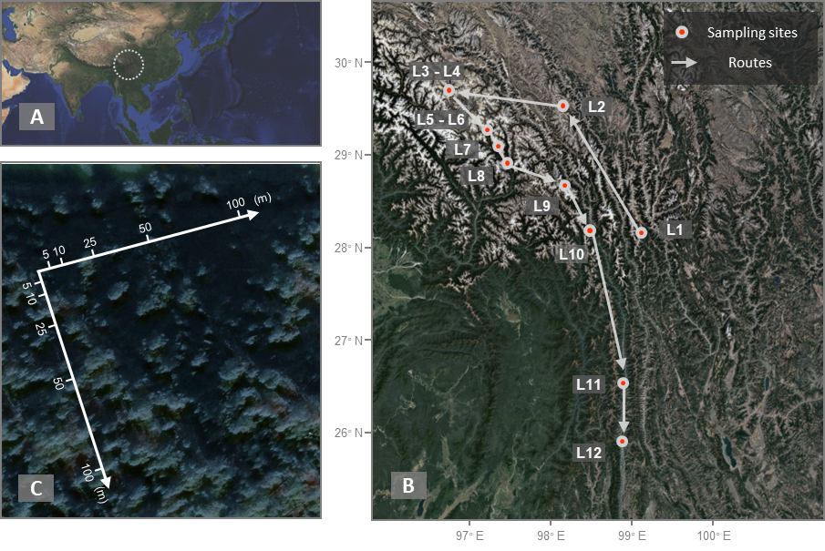

**Figure S1. Map of sampling sites and design along the elevational gradient in the southeastern Tibetan plateau.** (A) The circle represents the region of the Hengduan Mountains in the southeastern Tibetan plateau. (B) The sampling route in July 2019 based on Google Maps. (C) The sampling design of each elevation along two axes within a 100-m × 100-m L-shape plot.

**Figure S2. The measurements of Rs and edaphic properties along the elevation gradient.**

**Figure S3. Bacterial community compositions at the phylum level.** The top 10 most abundant phyla are shown. Elevations are labeled on the top of the panel. The numbers of sequence reads for each phylum are shown on the Y-axis.

**Figure S4. Fungal community compositions at the phylum level.** The top 10 most abundant phyla are shown. Elevations are labeled on the top of the panel. The numbers of sequence reads for each phylum are shown on the Y-axis.

**Figure S5. The distance-decay relationship in each elevation of bacterial communities.** Elevations are labeled at the top of each panel. Slopes of distance-decay were calculated by the distance-matrix regression model; The significance level is labeled by: *, P < 0.050; **, P < 0.010; ***, P < 0.001. The dashed line represents an insignificant distance-decay relationship (P > 0.050).

**Figure S6. The distance-decay relationship in each elevation of fungal communities.** Elevations are labeled at the top of each panel. Slopes of distance-decay were calculated by the distance-matrix regression model; The significance level is labeled by: *, P < 0.050; **, P < 0.010; ***, P < 0.001. The dashed line represents insignificant distance-decay relationships (P > 0.050).

**References**

Baselga A. Partitioning the turnover and nestedness components of beta diversity. Global ecology and biogeography 2010; 19: 134-143.

Podani J, Ricotta C, Schmera D. A general framework for analyzing beta diversity, nestedness and related community-level phenomena based on abundance data. Ecological Complexity 2013; 15: 52-61.