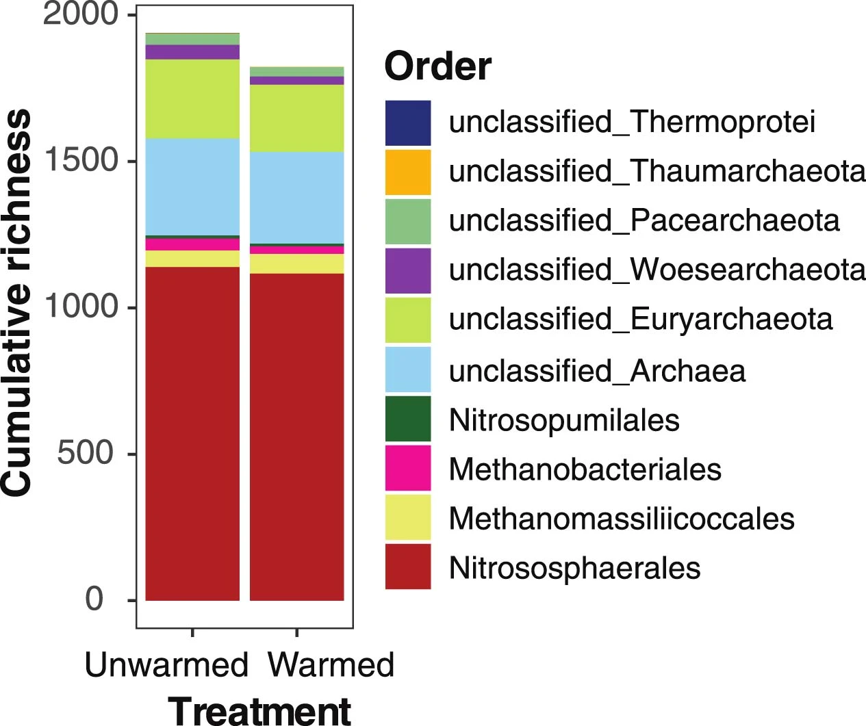
Extended Data Fig. 1 Effects of experimental warming on archaeal community composition under unwarmed and warmed conditions at the order level. Cumulative richness is expressed as the number of operational taxonomic units (OTUs).

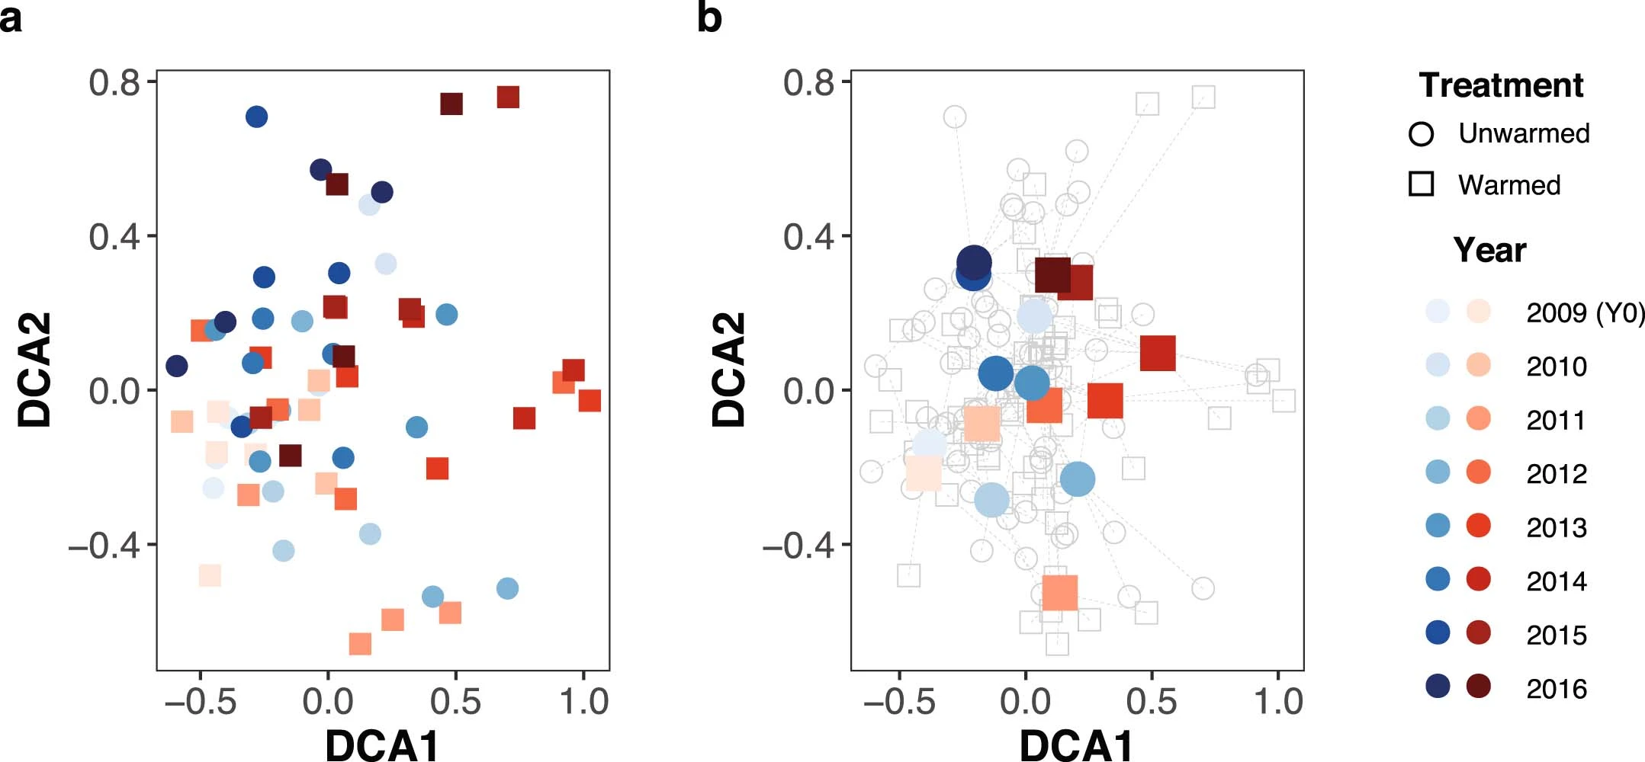
Extended Data Fig. 2 The succession of soil archaea communities under unwarmed and warmed treatments by detrended correspondence analysis (DCA). Individual samples from warmed and unwarmed plots within each year are shown in (a) and the centroids of four replicates from each treatment within each year are shown in (b). The analysis was performed based on Sorensen dissimilarity metric. Warmed samples are clustered together with control samples in year 0 (2009) and separated from control samples in the following seven years (2010–2016).

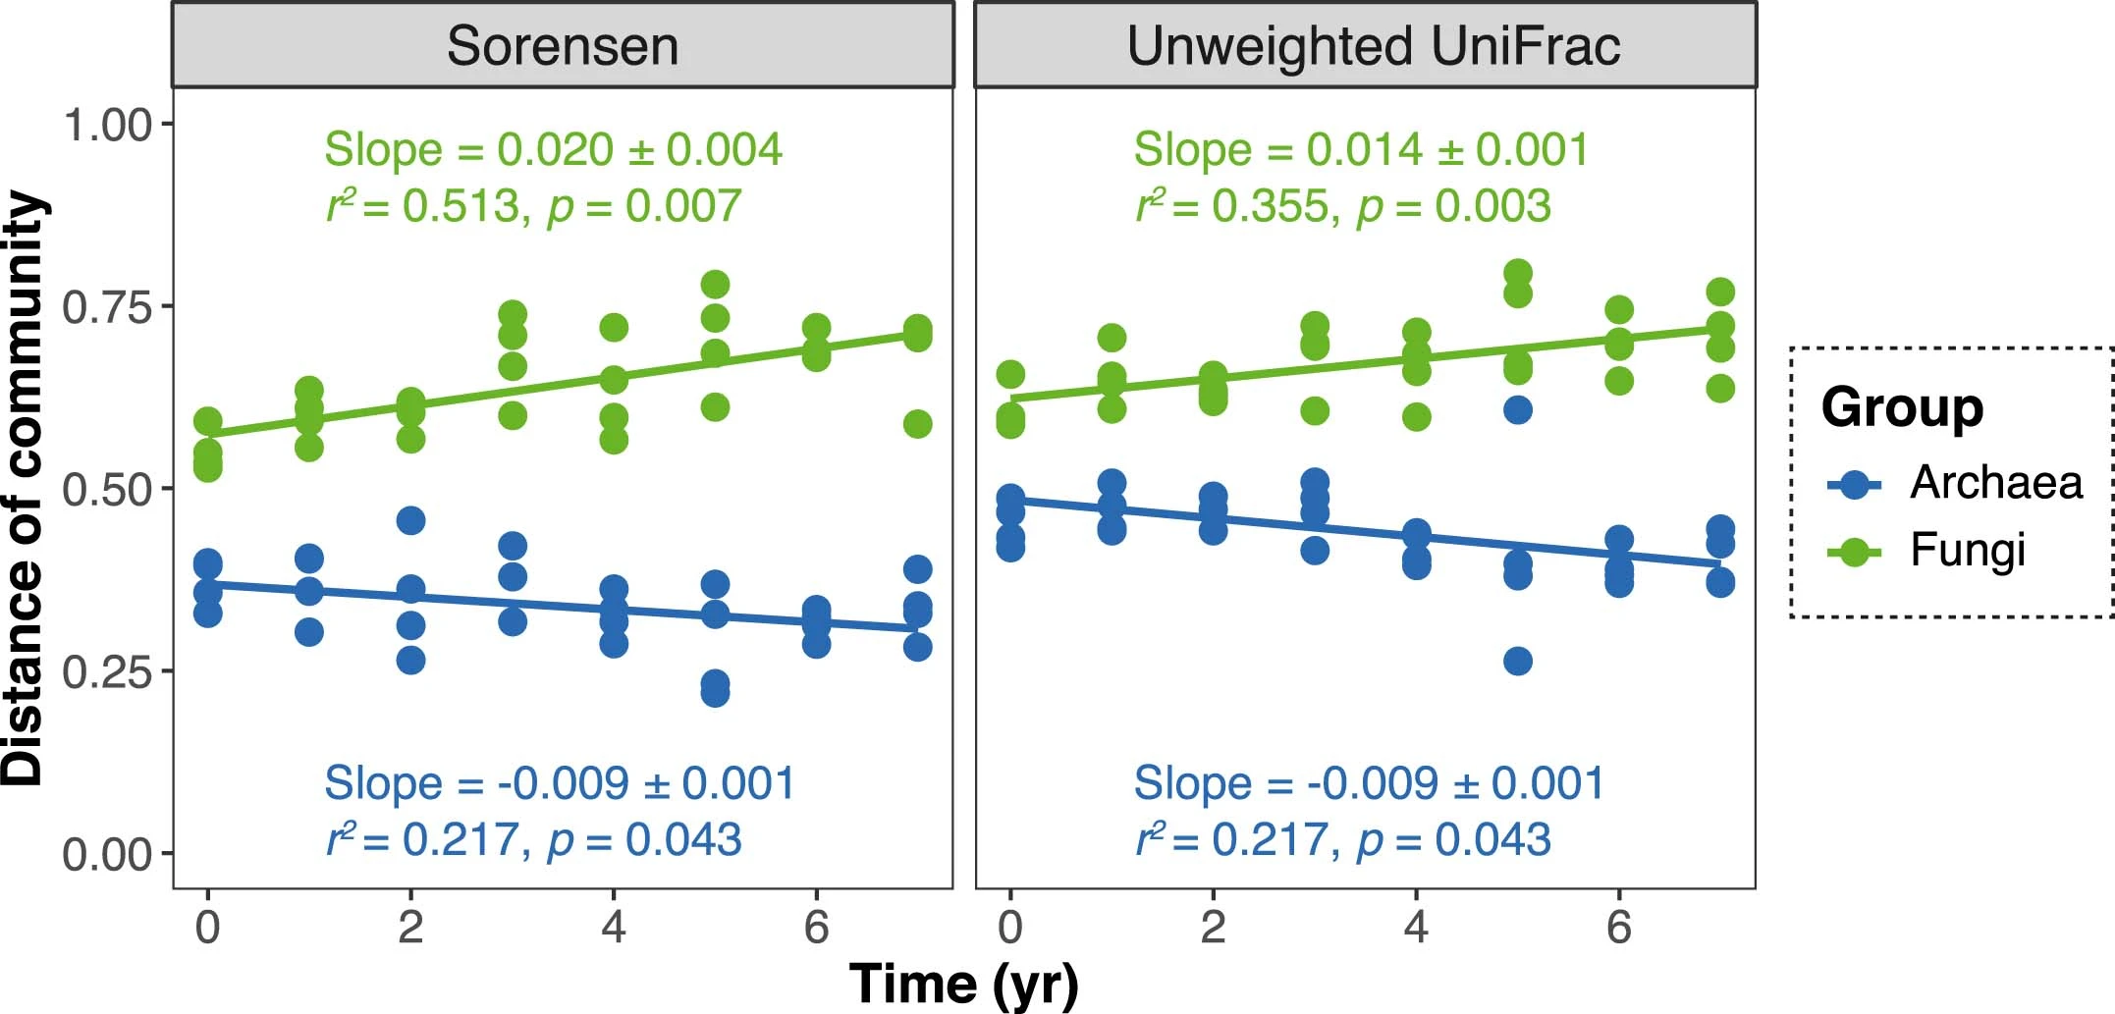
Extended Data Fig. 3 Temporal changes in community differences between warming and control conditions for archaea and fungi. The first year is 2009 (year 0). Considering the repeated-measures design, the warming-versus-control dissimilarity values at each block were fitted to the linear mixed-effects (LMMs) models with a fixed effect of time and a random intercept and slope effect among different pairs of plots (blocks). The slopes are presented as a coefficient in fixed effect ± standard error in random effect. The r2 values are calculated (details in Methods), reflecting the variance explained by the whole LMM model. p values were based on permutation tests (two-sided). The lines showed the fixed effects of the LMM.

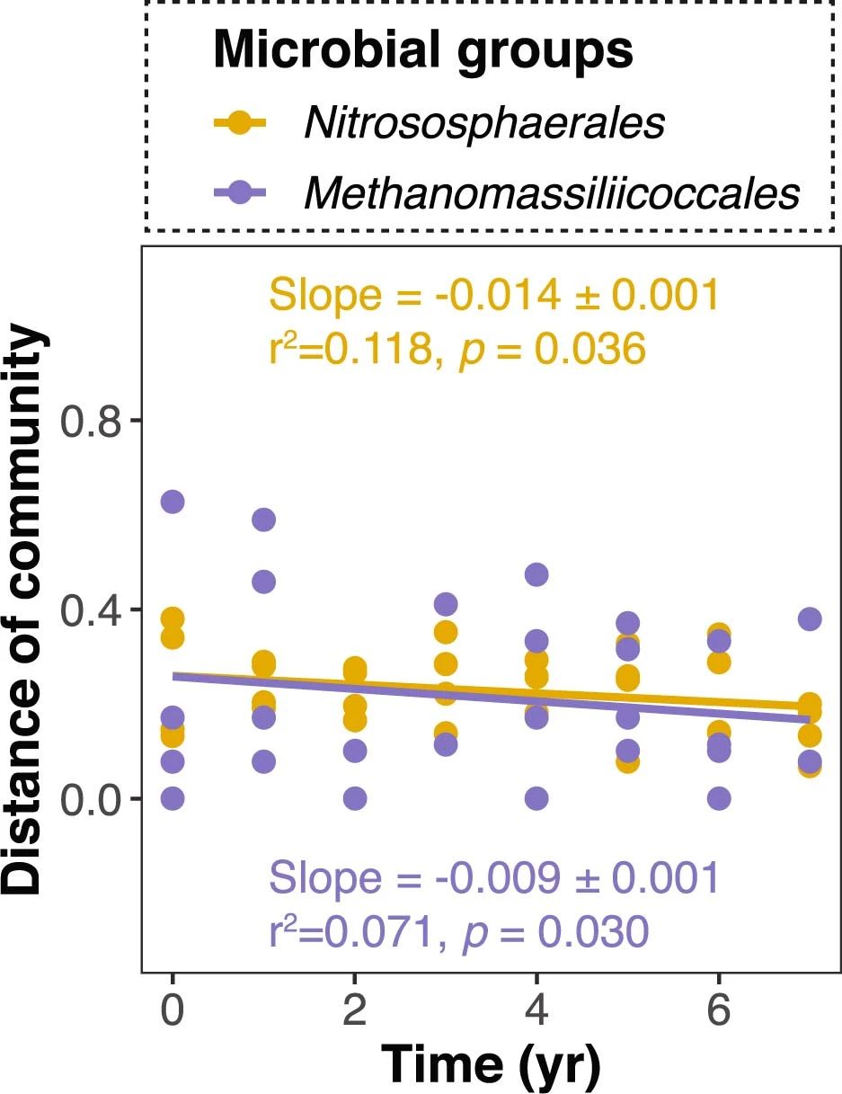
Extended Data Fig. 4 Temporal changes in community differences between warming and control conditions for orders Nitrososphaerales and Methanomassiliicoccales. The analysis was performed based on unweighted UniFrac metrics. Considering the repeated-measures design, the warming-versus-control dissimilarity values at each block were fitted to LMMs with a fixed effect of time and a random intercept and slope effect among different pairs of plots (blocks). The slopes are presented as a coefficient in fixed effect ± standard error in random effect. The r2 values are calculated (details in Methods), reflecting the variance explained by the whole LMM model. p values were based on permutation tests (two-sided). The lines showed the fixed effects of the LMM.

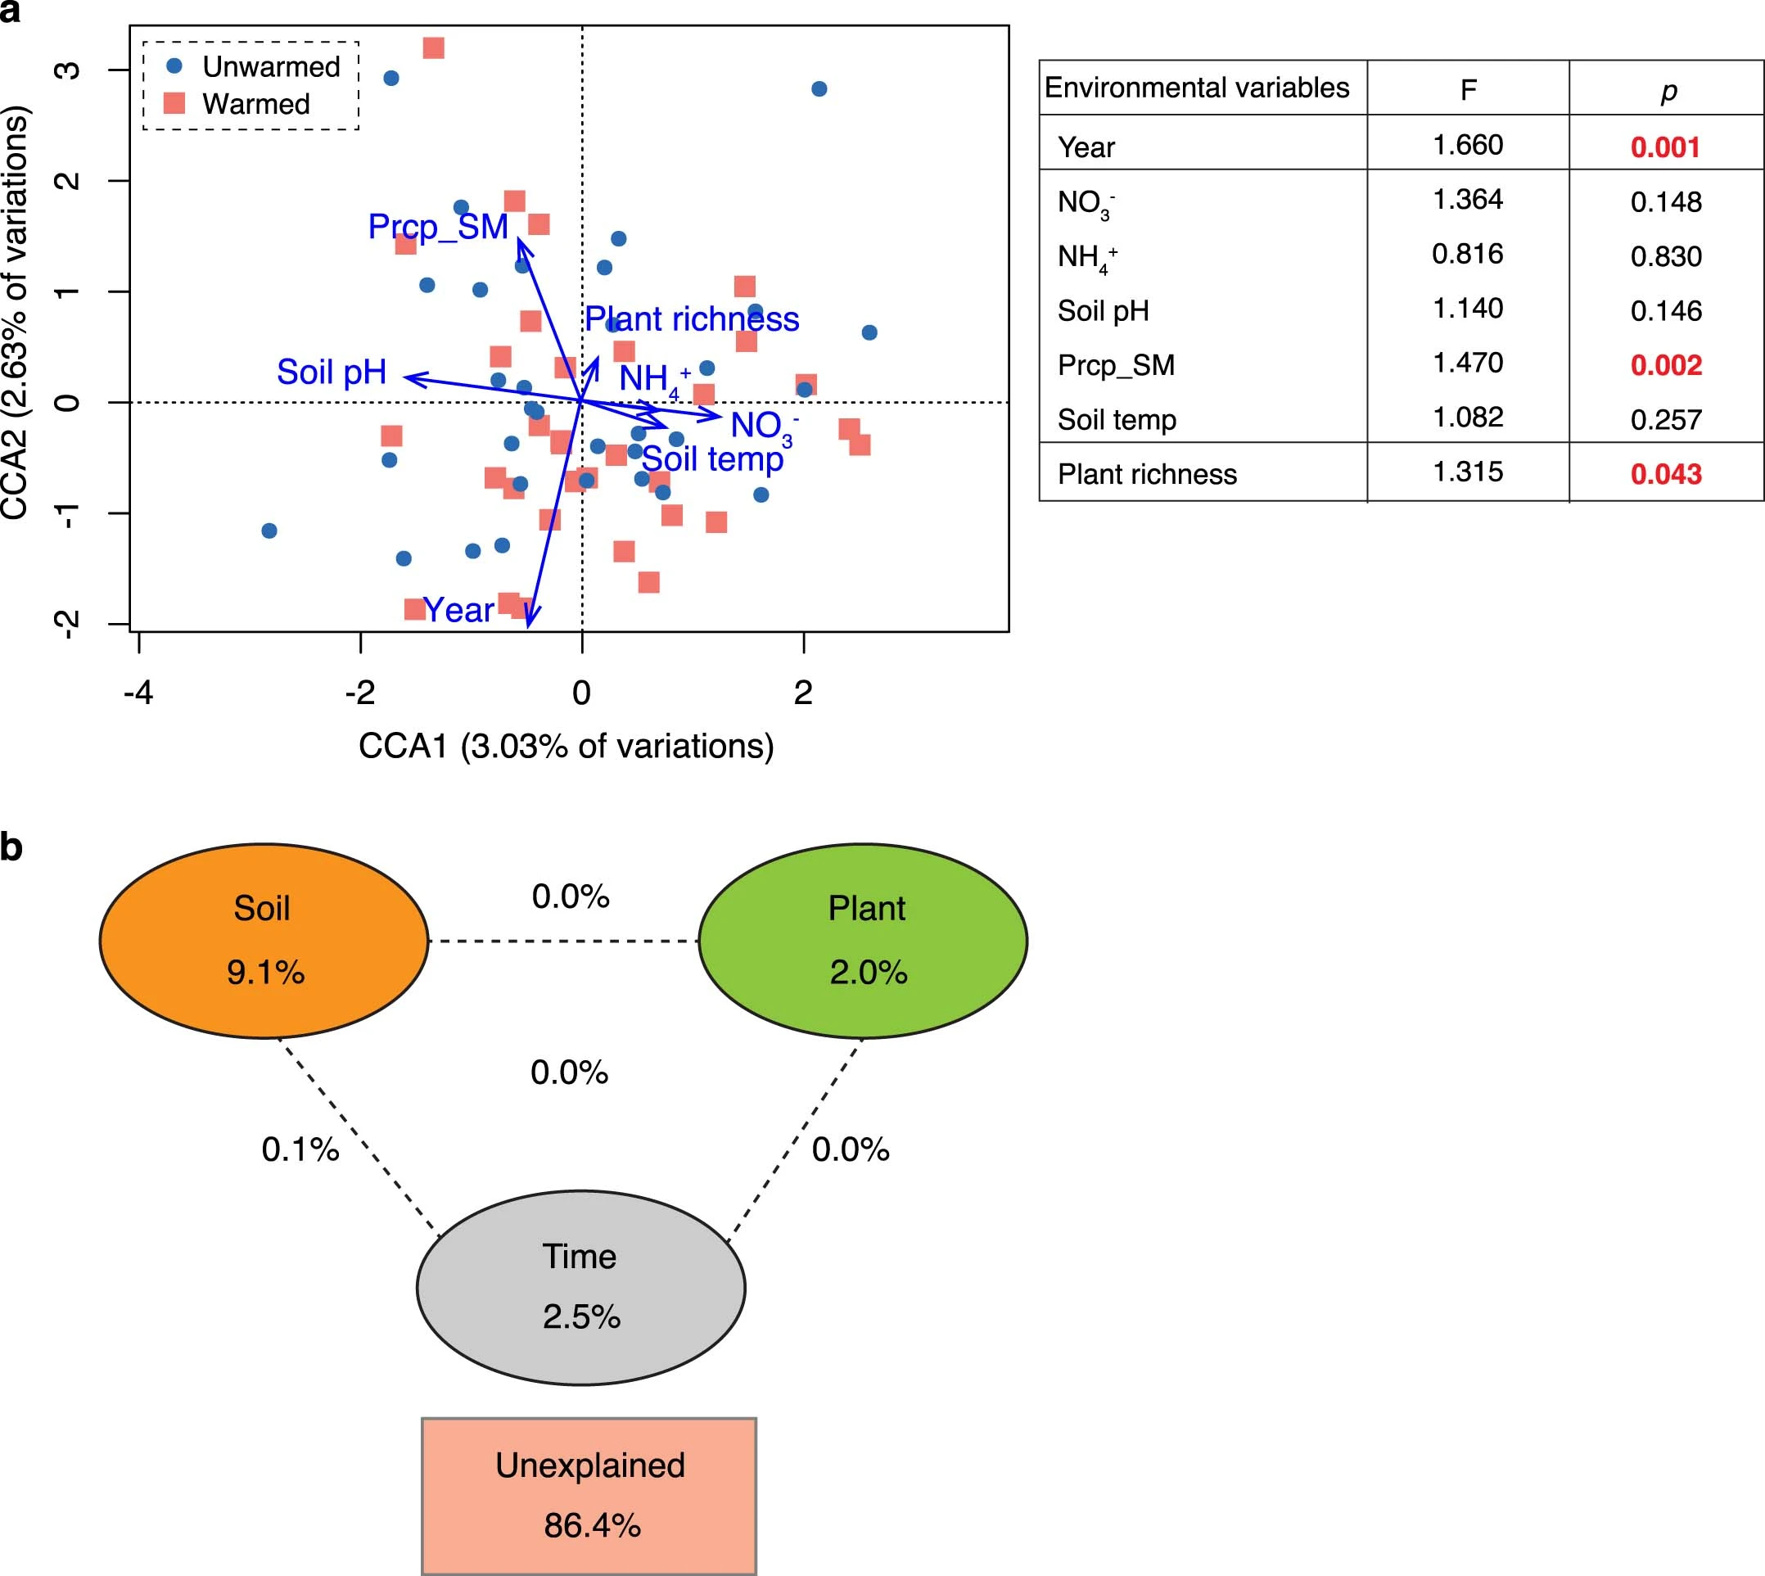

Extended Data Fig. 5 Constrained ordination analysis of archaeal communities. (a) Canonical correspondence analyses (CCA) of soil archaea community and environmental attributes. Tested environmental attributes include soil nitrate (NO3−), ammonium (NH4+), total nitrogen (TN), total organic C (TOC), pH, Precipitation of sampling month (Prcp_SM), temperature, moisutre drought index, C3 and C4 aboveground biomass, plant richness, and total biomass. The insert table shows the significance of each environmental variable in explaining the variations of archaeal community (one-way ANOVA test). (b) CCA-based variation partitioning analysis (VPA) showed the relative proportions of archaeal community variations that can be explained by different types of environmental factors. The numbers within the circles showed the variation explained by each group of environmental factors alone. The numbers between the circles showed the interactions of the two factors on either side and number in the center of the interactions of all three factors.

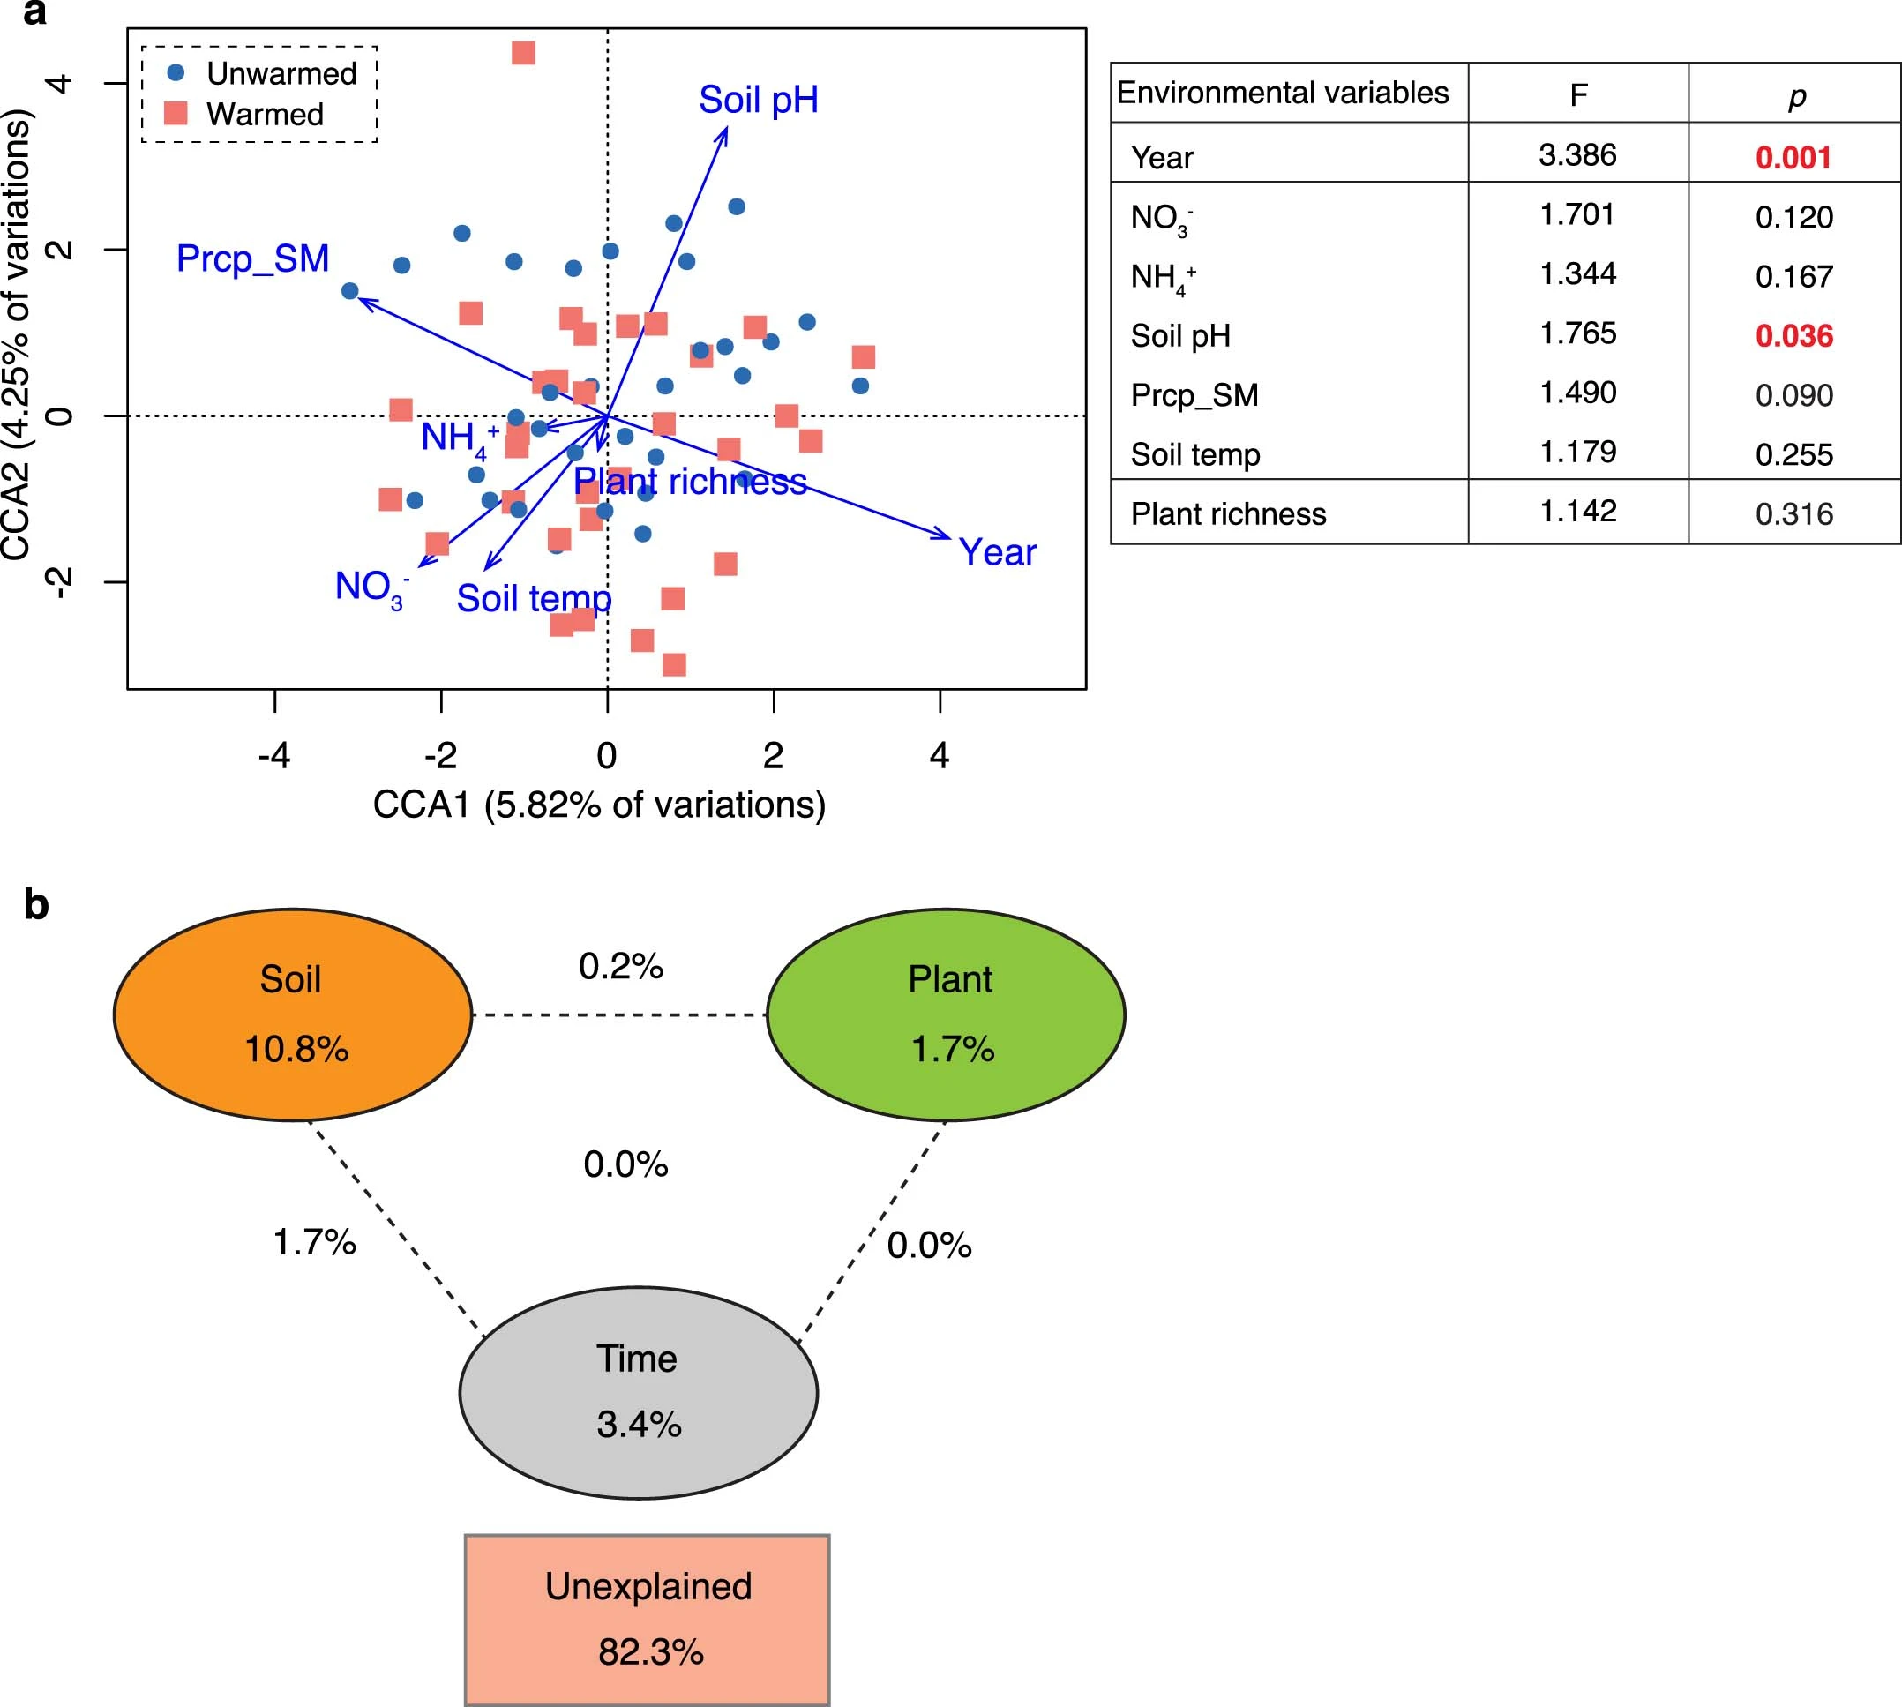
Extended Data Fig. 6 Constrained ordination analysis of the order Nitrososphaerales. (a) CCA of the Nitrososphaerales group and environmental attributes. The tested environmental attributes and other properties are the same as in Extended Data Fig. 5 (one-way ANOVA test). Significant tests (P < 0.05) are shown in bold red. (b) CCA-based VPA showed the relative proportions of variations in the Nitrososphaerales group that can be explained by different types of environmental factors. The numbers within the circles showed the variation explained by each group of environmental factors alone. The numbers between the circles showed the interactions of the two factors on either side and number in the center of the interactions of all three factors.

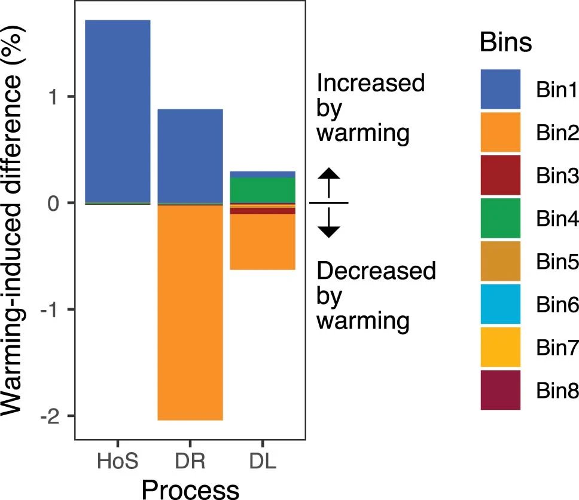
Extended Data Fig. 7 Warming-induced changes of different bins. Warming-induced difference between warming and control is expressed in percentages for the three dominating ecological processes—homogeneous selection (HoS), dispersal limitation (DL), and drift and others (DR).

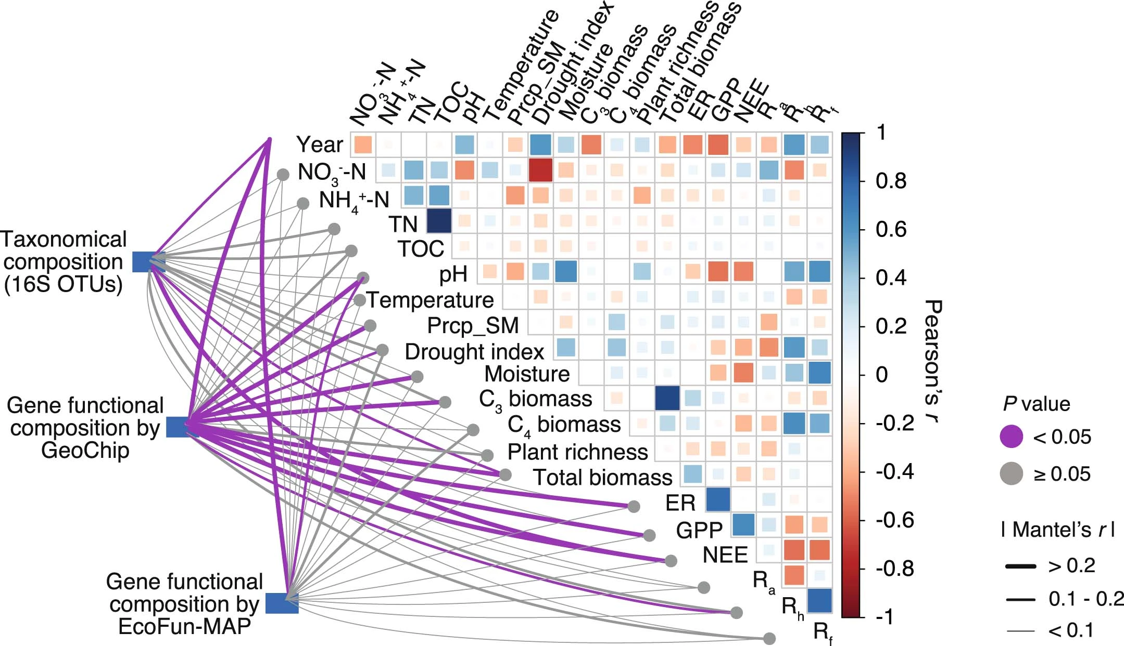

Extended Data Fig. 8 Relationships between archaeal community structure and environmental variables and ecosystem processes under control. Archaeal community structures, which include taxonomical composition by 16 S rRNA genes and functional gene composition by GeoChip and EcoFUN-MAP, were tested against time, soil and plant variables and ecosystem C fluxes. All the other properties are the same as Fig. 4a.

