**Supporting Information**

**Electrostimulation triggers an increase in cross-niche microbial associations toward enhancing organic nitrogen wastewater treatment**

Ke Shia,b, Bin Lianga,*, Kai Fengc, Daliang Ningd, Carolyn R. Cornelle, Yanqing Zhanga, Wenbin Xua, Min Zhoua, Ye Dengc, Jiandong Jiangf, Tiejun Liua, Aijie Wanga,b,c, Jizhong Zhoud,g,h,i

aState Key Laboratory of Urban Water Resource and Environment, Shenzhen Key Laboratory of Organic Pollution Prevention and Control, School of Civil & Environmental Engineering, Harbin Institute of Technology Shenzhen, Shenzhen 518055, China

bState Key Laboratory of Urban Water Resource and Environment, School of Environment, Harbin Institute of Technology, Harbin 150090, China

cKey Laboratory of Environmental Biotechnology, Research Center for Eco-Environmental Sciences, Chinese Academy of Sciences, Beijing 100085, China

dInstitute for Environmental Genomics and Department of Microbiology and Plant Biology, University of Oklahoma, Norman, OK 73019, USA

eDepartment of Civil and Environmental Engineering, Rice University, Houston, Texas, 77005, USA

fKey Lab of Agricultural Environmental Microbiology, Ministry of Agriculture, College of Life Sciences, Nanjing Agricultural University, 210095 Nanjing, China

gSchool of Civil Engineering and Environmental Sciences, University of Oklahoma, Norman, OK 73019, USA

hSchool of Computer Science, University of Oklahoma, Norman, OK 73019, USA

iEarth and Environmental Sciences, Lawrence Berkeley National Laboratory, Berkeley, CA 94720, USA

**\*Corresponding author.** E-mail: liangbin1214@163.com (B. Liang).

Methods

Wolf’s vitamin solution contained the following vitamins (in milligrams) per liter of distilled water: biotin, 20; folic acid, 20; pyridoxine hydrochloride, 100; riboflavin, 50; thiamine, 50; nicotinic acid 50; pantothenic acid, 50; vitamin B12, 1; p-aminobenzoic acid, 50; thioctic acid, 50.

Wolf’s trace elements solution contained the following amounts (in grams) of salts per liter of distilled water: nitrilotriacetic acid, 15; MgSO4, 30; MnSO4, 5; NaCl, 10; FeSO4, 1; CaCl2, 1; CoCl2, 1; ZnSO4, 1; CuSO4, 0.1; AlK(SO4)2, 0.1; H3BO3, 0.1; Na2MoO4, 0.1.

Results



**Fig. S1.** AYR degradation and PPD formation for planktonic sludge (a) and electrode biofilm (b)

**Fig. S2.** Comparison of relative abundance at the genus level for HA and eHA (Kruskal-Wallis H test, *: *P* < 0.05, **: *P* < 0.01).

 **Fig. S3.** Correlation analysis between the AYR degradation rate and the relative abundances of dominant genera.



**Fig. S4.** Microbial networks of planktonic sludge and electrode biofilm under electrostimulation (eHA) and control (HA), different modules are shown in different colors.



**Fig. S5.** Subnetworks of dominant genera interactions and topological parameters (green links stand for positive associations and red links stand for negative associations).



**Fig. S6.** Cross-niche microbial networks and classification of nodes to identify putative keystone taxa within networks for HA (a, c) and eHA (b, d), green links stand for positive associations and red links stand for negative associations.

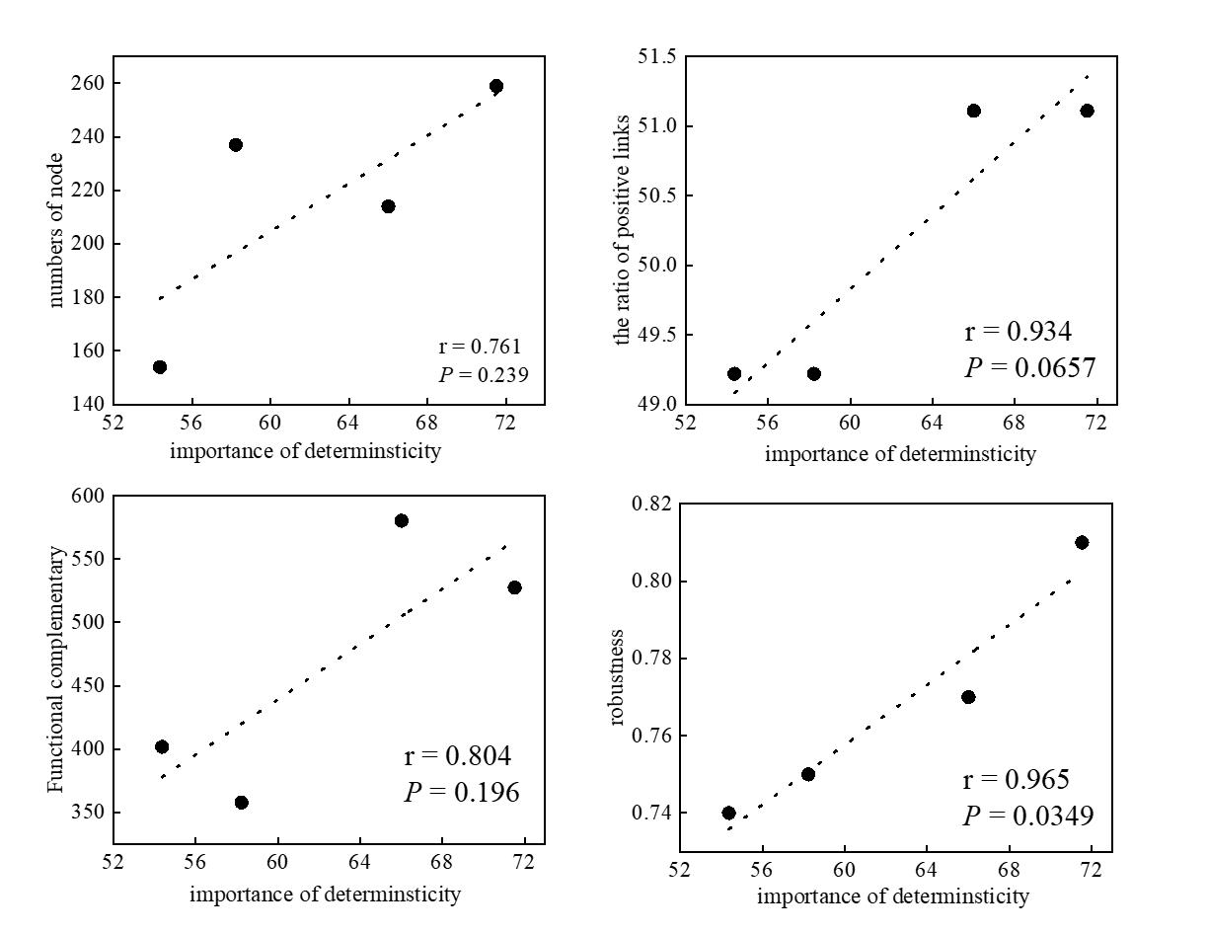

**Fig. S7.** Correlation analysis between the biotic factors and the relative importance of deterministic assembly.