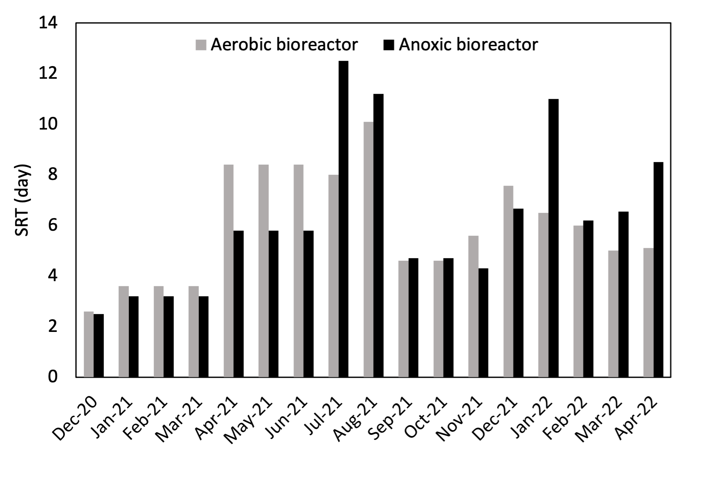
Figure S1. Monthly average SRTs of the aerobic and anoxic bioreactors from December 2020 to April 2022

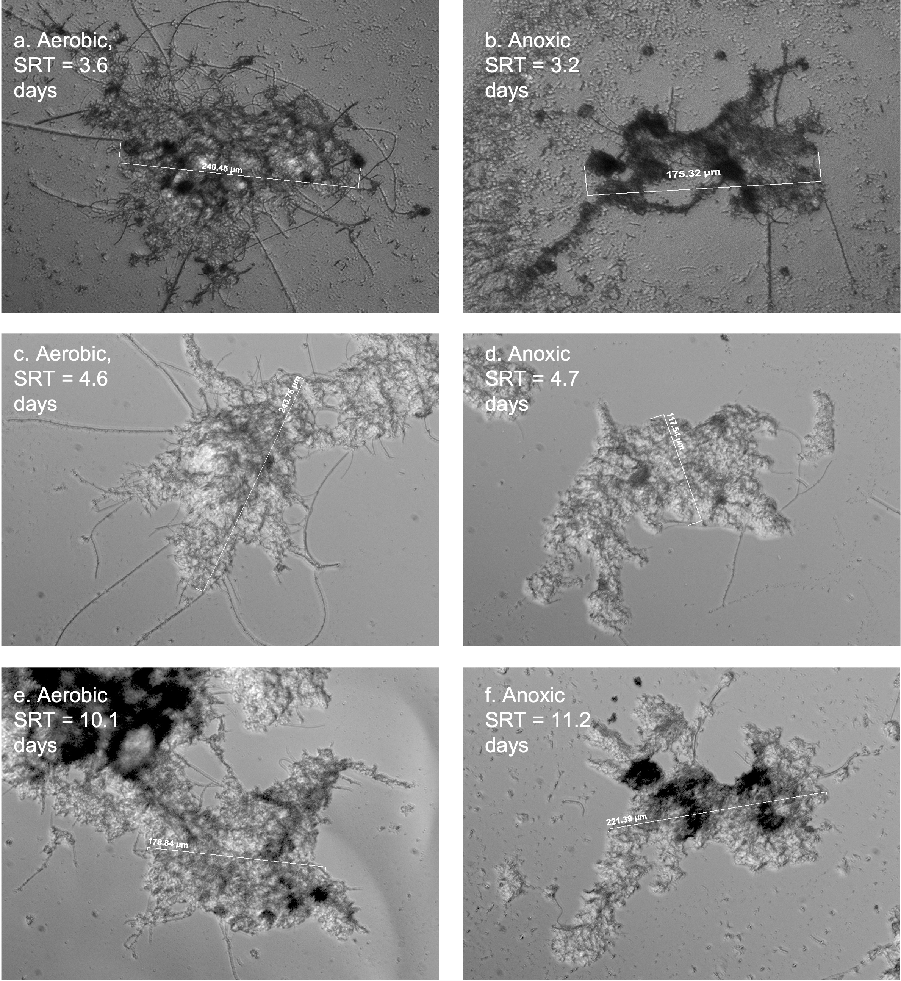
Figure S2. Aerobic and anoxic flocs observation based on light microscopy examination (200x magnification direct illumination)

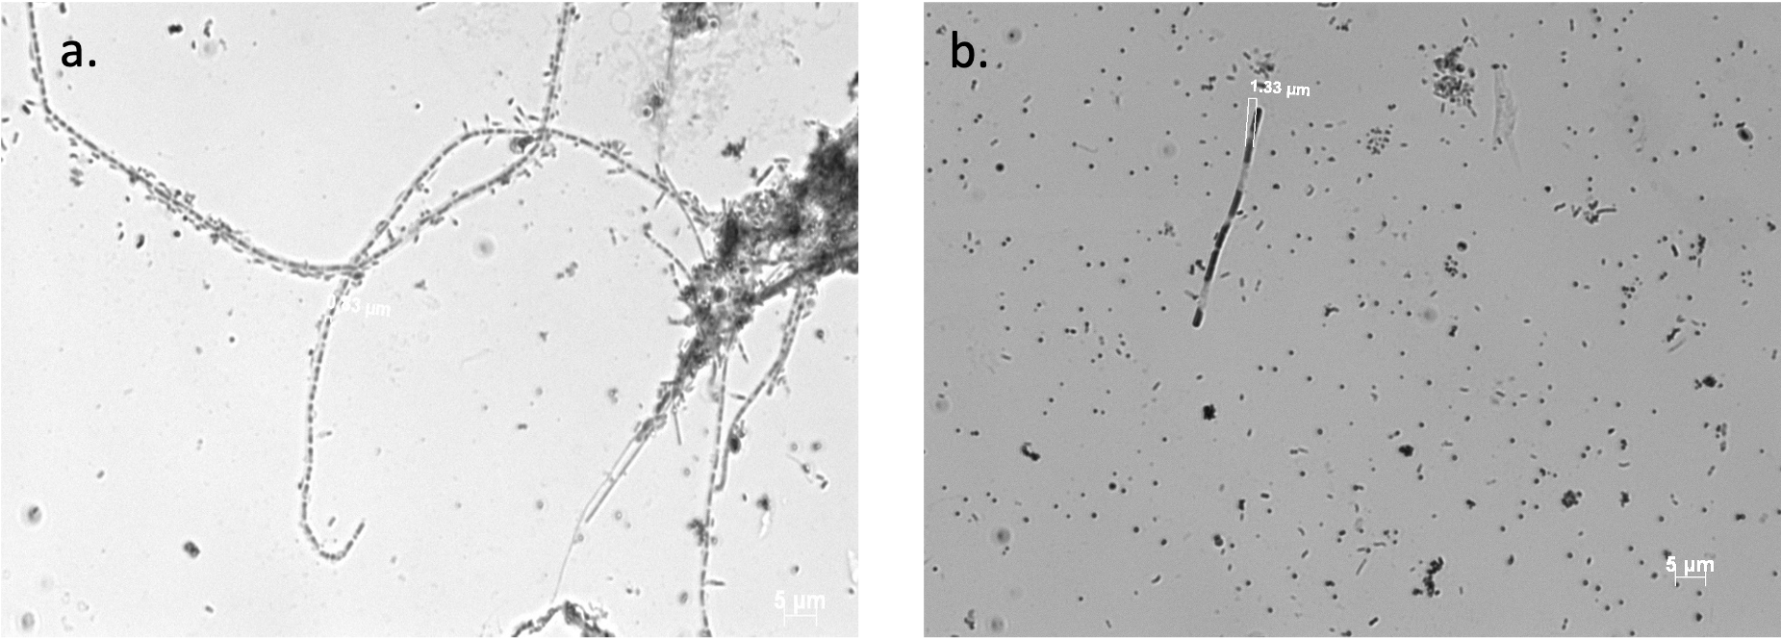
Figure S3 Dispersed growth observed in the aerobic (a) and anoxic (b) suspended growth under 1000x magnification direct illumination. Suspended growth SRTs: aerobic = 10.1 days, anoxic = 11.2 days.

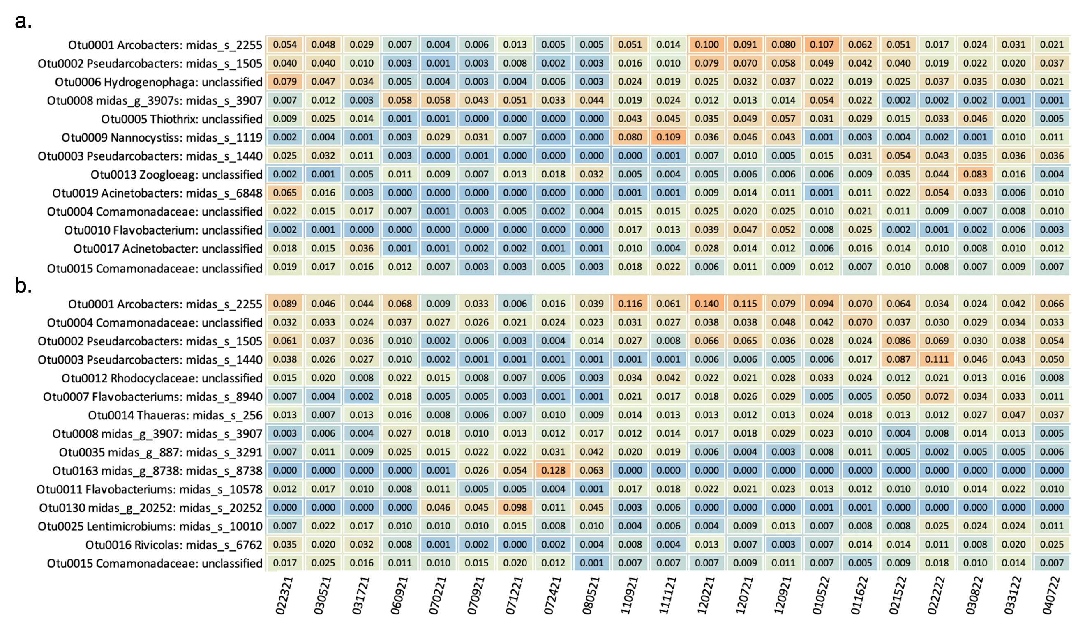
Figure S4 The taxonomy and relative abundances of the top OTUs (mean relative abundance > 1%) in the aerobic community (a) and anoxic community (b). The x-axis indicated the sampling dates (e.g., 022321 = February 23, 2021).

