Supplementary Table 1
The parameters of soil used in PSF experiment.
pH | Organic matter  (%) | NH₄-N (mg/kg) | NO₃-N (mg/kg) | Total Nitrogen  (%) | Total carbon (%）
6.8 | 2.2 | 2.5 | 3.3 | 0.0479 | 0.5078
Total digest P  (mg/kg) | Total digest K  (mg/kg) | Sand (%) | Silt  (%) | Clay  (%) | Texture
35.9 | 262 | 80 | 4 | 16 | Loam

Supplementary Table 2. Real-time PCR quantification of 16S rRNA gene

Treatments | Abundance of 16S rRNA gene  log₁₀ (copies/g soil)
Slow-growth stage | 9.20±0.09 b
Fast-growth stage | 9.51±0.09 a
Control | 9.6±0.12 a
The copy number of genes in 1 g dry soil was estimated based on the results of real-time PCR. The different letters “a” and “b” here used for the marker of statistically significant difference (p < 0.05), if there is significant difference between treatments, they are marked as “a” and “b” separately, if not, they are both marked as “a” (mean ± SD, n =9) .

Supplementary Table 3. Effects of different exudate amendments on soil bacterial alpha-diversity indices

Treatment | Sobs | Chao1 | Shannon diversity | Evenness
Control | 2600±96 a | 3275±224 a | 6.5±0.06 a | 0.83±0.01 a
Slow growing stage | 2611±167 a | 3366±200 a | 6.6±0.17 a | 0.84±0.02 a
Fast growing stage | 2113±71 b | 2919±77 b | 5.5±0.17 b | 0.72±0.02 b

Values (mean ± SD, n = 3) within the same column followed by different letters are significantly different at p < 0.05 according to the Turkey's post-hoc test.

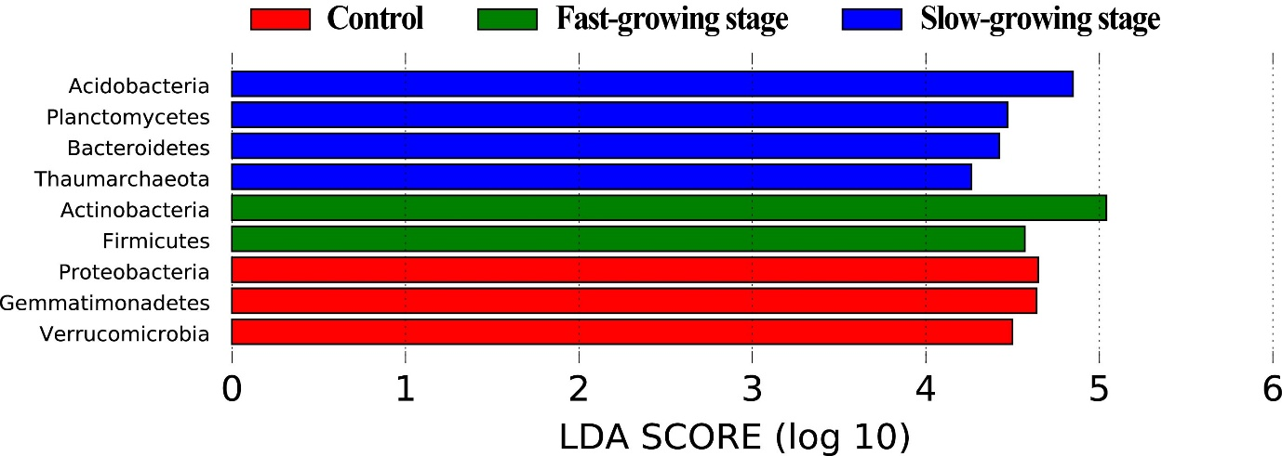
Supplementary Figure 1
Major bacterial phyla (average relative abundance > 1%) significantly enriched after soil conditioning by different root exudates. The discriminating phyla were identified based on linear discriminant analysis (LDA) score ≥ 2.
Note: Red, green and blue circles stand for taxa that were enriched in the Control, fast-growth stage and slow-growth stage treatment, respectively. Control: soil conditioning with sterile ddH₂O; Slow-growth stage: soil conditioning with slow-growth stage root exudates; Fast-growth stage: soil conditioning with fast-growth stage root exudates.

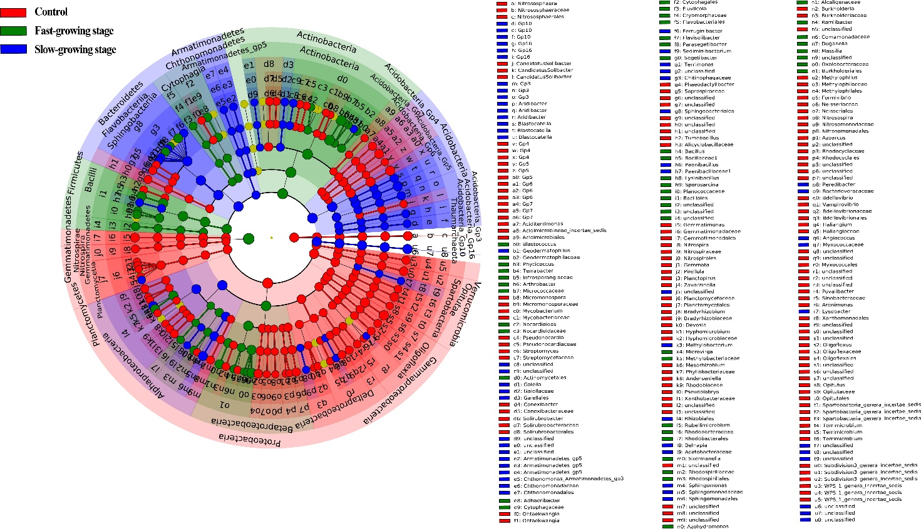
Supplementary Figure 2
Linear discriminant effect size analysis (LDA > 3 were shown) cladogram of comparison results among the bacterial communities of Control, slow-growth stage, fast-growth stage treatments.
Note: Red, green and blue circles stand for taxa that were enriched in the Control, fast-growth stage and slow-growth stage treatment, respectively. The five rings of the cladogram stand for phylum, class, order, family, and genus from the inside to outside, respectively. Control: soil conditioning with sterile ddH₂O; Slow-growth stage: soil conditioning with slow-growth stage root exudates; Fast-growth stage: soil conditioning with fast-growth stage root exudates.

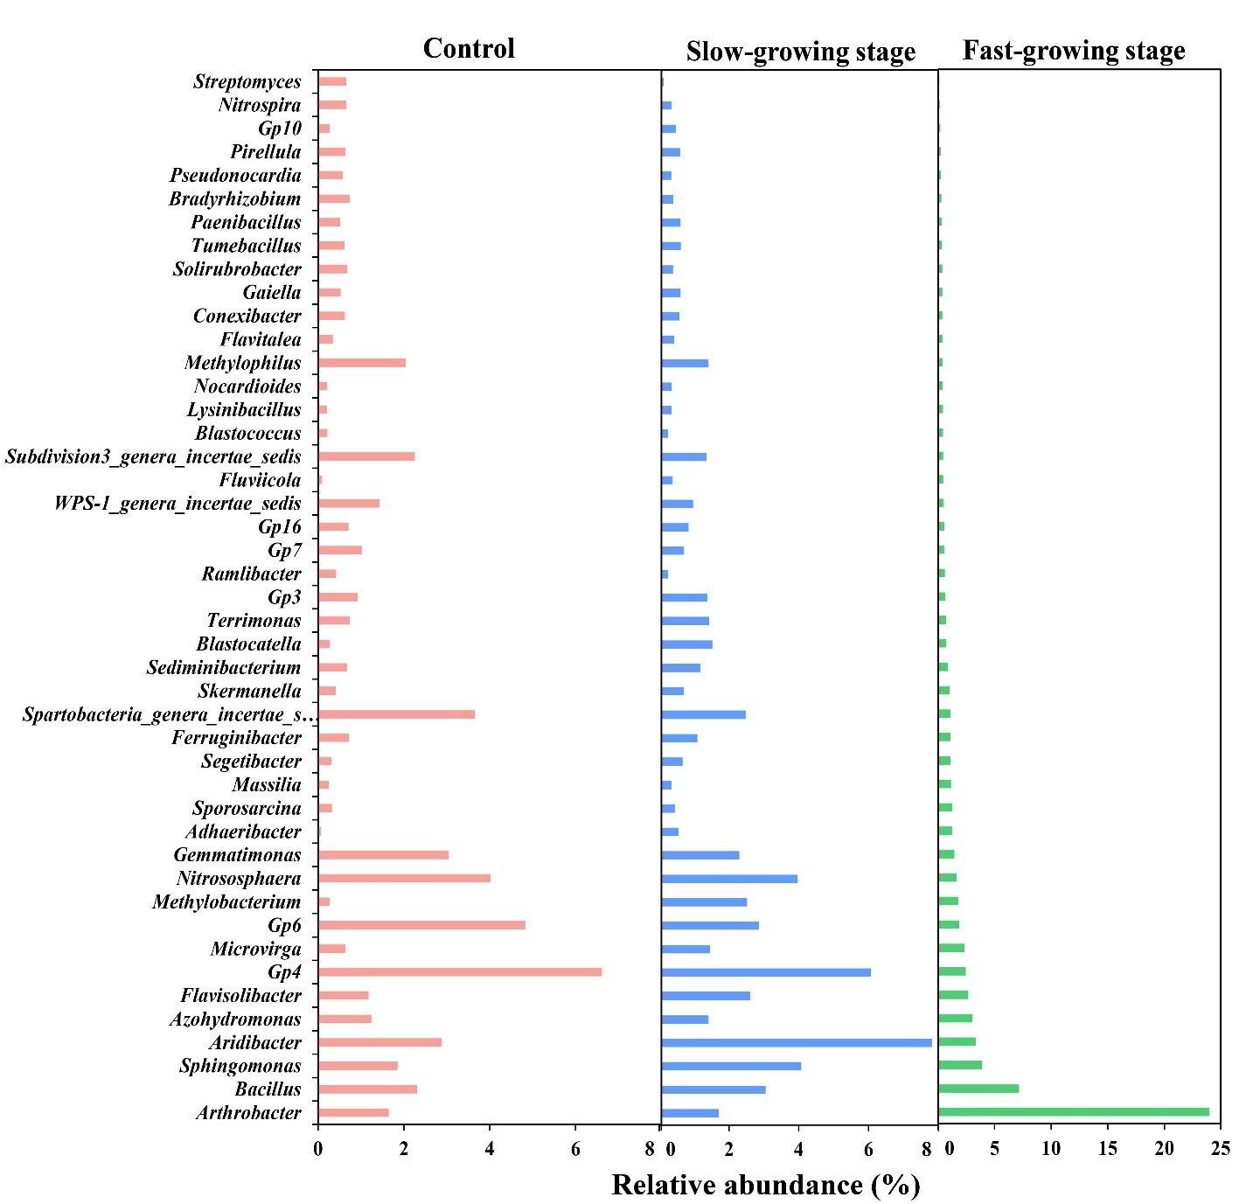
Supplementary Figure 3
Core microbiome analysis for each treatment. Abundance of taxa belonging to the core microbiome of different treatments. Relative abundance of these groups shown in figure is the average of the all replicates, and all of them were significantly different among each others.
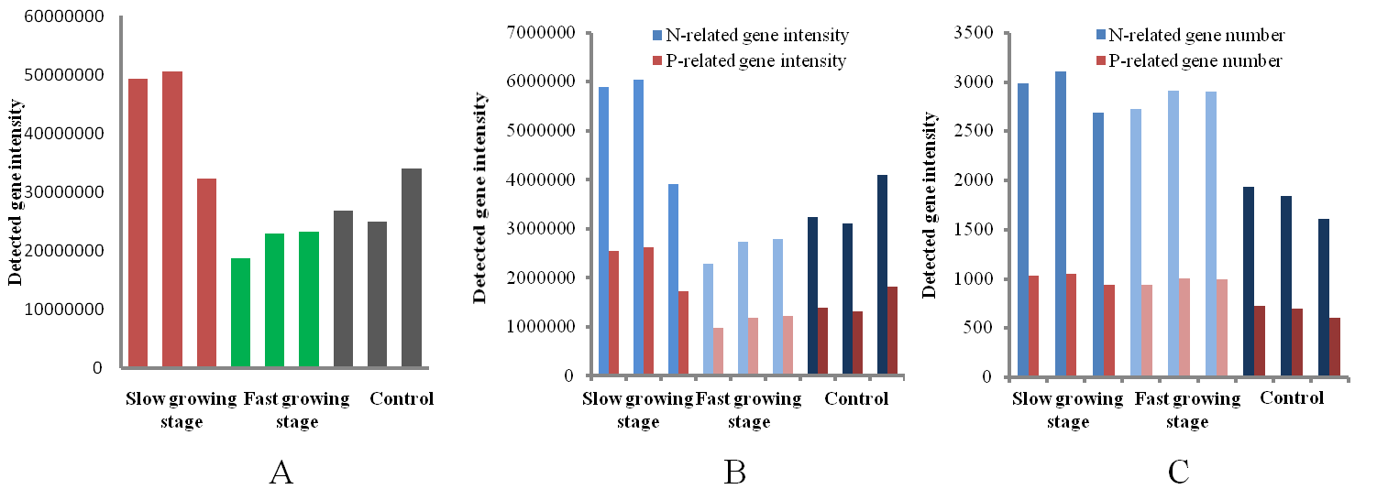
Supplementary Figure 4
A: Total detected gene intensity of control and root exudate conditioned soils;
B: Both detected N-related gene intensity and P-related gene intensity of control and root exudate conditioned soils;
C: Both detected N-related gene number and P-related gene number of control and root exudate conditioned soils.

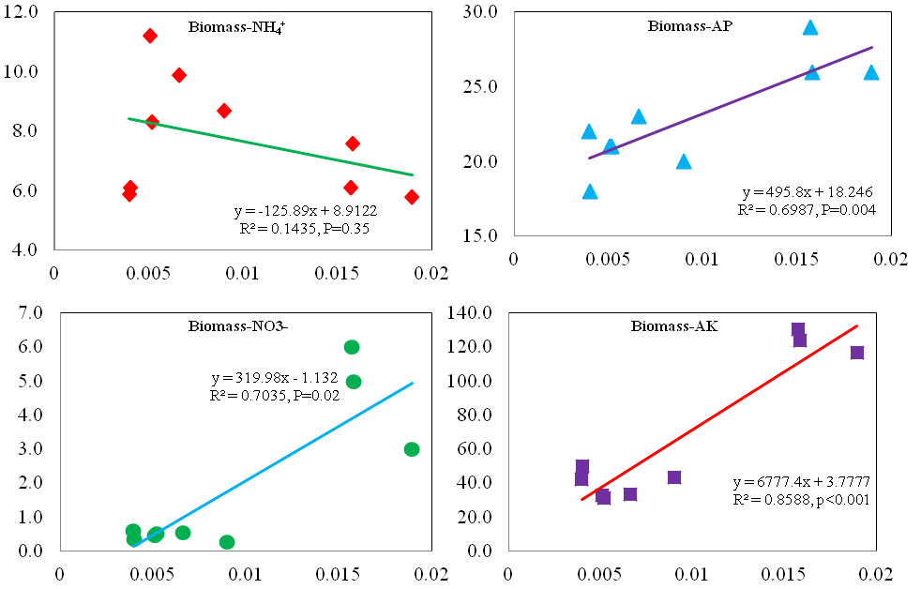
Supplemental Figure 5
The relationship between available nutrients content in soils and plant biomass. Available nutrients included nitrate, ammonium, available phosphorus, and available potassium. x-axis means plant biomass (g), and y-axis means the concentration of available nutrients (mg/kg).

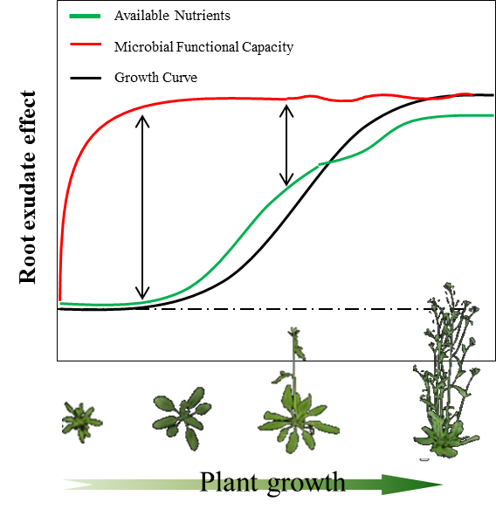
Supplemental Figure 6

Model of plant available nutrients level and soil bacterial functional capacity level dynamic changes during lifetime of plant. At early stage, rhizosphere soil bacterial functional capacity level was raised by root exudate to the maximum in short time and kept relative stable, while plant available nutrients level was promoted slowly at slow-growth stage while speedily at fast-growth stage with the increasing nutrients desired.

