Supplementary Material

Supplementary Data
Supplementary Material should be uploaded separately on submission. Please include any supplementary data, figures and/or tables. All supplementary files are deposited to FigShare for permanent storage and receive a DOI.
Supplementary material is not typeset so please ensure that all information is clearly presented, the appropriate caption is included in the file and not in the manuscript, and that the style conforms to the rest of the article. To avoid discrepancies between the published article and the supplementary material, please do not add the title, author list, affiliations or correspondence in the supplementary files.

Supplementary Figures and Tables

Supplementary Figures
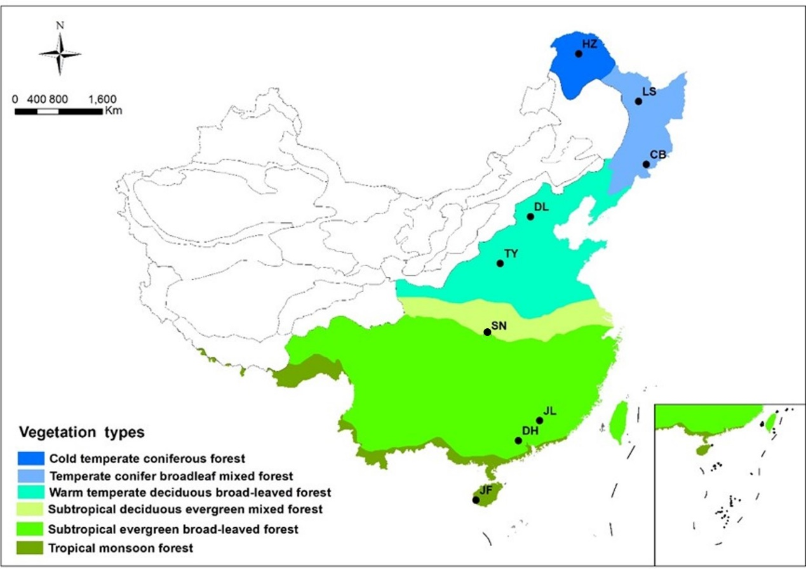
Supplementary Figure 1. Distribution of typical forest ecosystems along the North-South Transect of eastern China (NSTEC). The abbreviations of sampling sites from north to south are as follows: HZ, Huzhong; LS, Liangshui; CB, Changbai; DL, Dongling; TY, Taiyue; SN, Shennong; JL, Jiulian; DH, Dinghu; JF, Jianfeng.
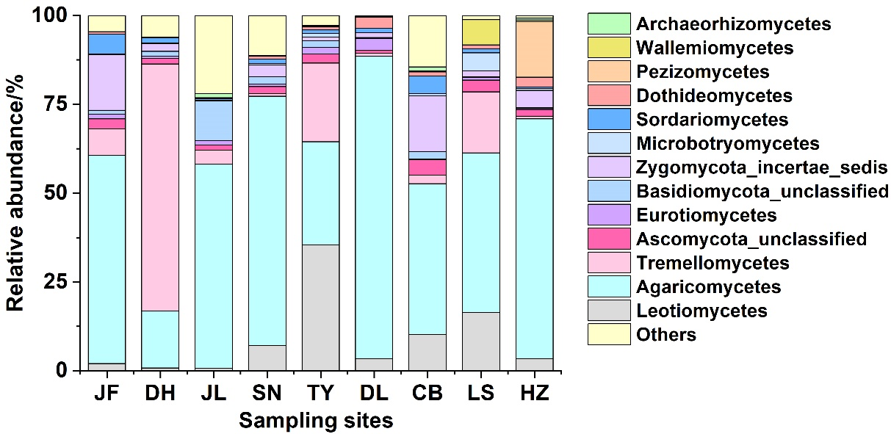
Supplementary Figure 2. Relative abundances of the dominant fungal classes.
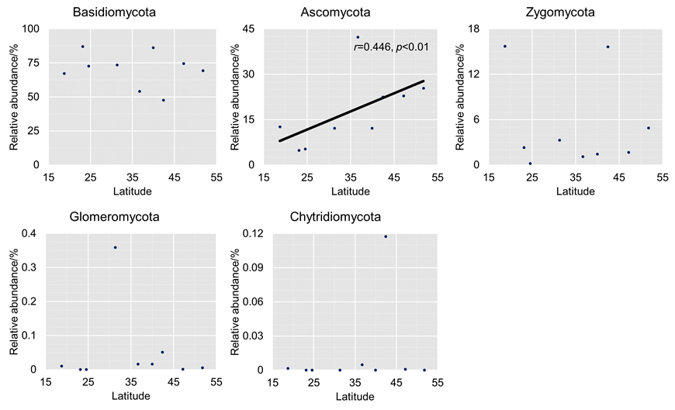
Supplementary Figure 3. Relationships between relative abundance (%) and latitude for dominant fungal phyla.
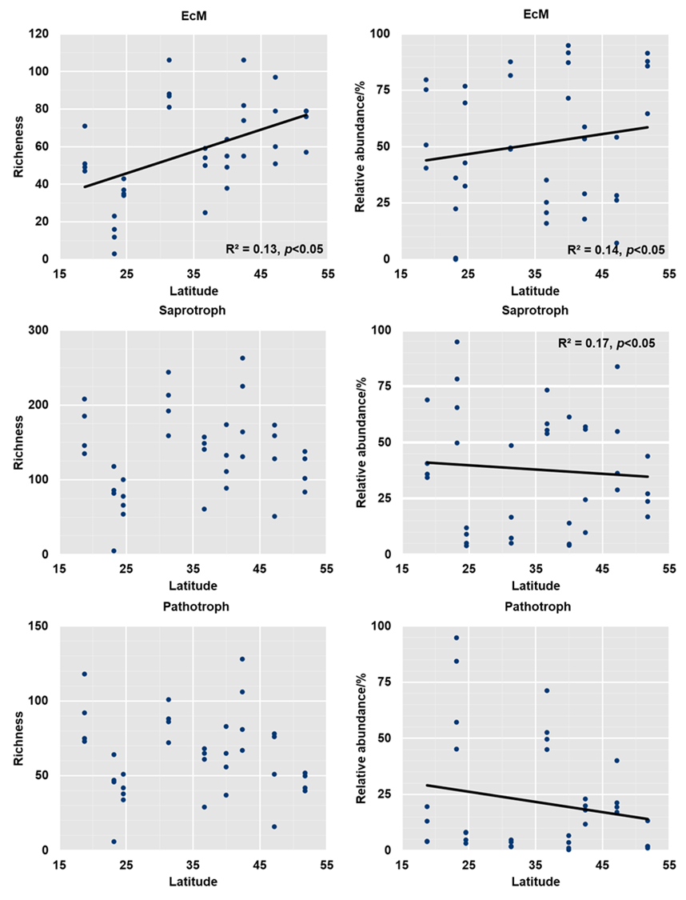
Supplementary Figure 4. Relationships between richness and relative abundance with latitude for fungal functional guilds.
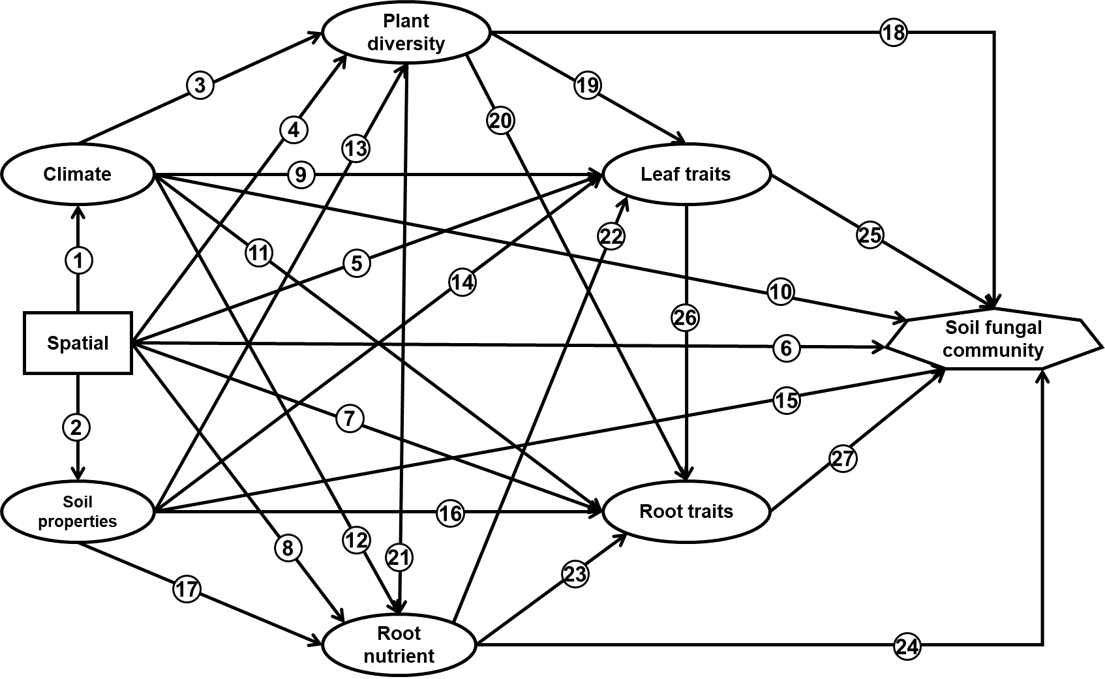
Supplementary Figure 5. A priori path model for plant traits explains latitudinal patterns in topsoil fungal communities. Arrows indicate causal directed relationships between variables. The climate (1), soil (2), plant diversity (4) (Harrison et al., 2020), and plant traits (5) (7) (8) (Wang et al., 2018; Zhang et al., 2018) vary with latitude across wide spatial scales. These biotic and abiotic factors influence soil fungal community, including geographic isolation (6) (Cox et al., 2016), climate (10) (Tedersoo et al., 2014; Zhou et al., 2016), soil properties (15) (Leifheit et al., 2014; Guo et al., 2019), and plant diversity (18) (Peay et al., 2013; Cline et al., 2018). Plant diversity influences the quantity and composition of plant inputs (19) (20) (21) (Wardle et al., 2004; Bardgett and van der Putten, 2014). Community-weighted means of leaf traits such as specific area, dry matter content, and nitrogen concentration can impact soil fungal community by influencing litter decomposition (25) (Quested et al., 2007; Fortunel et al., 2009; Eichenberg et al., 2015), soil nutrients cycles, and belowground processes (de Vries et al., 2012; Pei et al., 2016; De Long et al., 2019). Fine root decomposition and root exudates are major C contributors to forest soil microbial communities and regulate microbial metabolism (Freschet and Cornelissen, 2013; Ponge, 2013). The chemical traits of fine roots are the best indicators of community-level root decomposition and root exudates (24) (Prieto et al., 2016; See et al., 2019). Fine roots with large specific root lengths (SRL) are positively correlated with fungal: bacterial (F: B) ratios (27) (Legay et al., 2014). In addition, plant diversity (3) (4) (13) (Harrison et al., 2020) and leaf nutrients (5) (9) (14) (Zhang et al., 2018), root nutrients (8) (12) (17) (Zhang et al., 2018) and root biomass allocation (7) (11) (16) are all strongly depend upon climatic and edaphic variables. Leaf and root traits often show coordinated variation in stoichiometry (22) (Freschet and Cornelissen, 2013). Leaf and root nutrients, scale with plant photosynthetic and relative growth rates (23) (26) (Reich, 2014).

Supplementary Tables
Supplementary Table 1. Summary statistics of the geographic and environmental characteristics of the nine forest sites.
 |  | Latitude  (°N) | Longitude (°E) | MAT  (℃) | MAP  (mm) | SOC  (g/kg) | TN  (g/kg) | C/N | TP  (g/kg) | pH | Leaf traits |  |  | Root traits |  |  |  |  | Plant diversity
 |  |  |  |  |  |  |  |  |  |  | C (mg/g) | N (mg/g) | P (mg/g) | C  (mg/g) | N  (mg/g) | P  (mg/g) | Biomass  (t/hm2) | SRL (m/g)
HZ | Mean | 51.8 | 123.0 | -3.7 | 473.0 | 42.2 | 3.1 | 13.8 | 0.8 | 6.8 | 488.0 | 19.7 | 2.1 | 502.4 | 8.6 | 1.1 | 14.1 | 35.0 | 22
 | SD |  |  |  |  | 3.3 | 0.7 | 2.9 | 0.1 | 0.2 | 0.3 | 0.1 | 0.0 | 2.3 | 0.6 | 0.1 | 7.0 | 6.6 | 7
LS | Mean | 47.2 | 128.9 | 0.0 | 648.3 | 68.9 | 4.6 | 14.9 | 0.6 | 6.1 | 474.9 | 22.7 | 1.6 | 490.3 | 9.3 | 1.4 | 29.5 | 36.5 | 40
 | SD |  |  |  |  | 22.6 | 1.2 | 2.2 | 0.1 | 0.3 | 3.5 | 1.1 | 0.1 | 3.0 | 0.6 | 0.0 | 3.3 | 9.7 | 1
CB | Mean | 42.4 | 128.1 | 2.8 | 691.0 | 70.0 | 6.4 | 11.1 | 1.8 | 6.3 | 473.1 | 25.8 | 1.2 | 484.1 | 15.0 | 0.7 | 29.3 | 82.2 | 27
 | SD |  |  |  |  | 7.3 | 0.9 | 0.9 | 0.4 | 0.3 | 1.7 | 0.8 | 0.0 | 1.0 | 0.1 | 0.0 | 2.6 | 4.7 | 3
DL | Mean | 40.0 | 115.4 | 6.6 | 539.1 | 39.5 | 3.1 | 12.7 | 0.6 | 6.9 | 470.1 | 25.7 | 1.7 | 489.8 | 11.3 | 1.1 | 32.4 | 64.1 | 49
 | SD |  |  |  |  | 1.9 | 0.2 | 0.4 | 0.0 | 0.1 | 11.3 | 1.7 | 0.2 | 10.0 | 0.8 | 0.1 | 4.2 | 20.3 | 9
TY | Mean | 36.7 | 112.1 | 6.0 | 644.4 | 43.4 | 2.6 | 17.0 | 0.5 | 6.8 | 496.2 | 18.3 | 1.1 | 471.6 | 10.9 | 0.5 | 30.7 | 92.0 | 23
 | SD |  |  |  |  | 7.7 | 0.4 | 0.7 | 0.0 | 0.2 | 7.6 | 2.6 | 0.1 | 6.3 | 0.9 | 0.0 | 6.7 | 6.5 | 9
SN | Mean | 31.3 | 110.5 | 8.5 | 1446.7 | 38.3 | 3.8 | 10.1 | 0.8 | 6.9 | 479.4 | 20.3 | 1.2 | 474.4 | 7.8 | 1.0 | 79.8 | 115.5 | 77
 | SD |  |  |  |  | 6.2 | 0.3 | 0.8 | 0.0 | 0.1 | 13.0 | 1.3 | 0.1 | 7.8 | 2.4 | 0.2 | 6.0 | 15.7 | 10
JL | Mean | 24.6 | 114.4 | 18.2 | 1769.9 | 33.8 | 2.3 | 14.3 | 0.4 | 5.8 | 486.8 | 18.0 | 0.8 | 488.4 | 8.9 | 0.6 | 58.4 | 70.4 | 85
 | SD |  |  |  |  | 6.8 | 0.3 | 1.4 | 0.0 | 0.7 | 4.8 | 0.3 | 0.0 | 1.9 | 2.0 | 0.1 | 8.1 | 21.1 | 2
DH | Mean | 23.2 | 112.5 | 21.8 | 1927.0 | 29.4 | 1.8 | 16.7 | 0.2 | 5.4 | 498.2 | 17.6 | 0.7 | 495.3 | 8.9 | 0.4 | 32.3 | 83.9 | 53
 | SD |  |  |  |  | 2.6 | 0.2 | 0.9 | 0.0 | 0.3 | 5.3 | 0.5 | 0.1 | 2.4 | 1.0 | 0.0 | 5.3 | 21.9 | 10
JF | Mean | 18.7 | 108.9 | 23.2 | 2265.8 | 28.4 | 1.9 | 14.6 | 0.2 | 6.3 | 475.5 | 19.1 | 0.8 | 489.9 | 9.4 | 0.7 | 51.3 | 94.9 | 116
 | SD |  |  |  |  | 3.2 | 0.1 | 1.6 | 0.0 | 0.1 | 3.3 | 0.5 | 0.0 | 10.1 | 0.7 | 0.1 | 20.3 | 23.3 | 10
MAP, mean annual precipitation; MAT, mean annual temperature; SOC, soil total carbon; TN, soil total nitrogen; C/N, soil carbon, nitrogen ratios; TP, soil total phosphorus; Leaf/Root C, leaf/root carbon content; Leaf/Root N, leaf/root nitrogen content; Leaf/Root P, leaf/root phosphorus content; SRL, specific root length.

Supplementary Table 2. Summary of the best ordinary least squares (OLS) multiple regression models of the species richness of different functional fungi with environmental variables.

 | Variables retained in the model and its contribution (%) | R²_{adj} | p value
Total fungi | C/N (45.3), SRL (23.1), PCNM2 (12.5), SOC (8.7), PCNM4 (7.9), Root C (2.6) | 0.577 | <0.001
EcM | C/N (51.9), pH (25.7), SOC (12.7), PCNM2 (7.5),  Root C (2.2) | 0.680 | <0.001
Saprotroph | C/N (55.0), SRL (22.8), SOC (13.5), PCNM4 (8.6) | 0.516 | <0.001
Pathotroph | C/N (52.4), SRL (16.7), PCNM4 (14.4), SOC (16.6) | 0.523 | <0.001
C/N, soil carbon/nitrogen ratios; SRL, specific root length; PCNM2/4, spatial factors; SOC, soil total carbon; TP, soil total phosphorus; Root C, leaf/root carbon content.

Supplementary Table 3. ANOSIM F statistic and associated p value of fungal community structure between pairwise forest ecosystems
 | HZ | LS | CB | DL | TY | SN | JL | DH
LS | 4.42  (0.030)
CB | 4.44  (0.032) | 3.25  (0.031)
DL | 3.12  (0.023) | 2.66  (0.022) | 2.57  (0.024)
TY | 5.45  (0.027) | 2.63  (0.031) | 4.42  (0.033) | 3.00  (0.030)
SN | 4.41  (0.032) | 3.70  (0.031) | 3.44  (0.032) | 2.29  (0.034) | 4.24  (0.028)
JL | 3.27  (0.045) | 2.59  (0.024) | 2.75  (0.024) | 1.83  (0.030) | 3.20  (0.032) | 2.55  (0.037)
DH | 9.13  (0.021) | 6.34  (0.035) | 7.47  (0.028) | 4.63  (0.027) | 9.02  (0.030) | 6.81  (0.036) | 4.25  (0.025)
JF | 6.38  (0.030) | 5.06  (0.022) | 4.30  (0.037) | 3.34  (0.024) | 6.39  (0.032) | 4.79  (0.038) | 3.20  (0.032) | 8.51  (0.033)

Reference
Bardgett, R.D., and van der Putten, W.H. (2014). Belowground biodiversity and ecosystem functioning. Nature 515: 505-511. doi: 10.1038/nature13855.
Cline, L.C., Hobbie, S.E., Madritch, M.D., Buyarski, C.R., Tilman, D., and Cavender-Bares, J.M. (2018). Resource availability underlies the plant-fungal diversity relationship in a grassland ecosystem. Ecology 99: 204-216. doi: 10.1002/ecy.2075.
Cox, F., Newsham, K.K., Bol, R., Dungait, J.A.J., and Robinson, C.H. (2016). Not poles apart: Antarctic soil fungal communities show similarities to those of the distant Arctic. Ecology Letters 19: 528-536. doi: 10.1111/ele.12587.
De Long, J.R., Jackson, B.G., Wilkinson, A., Pritchard, W.J., Oakley, S., Mason, K.E. et al. (2019). Relationships between plant traits, soil properties and carbon fluxes differ between monocultures and mixed communities in temperate grassland. Journal of Ecology 107: 1704-1719. doi: 10.1111/1365-2745.13160.
de Vries, F.T., Manning, P., Tallowin, J.R., Mortimer, S.R., Pilgrim, E.S., Harrison, K.A. et al. (2012). Abiotic drivers and plant traits explain landscape-scale patterns in soil microbial communities. Ecology Letters 15: 1230-1239
Eichenberg, D., Trogisch, S., Huang, Y.Y., He, J.S., and Bruelheide, H. (2015). Shifts in community leaf functional traits are related to litter decomposition along a secondary forest succession series in subtropical China. Journal of Plant Ecology 8: 401-410
Fortunel, C., Garnier, E., Joffre, R., Kazakou, E., Quested, H., Grigulis, K. et al. (2009). Leaf traits capture the effects of land use changes and climate on litter decomposability of grasslands across Europe. Ecology 90: 598-611. doi: Doi 10.1890/08-0418.1.
Freschet, G.T., and Cornelissen, J.H.C. (2013). Linking litter decomposition of above- and below-ground organs to plant-soil feedbacks worldwide. Journal of Ecology 101: 943-952
Guo, J., Ling, N., Chen, Z., Xue, C., Li, L., Liu, L. et al. (2019). Soil fungal assemblage complexity is dependent on soil fertility and dominated by deterministic processes. New Phytologist 226: 232-243. doi: 10.1111/nph.16345.
Harrison, S., Spasojevic, M.J., and Li, D. (2020). Climate and plant community diversity in space and time. Proceedings of the National Academy of Sciences 117: 4464-4470. doi: 10.1073/pnas.1921724117.
Legay, N., Baxendale, C., Grigulis, K., Krainer, U., Kastl, E., Schloter, M. et al. (2014). Contribution of above- and below-ground plant traits to the structure and function of grassland soil microbial communities. Annals of Botany 114: 1011-1021. doi: 10.1093/aob/mcu169.
Leifheit, E.F., Veresoglou, S.D., Lehmann, A., Morris, E.K., and Rillig, M.C. (2014). Multiple factors influence the role of arbuscular mycorrhizal fungi in soil aggregation—a meta-analysis. Plant and Soil 374: 523-537. doi: 10.1007/s11104-013-1899-2.
Peay, K.G., Baraloto, C., and Fine, P.V.A. (2013). Strong coupling of plant and fungal community structure across western Amazonian rainforests. Isme Journal 7: 1852-1861. doi: 10.1038/ismej.2013.66.
Pei, Z.Q., Eichenberg, D., Bruelheide, H., Krober, W., Kuhn, P., Li, Y. et al. (2016). Soil and tree species traits both shape soil microbial communities during early growth of Chinese subtropical forests. Soil Biology & Biochemistry 96: 180-190. doi: 10.1016/j.soilbio.2016.02.004.
Ponge, J.-F. (2013). Plant–soil feedbacks mediated by humus forms: A review. Soil Biology and Biochemistry 57: 1048-1060. doi: https://doi.org/10.1016/j.soilbio.2012.07.019.
Prieto, I., Stokes, A., and Roumet, C. (2016). Root functional parameters predict fine root decomposability at the community level. Journal of Ecology 104: 725-733. doi: 10.1111/1365-2745.12537.
Quested, H., Eriksson, O., Fortunel, C., and Garnier, E. (2007). Plant traits relate to whole-community litter quality and decomposition following land use change. Functional Ecology 21: 1016-1026. doi: 10.1111/j.1365-2435.2007.01324.x.
Reich, P.B. (2014). The world-wide 'fast-slow' plant economics spectrum: a traits manifesto. Journal of Ecology 102: 275-301. doi: Doi 10.1111/1365-2745.12211.
See, C.R., Luke McCormack, M., Hobbie, S.E., Flores-Moreno, H., Silver, W.L., and Kennedy, P.G. (2019). Global patterns in fine root decomposition: climate, chemistry, mycorrhizal association and woodiness. Ecology Letters 22: 946-953. doi: 10.1111/ele.13248.
Tedersoo, L., Bahram, M., Polme, S., Koljalg, U., Yorou, N.S., Wijesundera, R. et al. (2014). Global diversity and geography of soil fungi. Science 346: 1256688. doi: 10.1126/science.1256688.
Wang, R.L., Wang, Q.F., Zhao, N., Xu, Z.W., Zhu, X.J., Jiao, C.C. et al. (2018). Different phylogenetic and environmental controls of first-order root morphological and nutrient traits: Evidence ofmultidimensional root traits. Functional Ecology 32: 29-39. doi: 10.1111/1365-2435.12983.
Wardle, D.A., Bardgett, R.D., Klironomos, J.N., Setala, H., van der Putten, W.H., and Wall, D.H. (2004). Ecological linkages between aboveground and belowground biota. Science 304: 1629-1633. doi: DOI 10.1126/science.1094875.
Zhang, J., Zhao, N., Liu, C., Yang, H., Li, M., Yu, G. et al. (2018). C:N:P stoichiometry in China's forests: From organs to ecosystems. Functional Ecology 32: 50-60. doi: https://doi.org/10.1111/1365-2435.12979.
Zhou, J., Deng, Y., Shen, L., Wen, C., Yan, Q., Ning, D. et al. (2016). Temperature mediates continental-scale diversity of microbes in forest soils. Nature Communications 7: 12083. doi: 10.1038/ncomms12083.

