Figure S1. Non-metric multidimensional scaling (NMDS) ordination of carbon cycle, nitrogen cycle, phosphorus cycle, and stress gene community based on Bray-Curtis dissimilarity index. N: nitrogen amendment; W: water table lowering; WN: nitrogen amendment and water table lowering.
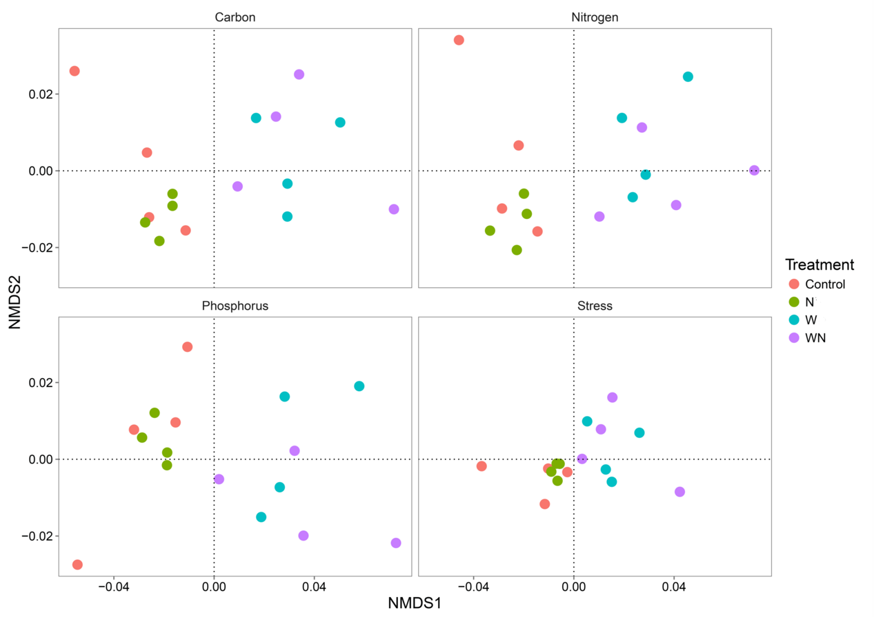

Figure S2. Polygon graph of the number of operational taxonomic units (OTUs) belonging to different niche widths. The polygon was drawn based on 30 bins of the dataset. Different colors denote different treatments.

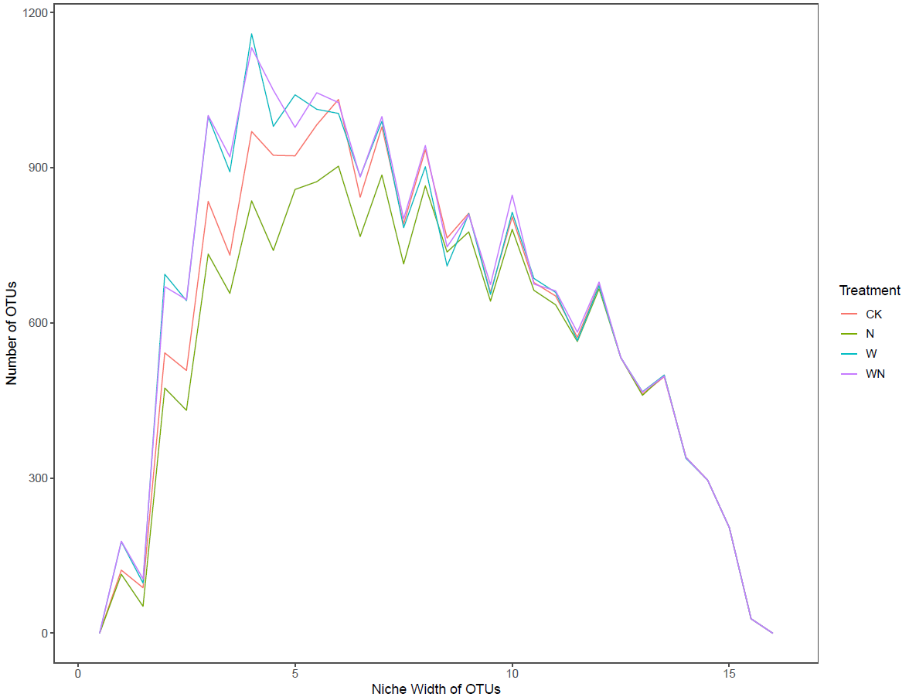
Table SI. Bacterial α-diversity in different treatments. Values in brackets represent standard deviation. Different letters denote significant differences. PD: Phylogenetic diversity; OTUs: species richness. N: nitrogen amendment; W: water table lowering; WN: nitrogen amendment and water table lowering.

Index | Control | N | W | WN
PD | 199 (4)a | 187 (4)b | 203 (3)a | 206 (10)a
OTUs | 4809 (136)a | 4442 (126)b | 5021 (75)a | 5118 (303)a

Table SII. Pairwise OTU overlap among all treatments. Common stands for species shared between two treatments. Unique1 and Unique2 stand for species only present in treatment1 and treatment2, respectively. N: nitrogen amendment; W: water table lowering; WN: nitrogen amendment and water table lowering.

Treatment1 | Treatment2 | Common | Unique1 | Unique2
Control | N | 3755 | 1680 | 1180
Control | W | 3755 | 1671 | 2027
Control | WN | 3834 | 1592 | 1990

Table SIII. Functional gene alpha diversity in different treatments. Different letters denote significant differences. N: nitrogen amendment; W: water table lowering; WN: nitrogen amendment and water table lowering.

Index | Control | N | W | WN
Shannon Index | 10.9(0.1) | 11.0(0.0) | 10.9(0.0) | 10.9(0.0)
Simpson Index | 5732(2795) | 5995(387) | 5680(1093) | 5673(1649)
Pielou evenness | 0.99(0.00) | 0.99(0.00) | 0.99(0.00) | 0.99(0.00)
Simpson evenness | 0.97(0.00) | 0.97(0.00) | 0.97(0.00) | 0.97(0.00)

Table SIV. Pairwise comparison of bacterial community structure using ADONIS (P<0.05) analysis. Significant differences are indicated in bold. N: nitrogen amendment; W: water table lowering; WN: nitrogen amendment and water table lowering.

Comparison | R² | P
N vs. W | 0.461 | 0.035
N vs. WN | 0.398 | 0.001
Control vs. W | 0.368 | 0.001
Control vs. WN | 0.316 | 0.001
Control vs. N | 0.230 | 0.001
W vs. WN | 0.203 | 0.062

Table SV. Relative abundances of dominant bacterial phyla (A) and functional gene categories (B) in different treatments. 0.00 stands for values less than 0.01. N: nitrogen amendment; W: water table lowering; WN: nitrogen amendment and water table lowering.

Phylum | Control | N | W | WN
Actinobacteria | 0.26(0.02) | 0.23(0.03) | 0.29(0.03) | 0.29(0.01)
Betaproteobacteria | 0.14(0.01) | 0.15(0.01) | 0.12(0.01) | 0.09(0.01)
Alphaproteobacteria | 0.08(0.00) | 0.07(0.01) | 0.14(0.01) | 0.14(0.02)
Bacteroidetes | 0.10(0.02) | 0.19(0.02) | 0.04(0.01) | 0.08(0.03)
Chloroflexi | 0.11(0.00) | 0.09(0.00) | 0.08(0.01) | 0.09(0.00)
Acidobacteria | 0.05(0.00) | 0.04(0.00) | 0.10(0.02) | 0.06(0.01)
Deltaproteobacteria | 0.05(0.00) | 0.04(0.00) | 0.05(0.00) | 0.04(0.00)
Firmicutes | 0.04(0.01) | 0.06(0.02) | 0.03(0.00) | 0.04(0.02)
Gammaproteobacteria | 0.04(0.00) | 0.02(0.00) | 0.04(0.00) | 0.04(0.00)
Planctomycetes | 0.01(0.00) | 0.01(0.00) | 0.03(0.00) | 0.03(0.01)
AD3 | 0.01(0.00) | 0.01(0.00) | 0.01(0.00) | 0.01(0.00)
Nitrospirae | 0.00(0.00) | 0.00(0.00) | 0.00(0.00) | 0.01(0.00)
Other | 0.11(0.02) | 0.09(0.01) | 0.07(0.01) | 0.08(0.00)

Gene Category | Control | N | W | WN
Metal Homeostasis | 0.264(0.00) | 0.264(0.00) | 0.263(0.00) | 0.263(0.00)
Carbon Cycling | 0.161(0.00) | 0.161(0.00) | 0.161(0.00) | 0.161(0.00)
Stress | 0.154(0.00) | 0.155(0.00) | 0.156(0.00) | 0.156(0.00)
Virulence | 0.125(0.00) | 0.124(0.00) | 0.125(0.00) | 0.124(0.00)
Organic Remediation | 0.087(0.00) | 0.087(0.00) | 0.087(0.00) | 0.087(0.00)
Nitrogen | 0.042(0.00) | 0.042(0.00) | 0.043(0.00) | 0.043(0.00)
Sulfur | 0.028(0.00) | 0.028(0.00) | 0.028(0.00) | 0.028(0.00)
Secondary metabolism | 0.028(0.00) | 0.028(0.00) | 0.028(0.00) | 0.028(0.00)
Virulence | 0.027(0.00) | 0.028(0.00) | 0.027(0.00) | 0.027(0.00)
Phosphorus | 0.022(0.00) | 0.021(0.00) | 0.022(0.00) | 0.022(0.00)
Virus | 0.009(0.00) | 0.009(0.00) | 0.008(0.00) | 0.008(0.00)
Electron transfer | 0.005(0.00) | 0.005(0.00) | 0.005(0.00) | 0.005(0.00)
Other | 0.047(0.00) | 0.048(0.00) | 0.048(0.00) | 0.048(0.00)

Table SVI. Two-way ANOVA and response value of major bacterial phylum that significantly changed under N amendment or water table lowering treatment. Significant values (P<0.05) are listed in bold. N: nitrogen amendment; W: water table lowering; N*W: the interaction of N amendment and water table lowering. Response values were calculated using the following formula: Response (%) = (average relative abundance N⁺/W⁻ - average relative abundance N⁰/W⁰) / average relative abundance N⁰/W⁰)*100%.

Phylum | N |  |  | W |  |  | N*W
 | F | P | Response | F | P | Response | F | P
Acidobacteria | 8.751 | 0.012 | -28.73 | 15.603 | 0.002 | 57.73 | 3.68 | 0.079
Alphaproteobacteria | 0.301 | 0.593 | -2.28 | 48.441 | <0.001 | 86.86 | 0.814 | 0.385
Bacteroidetes | 6.047 | 0.03 | 82.06 | 20.903 | 0.001 | -55.91 | 0.01 | 0.923
Betaproteobacteria | 0.967 | 0.345 | -8.47 | 8.231 | 0.014 | -27.96 | 0.258 | 0.62
Chlorobi | 3.034 | 0.107 | -22.7 | 13.713 | 0.003 | -42.79 | 0.141 | 0.714
Chloroflexi | 1.193 | 0.296 | -8.39 | 5.408 | 0.038 | -18.45 | 0.788 | 0.392
Gammaproteobacteria | 6.225 | 0.028 | -19.81 | 1.691 | 0.218 | 12.19 | 3.889 | 0.072
Planctomycetes | 0.017 | 0.899 | -1.84 | 9.615 | 0.009 | 108.7 | 0.285 | 0.603

Table SVII. Relative abundances of dominant taxonomic groups in each bacterial phylum (A) and signal intensity of major functional community members (B) that exhibited significant responses to treatments. Different letters in brackets denote significant differences. N: nitrogen amendment; W: water table lowering; WN: nitrogen amendment and water table lowering.
Phylum | Control | N | W | WN
Main taxon
Betaproteobacteria
Comamonadaceae | 0.06(b) | 0.079(c) | 0.032(a) | 0.032(a)
Chloroflexi
Anaerolineae | 0.07(b) | 0.05(ab) | 0.039(a) | 0.04(a)
Bacteroidetes
Bacteroidia | 0.033(b) | 0.028(b) | 0.006(a) | 0.01(a)
Flavobacteriia | 0.06(bc) | 0.151(c) | 0.027(a) | 0.058(ab)
Alphaproteobacteria
Hyphomicrobiaceae | 0.024(a) | 0.022(a) | 0.044(b) | 0.045(b)
Acidobacteria
Acidobacteria-6 | 0.024(a) | 0.02(a) | 0.066(b) | 0.031(a)
Gammaproteobacteria
Xanthomonadales | 0.025(b) | 0.019(a) | 0.023(b) | 0.022(b)
Planctomycetes
Planctomycetia | 0.013(a) | 0.012(a) | 0.026(b) | 0.028(b)
Chlorobi
Ignavibacteria | 0.004(c) | 0.003(bc) | 0.002(ab) | 0.001(b)

Gene category | Main gene | Control | N | W | WN
Carbon (degradation)
 | Camphor | 56.9(b) | 55.2(a) | 56.5(b) | 57(b)
 | Tannins | 187(b) | 182(ab) | 172(a) | 176(a)
 | Lignin | 1896(b) | 1899(b) | 1852(a) | 1840(a)
 | 3-hydroxypropionate bicycle | 95.8(b) | 91.8(b) | 90.1(ab) | 82.4(a)
Carbon (methane)
 | Methanogenesis | 1478(b) | 1488(b) | 1429(a) | 1445(a)
Nitrogen
 | respiration | 7.58(a) | 7.41(a) | 7.71(b) | 7.76(b)
Phosphorus
 | Phosphorus oxidation | 45(b) | 42.7(b) | 38(a) | 36.6(a)
Stress
 | Alkaline shock | 21.2(a) | 20.7(a) | 21.6(b) | 21.6(b)

Table SVIII. Pairwise comparison of functional community structure using ADONIS (P<0.05) analysis. Bold characters denote significant differences. N: nitrogen amendment; W: water table lowering; WN: nitrogen amendment and water table lowering.

ADONIS | R2 | P
Control vs. N | 0.159 | 0.187
Control vs. W | 0.219 | 0.006
Control vs. WN | 0.248 | 0.007
N vs. W | 0.312 | 0.001
N vs. WN | 0.352 | 0.001
W vs. WN | 0.093 | 0.795
Table SIX. Correlation between environmental factors and bacterial community diversity determined using Mantel Tests (P<0.05, permutation=999). Significant values are listed in bold. SM: Soil moisture; TC: Total carbon; TN: Total nitrogen; C/N: Carbon to Nitrogen ratio; DOC: Dissolved organic carbon; DON: Dissolved organic nitrogen; NH₄⁺: Ammonium; NO₃⁻: Nitrate.

Variable | r | P
pH | 0.655 | 0.001
SM | 0.430 | 0.002
TC | -0.036 | 0.631
TN | 0.001 | 0.440
C/N | 0.006 | 0.412
DOC | -0.113 | 0.848
DON | 0.110 | 0.159
NH₄⁺ | 0.126 | 0.116
NO₃⁻ | 0.115 | 0.160

Table SX. Correlations between environmental factors and functional community determined using Mantel Tests (P<0.05, permutation=999). Significant values are listed in bold. N: nitrogen amendment; W: water table lowering; WN: nitrogen amendment and water table lowering.

Variable | r | P
pH | 0.3406 | 0.002
SM | 0.2108 | 0.023
TC | 0.1125 | 0.188
TN | 0.01437 | 0.375
C/N | -0.09867 | 0.805
DOC | -0.2038 | 0.96
DON | -0.149 | 0.897
NH₄⁺ | 0.05861 | 0.31
NO₃⁻ | -0.04132 | 0.584

Table SXI. Correlations between environmental factors and major functional communities (Carbon cycling, Nitrogen cycling, Phosphorus cycling and Stress gene) determined using Mantel Tests (P<0.05, permutation=999). Significant values are listed in bold. SM: Soil moisture; TC: Total carbon; TN: Total nitrogen; C/N: Carbon to Nitrogen ratio; DOC: Dissolved organic carbon; DON: Dissolved organic nitrogen; NH₄⁺: Ammonium; NO₃⁻: Nitrate.

Gene category |  | pH | SM | TC | TN | C/N | DOC | DON | NH₄⁺ | NO₃⁻
Carbon | r | 0.33 | 0.2 | 0.109 | 0.016 | -0.096 | -0.22 | -0.124 | 0.037 | -0.026
 | p | 0.002 | 0.048 | 0.211 | 0.391 | 0.796 | 0.973 | 0.85 | 0.371 | 0.547
Nitrogen | r | 0.371 | 0.241 | 0.1 | -0.016 | -0.134 | -0.217 | -0.124 | 0.069 | -0.048
 | p | 0.002 | 0.013 | 0.183 | 0.514 | 0.915 | 0.983 | 0.847 | 0.275 | 0.635
Phosphorus | r | 0.305 | 0.221 | 0.152 | 0.027 | -0.093 | -0.19 | -0.118 | 0.032 | -0.016
 | p | 0.003 | 0.03 | 0.138 | 0.304 | 0.805 | 0.949 | 0.85 | 0.387 | 0.515
Stress | r | 0.332 | 0.225 | 0.111 | 0.027 | -0.089 | -0.187 | -0.111 | 0.056 | -0.031
 | p | 0.001 | 0.012 | 0.203 | 0.346 | 0.78 | 0.936 | 0.83 | 0.323 | 0.568

