Table S1. Environmental factors. The difference between warming and control in each layer was examined by the linear mixed model, where the block was termed as random intercept effects. Statistical significance is based on Wald type II χ² tests, with bold font indicating significant values (P < 0.05). Layer 1, the surface organic layer; Layer 2, the middle organic layer; Layer 3, the deep organic layer; and Layer 4, the mineral layer. R_{eco}, average ecosystem respiration of the growing season; GPP, average gross primary productivity of the growing season; NEE, average net ecosystem exchange of the growing season.

Factor | Layer 1 (surface organic layer) |  |  | Layer 2 (middle organic layer) |  |  | Layer 3 (deep organic layer) |  |  | Layer 4 (mineral layer) |  |  | All
 | control | warming |  | control | warming |  | control | warming |  | control | warming |  | control | warming
Winter temp. (ºC) | -2.3 | -1.6 |  | -1.6 | -1 |  | -1.2 | -0.7 |  | -0.9 | -0.4 |  | -1.5 | -0.9
Growing season temp. (ºC) | 7.4 | 7.4 |  | 5.1 | 5.5 |  | 2.6 | 3.6 |  | 1.1 | 2.2 |  | 4.1 | 4.7
Soil thaw duration (days) | 142 | 149.3 |  | 118.8 | 127 |  | 104.2 | 112.2 |  | 45.5 | 79.3 |  | 102.6 | 117
Soil bulk density (g/cm³) | 0.09 | 0.09 |  | 0.12 | 0.1 |  | 0.25 | 0.23 |  | 0.74 | 1.19 |  | 0.3 | 0.4
Total N  (g/100 g soil) | 1.3 | 1.2 |  | 1.4 | 1.4 |  | 1.6 | 1.6 |  | 0.7 | 0.5 |  | 1.3 | 1.2
Total C  (g/100 g soil) | 43.1 | 43 |  | 40.3 | 40 |  | 33.4 | 34.7 |  | 16 | 12.4 |  | 33.2 | 32.5
Moisture | 0.81 | 0.82 |  | 0.82 | 0.85 |  | 0.74 | 0.75 |  | 0.39 | 0.31 |  | 0.69 | 0.68
water saturated time (days) | 0.9 | 0.4 |  | 10.0 | 25.2 |  | 57.9 | 85.6 |  | 124 | 124 |  | 48.0 | 58.9
Thaw depth (cm) | - | - |  | - | - |  | - | - |  | - | - |  | 18.3 | 23.0
Plant biomass  (g/m²) | - | - |  | - | - |  | - | - |  | - | - |  | 1617 | 2025
Reco  (mg CO₂-C/m² h) | - | - |  | - | - |  | - | - |  | - | - |  | 94.7 | 163.7
GPP  (mg CO₂-C/m² h) | - | - |  | - | - |  | - | - |  | - | - |  | 169.3 | 279.7
NEE  (mg CO₂-C/m² h) | - | - |  | - | - |  | - | - |  | - | - |  | 74.6 | 116.0
Table S2. The relative abundance of the top 15 abundant bacterial phyla. Warming effects in each layer were examined by a linear mixed model, wherein the block was termed as random intercept effects. Statistical significance is based on Wald type II χ² tests, with bold font indicating significant values (P < 0.05). Layer 1, the surface organic layer; Layer 2, the middle organic layer; Layer 3, the deep organic layer; and Layer 4, the mineral layer.

Phylum | Layer 1 mean | Layer 1 control | Layer 1 warm | Layer 2 mean | Layer 2 control | Layer 2 warm | Layer 3 mean | Layer 3 control | Layer 3 warm | Layer 4 mean | Layer 4 control | Layer 4 warm
Acidobacteria | 32.25% | 30.80% | 33.70% | 29.66% | 27.87% | 31.45% | 36.10% | 35.79% | 36.41% | 19.78% | 20.22% | 19.33%
Proteobacteria | 30.74% | 30.31% | 31.17% | 31.35% | 32.60% | 30.09% | 24.82% | 25.16% | 24.47% | 30.55% | 27.47% | 33.63%
Actinobacteria | 12.16% | 13.80% | 10.52% | 12.92% | 15.25% | 10.58% | 16.27% | 17.41% | 15.12% | 17.91% | 20.24% | 15.58%
Verrucomicrobia | 7.66% | 7.87% | 7.45% | 8.68% | 7.40% | 9.95% | 8.11% | 7.34% | 8.88% | 3.85% | 4.28% | 3.42%
Bacteroidetes | 5.25% | 4.96% | 5.54% | 4.60% | 3.76% | 5.43% | 2.75% | 1.97% | 3.53% | 7.75% | 7.50% | 8.00%
Dormibacteraeota | 0.44% | 0.54% | 0.33% | 1.61% | 1.80% | 1.42% | 3.28% | 3.50% | 3.05% | 2.69% | 4.03% | 1.35%
Planctomycetes | 3.13% | 3.30% | 2.96% | 3.69% | 4.08% | 3.30% | 2.01% | 2.21% | 1.80% | 0.26% | 0.27% | 0.25%
Gemmatimonadetes | 0.10% | 0.10% | 0.09% | 0.18% | 0.14% | 0.22% | 0.46% | 0.40% | 0.51% | 3.45% | 4.00% | 2.89%
Firmicutes | 0.21% | 0.23% | 0.19% | 0.43% | 0.31% | 0.54% | 0.47% | 0.41% | 0.53% | 2.69% | 2.19% | 3.19%
Armatimonadetes | 1.16% | 1.19% | 1.13% | 0.72% | 0.85% | 0.59% | 0.27% | 0.30% | 0.24% | 0.22% | 0.13% | 0.30%
Chloroflexi | 0.05% | 0.06% | 0.03% | 0.41% | 0.51% | 0.30% | 0.14% | 0.17% | 0.10% | 1.52% | 1.04% | 2.00%
OD1 | 0.02% | 0.01% | 0.02% | 0.10% | 0.02% | 0.17% | 0.13% | 0.08% | 0.18% | 0.62% | 0.65% | 0.59%
Chlamydiae | 0.33% | 0.34% | 0.31% | 0.29% | 0.32% | 0.26% | 0.10% | 0.10% | 0.09% | 0.01% | 0.01% | 0.01%
Chlorobi | 0.00% | 0.00% | 0.00% | 0.03% | 0.00% | 0.06% | 0.15% | 0.15% | 0.14% | 0.43% | 0.45% | 0.41%
Crenarchaeota | 0.03% | 0.03% | 0.02% | 0.13% | 0.15% | 0.10% | 0.22% | 0.21% | 0.23% | 0.08% | 0.07% | 0.08%

Table S3. Correlation between the phylum Dormibacteraeota and environmental factors calculated by the Mantel test, partial Mantel test, and Pearson correlation. P-values were adjusted by Benjamini and Hochberg false discovery rate (FDR) controlling procedure.

Environmental factors | Mantel |  |  | Partial Mantel |  |  | Pearson
 | r | P-value |  | r | P-value |  | r | P-value
Growing season temperature | 0.60 | 0.002 |  | 0.57 | 0.002 |  | -0.51 | 0.001
Soil thaw duration | 0.52 | 0.002 |  | 0.49 | 0.002 |  | -0.48 | 0.004
Water saturated time | 0.49 | 0.002 |  | 0.44 | 0.002 |  | 0.41 | 0.013
C/N ratio | 0.38 | 0.002 |  | 0.37 | 0.002 |  | -0.50 | 0.001
Total C | 0.33 | 0.002 |  | 0.25 | 0.002 |  | -0.11 | 0.530
Moisture | 0.30 | 0.002 |  | 0.21 | 0.003 |  | -0.10 | 0.531
Winter temperature | 0.28 | 0.002 |  | 0.25 | 0.002 |  | 0.30 | 0.096
Soil bulk density | 0.21 | 0.008 |  | 0.12 | 0.104 |  | -0.04 | 0.776
Total N | 0.14 | 0.029 |  | 0.06 | 0.250 |  | 0.22 | 0.215
Plant biomass | 0.03 | 0.366 |  | -0.12 | 1 |  | -0.17 | 0.322
Reco | 0.00 | 0.513 |  | -0.16 | 1 |  | -0.25 | 0.182
GPP | 0.00 | 0.509 |  | -0.20 | 1 |  | -0.23 | 0.206
NEE | 0.03 | 0.366 |  | -0.15 | 1 |  | -0.17 | 0.322

Table S4. Changes in the total signal intensity of C degradation and Methanogenesis genes by warming in each layer. Warming effects were examined by the linear mixed model, where the block was termed as random intercept effects. Statistical significance is based on Wald type II χ² tests, with bold font indicating significant values (P < 0.05). P-values were adjusted by Benjamini and Hochberg false discovery rate (FDR) controlling procedure. L1, the surface organic layer; L2, the middle organic layer; L3, the deep organic layer; and L4, the mineral layer.

Gene | Subcategory | L1 change (%) | L1.se | L2 change (%) | L2.se | L3 change (%) | L3.se | L4 change (%) | L4.se
amyA | Starch | -0.21 | 2.45 | -4.88 | 2.04 | -6.01 | 2.49 | -0.76 | 5.35
amyx | Starch | -0.18 | 2.16 | -1.98 | 1.05 | -0.03 | 1.14 | -0.25 | 1.29
apu | Starch | 28.15 | 9.94 | 0.86 | 1.24 | 0.67 | 0.95 | 0.99 | 3.81
cda | Starch | -4.84 | 2.98 | -3.10 | 3.10 | -5.44 | 2.86 | 0.88 | 6.81
glucoamylase | Starch | 0.48 | 3.55 | -4.46 | 3.69 | -10.74 | 3.63 | -0.99 | 8.38
isopullulanase | Starch | -1.52 | 1.41 | -2.36 | 1.73 | -2.51 | 0.92 | 1.08 | 1.02
nplT | Starch | 1.53 | 5.32 | -10.18 | 3.74 | -16.48 | 4.10 | 5.74 | 8.64
pula | Starch | -0.81 | 2.34 | -7.44 | 2.33 | -2.95 | 2.41 | 1.63 | 4.38
inulinase | Inulin | -0.21 | 0.87 | -0.98 | 3.70 | -7.29 | 4.97 | 3.69 | 7.36
ara | Hemicellulose | -1.83 | 2.45 | -3.89 | 1.74 | -3.07 | 2.91 | -1.33 | 4.96
mannanase | Hemicellulose | -1.09 | 2.65 | -3.59 | 1.63 | -2.83 | 3.65 | -0.53 | 4.78
xyla | Hemicellulose | -0.40 | 1.52 | -3.26 | 2.46 | -2.99 | 3.71 | -3.48 | 4.48
xylanase | Hemicellulose | 0.27 | 2.46 | -7.12 | 2.70 | -7.35 | 3.54 | -0.05 | 5.16
xylose_isomerase_Oomycetes | Hemicellulose | 0.16 | 1.67 | 1.16 | 0.89 | -8.76 | 8.91 | 1.07 | 2.04
lactase_fungi | Lactose | 2.60 | 4.55 | -8.47 | 2.72 | 11.89 | 10.18 | 4.81 | 11.35
endopolygalacturonase_fungi | Pectin | 2.53 | 5.94 | -20.55 | 7.41 | 5.67 | 8.46 | 3.34 | 6.64
exopolygalacturonase_fungi | Pectin | -6.95 | 2.74 | -14.22 | 5.17 | -11.77 | 2.47 | -18.63 | 5.97
pec_Cdeg | Pectin | -1.13 | 2.41 | -4.19 | 2.13 | -8.75 | 2.55 | 2.09 | 7.34
pectate_lyase_Oomycetes | Pectin | -6.13 | 1.52 | -0.65 | 3.66 | -2.39 | 3.67 | 3.58 | 3.27
pectin_lyase_Oomycetes | Pectin | 2.29 | 4.67 | -12.92 | 5.28 | -1.15 | 1.02 | 1.50 | 11.21
pectinase (pectate_lyase) | Pectin | -4.10 | 1.63 | -3.90 | 2.32 | 0.21 | 3.40 | 0.49 | 2.79
pel_Cdeg | Pectin | 9.67 | 6.25 | 0.56 | 0.81 | -1.85 | 2.84 | 4.07 | 8.11
Pg_Oomycetes | Pectin | 2.86 | 4.22 | -5.50 | 2.98 | -6.43 | 7.74 | -17.69 | 8.18
pme | Pectin | -0.87 | 2.39 | -4.71 | 1.84 | -2.49 | 1.93 | -4.28 | 5.82
pme_Cdeg | Pectin | 6.85 | 3.00 | -7.62 | 2.38 | -0.51 | 4.48 | -4.24 | 6.60
RgaE | Pectin | 1.45 | 2.67 | -5.85 | 2.56 | -5.54 | 4.05 | -1.76 | 3.59
rgh | Pectin | -8.12 | 5.12 | -12.93 | 5.57 | -13.09 | 10.72 | -11.98 | 5.92
rgl | Pectin | -0.61 | 2.10 | -7.04 | 2.26 | -7.60 | 3.66 | -4.64 | 5.42
axe | Cellulose | -4.45 | 2.76 | -5.74 | 2.20 | -1.51 | 0.71 | 7.08 | 5.30
cellobiase | Cellulose | 0.66 | 1.50 | -5.55 | 2.95 | -7.49 | 3.41 | -3.31 | 6.14
cellulase_GH7_Parabasalia | Cellulose | 0.79 | 0.64 | -1.70 | 1.00 | -2.59 | 2.19 | -0.05 | 2.67
endoglucanase | Cellulose | 2.00 | 2.40 | -4.63 | 2.59 | -4.37 | 4.10 | -1.90 | 7.47
exoglucanase | Cellulose | 3.14 | 4.05 | -6.86 | 3.44 | -9.83 | 4.16 | 5.35 | 6.40
phospholipase_A2_fungi | Phospholipids | -3.74 | 1.90 | 2.43 | 2.77 | -4.67 | 2.47 | 0.23 | 5.59
phospholipase_C_fungi | Phospholipids | 1.19 | 2.10 | -6.78 | 7.97 | -11.04 | 2.88 | 13.54 | 10.56
phospholipase_D_fungi | Phospholipids | -7.34 | 5.78 | -2.80 | 3.68 | -2.80 | 3.67 | 4.72 | 4.56
camdcab | Camphor | 1.25 | 0.71 | -5.50 | 3.02 | -2.49 | 4.23 | -3.39 | 2.72
cdh | Terpenes | -2.89 | 2.89 | -9.31 | 1.77 | -5.72 | 3.40 | -0.67 | 4.50
limeh | Terpenes | -0.64 | 3.75 | -7.01 | 1.98 | -7.99 | 3.60 | -3.63 | 3.68
lmo | Terpenes | 15.44 | 7.09 | 6.30 | 3.70 | -3.56 | 2.56 | -3.84 | 6.68
cutinase | Cutin | -0.19 | 1.58 | -1.56 | 2.05 | -6.92 | 2.11 | -1.07 | 4.91
tannase_Cdeg | Tannins | -2.35 | 3.45 | -5.76 | 2.45 | -16.23 | 2.02 | -0.99 | 8.24
acetylglucosaminidase | Chitin | -0.92 | 2.09 | -7.54 | 1.99 | -2.43 | 3.65 | -1.33 | 5.76
chitin_deacetylase_fungi | Chitin | 4.17 | 5.29 | -11.57 | 7.18 | 5.12 | 6.51 | 15.52 | 9.99
chitinase | Chitin | -1.01 | 2.82 | -6.29 | 2.03 | -7.64 | 2.61 | -1.34 | 5.37
vana | Vanillin/Lignin | 1.29 | 2.68 | -3.30 | 1.97 | -3.97 | 1.60 | -1.86 | 4.75
vdh | Vanillin/Lignin | -5.22 | 2.13 | -8.25 | 2.46 | -7.44 | 2.80 | 4.24 | 9.12
glx | Lignin | -0.71 | 3.80 | -4.32 | 1.93 | -3.53 | 3.91 | -2.64 | 6.74
ligninase | Lignin | -6.91 | 3.23 | -5.38 | 5.30 | -10.77 | 9.11 | 10.69 | 4.46
mnp | Lignin | 4.95 | 3.11 | -9.11 | 1.75 | -9.73 | 3.24 | 1.46 | 9.80
phenol_oxidase | Lignin | 2.52 | 3.06 | -5.96 | 2.56 | -10.00 | 3.19 | 2.42 | 6.25
fmdB_fwdB | Methanogenesis | 0.08 | 2.99 | -6.69 | 2.22 | -10.03 | 4.58 | -23.13 | 3.96
Ftr | Methanogenesis | -0.35 | 0.76 | -2.32 | 0.60 | -2.01 | 0.73 | 0.07 | 1.24
hdrB | Methanogenesis | 2.71 | 3.96 | -5.21 | 2.43 | -5.80 | 3.70 | 2.29 | 5.21
Mch_methane | Methanogenesis | 16.68 | 4.32 | -11.46 | 4.77 | -13.28 | 2.33 | -2.49 | 8.28
mcrA | Methanogenesis | 3.64 | 3.10 | -1.78 | 2.78 | -2.62 | 4.37 | 2.84 | 5.52
Mer_methane | Methanogenesis | 4.25 | 7.11 | 7.66 | 6.56 | -14.13 | 4.68 | 13.24 | 5.18
mrtH | Methanogenesis | 1.14 | 3.77 | 0.86 | 2.51 | -1.30 | 2.63 | -2.05 | 7.45
MT2 | Methanogenesis | -21.77 | 3.64 | 2.67 | 11.54 | -20.86 | 11.82 | 15.23 | 15.66
mtaB | Methanogenesis | -0.82 | 1.01 | -0.68 | 0.85 | 1.90 | 1.66 | 1.39 | 2.11
mtbC_mttC | Methanogenesis | 0.38 | 6.75 | -20.09 | 4.40 | -10.31 | 12.99 | 19.55 | 40.26
mtmB | Methanogenesis | 0.27 | 1.55 | 1.16 | 0.90 | -7.86 | 8.20 | -1.54 | 4.91
mtxX | Methanogenesis | 2.77 | 1.51 | 2.06 | 1.65 | 2.25 | 3.15 | -1.70 | 1.50

Table S5. Changes in the signal intensity of mcrA genes by warming in each layer. Warming effects in each layer were examined by the linear mixed model, where the block was termed as random intercept effects. Statistical significance is based on Wald type II χ² tests, with bold font indicating significant values (P < 0.05). P-values were adjusted by Benjamini and Hochberg false discovery rate (FDR) controlling procedure. L1, the surface organic layer; L2, the middle organic layer; L3, the deep organic layer; and L4, the mineral layer.

Probe ID | Gene | Organism | L1  change | L1.P | L2 change | L2.P | L3 change | L3.P | L4 change | L4.P
153998677 | mcrA | Candidatus Methanoregula boonei 6A8 | -21.38% | 0.774 | NA | NA | NA | NA | NA | NA
148642962 | mcrA | Methanobrevibacter smithii ATCC 35061 | 1.39% | 0.498 | -0.89% | 0.941 | -5.40% | 0.164 | 19.38% | 0.660
68184737 | mcrA | Methanococcoides burtonii DSM 6242 | -20.25% | 0.774 | 20.82% | 0.729 | NA | NA | 1.24% | 0.998
124363917 | mcrA | Methanocorpusculum labreanum Z | -0.72% | 0.929 | -1.07% | 0.730 | -0.63% | 0.774 | 0.70% | 0.956
380692198 | mcrA | Methanofollis ethanolicus | -0.83% | 0.897 | 1.31% | 0.710 | 15.27% | 0.730 | -3.95% | 0.010
298674844 | mcrA | Methanohalobium evestigatum Z-7303 | -3.74% | 0.133 | -0.42% | 0.990 | -34.65% | 0.348 | -3.30% | 0.990
380692170 | mcrA | Methanolobus profundi | 1.19% | 0.774 | 4.71% | 0.427 | 1.17% | 0.998 | -5.12% | 0.953
307354128 | mcrA | Methanoplanus petrolearius DSM 11571 | -2.43% | 0.575 | -0.58% | 0.967 | -100.0% | 0.010 | -100.0% | 0.000
386001204 | mcrA | Methanosaeta harundinacea 6Ac | -0.52% | 0.730 | 0.04% | 0.998 | -0.40% | 0.967 | 1.86% | 0.491
77862464 | mcrA | uncultured archaeon | 100.0% | 0.000 | NA | NA | NA | NA | NA | NA
380766215 | mcrA | uncultured archaeon | 100.0% | 0.001 | NA | NA | 100.0% | 0.010 | 100.0% | 0.000
94449436 | mcrA | uncultured archaeon | -100.0% | 0.010 | -100.0% | 0.010 | NA | NA | NA | NA
385654586 | mcrA | uncultured archaeon | -100.0% | 0.010 | NA | NA | NA | NA | NA | NA
82523664 | mcrA | uncultured archaeon | 1.35% | 0.507 | 0.50% | 0.842 | -0.60% | 0.804 | -1.11% | 0.871
295982796 | mcrA | uncultured archaeon | 1.14% | 0.730 | -0.81% | 0.774 | -3.39% | 0.218 | 6.14% | 0.460
158147971 | mcrA | uncultured archaeon | 1.89% | 0.348 | -1.54% | 0.737 | 1.12% | 0.937 | -1.00% | 0.941
126013262 | mcrA | uncultured archaeon | 24.73% | 0.774 | 100.0% | 0.010 | NA | NA | 5.41% | 0.963
262284393 | mcrA | uncultured archaeon | 0.95% | 0.743 | 2.73% | 0.682 | 1.39% | 0.745 | 5.06% | 0.000
380766219 | mcrA | uncultured archaeon | 0.44% | 0.775 | -0.16% | 0.941 | -0.74% | 0.551 | -0.76% | 0.730
211906109 | mcrA | uncultured archaeon | 1.04% | 0.654 | -1.89% | 0.061 | 0.71% | 0.819 | 0.45% | 0.967
61398352 | mcrA | uncultured archaeon | -2.36% | 0.775 | -9.46% | 0.958 | NA | NA | NA | NA
138754346 | mcrA | uncultured archaeon | 0.29% | 0.962 | 1.23% | 0.577 | 0.01% | 0.998 | 5.70% | 0.010
321146120 | mcrA | uncultured archaeon | -3.81% | 0.990 | 17.85% | 0.728 | -17.87% | 0.633 | -19.13% | 0.774
388556644 | mcrA | uncultured archaeon | -0.23% | 0.967 | 0.46% | 0.990 | -5.36% | 0.774 | -0.40% | 0.997
56967343 | mcrA | uncultured archaeon | -3.85% | 0.997 | -17.50% | 0.577 | NA | NA | NA | NA
321146126 | mcrA | uncultured archaeon | -1.47% | 0.998 | 100.00% | 0.010 | -100.0% | 0.010 | NA | NA
56967347 | mcrA | uncultured archaeon | 0.21% | 0.998 | -100.0% | 0.010 | 100.0% | 0.000 | NA | NA
94449468 | mcrA | uncultured archaeon | 0.00% | 0.998 | 1.33% | 0.743 | -3.05% | 0.243 | 1.48% | 0.654
363987226 | mcrA | uncultured archaeon | NA | NA | 100.0% | 0.001 | NA | NA | NA | NA
388556628 | mcrA | uncultured archaeon | NA | NA | 27.77% | 0.505 | 26.35% | 0.774 | 22.55% | 0.633
46389791 | mcrA | uncultured archaeon | NA | NA | NA | NA | 0.84% | 0.998 | 31.78% | 0.435
12802200 | mcrA | uncultured archaeon 85A | 6.88% | 0.185 | 5.35% | 0.460 | -4.93% | 0.577 | -22.27% | 0.428
110006524 | mcrA | uncultured euryarchaeote | -2.16% | 0.427 | -1.86% | 0.297 | -2.19% | 0.000 | 0.71% | 0.926
38570178 | mcrA | uncultured euryarchaeote | 0.72% | 0.819 | -1.53% | 0.682 | -2.39% | 0.477 | 2.81% | 0.730
87082457 | mcrA | uncultured euryarchaeote | 1.35% | 0.774 | -4.77% | 0.654 | 17.19% | 0.729 | 23.57% | 0.577
110006576 | mcrA | uncultured euryarchaeote | 0.05% | 0.998 | -2.77% | 0.156 | 2.52% | 0.730 | -1.57% | 0.774
62512339 | mcrA | uncultured methanogenic archaeon | 100.0% | 0.000 | -100.0% | 0.000 | -100.0% | 0.001 | -100.0% | 0.011
353682250 | mcrA | uncultured methanogenic archaeon | -100.0% | 0.010 | NA | NA | NA | NA | NA | NA
145553716 | mcrA | uncultured methanogenic archaeon | 100.0% | 0.010 | -100.0% | 0.001 | NA | NA | 100.0% | 0.000
283481909 | mcrA | uncultured methanogenic archaeon | -2.63% | 0.665 | -1.79% | 0.297 | -0.65% | 0.819 | 20.28% | 0.673
34017032 | mcrA | uncultured methanogenic archaeon | 1.88% | 0.435 | -2.52% | 0.149 | -0.41% | 0.920 | -3.24% | 0.416
349586286 | mcrA | uncultured methanogenic archaeon | -1.04% | 0.730 | -1.78% | 0.014 | -4.34% | 0.498 | 0.68% | 0.967
119395258 | mcrA | uncultured methanogenic archaeon | 1.37% | 0.730 | -18.00% | 0.615 | -15.16% | 0.740 | -18.34% | 0.774
112441755 | mcrA | uncultured methanogenic archaeon | 1.47% | 0.775 | -3.75% | 0.156 | -4.02% | 0.507 | -10.20% | 0.010
283481860 | mcrA | uncultured methanogenic archaeon | -0.14% | 0.997 | 1.38% | 0.745 | -2.07% | 0.217 | -1.31% | 0.774
48527134 | mcrA | uncultured Methanomicrobiales archaeon | 100.0% | 0.010 | NA | NA | NA | NA | NA | NA
379656828 | mcrA | uncultured Methanomicrobiales archaeon | 0.70% | 0.729 | -1.30% | 0.730 | -2.05% | 0.575 | -3.93% | 0.416
48527126 | mcrA | uncultured Methanomicrobiales archaeon | NA | NA | -1.14% | 0.898 | NA | NA | NA | NA
371445221 | mcrA | uncultured Methanosaeta sp. | 1.93% | 0.729 | -3.40% | 0.498 | -6.00% | 0.214 | 12.81% | 0.774
371445215 | mcrA | uncultured Methanosaeta sp. | -0.07% | 0.998 | 1.59% | 0.774 | 0.03% | 0.998 | -5.44% | 0.427

Table S6. Changes in the total signal intensity of iron and sulfur cycling genes by warming in each layer. Warming effects in each layer were examined by the linear mixed model, where the block was termed as random intercept effects. Statistical significance is based on Wald type II χ² tests, with bold font indicating significant values (P < 0.05). P-values were adjusted by Benjamini and Hochberg false discovery rate (FDR) controlling procedure. L1, the surface organic layer; L2, the middle organic layer; L3, the deep organic layer; and L4, the mineral layer.

Gene | Gene_category | Subcategory1 | L1 change | L1.P | L2 change | L2.P | L3 change | L3.P | L4 change | L4.P
C_type_cytochrome | Iron | electron transfer | 9.16% | 0.131 | -8.78% | 0.023 | 1.74% | 0.792 | 12.33% | 0.002
C_type_cytochrome_1 | Iron | electron transfer | -4.11% | 0.039 | -5.40% | 0.238 | -15.54% | 0.000 | -3.03% | 0.823
c_type_cytochrome_3 | Iron | electron transfer | 2.55% | 0.611 | -3.55% | 0.548 | -15.31% | 0.001 | -26.02% | 0.002
c_type_cytochrome_4 | Iron | electron transfer | -13.51% | 0.000 | -11.64% | 0.001 | -12.59% | 0.136 | -0.05% | 0.998
c_type_cytochrome_6 | Iron | electron transfer | -8.29% | 0.329 | 20.17% | 0.032 | 1.91% | 0.948 | 21.83% | 0.250
c_type_cytochrome_b | Iron | electron transfer | -5.82% | 0.173 | -2.16% | 0.508 | 3.46% | 0.501 | 2.48% | 0.760
acsC | Iron | iron uptake | 3.46% | 0.153 | 0.19% | 0.969 | -7.91% | 0.548 | 1.85% | 0.603
acsD | Iron | iron uptake | 0.23% | 0.938 | -2.44% | 0.158 | -30.17% | 0.000 | -20.20% | 0.061
chuA | Iron | iron uptake | -5.27% | 0.522 | -5.78% | 0.692 | -3.25% | 0.806 | -22.97% | 0.228
chuS | Iron | iron uptake | 2.17% | 0.559 | 2.71% | 0.343 | -1.14% | 0.698 | -15.96% | 0.548
chuT | Iron | iron uptake | 2.17% | 0.250 | 0.19% | 0.952 | -1.43% | 0.528 | 0.62% | 0.823
chuW | Iron | iron uptake | 4.25% | 0.792 | -1.89% | 0.422 | -2.39% | 0.181 | -10.31% | 0.326
fptA | Iron | iron uptake | 0.53% | 0.841 | 1.54% | 0.760 | -2.26% | 0.367 | -2.85% | 0.382
frgA | Iron | iron uptake | -13.72% | 0.628 | -21.07% | 0.503 | -5.98% | 0.002 | NA | NA
fyuA | Iron | iron uptake | 34.84% | 0.190 | -32.12% | 0.012 | -0.05% | 0.998 | -40.98% | 0.267
hhu | Iron | iron uptake | 100.00% | 0.012 | NA | NA | NA | NA | NA | NA
hxuB | Iron | iron uptake | -14.93% | 0.267 | -2.31% | 0.250 | -6.57% | 0.591 | 1.73% | 0.951
hxuC | Iron | iron uptake | -0.76% | 0.841 | -19.66% | 0.732 | -100.00% | 0.012 | -100.00% | 0.000
ira | Iron | iron uptake | NA | NA | NA | NA | NA | NA | NA | NA
irgB | Iron | iron uptake | 4.73% | 0.795 | -41.35% | 0.000 | -35.22% | 0.013 | -0.05% | 0.998
iro | Iron | iron uptake | -0.54% | 0.933 | -4.08% | 0.167 | -5.22% | 0.046 | 0.72% | 0.951
isdC | Iron | iron uptake | NA | NA | NA | NA | NA | NA | -33.74% | 0.130
iuc | Iron | iron uptake | -12.66% | 0.000 | -17.41% | 0.000 | -4.68% | 0.545 | -17.24% | 0.167
iutA | Iron | iron uptake | -5.84% | 0.806 | -2.53% | 0.133 | -1.57% | 0.717 | -0.14% | 0.978
mbtA | Iron | iron uptake | -36.39% | 0.016 | -1.37% | 0.423 | 1.23% | 0.757 | 0.44% | 0.951
mbtB | Iron | iron uptake | 1.15% | 0.692 | -1.14% | 0.639 | 0.96% | 0.813 | -1.05% | 0.996
mbtE | Iron | iron uptake | -1.28% | 0.456 | -2.52% | 0.050 | -1.71% | 0.167 | 1.90% | 0.508
mbtF | Iron | iron uptake | 0.19% | 0.951 | -2.02% | 0.179 | -1.35% | 0.152 | 1.16% | 0.692
mce3 | Iron | iron uptake | -5.11% | 0.548 | -26.52% | 0.000 | -38.19% | 0.000 | -10.49% | 0.548
pchR | Iron | iron uptake | 19.31% | 0.792 | NA | NA | NA | NA | NA | NA
AprA | Sulfur | adenylylsulfate reductase | -6.16% | 0.412 | -4.90% | 0.522 | -18.74% | 0.000 | -5.14% | 0.611
aps_apra | Sulfur | adenylylsulfate reductase | 0.92% | 0.876 | -5.42% | 0.136 | -5.85% | 0.032 | 3.16% | 0.717
APS_AprB | Sulfur | adenylylsulfate reductase | -5.15% | 0.382 | -9.41% | 0.153 | -13.74% | 0.010 | -3.82% | 0.758
5f1_DMSP_lyase | Sulfur | DMSP degradation | 2.65% | 0.548 | 6.62% | 0.261 | -16.29% | 0.000 | -16.31% | 0.000
dmdA | Sulfur | DMSP degradation | -3.40% | 0.190 | -10.53% | 0.000 | -4.97% | 0.190 | 4.46% | 0.548
cysJ | Sulfur | Reduction | -3.00% | 0.179 | -5.77% | 0.038 | -2.22% | 0.516 | -1.95% | 0.807
fccab | Sulfur | Sulfide Oxidation | -0.06% | 0.996 | -6.77% | 0.258 | -5.90% | 0.130 | -6.35% | 0.508
sqr | Sulfur | Sulfide Oxidation | -4.40% | 0.158 | -4.73% | 0.394 | -0.88% | 0.951 | 5.93% | 0.319
dsra | Sulfur | sulfite reduction | -0.85% | 0.918 | -9.65% | 0.013 | -8.21% | 0.032 | -1.34% | 0.948
dsrB | Sulfur | sulfite reduction | 1.60% | 0.665 | -8.79% | 0.018 | -5.66% | 0.130 | 1.24% | 0.948
Sir | Sulfur | sulfite reduction | 0.15% | 0.989 | -5.00% | 0.343 | -5.16% | 0.242 | -3.94% | 0.692
APS_kinase_protist | Sulfur | sulfur assimilation | -9.70% | 0.033 | -20.39% | 0.000 | -4.48% | 0.660 | -11.85% | 0.660
APS_reductase_protist | Sulfur | sulfur assimilation | 0.54% | 0.850 | -0.52% | 0.850 | -7.99% | 0.335 | -7.80% | 0.548
ATP_sulfurylase_protist | Sulfur | sulfur assimilation | -7.07% | 0.792 | -24.02% | 0.002 | -38.09% | 0.032 | 39.64% | 0.548
ATP_sulphurylase | Sulfur | sulfur assimilation | -0.05% | 0.998 | -14.50% | 0.000 | -9.26% | 0.017 | -6.49% | 0.661
cysteine_synthase_protist | Sulfur | sulfur assimilation | -1.75% | 0.665 | -7.87% | 0.015 | 0.16% | 0.990 | -8.56% | 0.267
PAPS_reductase | Sulfur | sulfur assimilation | -6.96% | 0.136 | -4.04% | 0.412 | -26.20% | 0.000 | -17.00% | 0.136
Serine_acetyltransferase_protist | Sulfur | sulfur assimilation | -0.07% | 0.976 | -8.82% | 0.319 | -12.46% | 0.033 | 1.95% | 0.933
sulfate_transporter | Sulfur | sulfur assimilation | 18.91% | 0.070 | 3.60% | 0.609 | 1.44% | 0.951 | 32.60% | 0.315
sulfate_transporter_protist | Sulfur | sulfur assimilation | 9.13% | 0.285 | -5.49% | 0.420 | -14.35% | 0.004 | -6.90% | 0.694
sulfite_reductase_protist | Sulfur | sulfur assimilation | -0.02% | 0.998 | -0.47% | 0.989 | -0.49% | 0.951 | 7.12% | 0.806
cysI | Sulfur | sulfur other | -3.37% | 0.250 | -4.83% | 0.130 | -4.68% | 0.097 | -0.70% | 0.951
soxA | Sulfur | Sulfur Oxidation | -1.69% | 0.548 | -2.96% | 0.440 | -7.04% | 0.158 | -11.86% | 0.000
soxB | Sulfur | Sulfur Oxidation | -17.88% | 0.024 | -10.05% | 0.358 | 3.18% | 0.833 | 21.17% | 0.094
soxC | Sulfur | Sulfur Oxidation | 0.21% | 0.983 | 0.58% | 0.951 | -13.12% | 0.000 | 2.09% | 0.841
soxV | Sulfur | Sulfur Oxidation | -1.75% | 0.780 | -5.06% | 0.424 | -14.32% | 0.000 | -13.03% | 0.109
soxY | Sulfur | Sulfur Oxidation | -3.40% | 0.418 | -2.75% | 0.420 | -5.89% | 0.101 | 0.49% | 0.983

Table S7. Changes in the signal intensity of iron and sulfur cycling gene probes by warming in each layer. Warming effects were tested by the linear mixed model, where the block was termed as random intercept effects. Statistical significance is based on Wald type II χ² tests, with bold font indicating significant values (P < 0.05). P-values were adjusted by Benjamini and Hochberg false discovery rate (FDR) controlling procedure. Probes changed by warming in at least one layer are shown.

See the excel file.

Table S8. Partial Mantel tests showing the correlations of dissimilarities of bacterial community composition and those of environmental factors in each layer. Mantel’s r values are shown, with the significance ones (P < 0.05) indicated in bold. L1, the surface organic layer; L2, the middle organic layer; L3, the deep organic layer; and L4, the mineral layer. R_{eco}, average ecosystem respiration of the growing season; GPP, average gross primary productivity of the growing season; NEE, average net ecosystem exchange of the growing season.

Environmental factors | Layer 1 |  |  |  |  | Layer 2 |  |  |  | Layer 3 |  |  |  | Layer 4
 | r Bacteria | r Fungi | r FG |  | r Bacteria |  | r Fungi | r FG |  | r Bacteria | r Fungi | r FG |  | r Bacteria | r Fungi | r FG
Water saturated time | 0.36 | 0.00 | -0.09 |  | 0.00 |  | -0.03 | -0.17 |  | 0.03 | 0.25 | 0.00
Moisture | 0.40 | 0.11 | -0.09 |  | 0.00 |  | 0.17 | 0.08 |  | 0.17 | -0.35 | -0.17 |  | -0.34 | -0.05 | 0.48
Soil thaw duration | -0.20 | -0.17 | -0.09 |  | 0.05 |  | -0.11 | -0.12 |  | -0.15 | -0.25 | -0.05 |  | 0.06 | 0.04 | -0.16
Total C | 0.05 | 0.03 | 0.19 |  | -0.16 |  | -0.07 | -0.16 |  | 0.01 | -0.29 | -0.18 |  | -0.21 | 0.05 | 0.28
Soil bulk density | -0.01 | -0.26 | -0.13 |  | 0.15 |  | 0.30 | 0.12 |  | 0.28 | -0.29 | -0.18 |  | 0.51 | -0.27 | -0.11
Growing season temperature | -0.34 | -0.05 | -0.02 |  | -0.09 |  | -0.19 | -0.14 |  | -0.15 | -0.21 | -0.16 |  | 0.01 | 0.40 | 0.45
Total N | -0.13 | -0.10 | 0.02 |  | -0.03 |  | 0.05 | -0.01 |  | -0.06 | -0.10 | 0.06 |  | -0.17 | 0.00 | 0.36
Winter temperature | -0.08 | 0.09 | -0.03 |  | -0.07 |  | -0.09 | 0.17 |  | 0.28 | 0.06 | 0.25 |  | -0.24 | 0.03 | -0.18
C/N ratio | -0.19 | -0.12 | 0.00 |  | -0.07 |  | 0.03 | -0.04 |  | 0.08 | 0.03 | 0.17 |  | 0.47 | -0.27 | 0.09
Plant biomass | 0.37 | -0.13 | -0.05 |  | 0.17 |  | -0.09 | -0.29 |  | -0.25 | 0.00 | -0.03 |  | 0.30 | 0.01 | -0.33
R_{eco} | 0.08 | -0.14 | 0.08 |  | 0.11 |  | -0.04 | 0.09 |  | -0.05 | 0.01 | -0.02 |  | 0.15 | -0.12 | -0.48
GPP | 0.32 | -0.03 | 0.08 |  | 0.44 |  | 0.17 | 0.05 |  | -0.06 | 0.12 | -0.02 |  | 0.18 | -0.13 | -0.47
NEE | 0.31 | 0.05 | 0.03 |  | 0.52 |  | 0.28 | 0.00 |  | -0.07 | 0.20 | 0.06 |  | 0.12 | 0.06 | -0.20

Figure S1. (a) A photo showing experimental blocks at the CiPEHR experimental warming site in Alaska, USA, and (b) the diagram demonstrating the soil samples taken across four different depths.

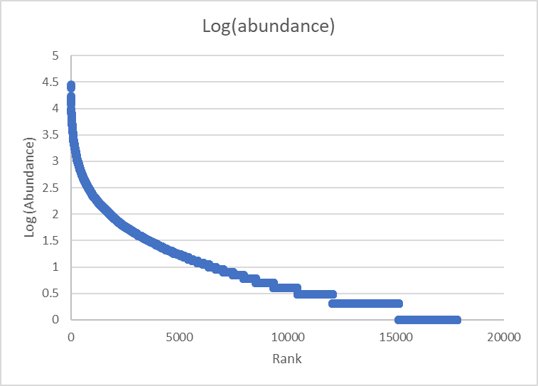

Figure S2. The long-tailed pattern of 18,722 16S OTU relative abundance ranking and distribution based on sequencing data.

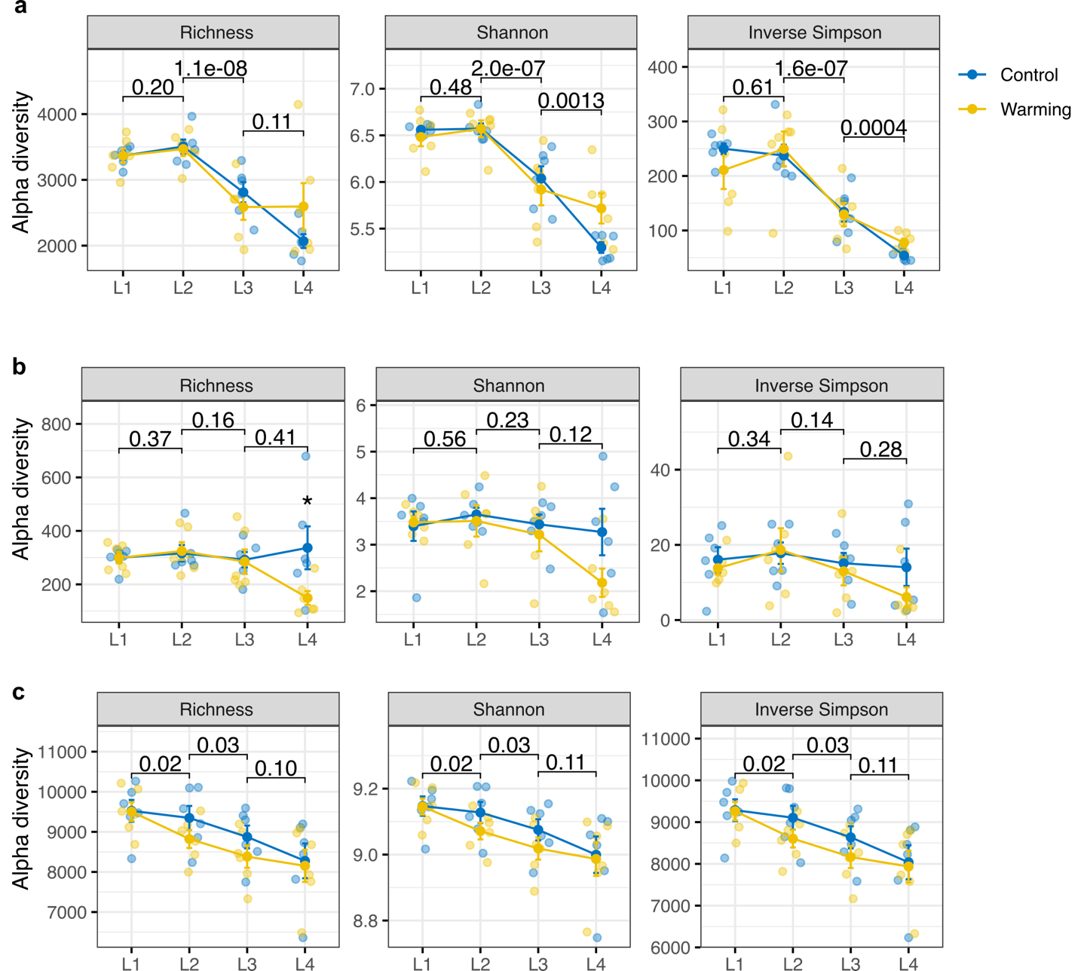

Figure S3. Effects of warming and depths on α-diversity of (a) bacteria, (b) fungi, and (c) functional genes. Lines represent the mean values, and error bars represent the standard errors. The difference between any two adjacent layers was examined by the linear mixed model, and P-values based on Wald type II χ² tests are indicated on the plot. In each layer, the difference between warming and control was also examined by linear mixed model. P-values are denoted by the asterisks: *** P < 0.001, ** P < 0.010, and * P < 0.050. L1, the surface organic layer; L2, the middle organic layer; L3, the deep organic layer; and L4, the mineral layer.

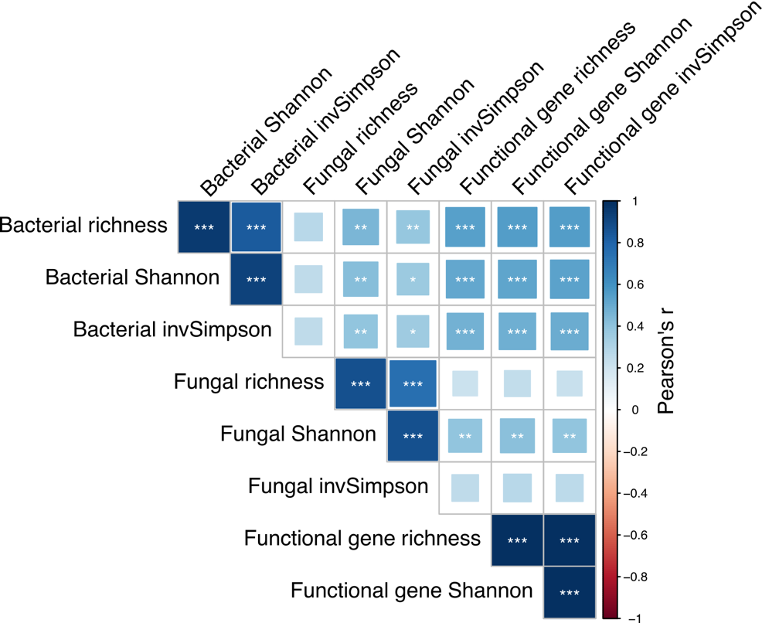

Figure S4. Pairwise correlations between different diversity indices. The color gradient indicates Pearson’s correlation coefficients, with more positive values (dark blue) indicating stronger positive correlations. The asterisks ‘*’ denote the significance levels of the Pearson’s correlation coefficients: *** P < 0.001, ** P < 0.01, * P < 0.05. The richness index was highly correlated with other diversity indices such as Shannon and inverse Simpson (Pearson’s r > 0.83 for bacteria; Pearson’s r > 0.75 for fungi, and Pearson’s r > 0.99 for functional genes by GeoChip).

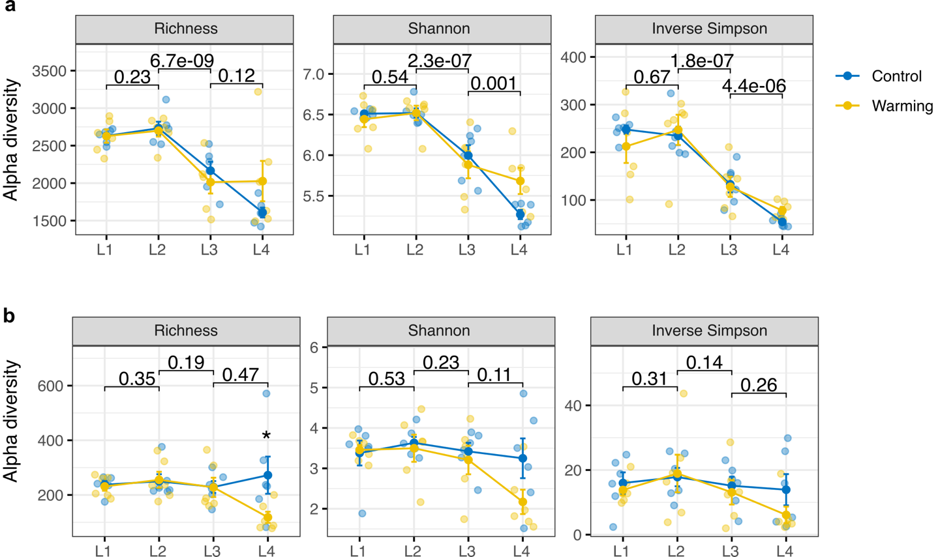

Figure S5. Effects of warming and depths on α-diversity of (a) bacteria and (b) fungi based on lower sequence depths. In a, the sequence depth (i.e., resample size) is 20,000, as compared to the original sequence depth of 34,673 reads per sample. In b, the sequence depth is 5,000, as compared to the original sequence depth of 9,255 reads per sample. Lines represent the mean values, and error bars represent the standard errors. The difference between any two adjacent layers was examined by the linear mixed model, and P-values based on Wald type II χ² tests are indicated on the plot. In each layer, the difference between warming and control was also examined by linear mixed model. P-values are denoted by the asterisks: *** P < 0.001, ** P < 0.010, and * P < 0.050. L1, the surface organic layer; L2, the middle organic layer; L3, the deep organic layer; and L4, the mineral layer.

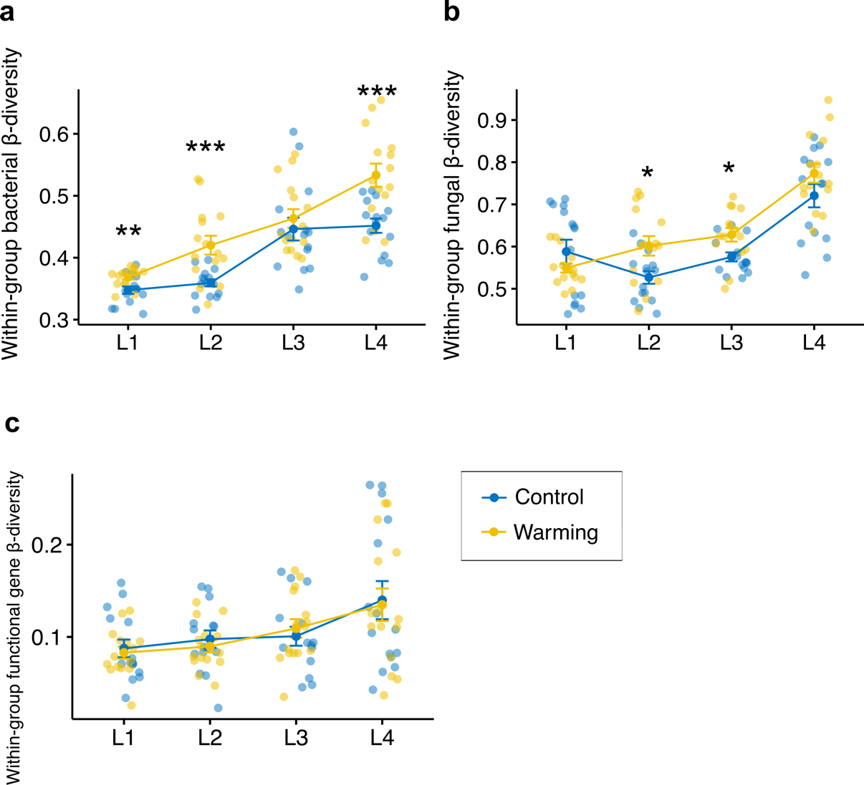

Figure S6. Warming effects on microbial β-diversity. β-diversity was calculated as the Bray-Curtis distance between biological replicates for (a) bacterial, (b) fungal, and (c) functional gene community compositions. In each layer, the difference between warming and control was examined by the linear mixed model, and statistical significance is based on Wald type II χ² tests, denoting as *** P < 0.001, ** P < 0.010, and * P < 0.050. Lines represent the mean values, and error bars represent the standard errors. L1, the surface organic layer; L2, the middle organic layer; L3, the deep organic layer; and L4, the mineral layer.

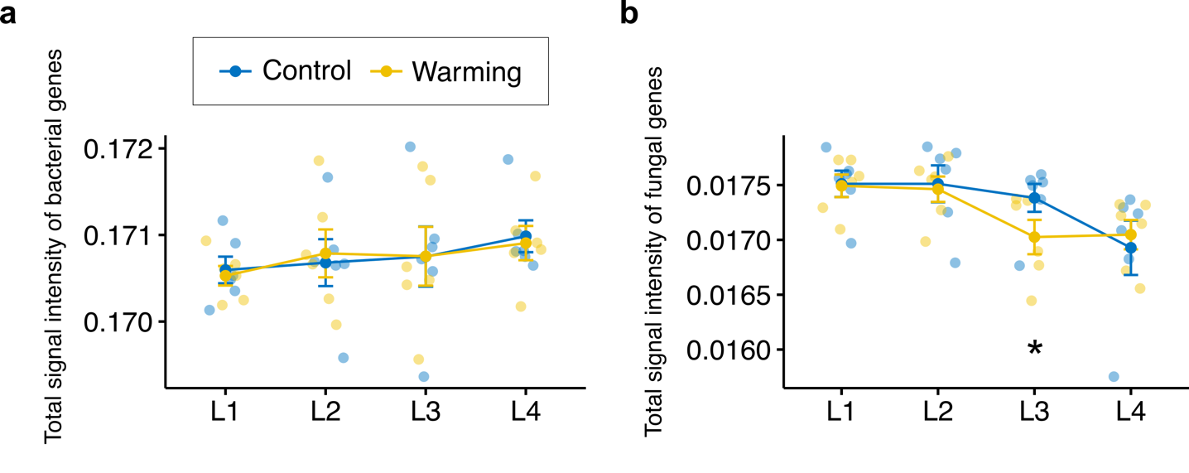

Figure S7. Bacterial and fungal gene signal intensity by GeoChip. a, The total normalized signal intensity of gene probes derived from bacteria. b, The total normalized signal intensity of gene probes derived from fungi. In each layer, the difference between warming and control was examined by the linear mixed model, and statistical significance is based on Wald type II χ² tests, denoting as *** P < 0.001, ** P < 0.010, and * P < 0.050. Lines represent the mean values, and error bars represent the standard errors. L1, the surface organic layer; L2, the middle organic layer; L3, the deep organic layer; and L4, the mineral layer.

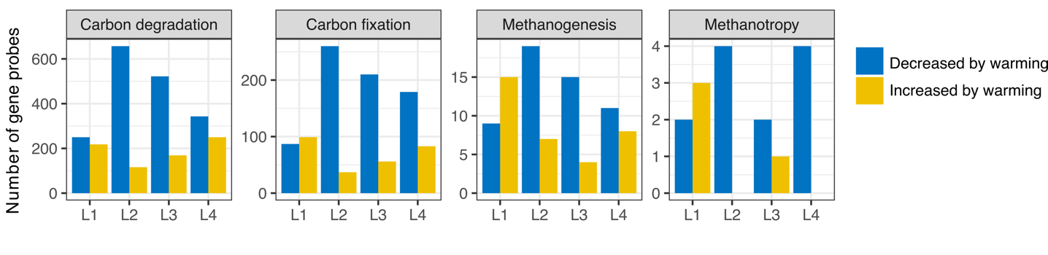

Figure S8. Warming effects on carbon cycling genes revealed by GeoChip. Bars represent the number of gene probes significantly (t-test, P < 0.05) increased or decreased by warming in each layer. L1, the surface organic layer; L2, the middle organic layer; L3, the deep organic layer; and L4, the mineral layer.

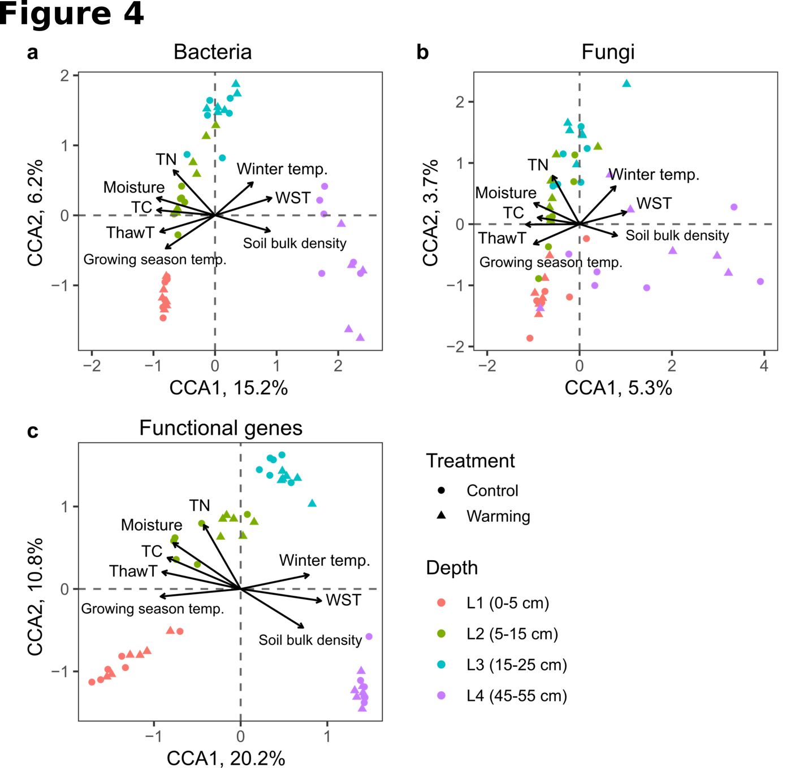
Figure S9. Canonical correspondence analysis (CCA) of microbial communities (circle and triangle symbols) and major environmental factors (arrows). a, Bacterial communities. b, Fungal communities. c, Functional gene compositions. The values in axis 1 and 2 labels are percentages of variations in the microbial community that the axis can explain. Abbreviation: TC, the total carbon content; TN, the total nitrogen content; Moisture, soil volumetric water content; ThawT, duration of soil thawed period in the growing season; Growing season temp., soil temperature of the growing season; Winter temp., winter soil temperature; WST, duration of soil being water-saturated during the growing season.

