**Supplementary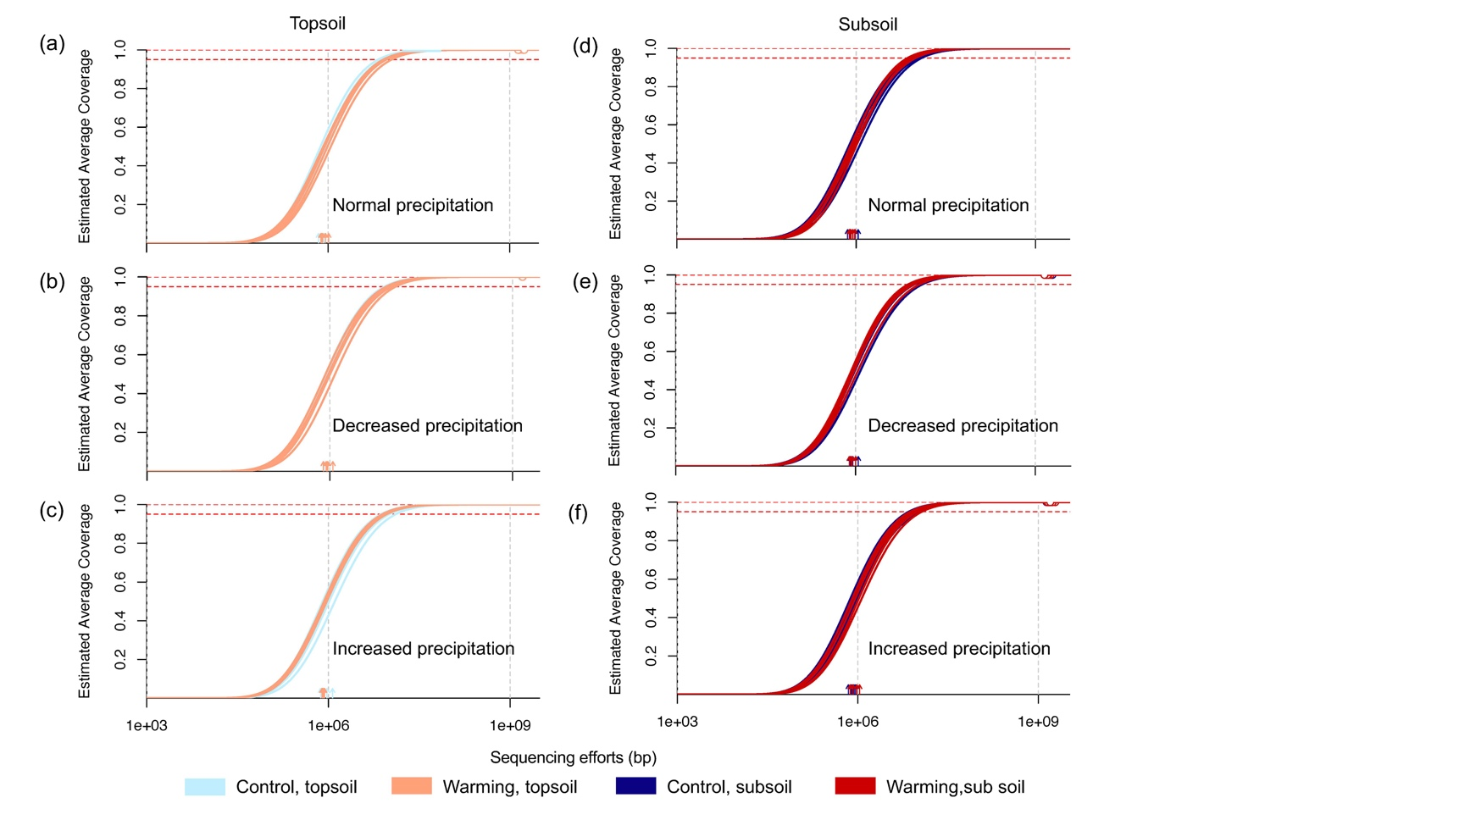 Figures 1-5**

**Supplementary Figure 1. Estimated sequencing coverage determined by Nonpareils.**The sequencing coverage of samples derived from normal precipitation (a), decreased precipitation (b), and increased precipitation (c) in the top soil, and the sequencing coverage of samples derived from normal precipitation (d), decreased precipitation (e), and increased precipitation (f).



**Supplementary Figure 2. Effects of four-years warming on soil respiration.** Error bars represent the standard error of the soil respiration in each treatment. “Decreased precip.”, samples from the decreased precipitation plots; “Increased precip.”, samples from the increased precipitation plots; “Decreased precip.”, samples from the decreased precipitation plots.The *β* and *P* values were calculated to indicate the interactive effects of warming and precipitation alterations on soil respiration by linear mixed-effects models. The *β* represents the regression coefficients of different treatment effects on the corresponding environmental variables in the linear mixed-effects models. The *P* value represents the significance of treatment effects on the corresponding environmental variables.

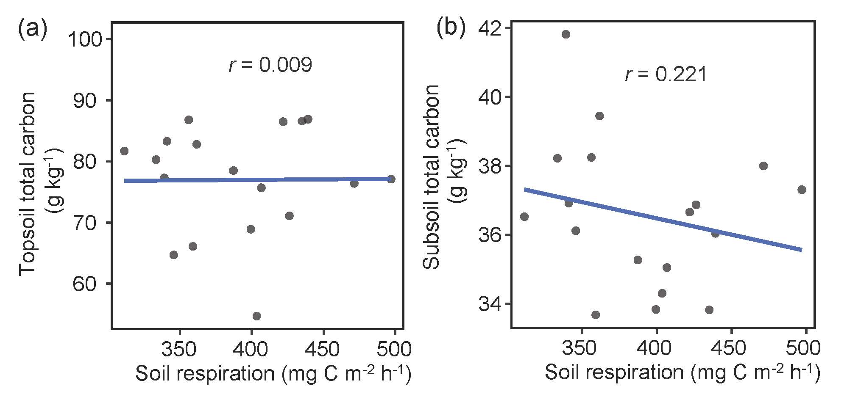

**Supplementary Figure 3. The correlation between soil respiration and total carbon in the topsoil and subsoil.** Pearson correlation was used to calculate the *r* values.

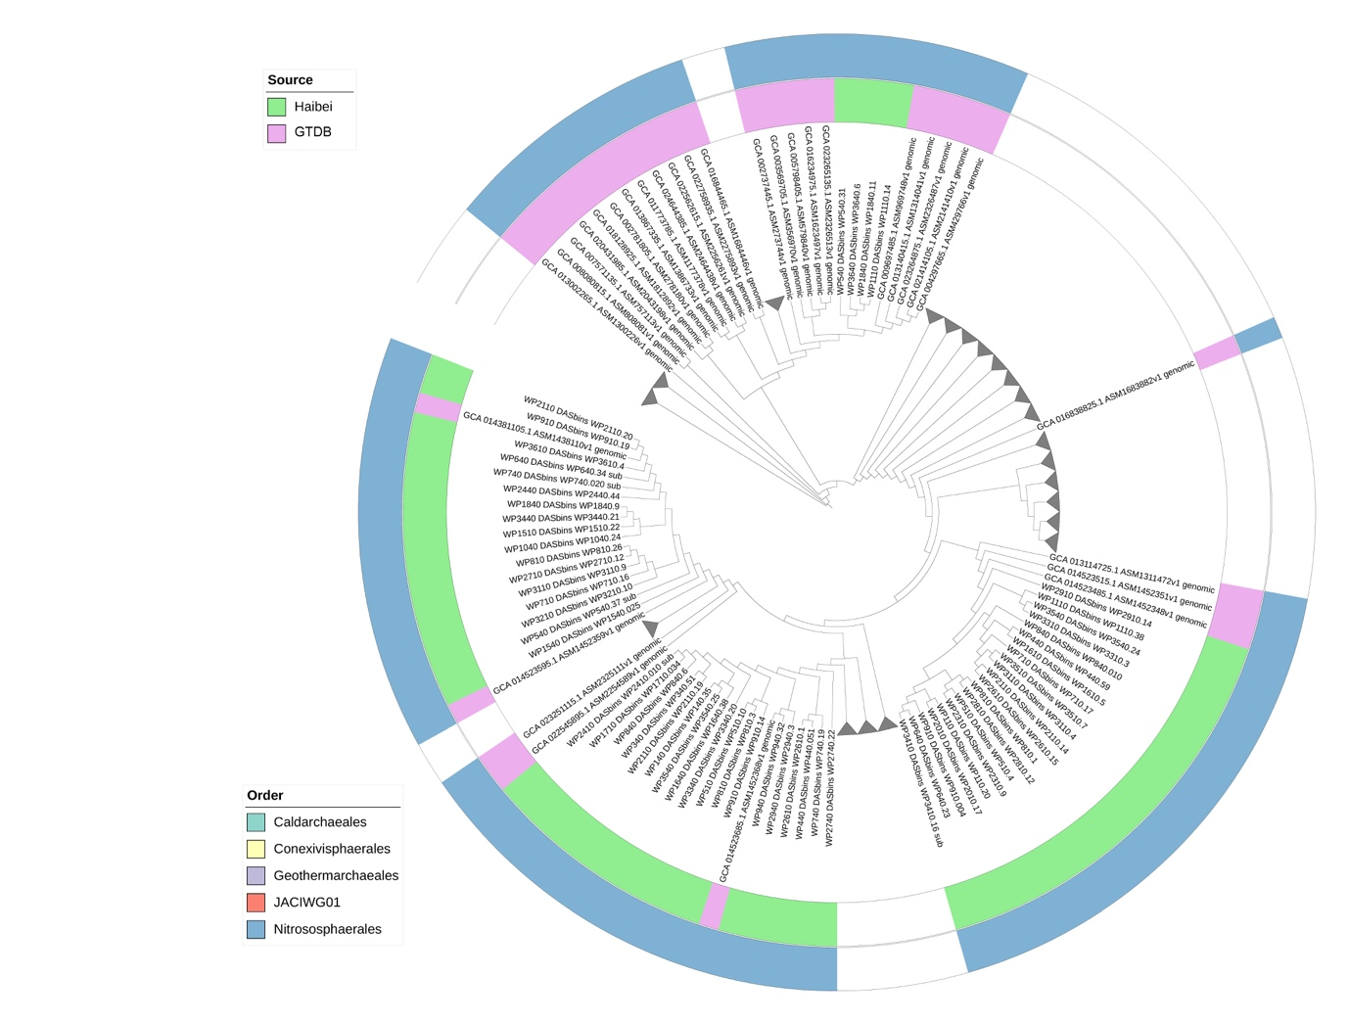

**Supplementary Figure 4. Phylogenetic Trees of Nitrososphaeria MAGs.** Phylogenetic trees encompassing 62 Nitrososphaeria MAGs assembled from Haibei Station samples and 350 representative Nitrososphaerota MAGs from the GTDB database are depicted. The inner circle is color-coded to denote the source of MAGs, distinguishing between MAGs obtained from our study and reference Nitrososphaerota MAGs from the GTDB database. The outer circle is color-coded based on the order information of each MAG. Triangles indicate branches comprising only GTDB database MAGs, which did not show detail branches.

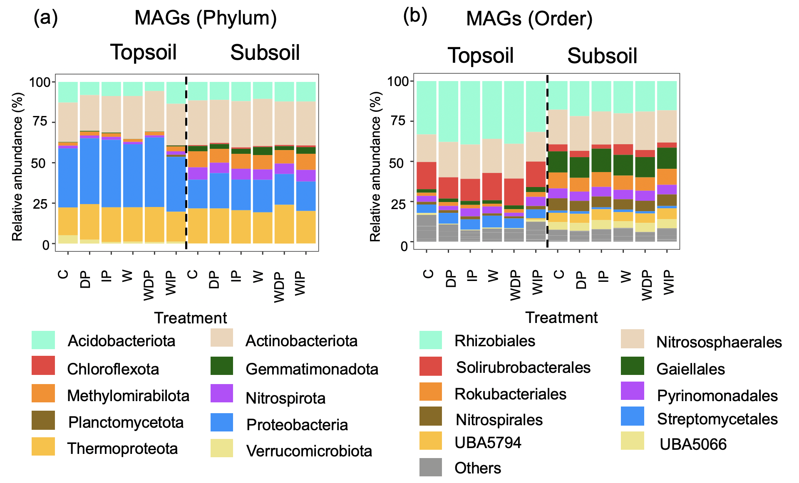

**Supplementary Figure 5. Taxonomic compositions of MAGs at phylum and order Levels.** (a) Taxonomic composition of MAGs at the phylum level. (b) Taxonomic composition of MAGs at the order level. C, control; IP, increased precipitation; DP, decreased precipitation; W, warming; WIP, the combination of warming of increased precipitation; WDP, the combination of warming and decreased precipitation. Colors of the bars are the phylum and order information.