## Supplementary information

### Tables:

Table S1 Names and categories of genes mentioned in this paper and corresponding proteins

|  |  |  |  |
| --- | --- | --- | --- |
| Category | Subcategory | Gene name | Protein name |
| Carbon cycling | Carbon fixation | *pcc* | Propionyl-CoA carboxylase |
| *rubisco* | Ribulose-bisphosphate carboxylase |
| Acetogenesis | *fhs* | Formyltetrahydrofolate synthetase |
| Methane oxidation | *pmoA* | Particulate methane monooxygenase |
| *mmoX* | Methane monooxygenase |
| Methane production | *mcrA* | methyl coenzyme M reductase |
| Carbon degradation | *aceA* | Isocitrate lyase |
| *gox* | Glucose oxidase |
| *lct* | Lactase |
| *gla* | Glucoamylase |
| *pel* | Pectate lyase |
| *pec* | Pectinase |
| *ara* | Alpha-L-arabinofuranosidase |
| *xylA* | Xylose isomerase |
| *egl* | Endoglucanase |
| *nag* | N-acetylglucosaminidase |
| *cda* | Chitin deacetylase |
| *ech* | Endochitinase |
| *exch* | Exochitinase |
| *chs* | Chitin synthase |
| *mep* | Metalloprotease |
| *dpr* | Aspartic protease |
| *cpr* | Cysteine protease |
| *plC* | Phospholipase C |
| *cut* | Cutinase |
| *lip* | Lignin peroxidase |
| *cdh* | Carveol dehydrogenase |
| *cyp101* | Cytochrome P450cam |
| *leh* | Limonene-1,2-epoxide hydrolase |
| Nitrogen cycling | Nitrogen fixation | *nifH* | Nitrogenase |
| Ammonification | *gdh* | Glutamate dehydrogenase |
| *ureC* | Urease |
| Nitrification | *amoA* | Ammonia monooxygenase |
| *hao* | Hydroxylamine oxidoreductase |
| Denitrification | *nar* | Nitrate reductase |
| *narG* | Nitrate reductase (bacterial or archaeal) |
| *nirS* | Cytochrome cd1 nitrite reductase |
| *nirK-D* | Copper-containing nitrite reductase in denitrifier |
| *nirK-N* | Copper-containing nitrite reductase in nitrifier |
| *nor* | Nitric oxide reductase |
| *norB* | Nitric oxide reductase (bacterial and/or archaeal) |
| *P450nor* | Fungal nitric oxide reductase |
| *nosZ* | Nitrous Oxide Reductase |
| Assimilatory N reduction | *nasA* | Assimilatory nitrate reductase |
| *nir* | Assimilatory nitrite reductase |
| Dissimilatory N reduction | *napA* | Periplasmic nitrate reductase |
| *nrfA* | Cytochrome c nitrite reductase |
| Anammox | *hzo* | Hydrazine oxidoreductase |
| Phosphorus utilization |  | *ppk* | Polyphosphate kinase |
| *ppx* | Phosphatase X |
| *phytase* | Phytase |

Table S1 (continued) Names and categories of genes mentioned in this paper and corresponding proteins

|  |  |  |  |
| --- | --- | --- | --- |
| Category | Subcategory | Gene name | Protein name |
| Stress | Nitrogen limitation | *glnR* | Glutamine synthetase transcriptional repressor |
| *tnrA* | Transcriptional regulator (required for nitrogen regulation) |
| *glnA* | Glutamine synthetase |
| Oxygen limitation | *arcB* | Aerobic respiration control sensor histidine protein kinase |
| *cydB* | Cytochrome d ubiquinol oxidase, subunit II |
| *narH* | Nitrate reductase, beta subunit |
| *narI* | Nitrate reductase, gamma subunit |
| *narJ* | Nitrate reductase, delta subunit |
| Oxygen stress | *ahpC* | Alkyl hydroperoxide reductase |
| *ahpF* | Alkyl hydroperoxide reductase, f52a |
| *fnr* | Fumarate/nitrate reduction transcriptional regulator |
| *perR* | Peroxide responsive repressor |
| Phosphate limitation | *phoA* | Alkaline phosphatase |
| *phoB* | Transcriptional regulator for the phosphate regulon |
| *pstS* | Phosphate ABC transporter |
| *pstS-D* | Phosphate ABC transporter in denitrifier |

Table S2 The number of functional genes detected in high (HEA) and low (LEA) N2O emission areas

|  |  |  |  |  |  |  |  |  |  |  |  |  |  |  |  |  |
| --- | --- | --- | --- | --- | --- | --- | --- | --- | --- | --- | --- | --- | --- | --- | --- | --- |
| Gene category | All kingdoms | | | | Archaea | | | | Bacteria | | | | Fungi | | | |
| HEA | LEA | *P* [1] | Ratio [2] | HEA | LEA | *P* | Ratio | HEA | LEA | *P* | Ratio | HEA | LEA | *P* | Ratio |
| Carbon cycling | 7305±514 | 8058±329 | **0.013** | -9.4% | 231±22 | 260±14 | **0.019** | -11.2% | 4645±297 | 5065±189 | **0.015** | -8.3% | 2402±195 | 2702±126 | **0.01** | -11.1% |
| Nitrogen | 4199±277 | 4622±182 | **0.011** | -9.2% | 224±24 | 275±20 | **0.002** | -18.5% | 3840±243 | 4190±156 | **0.014** | -8.4% | 66±3 | 74±2 | **<0.001** | -11.5% |
| Phosphorus | 767±58 | 836±34 | **0.029** | -8.3% | 5±1 | 4±0 | 0.374 | 10.7% | 700±52 | 764±32 | **0.028** | -8.3% | 62±6 | 69±3 | **0.041** | -9.5% |
| Sulphur | 2376±177 | 2596±138 | **0.037** | -8.5% | 45±4 | 50±3 | **0.026** | -10.6% | 2152±155 | 2352±127 | **0.035** | -8.5% | 120±13 | 129±8 | 0.171 | -7.1% |
| Energy process | 504±33 | 554±22 | **0.011** | -9.0% | 6±1 | 5±0 | / | 9.1% | 494±32 | 545±22 | **0.009** | -9.4% | 2±1 | 1±0 | / | 33.3% |
| Stress | 10538±739 | 11624±493 | **0.013** | -9.3% | 293±19 | 319±21 | **0.047** | -8.2% | 10018±702 | 11055±464 | **0.013** | -9.4% | 227±19 | 250±10 | **0.022** | -9.3% |
| Organic Remediation | 10933±543 | 11730±354 | **0.013** | -6.8% | 162±13 | 182±11 | **0.021** | -10.8% | 9838±455 | 10486±292 | **0.015** | -6.2% | 919±75 | 1046±52 | **0.007** | -12.2% |
| Antibiotic resistance | 1710±100 | 1857±62 | **0.012** | -7.9% | 40±3 | 44±2 | **0.028** | -7.7% | 1618±96 | 1757±58 | **0.012** | -7.9% | 32±3 | 34±2 | 0.205 | -5.5% |
| Metal Resistance | 5609±339 | 6101±207 | **0.013** | -8.1% | 125±9 | 141±8 | **0.009** | -11.6% | 5080±295 | 5512±173 | **0.011** | -7.8% | 368±31 | 407±25 | **0.040** | -9.6% |
| Soil borne pathogen | 674±51 | 755±35 | **0.009** | -10.7% | / | / | / | / | 250±17 | 279±15 | **0.012** | -10.3% | 243±17 | 269±11 | **0.011** | -9.6% |
| Virulence | 1888±127 | 2072±83 | **0.014** | -8.9% | 5±0 | 5±0 | / | -3.3% | 1715±114 | 1879±72 | **0.014** | -8.7% | 168±13 | 188±12 | **0.019** | -10.7% |
| Bacteria phage | 386±45 | 455±27 | **0.009** | -15.2% | / | / | / | / | / | / | / | / | / | / | / | / |
| Bioleaching | 394±36 | 442±23 | **0.021** | -10.8% | 137±20 | 163±11 | **0.017** | -16.1% | 244±15 | 264±13 | **0.025** | -7.8% | 14±2 | 15±1 | 0.453 | -5.7% |
| Soil benifit | 2117±132 | 2285±87 | **0.027** | -7.4% | 67±5 | 68±2 | 0.661 | -1.5% | 1386±77 | 1487±50 | **0.022** | -6.8% | 664±51 | 730±36 | **0.027** | -9.0% |
| Others | 1165±95 | 1295±62 | **0.019** | -10.0% | 17±1 | 18±2 | 0.121 | -8.3% | 1145±94 | 1273±61 | **0.019** | -10.0% | / | / | / | / |
| Total | 50281±3239 | 54988±2121 | **0.014** | -8.6% | 1328±117 | 1505±87 | **0.014** | -11.8% | 43026±2625 | 46809±1717 | **0.014** | -8.1% | 5127±416 | 5746±272 | **0.012** | -10.8% |

[1] *P* value of *t*-test. Significant values are in bold. “/” means not applicable.

[2] Ratio= (average number in HEA – average number of LEA)/maximum (average number in HEA, average number of LEA).

[3] Mean ± Standard deviation.

Table S3 Comparison of the percentage of detected genes involved in N cycling process between TSP forest soil and other reported forest soil

|  |  |  |  |  |  |  |  |  |  |  |  |
| --- | --- | --- | --- | --- | --- | --- | --- | --- | --- | --- | --- |
| **Functional process** | **TSP** | **Amazon-F** | **Amazon-S** | **Poland-O** | **Poland-M** | **JH** | **HJ** | **LS** | **GM** | **Total Probes [1]** | |
| Southwest China | Fazenda Nova Vida, Brazil | | Southern Poland | | Shenn ongjia, Southern China | | | |
| Ammonification | **68.6%±3.7%** | 74.8%±2.8% | 73.3%±2.8% | 54.3%±4.0% | 57.9%±3.8% | 56.4%±7.0% | 52.3%±8.7% | 50.8%±7.6% | 57.3%±8.0% | | 735 | |
| Anammox | **56.5%±6.6%** | 53.1%±5.2% | 54.2%±8.6% | 29.2%±2.6% | 31.8%±6.1% | 29.6%±8.1% | 25.4%±7.6% | 22.5%±8.6% | 29.6%±9.7% | | 32 | |
| Assimilatory N reduction | **63.7%±4.1%** | 67.0%±1.7% | 67.0%±3.6% | 49.9%±3.3% | 53.4%±3.3% | 63.5%±8.7% | 58.6%±10.8% | 57.2%±9.1% | 64.0%±10.8% | | 394 | |
| Denitrification | **79.9%±4.2%** | 80.6%±2.3% | 81.8%±4.5% | 59.6%±4.0% | 63.6%±4.3% | 62.8%±8.4% | 58.0%±10.3% | 57.1%±9.3% | 64.2%±10.2% | | 2248 | |
| Dissimilatory N reduction | **65.5%±3.7%** | 68.5%±3.1% | 67.7%±4.7% | 42.2%±3.5% | 45.2%±3.4% | 45.0%±8.1% | 40.3%±10.4% | 38.8%±8.8% | 46.3%±10.6% | | 579 | |
| Nitrification | **56.1%±3.1%** | 57.9%±3.3% | 58.2%±5.4% | 36.8%±2.7% | 39.6%±3.2% | 38.9%±6.6% | 35.9%±7.8% | 34.5%±6.2% | 39.7%±8.0% | | 1238 | |
| N fixation | **67.9%±3.8%** | 73.2%±3.0% | 73.8%±5.2% | 45.7%±4.2% | 49.5%±4.2% | 48.9%±9.6% | 44.3%±10.8% | 43.3%±9.7% | 49.8%±11.2% | | 1220 | |
| **Total** N **cycling** | **68.6%±4.9%** | 72.1%±2.2% | 72.5%±4.5% | 49.7%±3.7% | 53.2%±3.8% | 53.1%±8.0% | 48.8%±9.7% | 47.6%±8.4% | 54.2%±9.7% | | 6446 | |
| Forest type | Subtropical forest | Amazon rain forest | | Scots pine forests | | Deciduous Broadleaved forest | Mixed broadleaf forest | Coniferous forest | Shrubland |
| pH | **3.60±0.2** | 4.4±0.5 | 4.0±0.3 | 4.82±0.57 | 4.31±0.28 | 5.27±0.47 | 5.36±0.31 | 5.07±0.48 | 4.43±0.15 |
| aT (°C) [2] | 18.6 | 25.5 | | 7.5 | 8.2 | 9.5 | 5.9 | 4 | 4.62 |
| Elevation | 510-580 |  |  |  |  | 1784±36 | 2295±31 | 2456~2632 | 2720~2776 |
| Data source |  | http://ieg.ou.edu/4download/ | | GSE59620 | | GSE58433 | | | |

[1] Total number of probes targeting N functional genes in Geochip 4.2.

[2] Annual air temperature.

[3] Mean ± Standard deviation

Table S4 Dissimilarity test of microbial community functional structures between the high and low N2O emission areas by different methods

|  |  |  |  |  |
| --- | --- | --- | --- | --- |
| Dissimilarity method | Distance method | | | |
| Euclidean | Manhattan | Bray-cutis | Binomial |
| MRPP [1] | 156(0.003) | 20160(0.006) | 0.101(0.009) | 5401(0.005) |
| ANOSIM [2] | 0.326(0.014) | 0.339(0.019) | 0.339(0.011) | 0.472(0.003) |
| Adonis [3] | 0.197(0.004) | 0.304(0.005) | 0.304(0.01) | 0.328(0.003) |

[1] Multiple response permutation procedure, a nonparametric procedure that does not depend on assumptions such as normally distributed data or homogeneous variances, but rather depends on the internal variability of the data. Results were presented as “the mean distance (*P* value as significance)” in this row.

[2] Analysis of similarities. Results were presented as “the value of statistic R (*P* value as significance)” in this row.

[3] Non-parametric multivariate analysis of variance (MANOVA) with the adonis function. Results were presented as “the value of statistic R2 (*P* value as significance)” in this row.

Table S5 Gene overlap and uniqueness (red) between different samples from the high (H1~H6) and low (L1~L6) N2O emission areas

|  |  |  |  |  |  |  |  |  |  |  |  |  |
| --- | --- | --- | --- | --- | --- | --- | --- | --- | --- | --- | --- | --- |
| Sample | H1 | H2 | H3 | H4 | H5 | H6 | L1 | L2 | L3 | L4 | L5 | L6 |
| H1 | 0.3% | 84.1% | 89.6% | 84.7% | 82.1% | 77.5% | 89.3% | 85.3% | 89.7% | 83.5% | 90.2% | 86.9% |
| H2 |  | 0.2% | 84.2% | 90.1% | 75.2% | 82.0% | 85.8% | 89.4% | 86.0% | 89.9% | 87.1% | 87.4% |
| H3 |  |  | 0.8% | 84.2% | 80.6% | 77.2% | 91.9% | 85.2% | 93.0% | 83.2% | 90.9% | 89.3% |
| H4 |  |  |  | 0.1% | 74.7% | 81.2% | 86.1% | 88.9% | 86.8% | 89.7% | 88.0% | 87.1% |
| H5 |  |  |  |  | 0.2% | 75.0% | 79.9% | 77.0% | 79.0% | 74.2% | 78.9% | 79.3% |
| H6 |  |  |  |  |  | 0.1% | 77.6% | 81.1% | 77.1% | 82.5% | 78.3% | 79.4% |
| L1 |  |  |  |  |  |  | 0.4% | 87.2% | 93.1% | 85.3% | 91.7% | 90.1% |
| L2 |  |  |  |  |  |  |  | 0.2% | 87.0% | 90.5% | 88.1% | 88.8% |
| L3 |  |  |  |  |  |  |  |  | 1.0% | 85.2% | 92.9% | 90.3% |
| L4 |  |  |  |  |  |  |  |  |  | 0.2% | 86.7% | 86.6% |
| L5 |  |  |  |  |  |  |  |  |  |  | 0.6% | 89.6% |
| L6 |  |  |  |  |  |  |  |  |  |  |  | 0.5% |

Table S6 Alpha diversity index of samples from the high (HEA) and low (LEA) N2O emission areas

|  |  |  |  |
| --- | --- | --- | --- |
| Index | HEA | LEA | *P* (*t*-test) |
| Shannon Index | 10.39±0.07 | 10.47±0.06 | 0.067 |
| Simpson Index | 18879±1328 | 20915±1439 | 0.029 |
| Pielou evenness | 0.9571±0.0030 | 0.9566±0.0021 | 0.755 |
| Simpson evenness | 0.3629±0.0208 | 0.3701±0.0148 | 0.507 |

Table S7 Bacterial, archaeal and fungal gene groups which showed significantly different abundances between high and low N2O emission areas and belong to categories other than carbon, nitrogen cycling, phosphorus utilization and stress response. It is in bold if adjusted *P* <0.05.

| Gene Category | Gene Group [1] | Difference Ratio [2] | *P* [3] | Adjusted *P*[4] | Example Gene [5]  GeneBank ID |
| --- | --- | --- | --- | --- | --- |
| Antibiotic resistance | *B_lactamase_C.Bact* | 4.2% | <0.001 | **0.003** | 111073270 |
| Antibiotic resistance | *Tet.Bact* | 2.8% | 0.033 | 0.110 | 133913367 |
| Antibiotic resistance | *Van.Bact* | -22.7% | 0.004 | **0.021** | 109240377 |
| Antibiotic resistance | *ABC_antibiotic_transporter.Arch* | 11.8% | 0.019 | 0.074 | 239909704 |
| Antibiotic resistance | *ABC_antibiotic_transporter.Fung* | 25.8% | <0.001 | **<0.001** | 212527162 |
| Antibiotic resistance | *MATE_antibiotic.Bact* | -6.0% | 0.002 | **0.016** | 108462023 |
| Antibiotic resistance | *MFS_antibiotic.Bact* | 2.6% | 0.017 | 0.075 | 104781857 |
| Bioleaching | *drug_resistance_transporter.Arch* | 8.4% | 0.032 | 0.137 | 145701890 |
| Bioleaching | *drug_resistance_transporter.Bact* | 9.0% | 0.007 | 0.103 | 146401259 |
| Bioleaching | *acetyl_CoA_carboxylase.Bact* | 7.6% | 0.036 | 0.138 | 146402860 |
| Bioleaching | *biotin_carboxylase.Arch* | 6.1% | 0.046 | 0.142 | 13815768 |
| Bioleaching | *GAPDH.Arch* | 15.0% | 0.019 | 0.126 | 145702665 |
| Bioleaching | *GAPDH.Bact* | 11.4% | 0.020 | 0.126 | 124516461 |
| Bioleaching | *PGK.Arch* | 11.2% | 0.017 | 0.128 | 145702666 |
| Bioleaching | *pyruvate_carboxylase.Bact* | 7.2% | 0.002 | **0.049** | 146403333 |
| Bioleaching | *TIM.Arch* | -43.1% | <0.001 | **<0.001** | 10639456 |
| Bioleaching | *4Fe_4S_ferredoxin.Arch* | -15.3% | 0.024 | 0.110 | 145701216 |
| Bioleaching | *4Fe_4S_ferredoxin.Bact* | 8.0% | 0.049 | 0.146 | 148259363 |
| Bioleaching | *Fe_S_cluster_binding_protein.Bact* | 7.5% | 0.034 | 0.135 | 148261879 |
| Bioleaching | *ferredoxin_I.Bact* | 7.8% | 0.036 | 0.134 | 124516574 |
| Bioleaching | *ADP_heptose_synthase_EPS.Bact* | 9.6% | 0.015 | 0.120 | 124515312 |
| Bioleaching | *capsular_polysaccharide_*  *biosynthesis_protein_EPS.Bact* | 9.3% | 0.044 | 0.143 | 146401890 |
| Bioleaching | *GDP_EPS.Bact* | 9.9% | 0.023 | 0.119 | 148259564 |
| Bioleaching | *NAD_dependent_epimerase_*  *dehydratase_family_protein_EPS.Arch* | 10.1% | 0.014 | 0.127 | 145701469 |
| Bioleaching | *phosphoheptose_isomerase_EPS.Arch* | -100.0% | / | / | 10640131 |
| Bioleaching | *polysaccharide_biosynthesis_protein*  *_EPS.Bact* | 9.7% | 0.019 | 0.132 | 146402959 |
| Bioleaching | *tyrosine_protein_kinase_EPS.Arch* | 8.2% | 0.039 | 0.135 | 146303616 |
| Bioleaching | *tyrosine_protein_kinase_EPS.Bact* | 8.8% | 0.009 | **0.009** | 148261089 |
| Bioleaching | *UDP_glucose_6_dehydrogenase*  *_EPS.Arch* | -100.0% | / | / | 145702822 |
| Bioleaching | *UDS_EPS.Arch* | -100.0% | / | / | 145701206 |
| Bioleaching | *UDS_EPS.Bact* | 7.2% | 0.032 | 0.133 | 148261538 |
| Bioleaching | *UHGNAS_EPS.Bact* | 8.3% | 0.020 | 0.121 | 148261431 |
| Bioleaching | *ferrochelatase.Arch* | 8.0% | 0.007 | 0.088 | 10639454 |
| Bioleaching | *cadmium_resistance_gene.Arch* | -47.0% | 0.015 | 0.127 | 145701933 |
| Bioleaching | *peroxiredoxin.Arch* | -25.0% | 0.039 | 0.138 | 13815558 |
| Bioleaching | *nitrogen_fixation_genes.Bact* | -18.6% | <0.001 | **0.011** | 124515799 |
| Bioleaching | *ABC_transporter_I.Arch* | -8.7% | 0.007 | 0.093 | 145701214 |
| Bioleaching | *ABC_transporter_II.Bact* | -13.6% | 0.009 | 0.098 | 124514233 |
| Bioleaching | *ABC_transporter_IV.Arch* | 54.6% | 0.043 | 0.145 | 10639412 |
| Bioleaching | *ATP_synthase_F1_or_F0.Bact* | 6.5% | 0.049 | 0.144 | 146401095 |
| Bioleaching | *formate_dehydrogenase_family*  *_accessory_protein.Arch* | 9.8% | 0.027 | 0.121 | 146304086 |
| Bioleaching | *gyrB_gene.Arch* | -100.0% | / | / | 126008154 |
| Bioleaching | *gyrB_gene.Bact* | 45.5% | 0.023 | 0.112 | 119369904 |
| Bioleaching | *heat_shock_protein.Arch* | -18.5% | <0.001 | **0.005** | 10640402 |
| Bioleaching | *heat_shock_protein.Bact* | 6.9% | 0.022 | 0.117 | 146400900 |
| Bioleaching | *MPGS.Bact* | 9.9% | 0.023 | 0.114 | 148259564 |
| Bioleaching | *universal_stress_Family_protein_III.Arch* | -17.5% | 0.045 | 0.143 | 145701288 |
| Bioleaching | *related_thiosulfate_gene.Arch* | 26.0% | 0.006 | 0.102 | 146303141 |
| Bioleaching | *related_thiosulfate_gene.Bact* | 7.2% | 0.021 | 0.119 | 112982645 |
| Bioleaching | *sulfate_adenylyltransferase.Arch* | -38.6% | 0.003 | 0.067 | 13816283 |
| Bioleaching | *sulfite_dehydrogenase.Bact* | 9.6% | 0.038 | 0.138 | 146402652 |
| Bioleaching | *thioredoxin.Arch* | -34.6% | <0.001 | **0.011** | 146303415 |
| Energy process | *P450.Arch* | 14.9% | 0.004 | **0.028** | 110669570 |
| Energy process | *P450.Fung* | 35.4% | 0.040 | 0.139 | 149385868 |
| Metal Resistance | *aoxB.Arch* | 8.3% | 0.048 | 0.168 | 116063246 |
| Metal Resistance | *ArsA.Bact* | -12.9% | 0.002 | 0.068 | 114228251 |
| Metal Resistance | *arsA.Fung* | -5.3% | 0.014 | 0.122 | 116198075 |
| Metal Resistance | *arsB.Arch* | 7.8% | 0.034 | 0.162 | 110621602 |
| Metal Resistance | *arsM.Bact* | 11.0% | 0.006 | 0.126 | 110637918 |
| Metal Resistance | *cadBD.Bact* | -10.7% | 0.008 | 0.112 | 116098081 |
| Metal Resistance | *czcA.Bact* | 1.2% | 0.040 | 0.176 | 103488047 |
| Metal Resistance | *czcD.Arch* | -24.5% | 0.012 | 0.134 | 116753644 |
| Metal Resistance | *CopA.Arch* | -4.4% | 0.024 | 0.142 | 10640455 |
| Metal Resistance | *CopA.Bact* | 1.9% | 0.041 | 0.168 | 104780947 |
| Metal Resistance | *CopA.Fung* | 11.3% | 0.010 | 0.122 | 110556603 |
| Metal Resistance | *CusA.Bact* | -4.1% | 0.042 | 0.167 | 108466697 |
| Metal Resistance | *pbrD.Bact* | 8.9% | 0.013 | 0.124 | 56130717 |
| Metal Resistance | *merB.Bact* | 4.5% | 0.047 | 0.170 | 108765846 |
| Metal Resistance | *merF.Bact* | 100.0% | / | / | 194359405 |
| Metal Resistance | *merG.Bact* | 7.3% | 0.039 | 0.178 | 84310709 |
| Metal Resistance | *merP.Arch* | -38.2% | <0.001 | **0.014** | 10640685 |
| Metal Resistance | *merP.Bact* | 6.8% | 0.020 | 0.123 | 108757552 |
| Metal Resistance | *SmtA.Bact* | -18.0% | <0.001 | **0.006** | 104781851 |
| Metal Resistance | *TerC.Bact* | -1.6% | 0.019 | 0.128 | 108758817 |
| Metal Resistance | *TerD.Bact* | -2.6% | 0.031 | 0.159 | 10432467 |
| Metal Resistance | *ZitB.Fung* | -100.0% | / | / | 58577265 |
| Metal Resistance | *ZntA.Bact* | 1.4% | 0.014 | 0.113 | 10176661 |
| Organic Remediation | *arhA.Bact* | 7.0% | 0.014 | 0.110 | 112875704 |
| Organic Remediation | *BADH.Arch* | 7.4% | 0.047 | 0.152 | 10581102 |
| Organic Remediation | *BADH.Bact* | 4.7% | 0.002 | 0.059 | 109900198 |
| Organic Remediation | *badK.Bact* | 7.3% | 0.027 | 0.125 | 39647574 |
| Organic Remediation | *bbs.Bact* | 9.0% | 0.016 | 0.117 | 110831557 |
| Organic Remediation | *bbsG.Bact* | 7.7% | 0.029 | 0.120 | 111222973 |
| Organic Remediation | *benD.Bact* | -6.4% | 0.046 | 0.151 | 104782200 |
| Organic Remediation | *BpH.Fung* | -10.3% | 0.008 | 0.097 | 114190439 |
| Organic Remediation | *bphA.Arch* | -63.3% | 0.002 | 0.059 | 68568424 |
| Organic Remediation | *bphA.Bact* | 4.1% | 0.039 | 0.140 | 10505267 |
| Organic Remediation | *bphB.Fung* | -40.1% | <0.001 | **<0.001** | 145236164 |
| Organic Remediation | *carA.Bact* | 6.8% | 0.049 | 0.151 | 110646643 |
| Organic Remediation | *catB.Fung* | 9.3% | 0.013 | 0.111 | 145239905 |
| Organic Remediation | *Catechol.Bact* | 4.7% | 0.013 | 0.116 | 10440998 |
| Organic Remediation | *Catechol.Fung* | 16.0% | <0.001 | 0.089 | 115397181 |
| Organic Remediation | *cbdA.Bact* | 4.4% | 0.013 | 0.115 | 110819363 |
| Organic Remediation | *CMCI.Bact* | -18.0% | 0.002 | 0.055 | 166861916 |
| Organic Remediation | *cumA.Bact* | 4.9% | 0.003 | 0.052 | 10956842 |
| Organic Remediation | *cumC.Bact* | 7.3% | 0.042 | 0.148 | 193873617 |
| Organic Remediation | *cymC.Bact* | 7.8% | 0.045 | 0.149 | 21220201 |
| Organic Remediation | *ebdABC.Bact* | -8.3% | 0.018 | 0.121 | 56312785 |
| Organic Remediation | *fcbB.Bact* | 7.1% | 0.048 | 0.152 | 112361523 |
| Organic Remediation | *flnB.Bact* | 7.4% | 0.032 | 0.131 | 112821604 |
| Organic Remediation | *GcdB.Arch* | 10.8% | 0.011 | 0.104 | 126015215 |
| Organic Remediation | *GCoADH.Bact* | 1.6% | 0.036 | 0.138 | 10799845 |
| Organic Remediation | *hmgA.Bact* | 4.9% | 0.018 | 0.120 | 104783571 |
| Organic Remediation | *hmgA.Fung* | -8.6% | 0.006 | 0.091 | 111056483 |
| Organic Remediation | *hmgB.Bact* | 3.8% | 0.009 | 0.097 | 104783570 |
| Organic Remediation | *hmgB.Fung* | -7.5% | 0.008 | 0.310 | 114191985 |
| Organic Remediation | *hmgC.Bact* | 2.5% | 0.04 | 0.142 | 108760925 |
| Organic Remediation | *hmgC.Fung* | -9.8% | 0.021 | 0.121 | 115399028 |
| Organic Remediation | *mdlA.Bact* | 2.5% | 0.012 | 0.109 | 100123316 |
| Organic Remediation | *mdlC.Arch* | -14.3% | 0.026 | 0.127 | 10639669 |
| Organic Remediation | *mdlC.Bact* | 4.9% | 0.023 | 0.129 | 108765029 |
| Organic Remediation | *nagG.Bact* | 5.8% | 0.035 | 0.138 | 10956993 |
| Organic Remediation | *nagK.Bact* | 7.1% | 0.025 | 0.127 | 113528879 |
| Organic Remediation | *nahA.Arch* | -63.3% | 0.002 | 0.054 | 68568424 |
| Organic Remediation | *nahA.Bact* | 3.8% | 0.049 | 0.153 | 108798649 |
| Organic Remediation | *nahB.Bact* | 9.3% | 0.027 | 0.124 | 110162116 |
| Organic Remediation | *nbz.Bact* | 10.1% | 0.037 | 0.139 | 110823824 |
| Organic Remediation | *nbzB.Bact* | -17.4% | 0.016 | 0.119 | 118468355 |
| Organic Remediation | *nicdehydr.Arch* | -30.5% | 0.028 | 0.124 | 118690036 |
| Organic Remediation | *nidA.Bact* | 8.8% | 0.022 | 0.131 | 33333865 |
| Organic Remediation | *nitA.Bact* | 4.7% | 0.008 | 0.096 | 1001835 |
| Organic Remediation | *nmoA.Bact* | 3.4% | 0.028 | 0.122 | 104779489 |
| Organic Remediation | *nmoA.Fung* | -19.5% | 0.003 | 0.054 | 115386062 |
| Organic Remediation | *ohbAB.Bact* | 4.1% | 0.036 | 0.137 | 10956988 |
| Organic Remediation | *ophC.Fung* | 8.0% | 0.05 | 0.154 | 145251493 |
| Organic Remediation | *pcpA.Bact* | 15.1% | 0.01 | 0.104 | 113529862 |
| Organic Remediation | *phdJ.Bact* | -7.6% | 0.039 | 0.142 | 120594344 |
| Organic Remediation | *phtA.Bact* | 3.9% | <0.001 | 0.070 | 108462453 |
| Organic Remediation | *phtB.Bact* | 12.7% | <0.001 | **0.016** | 113473905 |
| Organic Remediation | *pimF.Bact* | 2.6% | 0.017 | 0.117 | 104781867 |
| Organic Remediation | *pimF.Fung* | -21.5% | 0.047 | 0.153 | 150866302 |
| Organic Remediation | *tfdA.Bact* | 2.6% | 0.001 | 0.062 | 103486649 |
| Organic Remediation | *tphB.Bact* | 5.9% | 0.028 | 0.120 | 60326841 |
| Organic Remediation | *tutFDG.Arch* | -13.4% | 0.031 | 0.129 | 11499044 |
| Organic Remediation | *tutFDG.Bact* | -3.7% | 0.027 | 0.123 | 106767370 |
| Organic Remediation | *xylJ.Bact* | 5.1% | 0.019 | 0.120 | 110817069 |
| Organic Remediation | *xylXY.Bact* | 7.8% | 0.014 | 0.113 | 111036262 |
| Organic Remediation | *exaA.Bact* | 5.2% | 0.006 | 0.087 | 109454353 |
| Organic Remediation | *rd.Bact* | -6.3% | 0.016 | 0.121 | 109640289 |
| Organic Remediation | *atzA.Arch* | -5.3% | 0.006 | 0.092 | 10580737 |
| Organic Remediation | *mauAB.Bact* | 6.9% | 0.008 | 0.095 | 104781656 |
| Organic Remediation | *pcpE.Arch* | 23.4% | 0.021 | 0.127 | 13815793 |
| Organic Remediation | *pcpE.Bact* | 4.4% | 0.006 | 0.096 | 110824271 |
| Organic Remediation | *pcpE.Fung* | -8.7% | 0.023 | 0.129 | 115390791 |
| Organic Remediation | *phn.Arch* | 9.5% | 0.025 | 0.129 | 109626259 |
| Organic Remediation | *trzA.Arch* | 14.4% | 0.002 | 0.061 | 109625739 |
| Organic Remediation | *trzN.Arch* | 25.0% | 0.005 | 0.097 | 109625740 |
| Organic Remediation | *trzN.Fung* | 8.6% | 0.024 | 0.128 | 146323215 |
| Organic Remediation | *akbA.Bact* | 10.0% | 0.025 | 0.126 | 110825054 |
| Organic Remediation | *cbeA.Bact* | -40.6% | 0.007 | 0.084 | 159147413 |
| Organic Remediation | *ChnD.Bact* | 9.4% | 0.034 | 0.137 | 41058920 |
| Organic Remediation | *cumD.Bact* | 7.5% | 0.026 | 0.125 | 91782285 |
| Organic Remediation | *dbdC.Bact* | 7.6% | 0.029 | 0.121 | 14423343 |
| Organic Remediation | *dbdC.Fung* | 7.3% | 0.043 | 0.146 | 145259288 |
| Organic Remediation | *phdK.Bact* | 9.5% | 0.023 | 0.130 | 2588986 |
| Organic Remediation | *aromatic_peroxygenase.Fung* | 40.2% | 0.009 | 0.098 | 223587960 |
| Organic Remediation | *alkJ.Fung* | -22.3% | 0.015 | 0.115 | 145244078 |
| Organic Remediation | *alkK.Arch* | -10.7% | 0.042 | 0.148 | 109625403 |
| Organic Remediation | *alkK.Fung* | -16.2% | 0.008 | 0.124 | 126094873 |
| Organic Remediation | *ChnA.Bact* | 6.1% | 0.043 | 0.148 | 115254776 |
| Organic Remediation | *ChnA.Fung* | -58.2% | 0.006 | 0.091 | 145236889 |
| Organic Remediation | *cpnA.Bact* | 7.8% | 0.022 | 0.132 | 118170744 |
| Organic Remediation | *cah.Bact* | -31.5% | 0.044 | 0.149 | 197932142 |
| Organic Remediation | *sdsA.Fung* | -27.4% | 0.001 | 0.065 | 134082005 |
| Organic Remediation | *linC.Arch* | 10.3% | 0.017 | 0.117 | 72395481 |
| Organic Remediation | *linC.Bact* | 2.8% | 0.025 | 0.124 | 111149586 |
| Soil_benifit | *pcbC.Fung* | 8.3% | 0.026 | 0.109 | 119478814 |
| Soil_benifit | *sid.Arch* | 9.2% | 0.013 | 0.081 | 16120152 |
| Soil_benifit | *sidA.Fung* | -13.9% | <0.001 | **0.023** | 111057115 |
| Soil_benifit | *vacuolar_iron_transport.Fung* | -9.5% | 0.009 | 0.059 | 115389622 |
| Soil_benifit | *bacA.Bact* | 9.0% | 0.017 | 0.086 | 146404013 |
| Soil_benifit | *pabA.Bact* | -16.1% | <0.001 | **0.015** | 111153621 |
| Soil_benifit | *phzF.Arch* | -22.5% | 0.016 | 0.089 | 19917587 |
| Soil_benifit | *phzF.Bact* | 5.3% | <0.001 | **0.015** | 116672197 |
| Soil_benifit | *prnB.Bact* | 7.4% | 0.044 | 0.160 | 5669520 |
| Soil_benifit | *sod_nickel.Bact* | -8.3% | 0.02 | 0.093 | 113474704 |
| Soil_benifit | *sped.Bact* | 2.3% | 0.035 | 0.139 | 108759872 |
| Soil_benifit | *tre.Arch* | 20.3% | 0.005 | 0.059 | 126179140 |
| Soil_benifit | *tre.Fung* | 3.2% | 0.005 | 0.069 | 115390000 |
| Soil_benifit | *cat.Arch* | 15.7% | 0.008 | 0.062 | 110620746 |
| Soil_borne_pathogen | *actin__Cercozoa.Fung* | -100.0% | / | / | 40647174 |
| Soil_borne_pathogen | *trehalose_synthase_Cercozoa.Fung* | 8.6% | 0.022 | 0.148 | 160332824 |
| Soil_borne_pathogen | *pat1.Bact* | 7.7% | 0.035 | 0.177 | 169157706 |
| Soil_borne_pathogen | *tom.Bact* | 7.7% | 0.03 | 0.143 | 260651577 |
| Soil_borne_pathogen | *enniatin_synthase_Fungi.Fung* | -22.9% | 0.011 | 0.154 | 119501377 |
| Soil_borne_pathogen | *acsC.Bact* | 7.4% | 0.047 | 0.197 | 16118727 |
| Soil_borne_pathogen | *fyuA.Bact* | -12.1% | 0.006 | 0.132 | 119898638 |
| Soil_borne_pathogen | *hasA.Bact* | -22.2% | 0.028 | 0.159 | 122087483 |
| Soil_borne_pathogen | *psn.Bact* | -100.0% | / | / | 307147183 |
| Soil_borne_pathogen | *arp1.Bact* | -43.6% | 0.016 | 0.180 | 45385183 |
| Soil_borne_pathogen | *avrBs2.Bact* | 8.9% | 0.019 | 0.161 | 325535564 |
| Soil_borne_pathogen | *hrpG1.Bact* | -100.0% | / | / | 237799994 |
| Soil_borne_pathogen | *pchB.Bact* | 8.5% | 0.038 | 0.180 | 71733475 |
| Soil_borne_pathogen | *pchG.Bact* | 8.1% | 0.049 | 0.198 | 52212038 |
| Soil_borne_pathogen | *xcpY.Bact* | 7.8% | 0.038 | 0.176 | 3978486 |
| Soil_borne_pathogen | *serine_protease_inhibitor*  *_Oomycetes.Fung* | -7.1% | 0.025 | 0.150 | 225580012 |
| Soil_borne_pathogen | *igaA.Bact* | -4.8% | 0.023 | 0.149 | 123444158 |
| Soil_borne_pathogen | *avrBs1.Bact* | 8.8% | 0.003 | 0.115 | 120589311 |
| Soil_borne_pathogen | *esaT6.Bact* | 7.8% | 0.049 | 0.193 | 119953925 |
| Soil_borne_pathogen | *hopAF1.Bact* | -28.1% | <0.001 | **0.031** | 120588524 |
| Soil_borne_pathogen | *hrpP.Bact* | 7.0% | 0.03 | 0.159 | 256259400 |
| Soil_borne_pathogen | *ptlB.Bact* | 100.0% | / | / | 188991080 |
| Soil_borne_pathogen | *yopN.Bact* | -55.1% | 0.017 | 0.165 | 262284530 |
| Soil_borne_pathogen | *txtA.Bact* | 7.9% | 0.019 | 0.150 | 260647178 |
| Sulphur | *AprA.Bact* | 3.5% | 0.024 | 0.202 | 151302120 |
| Sulphur | *sir.Arch* | -100.0% | / | / | 70607910 |
| Sulphur | *PAPS_reductase.Fung* | 9.0% | 0.015 | 0.366 | 116193649 |
| Sulphur | *sulfate_transporter.Fung* | -6.8% | 0.015 | 0.189 | 115388485 |
| Sulphur | *sox.Bact* | 2.4% | 0.029 | 0.180 | 109454940 |
| Virulence | *iuc.Bact* | -13.4% | <0.001 | **0.003** | 114317214 |
| Virulence | *iuc.Fung* | 7.7% | 0.021 | 0.074 | 189191346 |
| Virulence | *cap.Bact* | 6.7% | <0.001 | **0.001** | 110168569 |
| Virulence | *hly.Bact* | -1.8% | 0.001 | **0.017** | 10175486 |
| Virulence | *inv.Bact* | -6.3% | 0.003 | **0.023** | 118569258 |
| Virulence | *iro.Arch* | 8.1% | 0.038 | 0.096 | 167728638 |
| Virulence | *iro.Bact* | 3.7% | 0.004 | **0.021** | 104781490 |
| Virulence | *cad.Bact* | -35.0% | 0.042 | **0.098** | 34482364 |
| Virulence | *tcf.Bact* | 8.8% | 0.037 | 0.100 | 282766125 |
| Virulence | *type_III_secretion.Bact* | 3.2% | 0.048 | 0.106 | 108461025 |
| Virulence | *srt.Bact* | -4.9% | 0.012 | **0.047** | 104774195 |
| Virulence | *aflatoxin_aflL.Fung* | -37.5% | 0.003 | **0.027** | 145228407 |
| Virulence | *ochratoxin_PKS.Fung* | -21.6% | 0.004 | **0.021** | 189200292 |
| Virulence | *toxin.Bact* | -13.7% | 0.007 | **0.029** | 118475290 |
| Virulence | *conidial_laccase.Fung* | 22.8% | 0.030 | 0.089 | 119482403 |
| Virulence | *phospholipase_B.Fung* | -5.0% | 0.030 | 0.095 | 115397827 |

[1] Gene group names are in the format of “gene family name.kingdom abbreviation”, in which “Arch”, “Bact” and “Fung” represent Archaea, Bacteria and Fungi.

[2] Difference Ratio= (average number in HEA - average number of LEA)/maximum (average number in HEA, average number of LEA). HEA is high N2O emission area and LEA is low N2O emission area.

[3] *P* value of t-test. “/” means not applicable.

[4] *P* value was adjusted by FDR strategy.

[5] An example gene was randomly selected from the certain gene group.

Table S8 *P* values of the gene groups involved in Figure 2

| Gene category | Gene family[1] | *P* value | Adjusted *P* value |
| --- | --- | --- | --- |
| Carbon cycling | *pcc_Bact* | 0.012 | 0.042 |
| *rubisco_Arch* | 0.009 | 0.033 |
| *FTHFS_Bact* | <0.001 | 0.003 |
| *pmoA_Bact* | 0.003 | 0.016 |
| *AceA_Arch* | 0.007 | 0.028 |
| *Glucose_oxidase_Fung* | <0.001 | 0.006 |
| *lactase_Fung* | <0.001 | <0.001 |
| *glucoamylase_Fung* | 0.001 | 0.006 |
| *pec_CDeg_Fung* | <0.001 | <0.001 |
| *pectinase_Fung* | 0.003 | 0.016 |
| *ara_Arch* | <0.001 | 0.002 |
| *xylA_Fung* | 0.008 | 0.031 |
| *endoglucanase_Bact* | <0.001 | <0.001 |
| *endoglucanase_Fung* | <0.001 | <0.001 |
| *acetylglucosaminidase_Arch* | <0.001 | 0.001 |
| *chitin_deacetylase_Fung* | <0.001 | <0.001 |
| *endochitinase_Arch* | 0.012 | 0.043 |
| *exochitinase_Bact* | 0.024 | 0.078 |
| *chitin_synthase_Fung* | <0.001 | <0.001 |
| *metalloprotease_Fung* | 0.012 | 0.042 |
| *protease_aspartate_Fung* | <0.001 | <0.001 |
| *protease_cysteine_Fung* | <0.001 | 0.003 |
| *phospholipase_C_Fung* | <0.001 | 0.003 |
| *cutinase_Fung* | <0.001 | <0.001 |
| *lip_Fung* | <0.001 | 0.002 |
| *CDH_Bact* | <0.001 | <0.001 |
| *camDCAB_Bact* | 0.005 | 0.024 |
| *limEH_Bact* | 0.006 | 0.027 |
| Nitrogen cycling | *nifH.Arch* | 0.045 | 0.103 |
| *nifH.Bact* | 0.737 | 0.802 |
| *gdh.Arch* | 0.570 | 0.680 |
| *gdh.Bact* | 0.009 | 0.038 |
| *gdh.Fung* | 0.092 | 0.180 |
| *ureC.Arch* | 0.135 | 0.250 |
| *ureC.Bact* | 0.007 | 0.031 |
| *ureC.Fung* | 0.164 | 0.290 |
| *amoA.Arch* | <0.001 | 0.007 |
| *amoA.Bact* | 0.003 | 0.024 |
| *hao.Bact* | 0.001 | 0.015 |
| *nar.Arch* | 0.007 | 0.034 |
| *nar.Bact* | 0.030 | 0.086 |
| *nar.Fung* | <0.001 | 0.012 |
| *nirS.Bact* | 0.005 | 0.033 |
| *nirK_D.Bact* | 0.012 | 0.045 |
| *nirK_D.Fung* | 0.631 | 0.729 |
| *nirK_N.Arch* | 0.009 | 0.044 |
| *nirK_N.Bact* | 0.186 | 0.313 |
| *nor.Arch* | 0.049 | 0.127 |
| *nor.Bact* | 0.042 | 0.110 |
| *nor.Fung* | 0.002 | 0.018 |
| *nosZ.Arch* | 0.281 | 0.434 |
| *nosZ.Bact* | 0.255 | 0.410 |
| *nasA.Arch* | 0.904 | 0.929 |
| *nasA.Bact* | 0.503 | 0.642 |
| *Nir.Arch* | 0.343 | 0.470 |
| *Nir.Bact* | 0.979 | 0.979 |
| *napA.Bact* | 0.548 | 0.676 |
| *nrfA.Bact* | 0.049 | 0.125 |
| *hzo.Bact* | 0.716 | 0.803 |
| Phosphorus utilization | *Bacterial ppk* | 0.031 | 0.031 |
| *Bacterial ppk-D* | 0.022 | 0.024 |
| *Synechocystis sp. PCC 6803* | 0.007 | 0.013 |
| *Gramella forsetii KT0803* | 0.004 | 0.012 |
| *Sorangium cellulosum* | <0.001 | 0.001 |
| *Pseudovibrio sp. JE062* | <0.001 | <0.001 |
| *Gemmatimonas aurantiaca T-27* | <0.001 | <0.001 |
| *Chromobacterium violaceum* | 0.018 | 0.025 |
| *Azoarcus sp. EbN1* | 0.005 | 0.011 |
| *Pseudomonas fluorescens Pf-5* | 0.015 | 0.023 |
| *Rhizobium etli CFN 42* | 0.020 | 0.025 |
| Stress response | *glnR.Bact* | 0.002 | 0.005 |
| *tnrA.Bact* | 0.038 | 0.043 |
| *glnA.Bact* | 0.006 | 0.011 |
| *glnA.Arch* | <0.001 | 0.001 |
| *arcA.Bact* | 0.005 | 0.011 |
| *arcB.Bact* | 0.002 | 0.005 |
| *cydB.Bact* | <0.001 | <0.001 |
| *narH.Arch* | 0.006 | 0.011 |
| *narI.Bact* | <0.001 | <0.001 |
| *narJ.Bact* | <0.001 | <0.001 |
| *ahpC.Bact* | 0.017 | 0.024 |
| *ahpF.Bact* | <0.001 | 0.002 |
| *fnr.Bact* | 0.018 | 0.023 |
| *perR.Bact* | <0.001 | <0.001 |
| *phoA.Bact* | <0.001 | 0.001 |
| *phoB.Bact* | 0.011 | 0.018 |
| *pstS.Bact* | <0.001 | <0.001 |

[1] Gene family names are in the format of “gene family name.kingdom abbreviation”, in which “Arch”, “Bact” and “Fung” represent Archaea, Bacteria and Fungi.

### Figures:



Figure S1 (a) Location of Tieshanping (TSP) in China, (b) contour map of the site with high N2O emission area (HEA) and low N2O emission area (LEA), (c) sampling spots (black circles) distribution in HEA and LEA (d) sub-spots (black dots) distribution in each spot.

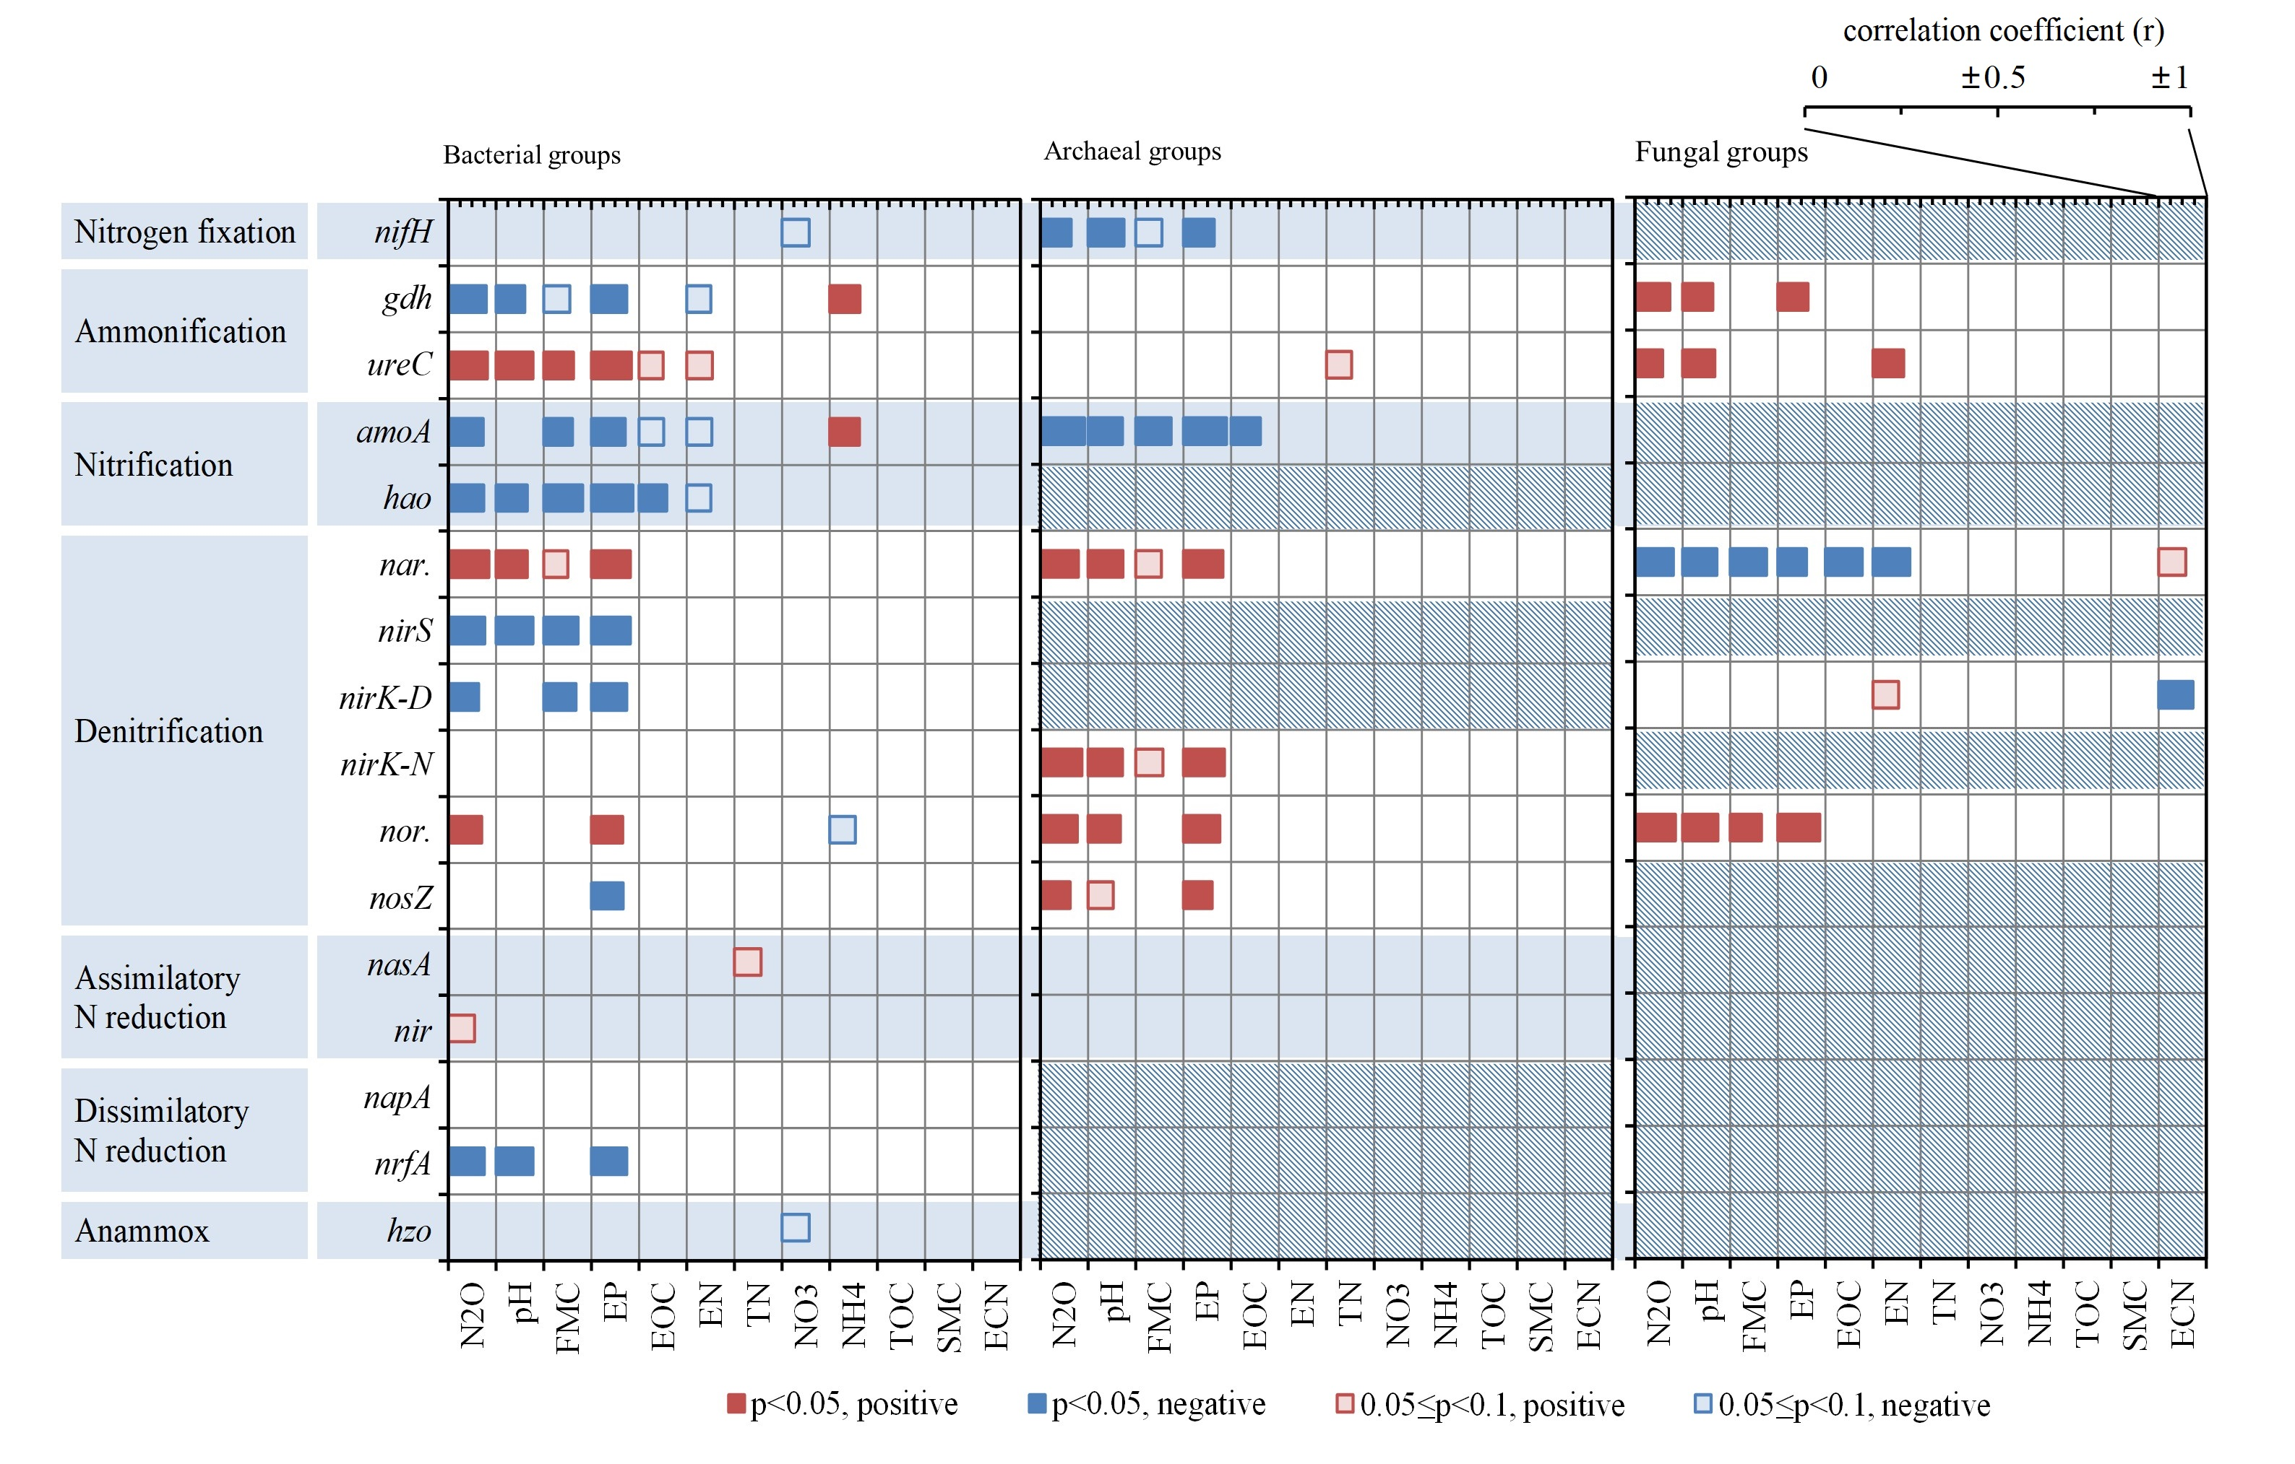

Figure S2 Pearson correlation coefficients between N cycling gene groups (bacterial, archaeal and fungal groups) and geochemical properties, as well as N2O emission rates. Red, positive correlation; blue, negative correlation; relative dark color bars, *P*<0.05; light color bars, 0.05≤*P*<0.1. Diagonal boxes, gene groups not targeted by GeoChip 4. Full names of abbreviated properties are the same as Figure S3. Description of the genes is in Table S1.

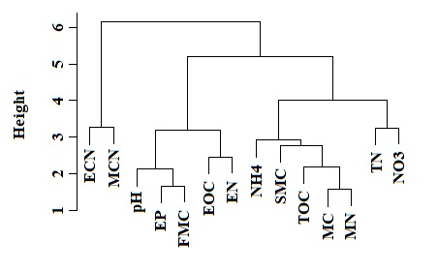

Figure S3 Hierarchical cluster analysis of geochemical properties and biomass in soil samples. EP, extractable phosphorus. EOC, extractable organic carbon. EN, extractable nitrogen. TN, total nitrogen. NO3, nitrate. NH4, ammonium. TOC, organic carbon. SMC, saturation moisture capacity. FMC, field moisture content. ECN, extractable carbon/nitrogen ratio. MC, microbial biomass carbon. MN, microbial biomass nitrogen. MCN, microbial biomass carbon/nitrogen ratio.

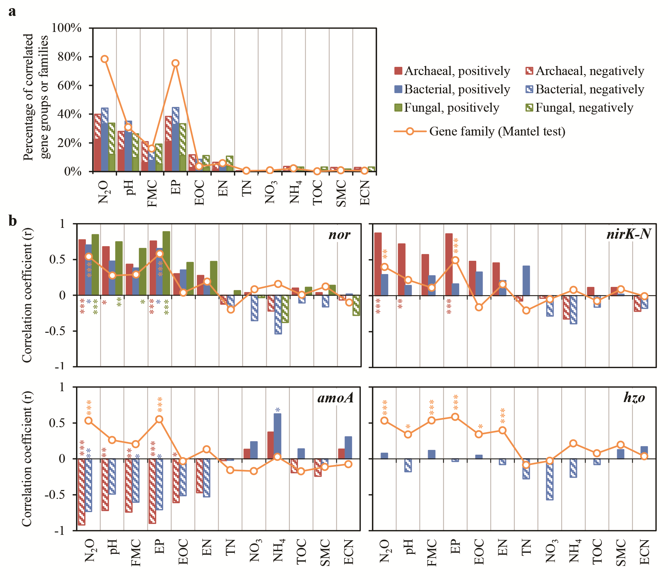

Figure S4 Percentage of gene families (line) or groups (columns) significantly (*P*<0.05) correlated with N2O emission rates or different geochemical properties. Orange lines with circles, values about gene families according to Mantel test. Columns, values about gene groups according to Pearson correlation test. Red, archaeal gene groups; blue, bacterial gene groups; green, fungal gene groups. Filled columns, positively; diagonal columns, negatively. *, *P*<0.05; **, *P*<0.01; ***, *P*<0.005. FMC, field moisture content. EP, extractable phosphorus. EOC, extractable organic carbon. EN, extractable nitrogen. TN, total nitrogen. NO3, nitrate. NH4, ammonium. TOC, organic carbon. SMC, saturation moisture capacity. ECN, extractable carbon/nitrogen ratio.

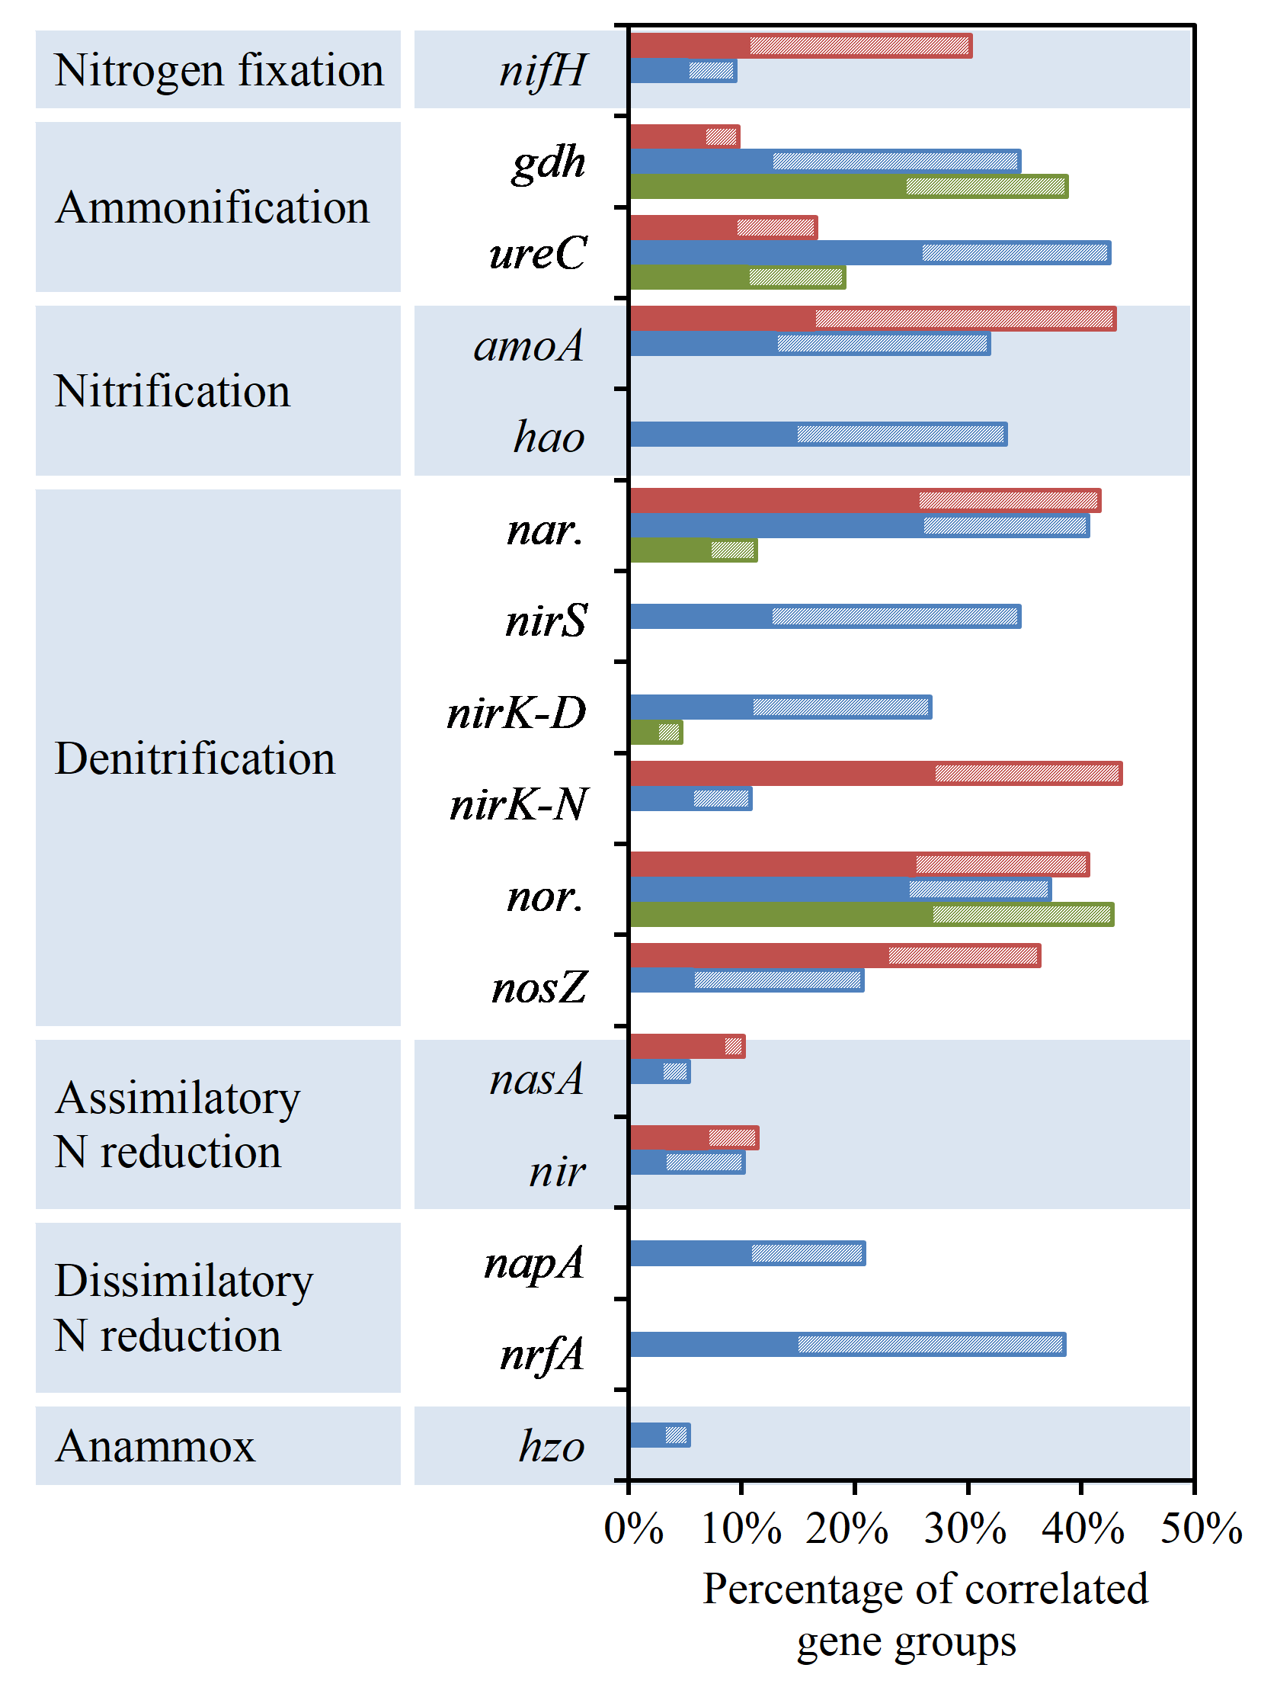

Figure S5 Percentage of gene groups significantly (*P*<0.05, Pearson correlation test) correlated with different N cycling gene groups. Close bars, positive correlation; diagonal bars, negative correlation. Red, archaeal gene group; Blue, bacterial gene group; green, fungal gene group. No bar in a position means the gene group not targeted by GeoChip 4. Description of the genes is in Table S1.

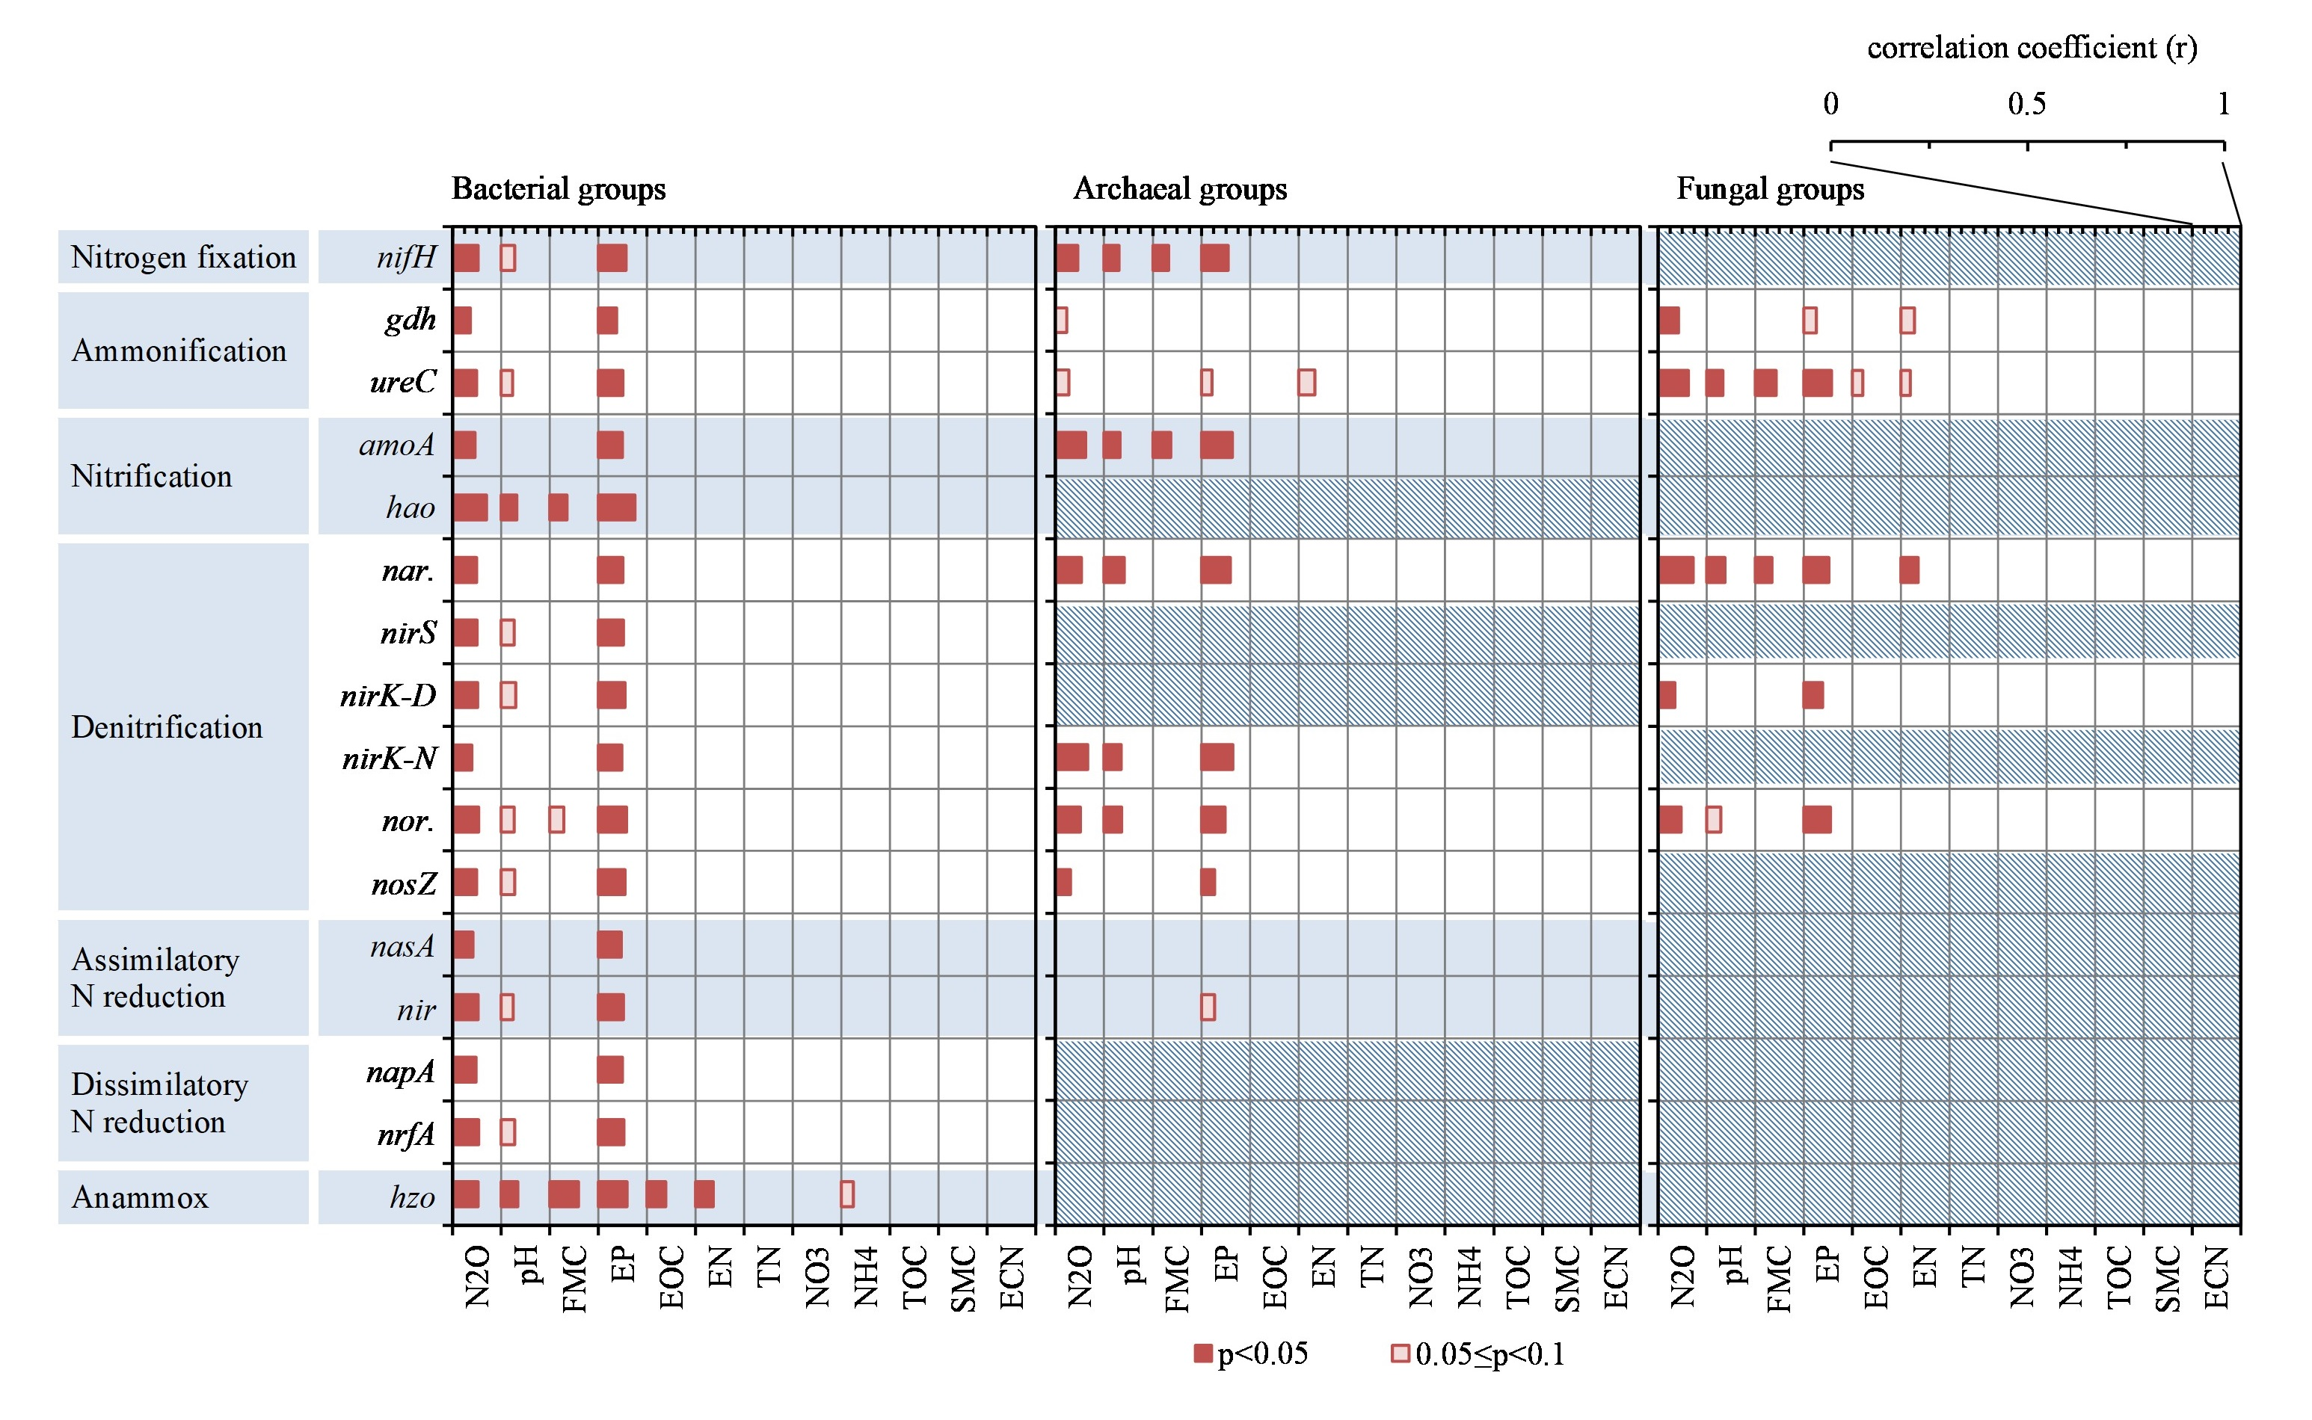

Figure S6 Correlation coefficients of Mantel test between N cycling gene groups (bacterial, archaeal and fungal groups) and geochemical properties, as well as N2O emission rates. Relative dark color bars, *P*<0.05; light color bars, 0.05≤*P*<0.1. Gray boxs indicated gene groups not targeted by GeoChip 4. Diagonal boxes, gene groups not targeted by GeoChip 4. Full names of abbreviated properties are the same as Figure S3. Description of the genes is in Table S1.