Supplementary results
Co-occurrence Network properties, null model analyses and subnetworks
A total of 3,802 OTUs were selected for network construction for their presenting in 11 or more samples. A minimum threshold of ρ=0.74 was determined for co-occurrence network construction by the RMT algorithm. The inferred consensus network consisted of 1,251 OTUs, including 1,065 16S OTUs, 127 nifH OTUs and 59 ITS OTUs. The degree distribution of the constructed network was well fit by a power law model (y = 1202x^{-1.702}, R² = 0.894, where y is the number of nodes with x connectivity), suggesting that the microbial co-occurrence network exhibited scale-free behavior. A total of 76 modules could be found by the greedy modularity optimization algorithm with modularity of 0.848. Among these, 21 modules were composed of 5 or more nodes. To evaluate whether the constructed consensus co-occurrence network was significantly different from random networks, a one-sample t-test was performed to statistically examine the differences between experimental network properties and null models. All parameters analyzed were significantly different (P < 0.0001), including average clustering coefficient (0.415 vs. 0.018±0.002), average geodesic distance (8.571 vs. 3.655±0.041), centralization of betweenness (0.133 vs. 0.042±0.003), and modularity (0.848 vs. 0.350±0.003). This suggested that the constructed microbial co-occurrence network followed basic social network behaviors such as scale-free, small-world and modular, and was significantly different from random networks.
A total of 4,922 co-occurrence relationships were inferred for the consensus microbial network (Fig. 1A). Co-occurrence patterns were dominated by Proteobacteria (34.7%), Acidobacteria (23.8%), Actinobacteria (11.5%), Verrucomicrobia (9.3%), Planctomycetes (5.2%), Bacteroidetes (5.0%), and Ascomycota (3.3%) when viewed by nodes. We also examined the sub-network representing diazotrophic-microbial and fungal-microbial co-occurrence patterns by extracting the first neighbor nodes of nifH and ITS OTUs, respectively. The diazotrophic-microbial network was mainly centered by nifH OTUs belonging to Proteobacteria and Cyanobacteria (Fig. 1B). The microbial phyla co-occurred with diazotrophic species were mainly Proteobacteria (25.7%), Acidobacteria (22.3%), Planctomycetes (13.2%), Verrucomicrobia (10.9%), Actinobacteria (8.3%), and Ascomycota (8.7%). For the fungal-microbial network (Fig. 1C), the microbial phyla co-occurred with fungi were Proteobacteria (46.4%), Acidobacteria (22.9%), Actinobacteria (11.4%), Verrucomicrobia (6.0%), Planctomycetes (6.0%), and Bacteroidetes (4.2%). Thus, different co-occurrence patterns were established by diazotrophic species and fungal species.

Supplementary figures
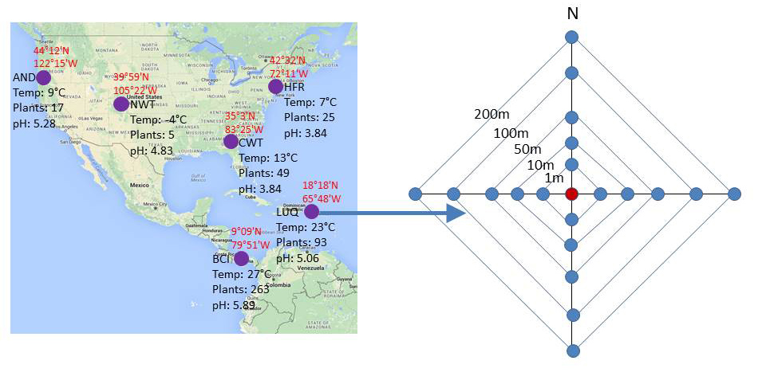

Fig. S1. The location of six forest ecosystems selected in this study (left) and the nested sampling design (right) implemented for sample collection in each site.

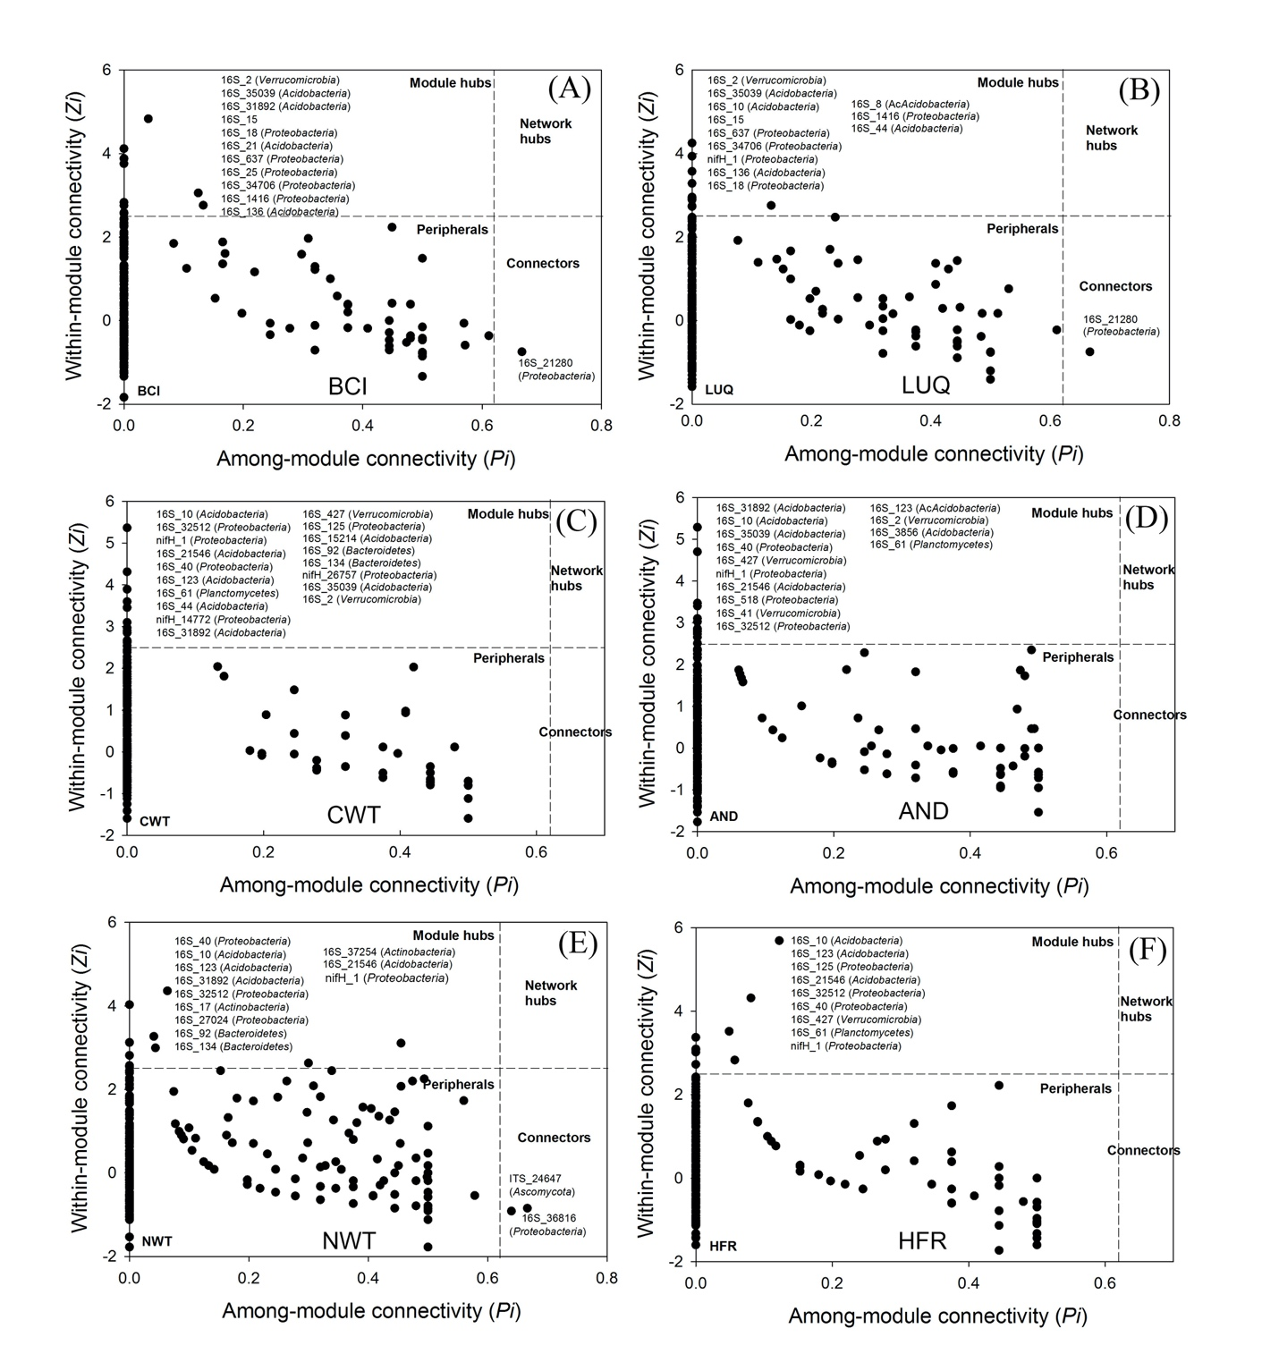
Fig. S2. Z-P plot showing the distribution of OTUs based on their topological roles: (A) BCI forest, (B) LUQ LTER, (C) CWT LTER, (D) AND LTER, (E) NWT LTER, and (F) HFR LTER. Each plot was divided in to four different regions based on cutoffs of Z_{i} = 2.5 and P_{i} = 0.62. Nodes falling in different regions have different functions.

