Supplementary materials
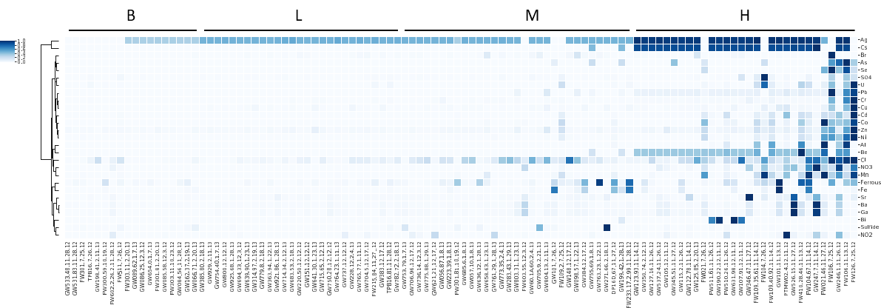Figure S1. Heatmap showing the profile of contaminants in the background (B), low (L), mediate (M) and high (H) contamination wells. The concentrations of each contaminant were scaled linearly [(X-min)/max] to 0-1 for comparison.

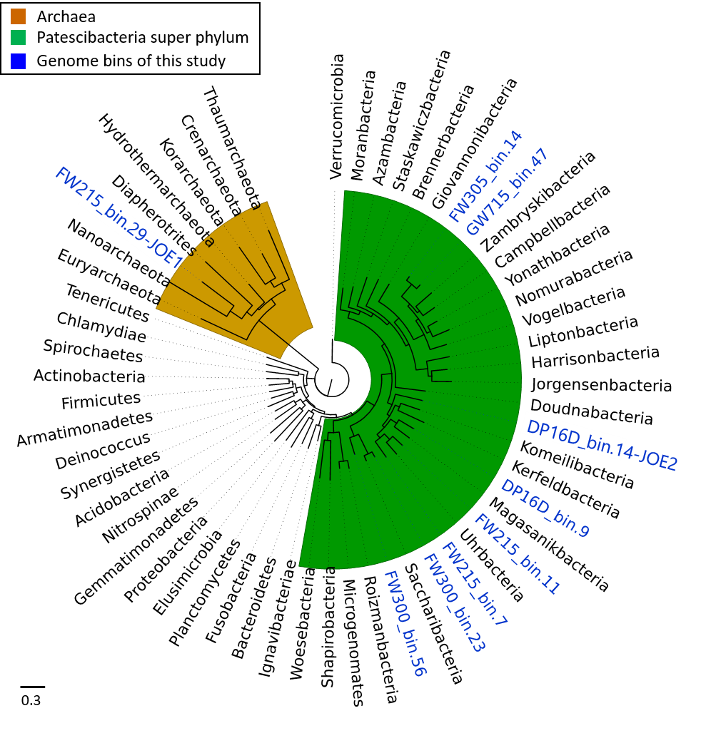
Figure S2. Maximum Likelihood (ML) tree of well-established bacterial and archaeal phyla, Patescibacteria superphylum and Candidate phyla of this study based on concatenated rp16 genes.

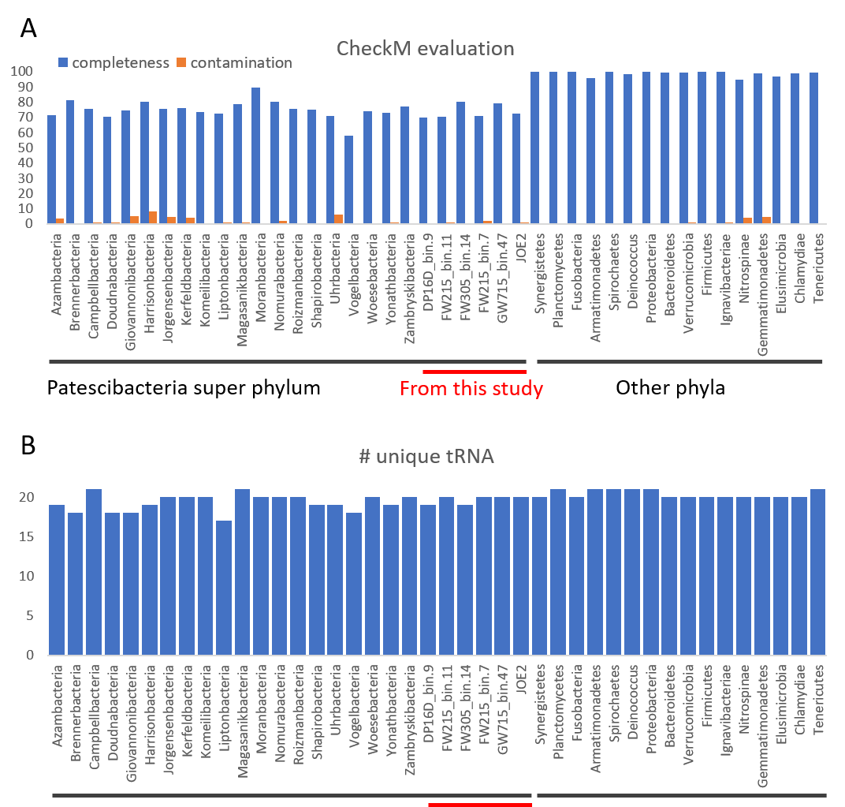
Figure S3. Completeness evaluation of genome bins based on CheckM analysis (A) and number of unique tRNA genes (B).
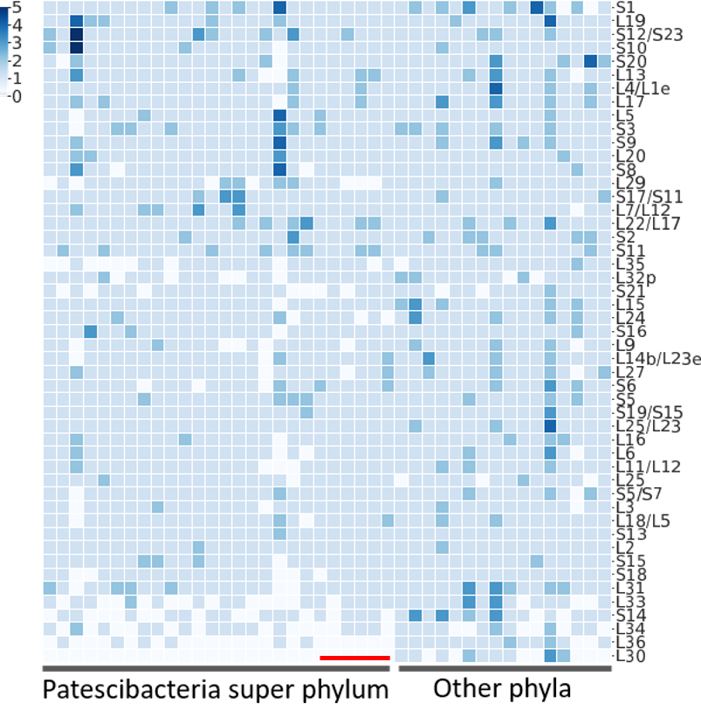
Figure S4. Comparison of ribosomal protein genes in the Patescibacteria superphylum and the other phyla.

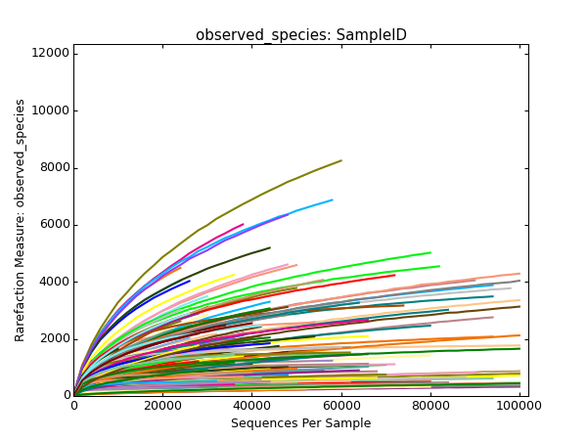
Figure S5. The rarefaction curve of the sequences showing the diversity index of observed OTUs and Shannon. The curves were based on calculation of diversity with step size of 2000 and iteration number of 10.

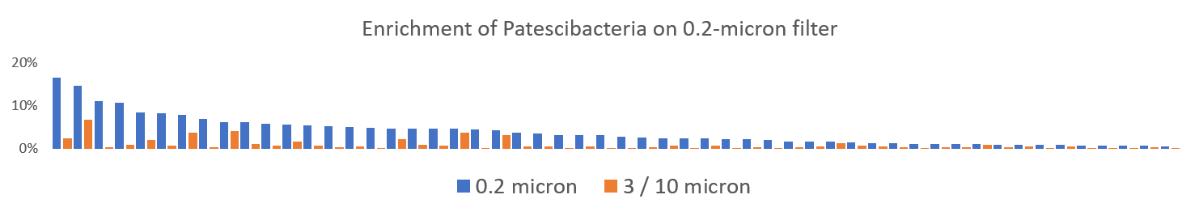
Figure S6 The enrichment of Patescibacteria cells on the 0.2-micron filter in comparison to the 10 or 3 micron filter (showing 108 sample with Patescibacteria abundance >0.5% in 0.2-micron filter).

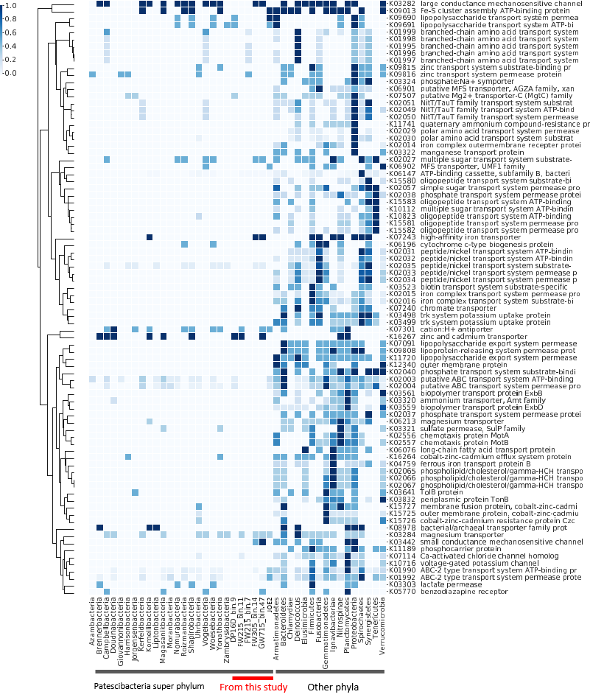
Figure S7. Comparison of transporter proteins in the superphylum Patescibacteria and other phyla.

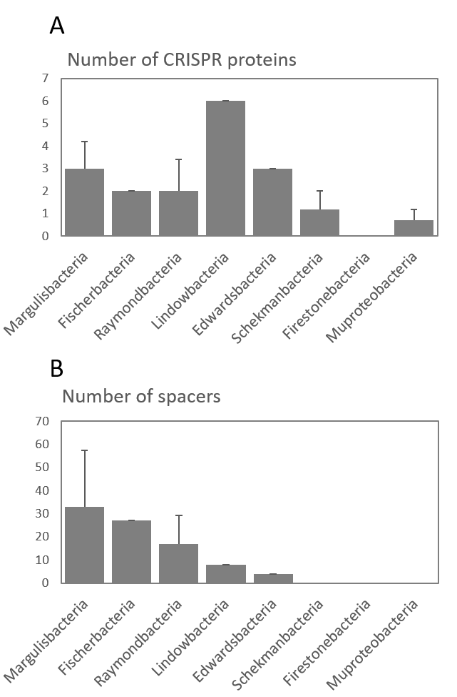
Figure S8. Number of CRISPR proteins (A) and CRISPR spacers (B) in the non-Patescibacteria phyla of Jillian Banfield’s binning.

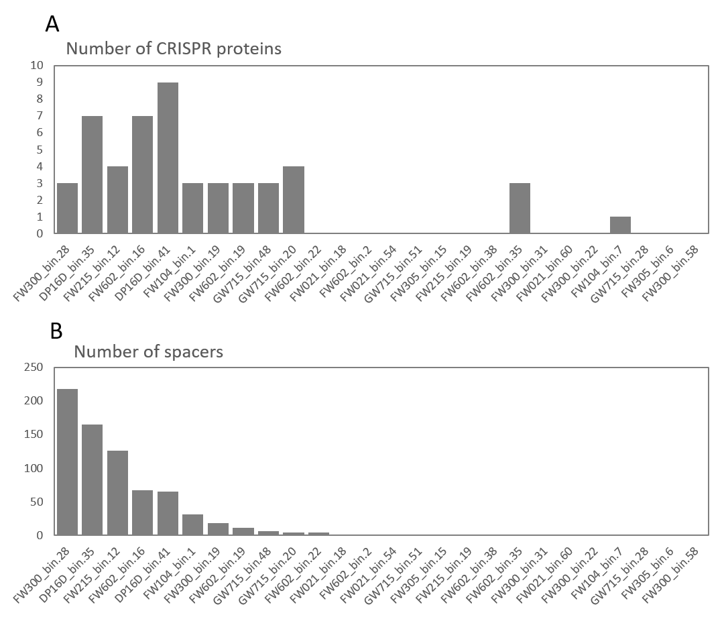
Figure S9. Number of CRISPR proteins (A) and CRISPR spacers (B) in the non-Patescibacteria phyla of this study.

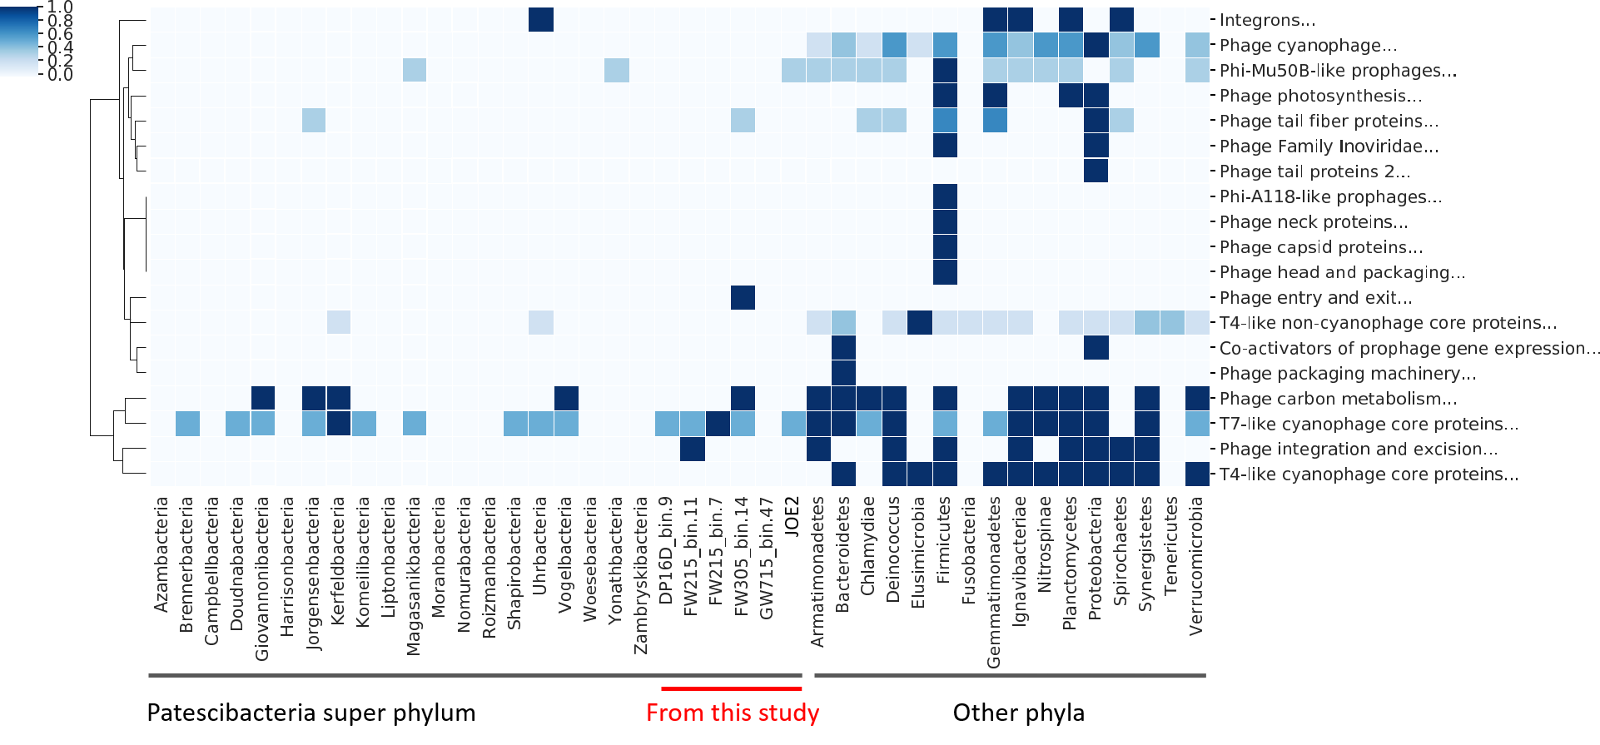Figure S10. A heatmap of comparison of phage-associated proteins including phage structure, phage integration and regulation in the Patescibacteria superphylum and the other phyla. The color indicates the standardized number of phage proteins in each genome / bin.

Table S1. Metadata of the ground water samples. See Figure S1 for the contaminant concentrations and the categorization of wells.
Sample ID | Collection Date | Longitude | Latitude | Depth (m) | Conductivity (S/m) | Dissovled Oxygen (mg/L) | Temperature (°C) | pH
DP16D-67-11-27-12 | 11/27/2012 | -84.274678 | 35.9755 | 22.2 | 661 | 0.26 | 17.05 | 6.67
FW021-46-11-27-12 | 11/27/2012 | -84.272033 | 35.977747 | 22.0 | 7967 | 0.27 | 16.41 | 3.43
FW104-67-11-14-12 | 11/14/2012 | -84.273562 | 35.97736 | 44.4 | 13660 | 1.18 | 14.57 | 5.22
FW106-11-13-12 | 11/13/2012 | -84.273484 | 35.977298 | 45.0 | 7864 | 0.18 | 14.84 | 3.55
FW109-35-61-11-14-12 | 11/14/2012 | -84.273577 | 35.977374 | 34.9 | 1531 | 0.19 | 16.89 | 3.68
FW109-40-92-11-14-12 | 11/14/2012 | -84.273577 | 35.977374 | 39.8 | 2726 | 0.29 | 12.42 | 4.08
FW126-7-25-12 | 7/25/2012 | -84.273414 | 35.977358 | 49.6 | 16780 | 0.2 | 33.95 | 3.1
FW215-84-11-27--12 | 11/27/2012 | -84.274722 | 35.975715 | 18.6 | 637.4 | 0.13 | 17.88 | 6.6
FW233-17-2-99-11-28-12 | 11/28/2012 | -84.274723 | 35.975743 | 17.3 | 801.9 | 0.26 | 15.74 | 6.37
FW300-59-10-19-12 | 10/19/2012 | -84.336176 | 35.941092 | 25.0 | 378.9 | 0.28 | 15.54 | 6.59
FW301-7-25-12 | 7/25/2012 | -84.336181 | 35.941069 | 21.9 | 205 | 0.45 | 22.6 | 6.08
FW301-81-10-19-12 | 10/19/2012 | -84.336181 | 35.941069 | 21.9 | 334.4 | 0.78 | 15.77 | 6.68
FW301-81-2-20-13 | 2/20/2013 | -84.336181 | 35.941069 | 21.9 | 44.19 | 3.58 | 12.2 | 5.42
FW303-11-10-23-12 | 10/23/2012 | -84.336279 | 35.941139 | 20.2 | 316.4 | 0.71 | 15.82 | 7.16
FW303-11-2-20-13 | 2/20/2013 | -84.336279 | 35.941139 | 20.2 | 304.5 | 1.75 | 12.86 | 7.28
FW410-28-46-11-13-12 | 11/13/2012 | -84.273957 | 35.977136 | 27.5 | 3355 | 0.34 | 16.02 | 3.69
FW510-26-11-26-12 | 11/26/2012 | -84.272082 | 35.978585 | 25.8 | 1800 | 0.14 | 16.37 | 4.01
FW511-61-11-26-12 | 11/26/2012 | -84.272035 | 35.978501 | 22.3 | 308.9 | 5.97 | 18.95 | 4.96
FW511-7-26-12 | 7/26/2012 | -84.272035 | 35.978501 | 22.3 | 297.4 | 1.32 | 23.23 | 5.01
FW602-2-26-2-11-28-12 | 11/28/2012 | -84.278931 | 35.974046 | 25.9 | 1704 | 0.41 | 16.42 | 6.48
FW603-55-12-3-12 | 12/3/2012 | -84.278791 | 35.973802 | 32.8 | 6913 | 0.54 | 17.85 | 6.08
GW056-87-1-8-13 | 1/8/2013 | -84.300532 | 35.957762 | 18.1 | 784.1 | 0.66 | 12.87 | 6.87
GW057-10-1-8-13 | 1/8/2013 | -84.300523 | 35.957737 | 55.2 | 1003 | 0.71 | 15.08 | 6.72
GW066-71-2-20-13 | 2/20/2013 | -84.281617 | 35.9708 | 22.8 | 69.32 | 0.48 | 11.91 | 6.2
GW084-56-11-28-12 | 11/28/2012 | -84.28314 | 35.973088 | 27.8 | 339.7 | 0.19 | 15.66 | 7.15
GW085-58-12-3-12 | 12/3/2012 | -84.281474 | 35.9725 | 58.8 | 365.1 | 2.5 | 19.2 | 7.29
GW086-25-12-3-12 | 12/3/2012 | -84.281497 | 35.972458 | 29.6 | 275.1 | 0.63 | 20.36 | 6.47
GW089-62-1-7-13 | 1/7/2013 | -84.299049 | 35.965917 | 25.0 | 327.8 | 0.37 | 12.94 | 7.95
GW098-57-1-22-13 | 1/22/2013 | -84.286314 | 35.968022 | 103.4 | 1331 | 0.11 | 16.01 | 6.43
GW101-11-13-12 | 11/13/2012 | -84.274117 | 35.97732 | 16.3 | 1721 | 0.96 | 18.12 | 6.81
GW101-7-26-12 | 7/26/2012 | -84.274117 | 35.97732 | 16.3 | 934.8 | 1.06 | 24.98 | 7.2
GW105-12-11-12 | 12/11/2012 | -84.271679 | 35.979239 | 16.1 | 1674 | 0.39 | 14.72 | 6.43
GW107-91-12-11-12 | 12/11/2012 | -84.269997 | 35.979044 | 12.5 | 2819 | 0.37 | 20.36 | 6.18
GW115-2-11-26-12 | 11/26/2012 | -84.273333 | 35.980507 | 52.0 | 581.6 | 0.41 | 17.45 | 7.03
GW122-78-11-14-12 | 11/14/2012 | -84.273278 | 35.976124 | 142.0 | 1454 | 0 | 16.66 | 6.64
GW123-93-11-14-12 | 11/14/2012 | -84.273314 | 35.976106 | 572.0 | 1631 | 0.02 | 16.61 | 9.99
GW125-85-2-20-13 | 2/20/2013 | -84.271975 | 35.976523 | 552.0 | 2538 | 0.51 | 14.19 | 9.99
GW127-16-11-26-12 | 11/26/2012 | -84.273424 | 35.976405 | 22.8 | 824.9 | 0.12 | 16.97 | 6.55
GW148-12-17-12 | 12/17/2012 | -84.238597 | 35.993332 | 10.6 | 1399 | 1.32 | 16.53 | 6.45
GW151-12-12-12 | 12/12/2012 | -84.236973 | 35.993413 | 96.0 | 432.2 | 0.25 | 15.4 | 7.07
GW162-37-2-19-13 | 2/19/2013 | -84.296806 | 35.968495 | 125.0 | 247.6 | 0.26 | 14.3 | 8.21
GW190-22-12-11-12 | 12/11/2012 | -84.271177 | 35.980705 | 25.9 | 345.4 | 0.92 | 17.91 | 6.69
GW198-41-2-11-13 | 2/11/2013 | -84.244751 | 35.994113 | 26.5 | 468.2 | 3.48 | 16.1 | 6.06
GW199-42-1-28-13 | 1/28/2013 | -84.244432 | 35.993718 | 22.5 | 581.6 | 0.5 | 14.29 | 6.53
GW220-50-12-12-12 | 12/12/2012 | -84.236976 | 35.993381 | 44.7 | 410.7 | 0.52 | 13.09 | 7.49
GW223-39-1-8-13 | 1/8/2013 | -84.239517 | 35.991954 | 90.0 | 466.5 | 0.41 | 16.41 | 6.83
GW228-12-2-4-13 | 2/4/2013 | -84.283453 | 35.96866 | 100.0 | 282.4 | 0.17 | 10.92 | 9.31
GW246-1-11-26-12 | 11/26/2012 | -84.272935 | 35.977144 | 74.6 | 18580 | 0.19 | 17.56 | 4.48
GW247-7-11-14-12 | 11/14/2012 | -84.272726 | 35.9773 | 74.9 | 20620 | 0.09 | 17.5 | 5.88
GW271-66-2-18-13 | 2/18/2013 | -84.27058705 | 35.97989558 | 29.4 | 521.9 | 0.03 | 15.57 | 7.71
GW283-43-1-29-13 | 1/29/2013 | -84.244414 | 35.991366 | 20.0 | 1089 | 0.07 | 18.01 | 6.95
GW314-97-2-19-13 | 2/19/2013 | -84.27177607 | 35.97587976 | 113.0 | 602.7 | 0.23 | 14.69 | 7.37
GW345-51-11-27-12 | 11/27/2012 | -84.276925 | 35.97508 | 26.0 | 183.8 | 1.19 | 15.07 | 5.23
GW346-47-11-27-12 | 11/27/2012 | -84.276916 | 35.975088 | 64.6 | 6931 | 0.26 | 14.79 | 6.58
GW350-74-2-12-13 | 2/12/2013 | -84.268309 | 35.978922 | 43.4 | 545 | 0.02 | 17.98 | 6.67
GW363-94-1-22-13 | 1/22/2013 | -84.287521 | 35.969048 | 75.0 | 424.9 | 0.03 | 15.28 | 9.13
GW383-12-17-12 | 12/17/2012 | -84.239422 | 35.992878 | 23.1 | 521.7 | 4.54 | 17.43 | 7.11
GW384-12-17-12 | 12/17/2012 | -84.239429 | 35.992922 | 55.7 | 802.9 | 0.08 | 16.95 | 6.64
GW385-80-2-18-13 | 2/18/2013 | -84.239425 | 35.992899 | 178.7 | 780.09 | 0.29 | 15.36 | 9.19
GW526-15-11-27-12 | 11/27/2012 | -84.276907 | 35.975102 | 123.0 | 9468 | 0.14 | 14.54 | 7.95
GW531-83-11-28-12 | 11/28/2012 | -84.281558 | 35.973944 | 38.2 | 39.68 | 4.32 | 15.07 | 5.49
GW533-48-11-28-12 | 11/28/2012 | -84.281393 | 35.974108 | 30.1 | 118 | 1.54 | 15.92 | 6.27
GW537-24-11-26-12 | 11/26/2012 | -84.280229 | 35.973362 | 23.0 | 2618 | 0.05 | 15.6 | 6.49
GW60-1A-60-2-4-13 | 2/4/2013 | -84.248782 | 35.987834 | 23.2 | 1076 | 0.23 | 19.23 | 7.38
GW621-21-12-17-12 | 12/17/2012 | -84.2909 | 35.964088 | 40.5 | 356.4 | 0.17 | 14.64 | 7.19
GW631-98-12-11-12 | 12/11/2012 | -84.2704 | 35.97923 | 15.0 | 318.8 | 0.26 | 16.86 | 4.32
GW636-32-1-28-13 | 1/28/2013 | -84.287902 | 35.967252 | 117.0 | 317.9 | 0.2 | 12.17 | 8.87
GW639-90-1-23-13 | 1/23/2013 | -84.291404 | 35.965809 | 125.5 | 845.3 | 0.32 | 12.05 | 9.2
GW641-30-1-23-13 | 1/23/2013 | -84.291542 | 35.965931 | 24.0 | 25.59 | 7.22 | 12.64 | 5.25
GW654-0-1-7-13 | 1/7/2013 | -84.302538 | 35.962761 | 15.3 | 269 | 2.35 | 13.01 | 7.19
GW658-63-1-23-13 | 1/23/2013 | -84.244105 | 35.991761 | 18.8 | 454.3 | 0.03 | 19.06 | 6.4
GW683-53-2-18-13 | 2/18/2013 | -84.299249 | 35.957053 | 196.8 | 393.6 | 5.42 | 13.82 | 7.49
GW685-6-1-8-13 | 1/8/2013 | -84.300271 | 35.957771 | 138.3 | 906.1 | 0.1 | 14.55 | 6.88
GW694-33-12-3-12 | 12/3/2012 | -84.290954 | 35.963467 | 204.5 | 444.6 | 0.15 | 15.11 | 7.3
GW704-5-12-17-12 | 12/12/2012 | -84.290837 | 35.96353 | 256.0 | 529.2 | 0.99 | 13.7 | 7.62
GW705-9-2-21-13 | 2/21/2013 | -84.29107919 | 35.96372889 | 307.0 | 891.7 | 0.33 | 12.37 | 9.19
GW706-96-12-17-12 | 12/17/2012 | -84.291005 | 35.963775 | 182.5 | 710.4 | 0.04 | 14.11 | 7.88
GW714-34-2-12-13 | 2/12/2013 | -84.313845 | 35.949511 | 145.0 | 514.2 | 0.14 | 13.92 | 7.48
GW715-65-2-12-13 | 2/12/2013 | -84.313801 | 35.949545 | 43.1 | 532.9 | 5.47 | 14.59 | 6.65
GW736-14-12-3-12 | 12/3/2012 | -84.280642 | 35.970896 | 102.4 | 916.7 | 0.13 | 15.88 | 6.64
GW737-12-12-12 | 12/12/2012 | -84.280741 | 35.97079 | 89.4 | 937.2 | 0.33 | 13.53 | 6.66
GW750-28-12-12-12 | 12/12/2012 | -84.235312 | 35.994376 | 72.3 | 367.6 | 0.23 | 15.12 | 7.11
GW753-79-1-7-13 | 1/7/2012 | -84.241126 | 35.993391 | 70.3 | 215 | 0.17 | 15.94 | 10.48
GW754-40-1-7-13 | 1/7/2013 | -84.241189 | 35.993378 | 23.9 | 176.6 | 1.29 | 15.91 | 3.13
GW755-69-1-8-13 | 1/8/2013 | -84.242031 | 35.994769 | 59.9 | 386.4 | 1.12 | 14.9 | 9.34
GW761-29-1-28-13 | 1/28/2013 | -84.250491 | 35.989904 | 15.2 | 380.9 | 4.72 | 15.96 | 6.59
GW763-23-1-22-13 | 1/22/2013 | -84.240111 | 35.992222 | 64.8 | 699.5 | 0.13 | 17.11 | 6.65
GW764-23-1-11-13 | 1/11/2013 | -84.257055 | 35.989269 | 31.5 | 197.1 | 0.95 | 19.06 | 8.57
GW765-77-1-11-13 | 1/11/2013 | -84.256997 | 35.989297 | 58.6 | 638.8 | 0.23 | 19.14 | 6.68
GW773-35-2-4-13 | 2/4/2013 | -84.246683 | 35.991147 | 56.2 | 330.1 | 0.24 | 13.43 | 7.46
GW775-88-1-29-13 | 1/29/2013 | -84.245848 | 35.989595 | 58.0 | 583.2 | 0.97 | 19.12 | 7.2
GW779-8-2-18-13 | 2/18/2013 | -84.25334197 | 35.9886503 | 62.0 | 460.9 | 0.2 | 16.74 | 9.55
GW782-72-2-18-13 | 2/18/2013 | -84.255601 | 35.985734 | 34.9 | 556.5 | 2.65 | 17.49 | 7.52
GW800-12-12-12 | 12/12/2012 | -84.28178 | 35.968949 | 29.4 | 379.1 | 8.01 | 13.13 | 6.7
GW803-31-1-23-13 | 1/23/2013 | -84.243755 | 35.991689 | 23.2 | 397.7 | 5.11 | 13.68 | 5.4
GW804-13-2-11-13 | 2/11/2013 | -84.24405271 | 35.99152444 | 23.5 | 603.1 | 6.57 | 15.48 | 4.91
GW921-86-1-28-13 | 1/28/2013 | -84.287507 | 35.970344 | 48.0 | 465.5 | 0.64 | 15.57 | 7.46
GW925-68-1-28-13 | 1/28/2013 | -84.287535 | 35.970325 | 147.0 | 654.7 | 0.35 | 11.97 | 9.79
GW928-54-2-11-13 | 2/11/2013 | -84.264657 | 35.987421 | 43.2 | 241.5 | 0.21 | 16.65 | 6.69
GW929-2-11-13 | 2/11/2013 | -84.264601 | 35.987452 | 28.0 | 34.79 | 3.09 | 16.07 | 5.18
PTMW02-4-12-11-12 | 12/11/2012 | -84.276332 | 35.975573 | 44.7 | 9307 | 0.16 | 14.42 | 4.72
TPB16-7-26-12 | 7/26/2012 | -84.274687 | 35.975643 | 15.3 | 1444 | 0.18 | 26.79 | 7.1
TPB16-81-11-28-12 | 11/28/2012 | -84.274687 | 35.975643 | 15.3 | 843.3 | 0.35 | 18.59 | 6.58

Table S2. Summary of the raw reads and qualified reads of the metagenomic data.
Sample ID | Raw reads (million) | Raw base (Gbp) | Duplication |  | Quality trimming and filtering |  |  |  |  |  |  |  | Total base (HQ reads, Gbp)
 |  |  |  |  | Forward read |  |  |  | Reverse read
 |  |  | Deduplicated reads | Duplication rate | No. of HQ reads (million) | No. of bases (Gbp) | No. of HQ bases (Gbp) | Q20 (percentage of HQ bases) | No. of HQ reads (million) | No. of bases (Gbp) | No. of HQ bases (Gbp) | Q20 (percentage of HQ base)
DP16D | 218.2 | 32.9 | 213.7 | 2.1% | 99.9 | 15.0 | 14.6 | 97.2% | 99.9 | 15.0 | 14.0 | 93.8% | 30.0
FW021 | 236.4 | 35.7 | 229.6 | 2.9% | 92.1 | 13.9 | 13.5 | 97.4% | 92.1 | 13.8 | 12.7 | 92.3% | 27.7
FW104 | 237.7 | 35.9 | 168.7 | 29.0% | 50.1 | 7.5 | 7.1 | 95.1% | 50.1 | 7.5 | 6.5 | 87.5% | 15.0
FW106 | 180.0 | 27.2 | 159.1 | 11.6% | 62.1 | 9.4 | 8.8 | 94.0% | 62.1 | 9.3 | 8.4 | 90.2% | 18.7
FW106-02 | 300.6 | 45.4 | 289.1 | 3.8% | 133.6 | 20.1 | 19.4 | 96.7% | 133.6 | 20.0 | 18.7 | 93.3% | 40.1
FW106-10 | 549.5 | 83.0 | 531.2 | 3.3% | 242.3 | 36.5 | 34.7 | 95.0% | 242.3 | 36.3 | 33.7 | 92.8% | 72.8
FW215 | 190.5 | 28.8 | 186.8 | 2.0% | 87.6 | 13.2 | 12.8 | 97.2% | 87.6 | 13.1 | 12.2 | 93.2% | 26.3
FW300 | 310.1 | 46.8 | 302.5 | 2.4% | 137.4 | 20.7 | 20.2 | 97.6% | 137.4 | 20.5 | 18.8 | 91.3% | 41.2
FW301 | 190.7 | 28.8 | 187.3 | 1.8% | 84.3 | 12.7 | 12.4 | 97.5% | 84.3 | 12.6 | 11.7 | 92.5% | 25.3
FW301-02 | 373.1 | 56.3 | 345.7 | 7.4% | 169.3 | 25.5 | 25.1 | 98.4% | 169.3 | 25.5 | 24.6 | 96.7% | 51.0
FW301-10 | 341.8 | 51.6 | 315.1 | 7.8% | 154.3 | 23.3 | 22.9 | 98.5% | 154.3 | 23.2 | 22.5 | 96.8% | 46.5
FW305 | 178.9 | 27.0 | 135.6 | 24.2% | 50.5 | 7.6 | 7.4 | 96.9% | 50.5 | 7.6 | 6.8 | 90.3% | 15.2
FW602 | 174.1 | 26.3 | 170.4 | 2.1% | 79.1 | 11.9 | 11.6 | 97.1% | 79.1 | 11.8 | 11.0 | 93.1% | 23.7
GW199 | 229.0 | 34.6 | 124.3 | 45.7% | 41.7 | 6.3 | 6.0 | 95.3% | 41.7 | 6.2 | 5.5 | 89.0% | 12.5
GW715 | 264.1 | 39.9 | 244.2 | 7.5% | 104.3 | 15.7 | 15.3 | 97.6% | 104.3 | 15.6 | 14.3 | 91.8% | 31.3
GW928 | 239.2 | 36.1 | 195.9 | 18.1% | 49.0 | 7.4 | 7.0 | 95.6% | 49.0 | 7.3 | 6.5 | 89.0% | 14.7
Total | 4213.7 | 636.3 | 3799.1 | - | 1637.8 | 246.5 | 238.8 | - | 1637.8 | 245.4 | 228.1 | - | 491.8
Mean | 263.4 | 39.8 | 237.4 | 10.7% | 102.4 | 15.4 | 14.9 | 96.7% | 102.4 | 15.3 | 14.3 | 92.1% | 30.7
SD | 97.1 | 14.7 | 102.3 | 12.5% | 54.0 | 8.1 | 7.9 | 1.3% | 54.0 | 8.1 | 7.8 | 2.6% | 16.2

Table S3. Metagenomic assembly of the samples plus supplementary sequence. Contigs with length >500 bp were summarized.

Sample ID | Contig number | Total base of contigs | Max sequence length | N50 length | GC content
DP16D | 118677 | 1.91E+08 | 273343 | 1952 | 54.77%
FW021 | 70823 | 2.09E+08 | 588991 | 8788 | 61.52%
FW104 | 13504 | 24809230 | 116275 | 2560 | 57.04%
FW106 | 18736 | 44868411 | 560079 | 12032 | 61.69%
FW106-02 | 18472 | 57771662 | 430515 | 11148 | 61.89%
FW106-10 | 43324 | 1.13E+08 | 430652 | 8514 | 60.03%
FW215 | 139593 | 2.01E+08 | 643366 | 1568 | 52.14%
FW300 | 175376 | 2.46E+08 | 735234 | 1453 | 55.77%
FW301 | 66427 | 86231473 | 199693 | 1279 | 60.14%
FW301-02 | 91051 | 1.18E+08 | 251934 | 1273 | 55.55%
FW305 | 42729 | 63729503 | 604198 | 1678 | 63.14%
FW602 | 133699 | 2.54E+08 | 1783802 | 2652 | 62.62%
GW199 | 6604 | 8090154 | 23002 | 1231 | 50.54%
GW715 | 135463 | 2.52E+08 | 1047723 | 2740 | 62.33%
GW928 | 45056 | 71729291 | 577390 | 1999 | 60.57%
* The assembly of the sample FW301-10 failed due to super large data size and high diversity of community.

Table S4. The alignment rates of each sample’s reads to its assembly. The alignment rates were calculated by Bowtie2 and Samtools.
Sample ID | # raw reads (million) | # base of raw reads (Gbp) | # base after deduplication, quality trimming and filtering (Gbp) | Percent of high quality reads mapping to assembly
DP16D | 218.2 | 32.9 | 30.0 | 19.64%
FW021 | 236.4 | 35.7 | 27.7 | 73.13%
FW104 | 237.7 | 35.9 | 15.0 | 36.62%
FW106 | 180.0 | 27.2 | 18.7 | 73.09%
FW106-02 | 300.6 | 45.4 | 40.1 | 65.77%
FW106-10 | 549.5 | 83.0 | 72.8 | 63.16%
FW215 | 190.5 | 28.8 | 26.3 | 17.36%
FW300 | 310.1 | 46.8 | 41.2 | 8.47%
FW301 | 190.7 | 28.8 | 25.3 | 3.94%
FW301-02 | 373.1 | 56.3 | 51.0 | 3.35%
FW305 | 178.9 | 27.0 | 15.2 | 16.91%
FW602 | 174.1 | 26.3 | 23.7 | 30.72%
GW199 | 229.0 | 34.6 | 12.5 | 11.92%
GW715 | 264.1 | 39.9 | 31.3 | 23.74%
GW928 | 239.2 | 36.1 | 14.7 | 31.87%

Table S5. Profiles of genome bins generated by MetaBat. Only genome bins with completeness >70% and contamination <10% are listed.
Bin ID | Taxonomic classification (by pplacer of CheckM) | Complet  eness | Contam  ination | Contig number | Total base of contigs | Max sequence length | N50 length
DP16D_bin.48 | k__Bacteria_(UID3187) | 100 | 5.45 | 120 | 3.23 | 125,024 | 41,819
FW021_bin.18 | k__Bacteria_(UID1452) | 100 | 1.85 | 100 | 2.87 | 394,163 | 148,845
FW106-10_bin.31 | k__Bacteria_(UID203) | 100 | 8.62 | 333 | 4.06 | 60,718 | 20,711
FW021_bin.60 | g__Mycobacterium_(UID1816) | 99.94 | 0.58 | 75 | 6.14 | 384,008 | 140,583
GW715_bin.37 | c__Alphaproteobacteria_(UID3422) | 99.89 | 2.73 | 43 | 5.77 | 515,386 | 266,291
FW106_bin.13 | c__Betaproteobacteria_(UID3959) | 99.62 | 2.56 | 54 | 5.99 | 560,079 | 200,020
FW301_bin.9 | o__Burkholderiales_(UID4000) | 99.53 | 0.35 | 626 | 4.65 | 38,806 | 10,565
FW021_bin.57 | o__Actinomycetales_(UID1593) | 99.49 | 1.26 | 41 | 3.95 | 516,796 | 325,858
FW106_bin.9 | o__Burkholderiales_(UID4001) | 99.49 | 0.33 | 336 | 4.02 | 123,784 | 17,717
FW106-10_bin.28 | o__Burkholderiales_(UID4001) | 99.49 | 0.2 | 165 | 3.09 | 93,290 | 33,103
FW305_bin.1 | o__Actinomycetales_(UID1590) | 99.41 | 0 | 13 | 2.68 | 604,198 | 341,920
FW300_bin.58 | c__Betaproteobacteria_(UID3888) | 99.36 | 0.88 | 26 | 2.48 | 312,961 | 212,466
FW305_bin.9 | c__Gammaproteobacteria_(UID4274) | 99.21 | 1.36 | 157 | 4.60 | 249,922 | 52,387
FW300_bin.35 | c__Alphaproteobacteria_(UID3422) | 99.08 | 2.23 | 95 | 4.91 | 318,114 | 97,883
GW715_bin.44 | o__Burkholderiales_(UID4000) | 98.81 | 0 | 91 | 8.98 | 634,046 | 178,790
FW021_bin.31 | p__Bacteroidetes_(UID2591) | 98.77 | 2.37 | 301 | 4.52 | 114,523 | 25,681
FW021_bin.74 | k__Bacteria_(UID1452) | 98.77 | 1.85 | 87 | 3.03 | 196,054 | 59,548
FW602_bin.22 | k__Bacteria_(UID1452) | 98.68 | 0.99 | 38 | 4.03 | 346,778 | 186,054
se_bin.6 | f__Xanthomonadaceae_(UID4214) | 98.64 | 1.51 | 389 | 3.66 | 63,506 | 15,930
DP16D_bin.19 | c__Gammaproteobacteria_(UID4274) | 98.61 | 1.04 | 144 | 4.49 | 214,456 | 50,311
FW021_bin.21 | c__Betaproteobacteria_(UID3959) | 98.58 | 1.85 | 86 | 3.41 | 397,732 | 111,098
GW715_bin.21 | o__Sphingomonadales_(UID3310) | 98.46 | 4.91 | 295 | 4.27 | 204,652 | 32,436
FW602_bin.15 | c__Betaproteobacteria_(UID3971) | 98.42 | 6.68 | 87 | 5.85 | 600,586 | 161,352
GW715_bin.18 | c__Betaproteobacteria_(UID3959) | 98.41 | 4.65 | 343 | 3.11 | 85,893 | 25,625
FW106_bin.8 | o__Burkholderiales_(UID4000) | 98.36 | 1.87 | 38 | 4.25 | 418,061 | 154,406
DP16D_bin.35 | k__Bacteria_(UID3187) | 98.18 | 2.73 | 145 | 3.63 | 273,343 | 56,966
GW715_bin.29 | c__Alphaproteobacteria_(UID3422) | 98.05 | 3 | 114 | 3.12 | 188,491 | 55,486
FW602_bin.18 | o__Rhizobiales_(UID3642) | 98.02 | 0.79 | 27 | 3.12 | 790,923 | 373,877
FW106-10_bin.30 | f__Xanthomonadaceae_(UID4214) | 97.99 | 1.12 | 49 | 3.38 | 365,303 | 124,146
FW301-02_bin.23 | o__Rhodospirillales_(UID3754) | 97.99 | 1.45 | 353 | 2.05 | 27,717 | 7,584
FW215_bin.12 | k__Bacteria_(UID2570) | 97.98 | 0 | 47 | 4.20 | 643,366 | 175,842
GW715_bin.31 | o__Rhodospirillales_(UID3754) | 97.97 | 1.49 | 50 | 6.46 | 924,814 | 338,475
FW021_bin.58 | f__Xanthomonadaceae_(UID4214) | 97.82 | 2.5 | 136 | 3.60 | 164,026 | 40,809
FW106-02_bin.9 | f__Xanthomonadaceae_(UID4214) | 97.66 | 3.35 | 308 | 3.53 | 69,506 | 17,558
FW106-02_bin.10 | f__Xanthomonadaceae_(UID4214) | 97.52 | 1.21 | 456 | 3.60 | 73,209 | 12,337
FW300_bin.28 | k__Bacteria_(UID3187) | 97.48 | 3.36 | 45 | 2.88 | 201,346 | 99,979
FW106-02_bin.3 | f__Xanthomonadaceae_(UID4214) | 97.47 | 2.67 | 203 | 3.81 | 235,300 | 41,120
FW021_bin.48 | k__Bacteria_(UID1452) | 97.38 | 3.94 | 90 | 3.19 | 173,571 | 62,330
FW021_bin.27 | o__Burkholderiales_(UID4000) | 97.35 | 1.03 | 122 | 3.14 | 153,140 | 39,867
FW021_bin.29 | f__Xanthomonadaceae_(UID4214) | 97.31 | 0.73 | 76 | 3.60 | 168,646 | 65,296
se_bin.5 | f__Xanthomonadaceae_(UID4214) | 97.29 | 3.21 | 97 | 3.89 | 230,714 | 76,916
FW106-10_bin.33 | f__Xanthomonadaceae_(UID4214) | 97.24 | 3.56 | 139 | 3.08 | 235,696 | 50,340
FW106-02_bin.7 | c__Gammaproteobacteria_(UID4202) | 97.21 | 2.83 | 442 | 3.07 | 34,202 | 8,847
FW301-02_bin.25 | o__Burkholderiales_(UID4000) | 97 | 3.54 | 453 | 4.91 | 76,807 | 15,656
FW602_bin.35 | c__Gammaproteobacteria_(UID4267) | 96.8 | 0.38 | 13 | 3.53 | 1,783,802 | 1,783,802
FW300_bin.52 | k__Bacteria_(UID3187) | 96.76 | 3.92 | 250 | 2.67 | 98,754 | 26,967
GW928_bin.16 | k__Bacteria_(UID3187) | 96.76 | 3.64 | 23 | 3.26 | 577,390 | 321,837
FW106-10_bin.21 | c__Betaproteobacteria_(UID3959) | 96.74 | 2.84 | 61 | 3.24 | 430,652 | 262,923
GW715_bin.16 | c__Alphaproteobacteria_(UID3305) | 96.61 | 0.65 | 66 | 6.02 | 363,860 | 176,897
GW715_bin.19 | f__Rhodocyclaceae_(UID3972) | 96.56 | 1.04 | 151 | 2.67 | 137,154 | 36,883
FW106_bin.6 | c__Gammaproteobacteria_(UID4202) | 96.49 | 1.36 | 139 | 3.78 | 241,417 | 55,622
FW602_bin.10 | c__Betaproteobacteria_(UID3959) | 96.45 | 1.18 | 169 | 3.56 | 106,972 | 30,446
GW715_bin.15 | c__Deltaproteobacteria_(UID3216) | 96.45 | 3.93 | 197 | 9.40 | 502,942 | 122,654
FW300_bin.22 | k__Bacteria_(UID3187) | 96.36 | 8.18 | 416 | 2.35 | 34,885 | 9,381
FW602_bin.2 | c__Gammaproteobacteria_(UID4202) | 96.29 | 4.59 | 187 | 3.96 | 135,350 | 35,064
GW715_bin.6 | k__Bacteria_(UID203) | 96.24 | 7.21 | 249 | 5.26 | 205,334 | 57,882
FW106-10_bin.17 | c__Betaproteobacteria_(UID3959) | 96.21 | 0.54 | 778 | 3.14 | 16,568 | 4,816
GW715_bin.41 | o__Actinomycetales_(UID1593) | 96.21 | 1.52 | 20 | 3.77 | 1,047,723 | 344,739
FW602_bin.16 | k__Bacteria_(UID1452) | 96.2 | 1.19 | 256 | 5.64 | 123,923 | 39,881
FW104_bin.7 | p__Proteobacteria_(UID3880) | 96.14 | 1.95 | 91 | 2.68 | 116,275 | 52,687
FW104_bin.1 | k__Bacteria_(UID3187) | 96.08 | 2.56 | 203 | 3.99 | 93,071 | 29,549
FW106-10_bin.11 | o__Rhizobiales_(UID3654) | 96.08 | 0.78 | 333 | 5.21 | 75,542 | 25,392
GW715_bin.48 | p__Bacteroidetes_(UID2591) | 96.06 | 1.72 | 318 | 2.25 | 165,550 | 37,642
FW106-02_bin.8 | g__Burkholderia_(UID4006) | 96.03 | 1.24 | 505 | 4.02 | 49,011 | 11,325
FW106-10_bin.23 | f__Xanthomonadaceae_(UID4214) | 95.81 | 0.95 | 86 | 5.90 | 284,499 | 125,043
GW715_bin.26 | f__Rhodocyclaceae_(UID3972) | 95.64 | 2.21 | 115 | 2.57 | 122,073 | 52,424
FW021_bin.3 | f__Xanthomonadaceae_(UID4214) | 95.6 | 1.7 | 78 | 3.62 | 189,940 | 75,682
FW300_bin.31 | c__Alphaproteobacteria_(UID3305) | 95.59 | 6.67 | 197 | 3.87 | 92,024 | 31,056
se_bin.2 | o__Burkholderiales_(UID4001) | 95.56 | 1.99 | 457 | 5.27 | 68,769 | 16,270
FW021_bin.26 | k__Bacteria_(UID3187) | 95.51 | 0.85 | 22 | 3.30 | 588,991 | 360,040
GW715_bin.46 | o__Rhodospirillales_(UID3754) | 95.45 | 0.25 | 176 | 5.16 | 197,652 | 46,428
DP16D_bin.41 | k__Bacteria_(UID2982) | 95.44 | 0.71 | 85 | 2.53 | 221,299 | 78,422
FW215_bin.17 | c__Gammaproteobacteria_(UID4388) | 95.33 | 3.79 | 566 | 2.76 | 34,001 | 6,904
DP16D_bin.30 | c__Gammaproteobacteria_(UID4274) | 95.14 | 0.92 | 353 | 4.65 | 75,019 | 21,150
FW106-02_bin.14 | f__Xanthomonadaceae_(UID4214) | 95.12 | 2.85 | 21 | 3.04 | 430,515 | 356,845
FW021_bin.20 | k__Bacteria_(UID1453) | 95.01 | 1.28 | 213 | 2.51 | 74,937 | 17,364
FW021_bin.4 | c__Betaproteobacteria_(UID3959) | 95 | 3.67 | 339 | 3.20 | 79,786 | 15,732
FW215_bin.19 | p__Bacteroidetes_(UID2605) | 94.85 | 0.89 | 412 | 3.49 | 45,037 | 12,920
FW106-10_bin.9 | k__Bacteria_(UID203) | 94.83 | 4.47 | 70 | 4.42 | 335,701 | 123,597
FW021_bin.54 | k__Bacteria_(UID3187) | 94.66 | 5.13 | 29 | 5.21 | 565,568 | 346,509
GW715_bin.28 | c__Gammaproteobacteria_(UID4202) | 94.57 | 1.49 | 63 | 3.57 | 199,209 | 99,515
FW106-02_bin.5 | g__Burkholderia_(UID4006) | 94.53 | 3.32 | 119 | 4.75 | 372,874 | 88,031
FW300_bin.19 | k__Bacteria_(UID2495) | 94.32 | 2.25 | 96 | 4.89 | 307,891 | 76,736
FW021_bin.37 | p__Bacteroidetes_(UID2591) | 94.09 | 1.48 | 625 | 4.98 | 62,909 | 11,185
FW106-10_bin.6 | g__Burkholderia_(UID4006) | 93.97 | 1.55 | 400 | 3.08 | 235,300 | 12,296
FW300_bin.41 | o__Burkholderiales_(UID4000) | 93.65 | 1.97 | 677 | 4.63 | 46,754 | 9,315
GW928_bin.19 | k__Bacteria_(UID3187) | 93.58 | 4.75 | 613 | 2.75 | 23,892 | 5,539
FW021_bin.35 | f__Xanthomonadaceae_(UID4214) | 93.4 | 1.4 | 29 | 2.98 | 308,486 | 179,307
GW715_bin.13 | k__Bacteria_(UID3187) | 93.35 | 3.64 | 613 | 4.20 | 46,154 | 9,597
GW199_bin.3 | k__Archaea_(UID2) | 93.13 | 6.63 | 393 | 1.56 | 23,002 | 5,356
FW106_bin.11 | o__Burkholderiales_(UID4000) | 92.93 | 5.3 | 22 | 3.26 | 463,761 | 267,194
FW300_bin.11 | o__Actinomycetales_(UID1593) | 92.83 | 3.69 | 425 | 2.27 | 108,177 | 7,809
GW715_bin.24 | f__Xanthomonadaceae_(UID4214) | 92.77 | 1.17 | 318 | 2.42 | 42,221 | 10,893
FW021_bin.42 | k__Bacteria_(UID1452) | 92.56 | 3.19 | 362 | 3.16 | 153,586 | 14,622
DP16D_bin.23 | c__Betaproteobacteria_(UID3971) | 92.07 | 2.37 | 576 | 3.12 | 25,766 | 6,981
FW602_bin.24 | c__Betaproteobacteria_(UID3971) | 91.96 | 5.56 | 492 | 4.02 | 70,999 | 12,771
DP16D_bin.2 | c__Deltaproteobacteria_(UID3216) | 91.94 | 1.33 | 313 | 2.13 | 36,266 | 8,991
FW215_bin.51 | c__Gammaproteobacteria_(UID4274) | 91.88 | 5.36 | 950 | 4.09 | 39,936 | 5,812
GW928_bin.17 | k__Archaea_(UID2) | 91.76 | 2.91 | 126 | 1.68 | 71,974 | 24,692
FW305_bin.6 | k__Bacteria_(UID1452) | 91.42 | 3.3 | 323 | 2.52 | 38,548 | 12,311
FW301_bin.2 | c__Gammaproteobacteria_(UID4266) | 90.4 | 1.31 | 356 | 4.58 | 154,330 | 19,863
FW021_bin.53 | c__Betaproteobacteria_(UID3959) | 90.05 | 0.24 | 125 | 2.99 | 101,654 | 38,336
FW106-02_bin.11 | c__Betaproteobacteria_(UID3959) | 89.91 | 1.29 | 280 | 4.20 | 92,148 | 30,501
FW602_bin.31 | f__Xanthomonadaceae_(UID4214) | 89.52 | 6.36 | 229 | 2.54 | 646,747 | 236,695
FW602_bin.52 | k__Bacteria_(UID1452) | 89.18 | 6.22 | 143 | 3.09 | 252,083 | 48,834
GW928_bin.5 | o__Rhodospirillales_(UID3754) | 89.06 | 2.11 | 775 | 4.69 | 31,369 | 8,637
FW301-02_bin.13 | k__Bacteria_(UID2982) | 88.85 | 3.08 | 1574 | 5.62 | 18,943 | 4,119
FW215_bin.33 | k__Bacteria_(UID2569) | 88.81 | 8.06 | 911 | 4.01 | 35,054 | 5,413
DP16D_bin.1 | c__Betaproteobacteria_(UID3959) | 88.48 | 3.01 | 462 | 2.34 | 27,705 | 6,812
FW300_bin.36 | o__Actinomycetales_(UID1663) | 88.28 | 1.35 | 745 | 3.26 | 24,798 | 5,210
FW305_bin.15 | k__Bacteria_(UID2495) | 87.44 | 5.25 | 577 | 4.10 | 43,895 | 9,881
FW106-02_bin.6 | f__Xanthomonadaceae_(UID4214) | 87.1 | 5.4 | 126 | 3.17 | 337,657 | 70,375
GW715_bin.45 | c__Alphaproteobacteria_(UID3422) | 86.85 | 4.26 | 514 | 3.21 | 81,823 | 9,340
FW300_bin.53 | c__Gammaproteobacteria_(UID4443) | 85.48 | 3.2 | 736 | 2.57 | 22,511 | 4,506
FW602_bin.25 | p__Bacteroidetes_(UID2591) | 85.44 | 2.53 | 778 | 4.80 | 32,653 | 7,987
FW021_bin.59 | k__Bacteria_(UID1452) | 85.24 | 1.85 | 507 | 2.11 | 16,683 | 4,931
GW928_bin.9 | k__Bacteria_(UID2565) | 85.13 | 1.08 | 816 | 4.43 | 33,802 | 7,094
FW602_bin.19 | k__Bacteria_(UID2570) | 84.88 | 6.47 | 717 | 3.84 | 32,534 | 6,958
FW602_bin.38 | k__Bacteria_(UID1452) | 82.73 | 4.55 | 84 | 3.25 | 116,370 | 59,107
FW301_bin.11 | c__Alphaproteobacteria_(UID3305) | 81.63 | 1.16 | 958 | 4.62 | 27,636 | 6,084
FW021_bin.52 | o__Rhizobiales_(UID3450) | 81.47 | 3.7 | 1067 | 4.62 | 27,666 | 5,143
GW928_bin.20 | k__Bacteria_(UID1452) | 81.35 | 3.3 | 439 | 2.66 | 57,125 | 8,732
FW305_bin.14 | k__Bacteria_(UID203) | 80.46 | 0 | 8 | 0.79 | 279,925 | 135,229
FW300_bin.13 | p__Bacteroidetes_(UID2591) | 80.31 | 1.89 | 855 | 3.09 | 21,801 | 4,314
GW715_bin.11 | c__Alphaproteobacteria_(UID3305) | 80.2 | 1.17 | 636 | 2.76 | 29,778 | 5,385
GW715_bin.20 | k__Bacteria_(UID3187) | 80.2 | 8.59 | 1081 | 4.14 | 26,280 | 4,431
DP16D_bin.15 | k__Bacteria_(UID2565) | 79.98 | 0 | 299 | 1.63 | 40,723 | 7,081
FW602_bin.17 | k__Bacteria_(UID1452) | 79.74 | 2.31 | 802 | 3.06 | 22,599 | 4,770
FW106-10_bin.24 | o__Burkholderiales_(UID4000) | 79.69 | 0.7 | 90 | 3.93 | 154,575 | 75,430
FW300_bin.39 | k__Bacteria_(UID1452) | 79.66 | 5.59 | 597 | 2.61 | 35,333 | 5,566
GW715_bin.47 | k__Bacteria_(UID2495) | 79.35 | 0 | 129 | 0.79 | 44,991 | 12,251
FW602_bin.30 | c__Betaproteobacteria_(UID3971) | 79.3 | 1.72 | 361 | 2.34 | 30,352 | 8,843
FW021_bin.24 | f__Xanthomonadaceae_(UID4214) | 78.81 | 0.82 | 46 | 2.65 | 158,767 | 99,477
DP16D_bin.55 | o__Rhodospirillales_(UID3754) | 78.79 | 3.06 | 850 | 3.10 | 22,657 | 4,059
FW215_bin.14 | k__Bacteria_(UID203) | 77.87 | 0.86 | 18 | 0.67 | 118,038 | 73,222
FW215_bin.29 | k__Archaea_(UID2) | 77.57 | 3.74 | 124 | 0.74 | 28,687 | 8,137
FW602_bin.41 | k__Bacteria_(UID1452) | 77.23 | 0 | 2 | 1.09 | 855,898 | 855,898
FW602_bin.51 | k__Bacteria_(UID3187) | 77.08 | 3.51 | 362 | 2.82 | 43,032 | 10,591
FW021_bin.39 | f__Xanthomonadaceae_(UID4214) | 76.96 | 3.46 | 814 | 2.99 | 19,587 | 4,200
GW715_bin.51 | k__Bacteria_(UID203) | 76.89 | 3.61 | 568 | 4.08 | 126,688 | 14,285
FW104_bin.10 | k__Bacteria_(UID2565) | 76.65 | 0.2 | 272 | 1.32 | 50,942 | 5,939
DP16D_bin.42 | p__Euryarchaeota_(UID49) | 75.48 | 0.73 | 419 | 1.34 | 21,160 | 3,491
DP16D_bin.6 | k__Bacteria_(UID203) | 75.29 | 5.49 | 145 | 0.92 | 159,544 | 39,264
FW215_bin.27 | k__Archaea_(UID2) | 75 | 1.86 | 279 | 1.11 | 17,919 | 4,691
FW021_bin.43 | k__Bacteria_(UID203) | 74.48 | 1.88 | 521 | 2.79 | 33,050 | 6,838
FW305_bin.8 | k__Bacteria_(UID2495) | 74.13 | 0 | 91 | 0.72 | 27,166 | 11,245
GW928_bin.18 | k__Archaea_(UID2) | 73.62 | 2.32 | 445 | 1.54 | 31,611 | 4,481
DP16D_bin.29 | k__Bacteria_(UID203) | 73.12 | 7.21 | 1121 | 3.85 | 21,209 | 3,766
FW300_bin.57 | k__Bacteria_(UID1452) | 73.1 | 2.92 | 250 | 1.41 | 48,451 | 13,646
DP16D_bin.14 | k__Bacteria_(UID1452) | 72.52 | 0.99 | 75 | 1.16 | 72,611 | 23,677
GW928_bin.3 | k__Bacteria_(UID2565) | 72.03 | 1.17 | 355 | 1.22 | 10,582 | 4,063
GW928_bin.10 | f__Rhodocyclaceae_(UID3972) | 71.77 | 3.14 | 563 | 2.18 | 22,772 | 4,525
FW300_bin.56 | k__Bacteria_(UID1452) | 70.83 | 0.93 | 2 | 0.77 | 494,791 | 494,791
FW215_bin.7 | k__Bacteria_(UID1452) | 70.79 | 1.98 | 73 | 1.00 | 93,230 | 19,827
FW602_bin.45 | k__Bacteria_(UID1452) | 70.7 | 0 | 2 | 0.98 | 842,311 | 842,311
FW300_bin.23 | k__Bacteria_(UID1453) | 70.6 | 1.8 | 38 | 0.89 | 93,980 | 51,973
FW215_bin.11 | k__Bacteria_(UID1452) | 70.3 | 0.99 | 97 | 1.01 | 40,847 | 15,215
DP16D_bin.9 | k__Bacteria_(UID1453) | 70.09 | 0 | 27 | 1.03 | 214,539 | 159,463

Table S6. Genome sizes of Patescibacteria and non-Patescibacteria members including well-established phyla, newly defined phyla and genome bins of this study.
Group | Bactterial Phylum/Genome Bin | Genome size / Calibrated (for genome bins) genome size (Mbp) | No. of genomes for genome size summary | Representative genomes / bins | Completeness of representative genomes / bins (%) | Contamination of representative genomes / bins (%)
Patescibacteria | Azambacteria | 0.83 | 1 | LCFX01000000 | 71.6 | 3.4
 | Brennerbacteria | 0.81 | 3 | MHHX01000000 | 81.2 | 0
 | Campbellbacteria | 0.99 | 4 | CP011215 | 75.7 | 1.1
 | Doudnabacteria | 1.25 | 8 | MFEF01000000 | 70.3 | 1
 | Giovannonibacteria | 1.07 | 4 | LCFO01000000 | 74.4 | 5.2
 | Harrisonbacteria | 1.06 | 2 | MHJL01000000 | 80.3 | 8.5
 | Jorgensenbacteria | 0.99 | 2 | LCQG01000000 | 75.7 | 4.5
 | Kerfeldbacteria | 1.4 | 6 | MHKI01000000 | 76.2 | 4
 | Komeilibacteria | 1.24 | 1 | MHKS01000000 | 73.4 | 0
 | Liptonbacteria | 1.02 | 3 | MHLE01000000 | 72.7 | 1
 | Magasanikbacteria | 1.48 | 5 | LCFY01000000 | 78.7 | 1.1
 | Moranbacteria | 1.5 | 7 | LBYD01000000 | 89.5 | 0
 | Nomurabacteria | 0.94 | 23 | LBRL01000000 | 80.1 | 2.3
 | Roizmanbacteria | 1.33 | 2 | LBST01000000 | 75.6 | 0
 | Shapirobacteria | 1.16 | 3 | LBTB01000000 | 74.8 | 0
 | Uhrbacteria | 1.77 | 1 | LCAU01000000 | 70.8 | 5.9
 | Vogelbacteria | 0.94 | 1 | MHTK01000000 | 57.8 | 0
 | Woesebacteria | 1.22 | 13 | CP011214 | 73.8 | 0
 | Yonathbacteria | 1 | 3 | MHUZ01000000 | 72.9 | 1.1
 | DP16D_bin.9 | 1.03 | 1 |  | 70.09 | 0
 | FW215_bin.11 | 1.01 | 1 |  | 70.3 | 0.99
 | FW215_bin.7 | 1 | 1 |  | 70.79 | 1.98
 | FW305_bin.14 | 0.79 | 1 |  | 80.46 | 0
 | GW715_bin.47 | 0.79 | 1 |  | 79.35 | 0
 | DP16D_bin.14 （JOE2） | 1.16 | 1 |  | 72.52 | 0.99
Other phyla | Acidobacteria | 5.31 | 6 | Terriglobus saanensis (NC_014963) | 100 | 1.7
 | Actinobacteria | 4.48 | 741 | Mycobacterium tuberculosis (NC_000962) | 99.9 | 0
 | Armatimonadetes | 5.23 | 1 | Chthonomonas calidirosea (NC_021487) | 95.7 | 0
 | Bacteroidetes | 3.71 | 268 | Bacteroides fragilis (NC_006347) | 99.3 | 0
 | Chlamydiae | 1.14 | 124 | Chlamydia trachomatis (NC_000117) | 98.9 | 0
 | Deinococcus | 2.94 | 27 | Thermus-Deinococcus geothermalis (NC_008025) | 98.3 | 0
 | Elusimicrobia | 1.64 | 1 | Elusimicrobium minutum (NC_010644) | 96.6 | 0
 | Firmicutes | 3.3 | 1570 | Bacillus subtilis (NC_014976) | 99.8 | 0.1
 | Fusobacteria | 2.42 | 22 | Fusobacterium nucleatum subsp. nucleatum (NC_003454) | 100 | 0
 | Gemmatimonadetes | 5.61 | 3 | Gemmatimonas aurantiaca (NC_012489) | 98.9 | 4.4
 | Ignavibacteriae | 3.3 | 1 | Melioribacter roseus (NC_018178) | 100 | 1.1
 | Nitrospinae | 3.1 | 1 | Nitrospina gracilis HG422173 | 94.9 | 3.9
 | Planctomycetes | 6.21 | 17 | Rhodopirellula baltica (NC_005027) | 99.9 | 0
 | Proteobacteria | 4.3 | 3924 | Pseudomonas aeruginosa (NC_002516) | 99.7 | 0.1
 | Saccharibacteria | 1.38 | 1 | Saccharibacteria bacterium (MKSO00000000) | 65.1 | 0.9
 | Spirochaetes | 2.58 | 72 | Treponema denticola (NC_002967) | 100 | 0
 | Synergistetes | 2.31 | 5 | Jonquetella anthropi (NZ_CM001376) | 100 | 0
 | Verrucomicrobia | 3.59 | 11 | Methylacidiphilum fumariolicum (NZ_LM997411) | 99.3 | 1

