**Table S1 Importance value (IV) of plant species in different warming treatments**

|  |  |  |  |  |
| --- | --- | --- | --- | --- |
| Family | Species | Important value (%) | | |
| CK | YW | WW |
| Gramineae | *Stipa capillacea* | **14.3 (III)** | **8.3(V)** | **13.3(IV)** |
|  | *S. purpurea* | 4.8 | 3.6 | 2.6 |
|  | *Poa crymophila* | 6.4 | 5.1 |  |
|  | *Festuca ovina* | 1.8 | 0.8 |  |
| Cyperaceae | *Kobresia pygmaea* | **12.4(IV)** | **18.6(III)** | **14.7(III)** |
|  | *Carex montis-everestii* | **47.0(I)** | **26.6(I)** | **24.3(I)** |
| Compositae | *Anaphalis xylorhiza* | 8.5 | **21.3(II)** | **20.1(II)** |
|  | *Heteropappus bowerii* | **26.0(II)** | 1.8 | 4.6 |
| Rosaceae | *Potentilla bifurca* | 5.7 | 3.6 | **11.3(V)** |
|  | *P. multifida* | 1.8 | 4 | 1.1 |
|  | *P. nivea* | 1.6 | 1.8 | 1.8 |
|  | *P. cuneata* | 1.0 | 2.1 | 1.1 |
| Caryophyllaceae | *Arenaria kansuensis* | 1.0 | 2.3 | 2.7 |
| Boraginaceae | *Microula sikkimensis* | 5.6 | 4.2 | 3.5 |
| Chenopodiaceae | *Chenopodium prostratum* | **8.9(V)** |  |  |
|  | *Salsola monoptera* | 0.4 |  |  |
| Apiaceae | *Pleurospermum hookeri var. thomsonii* | 0.8 | **8.4(IV)** |  |

CK: control; WW: winter-warming; YW: year-round warming

The roman numbers in parentheses represented the orders of important values of each species. The importance values of top five species were presented in bold.

“-” means no such species in sampling plots.

The importance value (IV) of different plant species was calculated by averaging the relative abundance (RA), relative coverage (RC), and relative biomass (RB).

**Table S2 Results of statistical analysis of differences in microbial communities and functional community structure in response to warming**

|  |  |  |
| --- | --- | --- |
|  | Treatments | Pairwise Permanova (*p*) |
| Bacterial community | CK-YW | 0.033 |
|  | CK-WW | 0.062 |
|  | YW-WW | 0.444 |
|  |  |  |
|  | CK-YW | 0.035 |
| Fungal community | CK-WW | 0.518 |
|  | YW-WW | 0.029 |
|  |  |  |
|  | CK-YW | 0.030 |
| Microbial functional community | CK-WW | 0.001 |
|  | YW-WW | 0.001 |

**Table S3 Pearson correlation between intensities of C degradation genes derived from fungi and bacterial and fungal abundance and communities**

|  |  |  |  |  |  |  |
| --- | --- | --- | --- | --- | --- | --- |
|  | total C degradation | Starch | Hemicellulose | Cellulose | Chitin | Lignin |
| Bacterial biomass | -0.006 | 0.02 | -0.017 | 0.043 | -0.001 | 0.03 |
| Fungal biomass | **0.569** | **0.608** | 0.490 | 0.364 | 0.434 | **0.622** |
| Fungi beta | **-0.601** | **-0.657** | -0.538 | **-0.685** | **-0.587** | **-0.706** |

Values in bold are significant at *p*=0.05 level.

**Table S4 Effects of soil warming on above-and belowground biomass**

|  |  |  |  |
| --- | --- | --- | --- |
|  | CK | YW | WW |
| Aboveground biomass (g m-2) | 146 a ± 2.43 | 90.3 b ± 6.74 | 106 b ± 9.91 |
| Belowground biomass (g m-2) | 713 a ± 111 | 777 a ± 75.3 | 580 a ± 106 |

Different lower-case letters indicate significant differences among treatments and numbers in brackets represent standard error of means (n = 4); CK: control; YW: year-round warming; WW: winter warming.

The plant biomass was estimated using a nondestructive method. The following equation was used to simulate the relationship between aboveground biomass and vegetation height (H) and cover (C): AGB=0.269+3.466c +0.752H (R2=0.658, p<0.001, N=80). The roots were collected by a soil drill sampler.



**Figure S1 SOM fractionation scheme (adapted from Yan and Tian et al., 2012)**

Coarse iPOM: coarse intra-aggregate particulate organic matter (inside macroaggregates but outside microaggregates); mM:microaggregates within macroaggregates; M-silt+clay: silt and clay-sized fractions inside macroaggregates; mM-POM: POM inside microaggregates within macroaggregates; mM-silt and clay: silt and clay-sized fractions inside mM; fine iPOM: fine intra-aggregate particulate organic matter (inside macroaggregates but outside microaggregates)

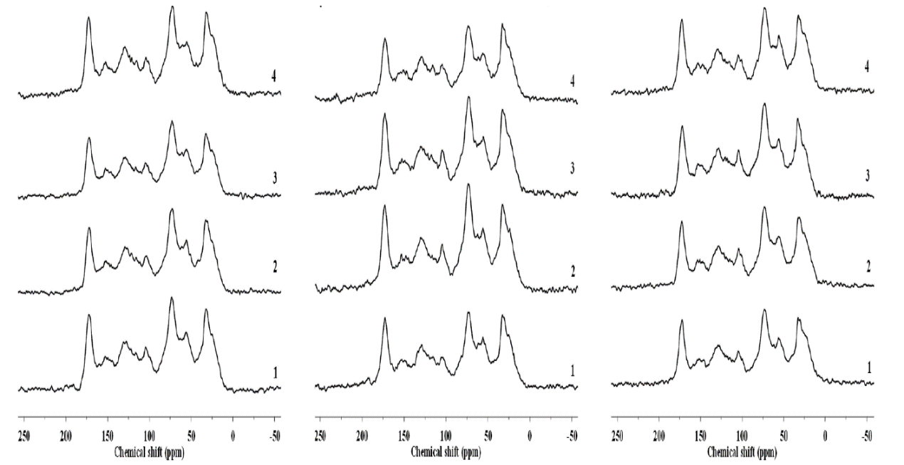

**Figure S2 Solid-state 13C CPMAS NMR spectra of soil under control (CK) (left), winter warming (WW) (middle) and year-round warming (YW) (right) treatments.**

**Figure S3 Main predictors of ecosystem respiration. The figure shows the Random Forest mean predictor importance (% of increase of MSE) of environmental and microbial drivers on ecosystem respiration. All these parameters can explain 67.2% variance of ecosystem respiration.**

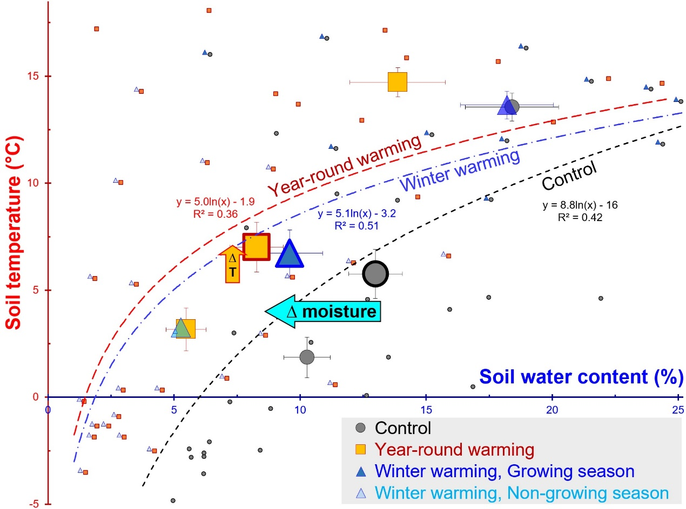

**Figure S4 Soil temperature and moisture at 5 cm depth in warming and control treatments**

The small points on the graph are monthly averaged soil temperature (°C) and moisture (v/v) for each plot from June 2012 to May 2015: Control: grey circles, Year-round warming: orange squares, Winter-warming: blue triangles. The large symbols are the average values for the duration of the experiment. The average values for the growing season and the non-growing season are indicated by the large symbols in the upper right, and lower left of the graph, respectively. The error bars in horizontal and vertical direction are the error bars of soil moisture(v/v) and temperature (°C) respectively. Curves are fitted using a [logarithmic](javascript:;) function according to monthly averaged soil temperature and moisture (black line for control, blue line for winter-warming and red line for year-round warming). The two arrows show the average increase of the temperature (∆T) and the decrease of soil moisture (∆ moisture).

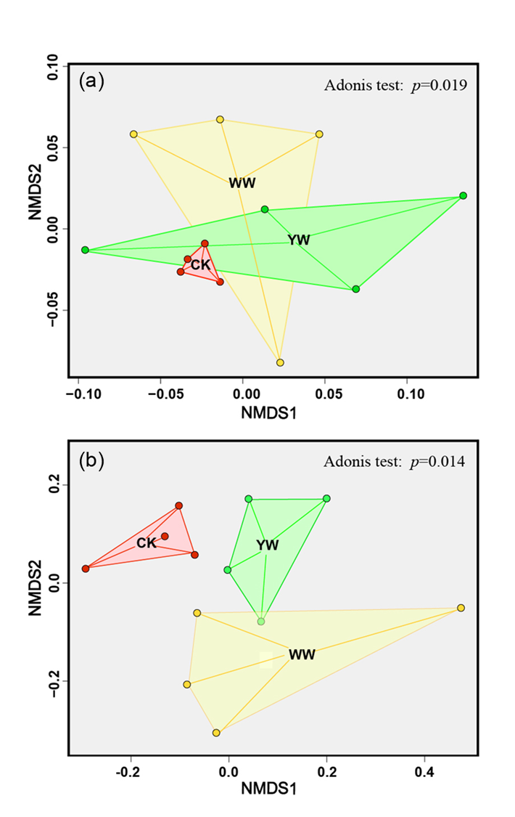

**Figure S5 Non-metric multidimensional scaling (NMDS) analyses for bacterial (a) and fungal (b) communities.**

CK: control; YW: year-round warming; WW: winter warming.



**Figure S6 A linear discriminant analysis effect size (LEfSe) method identifies the significantly abundant taxa of fungi**

In the evolutionary branch diagram, the circle radiating from inside to outside represents the classification level from the phylum to the genus. Each small circle at a different classification level represents a classification at that level. Differently colored nodes indicate the taxa that are significantly enriched in the corresponding group (red indicating control, green indicating year-round warming), and yellow nodes indicate microbial groups that have no significant difference. The threshold on the logarithmic LDA score was 2.0.

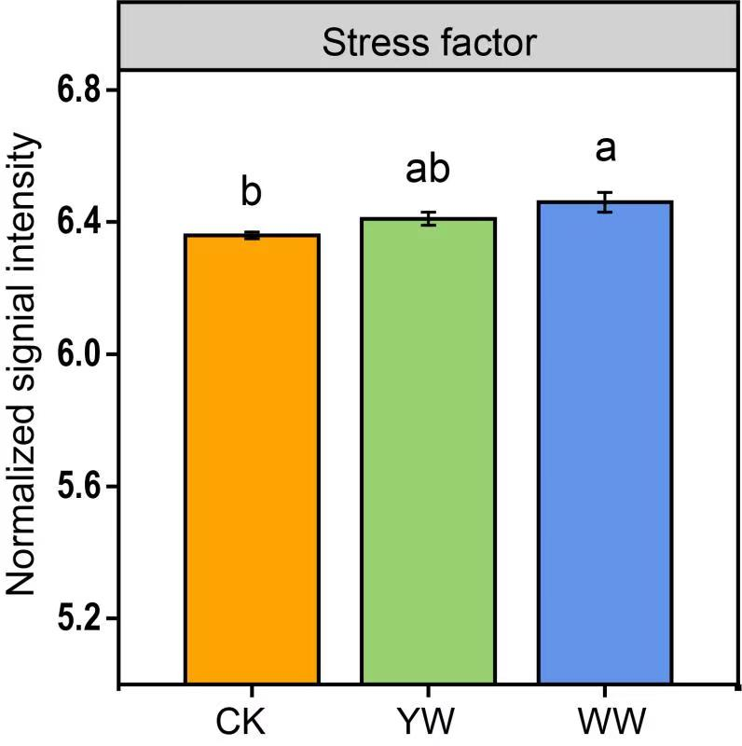

**Figure S7 The normalized average signal intensity of detected genes indicating stress response to warming**

Lowercase letters indicate significant differences between treatments; error bars indicate standard error of the mean (n=4). CK: control; YW: year-round warming; WW: winter warming.