Fig. S1. Flow Cytometer dot plot profiles of SYBR Green and Propidium Iodide (1:3) stained E.coli cells with viability of 0%, 25%, 50%, 75%, or 100% respectively. Live cells were mixed with dead cells killed by 70% isopropanol. P2 and P5 were the gate for dead and live cells, respectively. There was a strong correlation between the actual percentage of live cells and the percentage detected by Flow cytometer (p < 0.001).

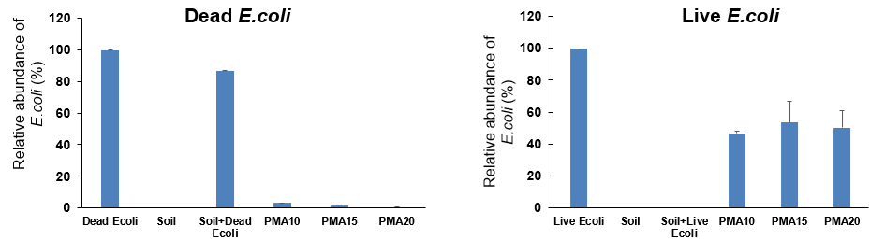
Not measured

Fig. S2. Optimization of light exposure time for PMA treatment of soil samples spiked with dead or live E. coli cells. The samples were exposed to LED light (470 nm) for 10 (PMA10), 15 (PMA15), or 20 (PMA20) minutes. PMA treatment efficiently removed E.coli DNA from dead cells.

Fig. S3. Richness of soil extractable bacteria with or without PMA treatment in four different extraction combinations. ANOVA indicates significant effect of PMA and cell extraction combinations (p < 0.001).

Fig. S4. Nonmetric multidimensional scaling (NMDS) ordination (stress = 0.18) of the weighted UniFrac distance for microbial communities in soil or soil extractable cells with different extraction methods. The detail combination was presented in Fig. 2. PERMANOVA indicates significant effect of PMA, cell fractions, extraction combination (p < 0.001).

Fig. S5. Relative abundance of several bacteria phyla (> 1%) are significantly different in extractable cells compared to the original soil samples (p < 0.05, ANOVA). PMA was used to remove DNA from dead cells. Soil cells were extracted using the combination of Blender + T20 + 80% Nycodenz. Stars indicate significant differences between samples with PMA treatments and samples without PMA treatment.

Fig. S6. Nonmetric multidimensional scaling (NMDS) ordination (stress = 0.19) of the weighted UniFrac distance for microbial communities of soil bacteria and soil extractable bacteria with or without PMA treatment in fresh and stored soils. PERMANOVA indicates significant effect of PMA, cell fraction, and storage (p < 0.001).

Fig. S7. Richness of soil bacteria and soil extractable bacteria with or without PMA treatment in fresh and stored soils. ANOVA analysis indicates significant effect of PMA, cell fraction, and storage (p < 0.001).

Fig. S8. Relative abundance of several viable bacteria phyla (> 1%) in 1st CELL extracted from fresh and stored soils (A). Lowercase letters indicate significant differences in a specific soil (p < 0.05, ANOVA). Log₂-fold change in relative abundances of OTUs of soil extractable cells compared with those of the fresh soil (B). Each circle represents a single OTU with an adjusted p value of < 0.1. Dashed line: 2-fold change. Dotted lines: 10-fold change.

Fig. S9. Relative abundance of several viable bacteria phyla (> 1%) in 2nd CELL extracted from fresh and stored soils (A). Lowercase letters indicate significant differences in a specific soil (p < 0.05, ANOVA). Log₂-fold change in relative abundances of OTUs of soil extractable cells compared with those of the fresh soil (B). Each circle represents a single OTU with an adjusted p value of < 0.1. Dashed line: 2-fold change. Dotted lines: 10-fold change.

