**SUPPLEMENTAL INFORMATION** *Nuccio et al. 2019 ISME J.*

**METHODS**

**Metatranscriptomic Sequencing (RNASeq)**

Metatranscriptome libraries were prepared and sequenced at the Joint Genome Institute. Ribosomal RNA was depleted from 1 µg of total RNA using the Ribo-Zero rRNA Removal Kit (Epicentre) for Plants and Bacteria. Stranded cDNA libraries were generated using the Illumina TruSeq Stranded RNA LT kit.  The rRNA depleted RNA was fragmented and reversed transcribed using random hexamers and SSII (Invitrogen) followed by second strand synthesis. The fragmented cDNA was treated with end-pair, A-tailing, adapter ligation, and 10 cycles of PCR. qPCR was used to determine the concentration of the libraries. Libraries were sequenced on the Illumina Hiseq.

The prepared libraries were quantified using KAPA Biosystem’s next-generation sequencing library qPCR kit and run on a Roche LightCycler 480 real-time PCR instrument. The quantified libraries were then multiplexed into pools of 1-3 libraries each, and the pool was then prepared for sequencing on the Illumina HiSeq sequencing platform utilizing a TruSeq paired-end cluster kit, v3, and Illumina’s cBot instrument to generate a clustered flowcell for sequencing. Sequencing of the flowcell was performed on the Illumina HiSeq2000 sequencer using a TruSeq SBS sequencing kit, v3, following a 2x150 indexed run recipe.

**Single Amplified Genome (SAG) Preparation and Sequencing**

Cell suspensions for single cell sorting were created for rhizosphere soil and root endophytes. Approximately ~3 grams of roots covered in rhizosphere soil were washed in 10ml cell release buffer (CRB: 0.5% tween, 2.24 mM Na pyrophosphate in PBS).  Roots were vortexed 4x times for 1 min on full speed on a horizontal shaker; between each step, the soil was soft pelleted (2KxG for 2 min), and the roots and supernatant were retained and moved into a clean tube. Cells in the CRB were counted using an Axioimager and SYBR fluorescence (final concentration 10^7 cells), and then glycerol was added (15% final concentration) prior to freezing at -80C for storage.  The remaining roots were washed in PBS to remove the any remaining soil, shaken in 10% bleach for 1 min, rinsed in water, and dried in a final centrifugation step.  Roots were frozen at –80C, and then later macerated with a sterile mortar and pestle to create an endophyte suspension for cell sorting (Levy et al. 2018).

Single amplified genomes (SAGs) were generated following standard procedures in the Department of Energy Joint Genome Institute workflow (Rinke et al. 2014). Briefly, individual cells were sorted on a BD Influx (BD Biosciences) and treated with Ready-Lyse lysozyme (Epicentre; 5 U/μl final concentration) for 15 min at room temperature prior to the addition of lysis solution. Whole-genome amplification was performed with the REPLI-g Single Cell Kit (Qiagen) in 2 μl reactions set up with an Echo acoustic liquid handler (Labcyte). Amplification reactions were terminated after 6 h.  Sequencing libraries were generated using the Nextera XT v2 kit (Illumina), and 2X150bp sequencing reads were sequenced on the Illumina Nextseq platform.

**Amplicon Sequencing (16S and ITS iTags)**

Each RNA sample prepared for metatranscriptomics sequencing was also reverse transcribed to create a paired cDNA sample for 16S and ITS amplicon analysis. 400 ng of TURBO DNase-treated RNA was reverse transcribed using the SuperScript III First-Strand Synthesis System (Invitrogen) with random hexamers according to the manufacturer’s protocol. Plate-based 16S V4 region and ITS iTag preps are performed on the PerkinElmer Sciclone NGS robotic liquid handling system using 30 ng sample input, custom designed target primers with incorporated Illumina sequencing adapters. PCR amplicons were created using 25ul reactions using 10 ng cDNA, 1x 5PRIME HotMasterMix (Quantabio), 0.4 mg/ml BSA, and 200 nmol each primers (515F GTGCCAGCMGCCGCGGTAA; 805R GGACTACHVGGGTWTCTAAT) or Fungal ITS2 primers (ITS9 GAACGCAGCRAAIIGYGA; ITS4 TCCTCCGCTTATTGATATGC). Reverse primers were barcoded. Amplification procedure was as follows: initial denaturing at 94°C (3 min), 30 cycles of 94°C (45 sec), 50°C (60 sec), 72°C (90 sec), with a final extension at 72°C (10 min). After library sample prep, the samples from each target primer set were pooled together and the pool quantified using KAPA Biosystem’s next-generation sequencing library qPCR kit and run on a Roche LightCycler 480 real-time PCR instrument. The pool was then loaded and sequenced on the Illumina MiSeq sequencing platform utilizing a MiSeq Reagent Kit, v3 600 cycle, following a 2x300 indexed run recipe.

**FIGURES**

**B.**

**C.**

**A.**

**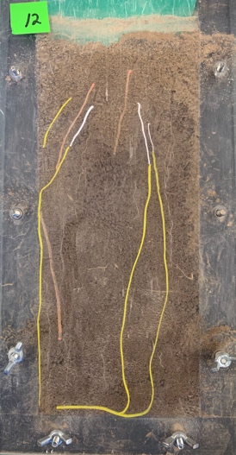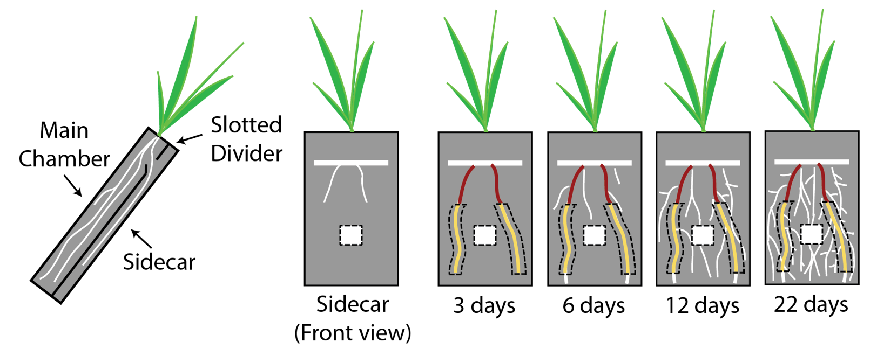**

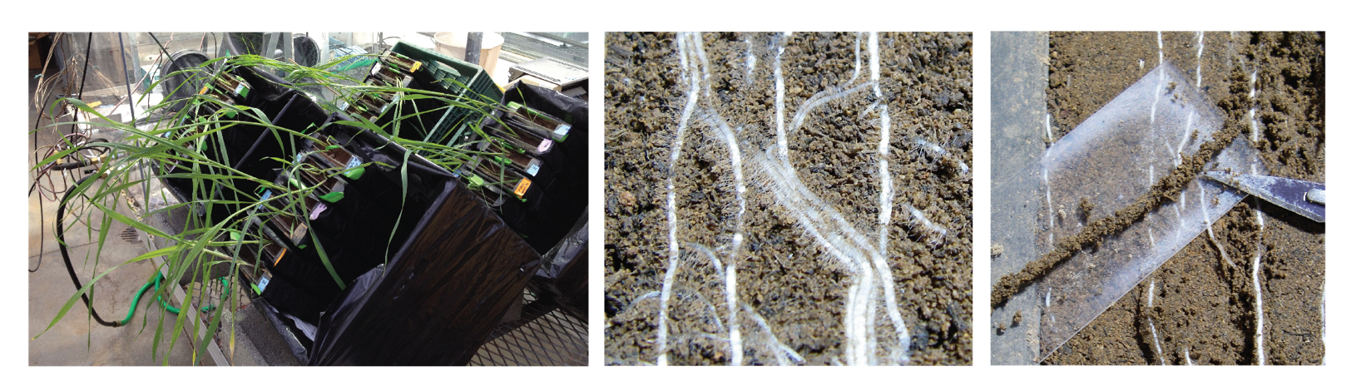

**D.**

**E.**

**F.**

**Rhizo/Bulk \* Detritus/No Detritus \* 4 timepoints \* 3 reps =**

**48 soil metatranscriptomes**

**Figure S1:** Experimental design. (A.) Plants were grown in microcosms with a main plant chamber and separate experimental root chamber (sidecar) separated by a divider. After 6 weeks of plant growth, the solid divider was replaced with a slotted divider to allow root growth into the sidecar. (B.) Each sidecar contained a mesh bag filled with bulk soil (dashed white squares). To synchronize root age among all the microcosms, root growth was tracked through the clear sidecar wall using a waterproof marker. “Red” root sections indicate those that initially grew into the sidecar. Marked “yellow” roots surrounded by dashed lines represent three days of subsequent root growth; these root sections were allowed to age and were the only root sections harvested in this study. Marked root sections were destructively sampled at 3, 6, 12, and 22 days. (C.) Photo of clear sidecar wall which has been marked to track root age; yellow sections were harvested, which are 12 days old in this photo. (D.) Microcosms were tilted after replacing solid divider with slotted divider to encourage root growth into the sidecar. (E.) Roots and associated rhizospheres are visible at the soil surface after removing the clear sidecar wall. (F.) Rhizosphere soil was identified by using a scalpel to cut along the edge of the root hairs (~2mm from root surface) and then peeling the root out of the side car. Root sections with attached rhizosphere soil were immediately placed in ice cold Lifeguard solution, and rhizosphere soil was washed off later that day.

**Figure S2:** Average number of potential mRNA reads per sample after removing sequencing contaminants and ribosomal RNA reads (+/- standard deviation). Reads are averaged by treatment over time (3, 6, 12, 22 days) after exposure to the root (Rhizosphere, blue), bulk soil (Bulk, red), and amending both these habitats with root detritus (Rhizosphere + Detritus, light blue; Bulk + Detritus, yellow).

MTX_evenness.pdf

MTX_richness.pdf

MTX_shannon_diversity.pdf

**Figure S3:** Average mRNA diversity after mapping to reference database for all rhizosphere (blue) and bulk soil (red) samples over time. Diversity is presented as average evenness (A), average richness (B), and average Shannon diversity (C) +/- standard deviation. H1-H4 refers to timepoints 3, 6, 12, 22 days, respectively.

**A. B.**

**Figure S4:** Average gravimetric soil moisture (A) and pH (B) of the microcosm soil amended with root detritus (blue) and without root detritus (orange) at each time point (+/- standard deviation). Letters represent Tukey HSD post hoc significance groups.

**A. B.**

****

**Figure S5:** Influence of time on 16S bacterial communities (A) and mRNA transcripts (B). Symbols represent the different treatments:Rhizosphere (hollow triangles), Rhizosphere + Detritus (filled triangles), Bulk (hollow circles), Bulk + Detritus (filled circles). Points are shaded by time point from light blue (3 days) to purple (22 days). Arrow overlays on indicate significant factors (Rhizosphere, Bulk) and numerical correlates (moisture, time) driving the community composition, as calculated by envfit.



**Figure S6:** The cumulative number of significantly upregulated CAZy genes in the treatments relative to bulk soil for four CAZy enzyme classes (auxiliary activity, carbohydrate esterases, glycoside hydrolases, polysaccharide lyases) over the time-course experiment. The treatments are rhizosphere samples that contain detritus (red circles), bulk soil samples that contain detritus (black square), and rhizosphere without detritus addition (blue triangle).

**Supplemental Figure S7:** Population metatranscriptomes for carbohydrade degradation CAZymes for the 26 populations (A-X below) that had 4 or more CAZymes significantly expressed. Gene annotation is presented in rows (CAZyme number and consensus annotation). Treatments are Rhizosphere (R), Rhizosphere + Detritus (RL), and Bulk Soil + Detritus (BL). H1-H4 represents the timepoints (3, 6, 12, 22 days, respectively). “S.P.” indicates that the reference gene sequence had a potential signal peptide as calculated by SignalP (Petersen et al. 2011). 226 of 407 enzymes had recognizable signal peptides.

1. **Burkholderiales 54\_8 (Rhizosphere guild)**

****

1. **Janthinobacterium 65\_15 (Rhizosphere guild)**

****

**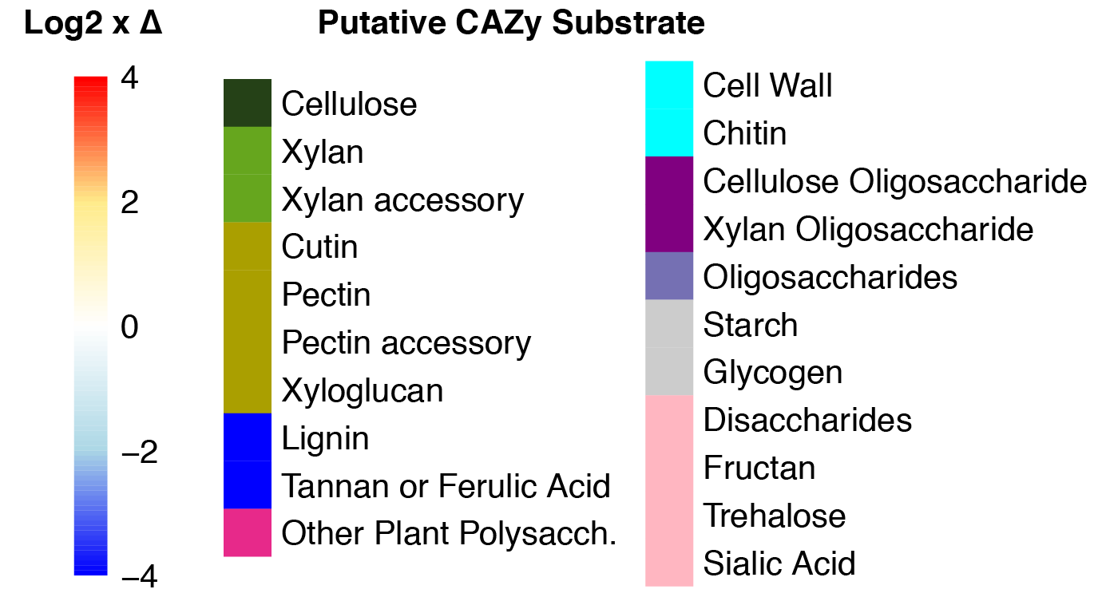**

1. **Massilia 66\_12 (Rhizosphere guild)**

****

1. **Verrucomicrobiota 63\_30 (Rhizosphere guild)**

****

1. **Burkholderiales 62\_29 (Rhizosphere guild)**

****

1. **Asticcacaulis 63\_11 (Detritusphere guild)**

****

****

1. **Fibrobacterota 63\_12 (Detritusphere guild)**

****

1. **Segetibacter b85 (Detritusphere guild)**

****

****

1. **Devosia JGI 030 (Detritusphere guild)**

****

1. **Niastella b58 (Detritusphere guild)**

****

****

1. **Rhizobium 59\_9 (Detritusphere guild)**

****

1. **Streptomyces tu. 70\_12 (Detritusphere guild)**

****

****

1. **Steptomyces 70\_9 (Aging root guild)**

****

1. **Steptomyces 71\_13 (Aging root guild)**

****

****

1. **Streptomyces 71\_16 (Aging root guild)**

****

1. **Streptomyces 70\_12 (Aging root guild)**

****

1. **Actinobacteriota 70\_8 (Aging root guild)**

****

****

1. **Catenulisporales 70\_18 (Aging root guild)**

****

1. **Streptomyces URHA0041 (Aging root guild)**

****

1. **Gammaproteobacteria b1 (Low response)**

****

****

1. **Niabella b75 (Low response)**

****

1. **Micromonosporaceae (Low response)**

****

1. **Bradyrhizobium URHA0013 (Low response)**

****

1. **Kribbella b6 (Low response)**

****

****

**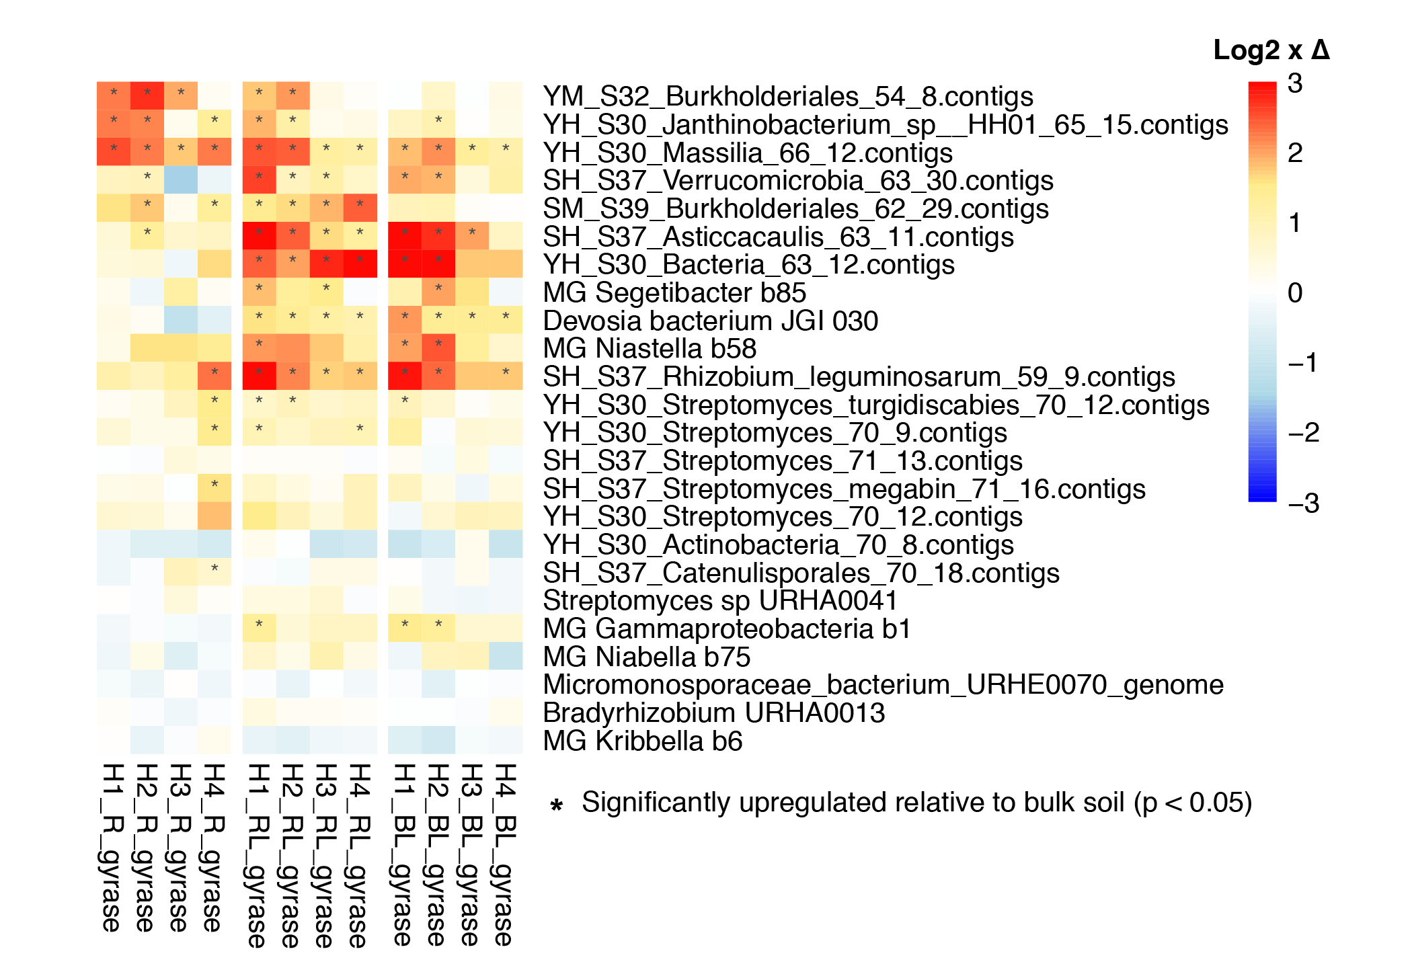**

**Figure S8.** Population increases based on housekeeping gene expression (gyrase A, B), or “Growers.” Heatmaps colors indicate the log2 fold increase (red) or decrease (blue) of average gyrase gene expression per genome relative to bulk soil over time (3, 6, 12, 22 days). Stars (\*) indicate significant upregulation of gene expression relative to bulk soil by DESeq2.

**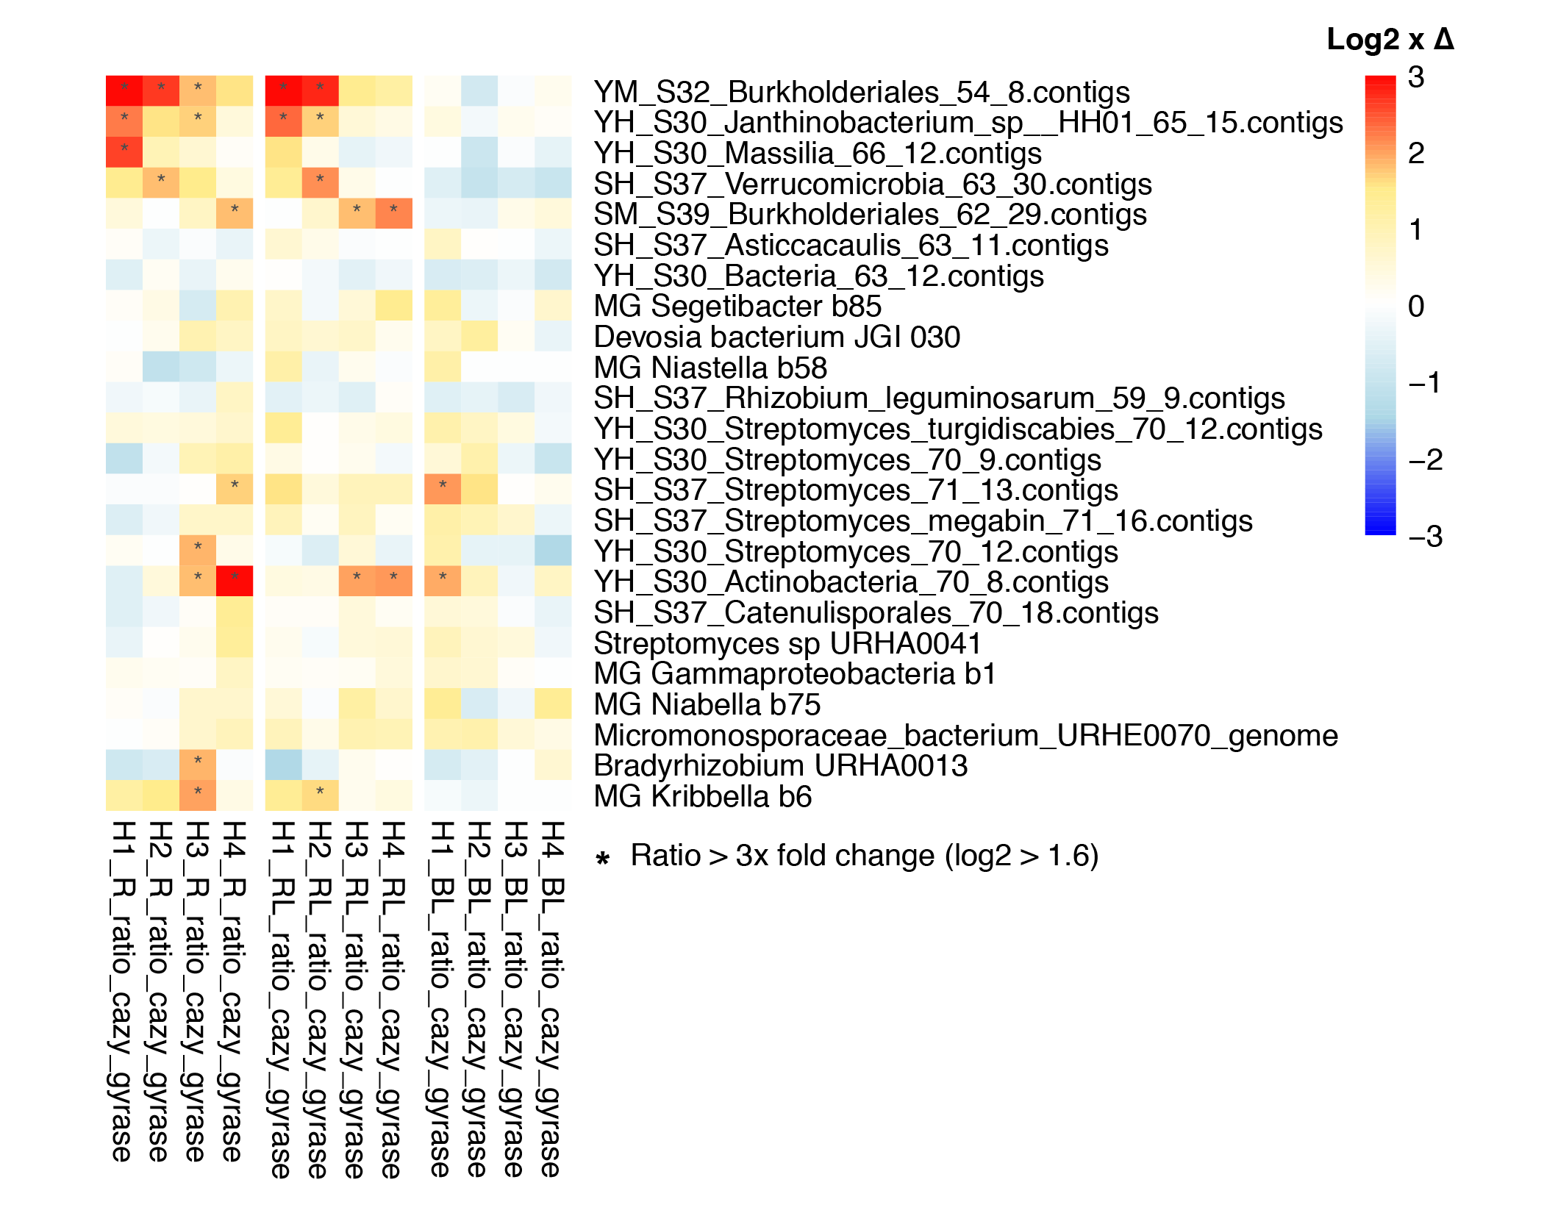**

**Figure S9.** Population abundance-normalized CAZyme expression depicting “Upregulators.” Heatmaps colors indicate the log2 fold increase (red) or decrease (blue) of average CAZyme gene expression per genome relative to housekeeping gene expression (gyrase A, B) over time (3, 6, 12, 22 days). Stars (\*) indicate > 1.6x log2 fold change (i.e., 3-fold change).

**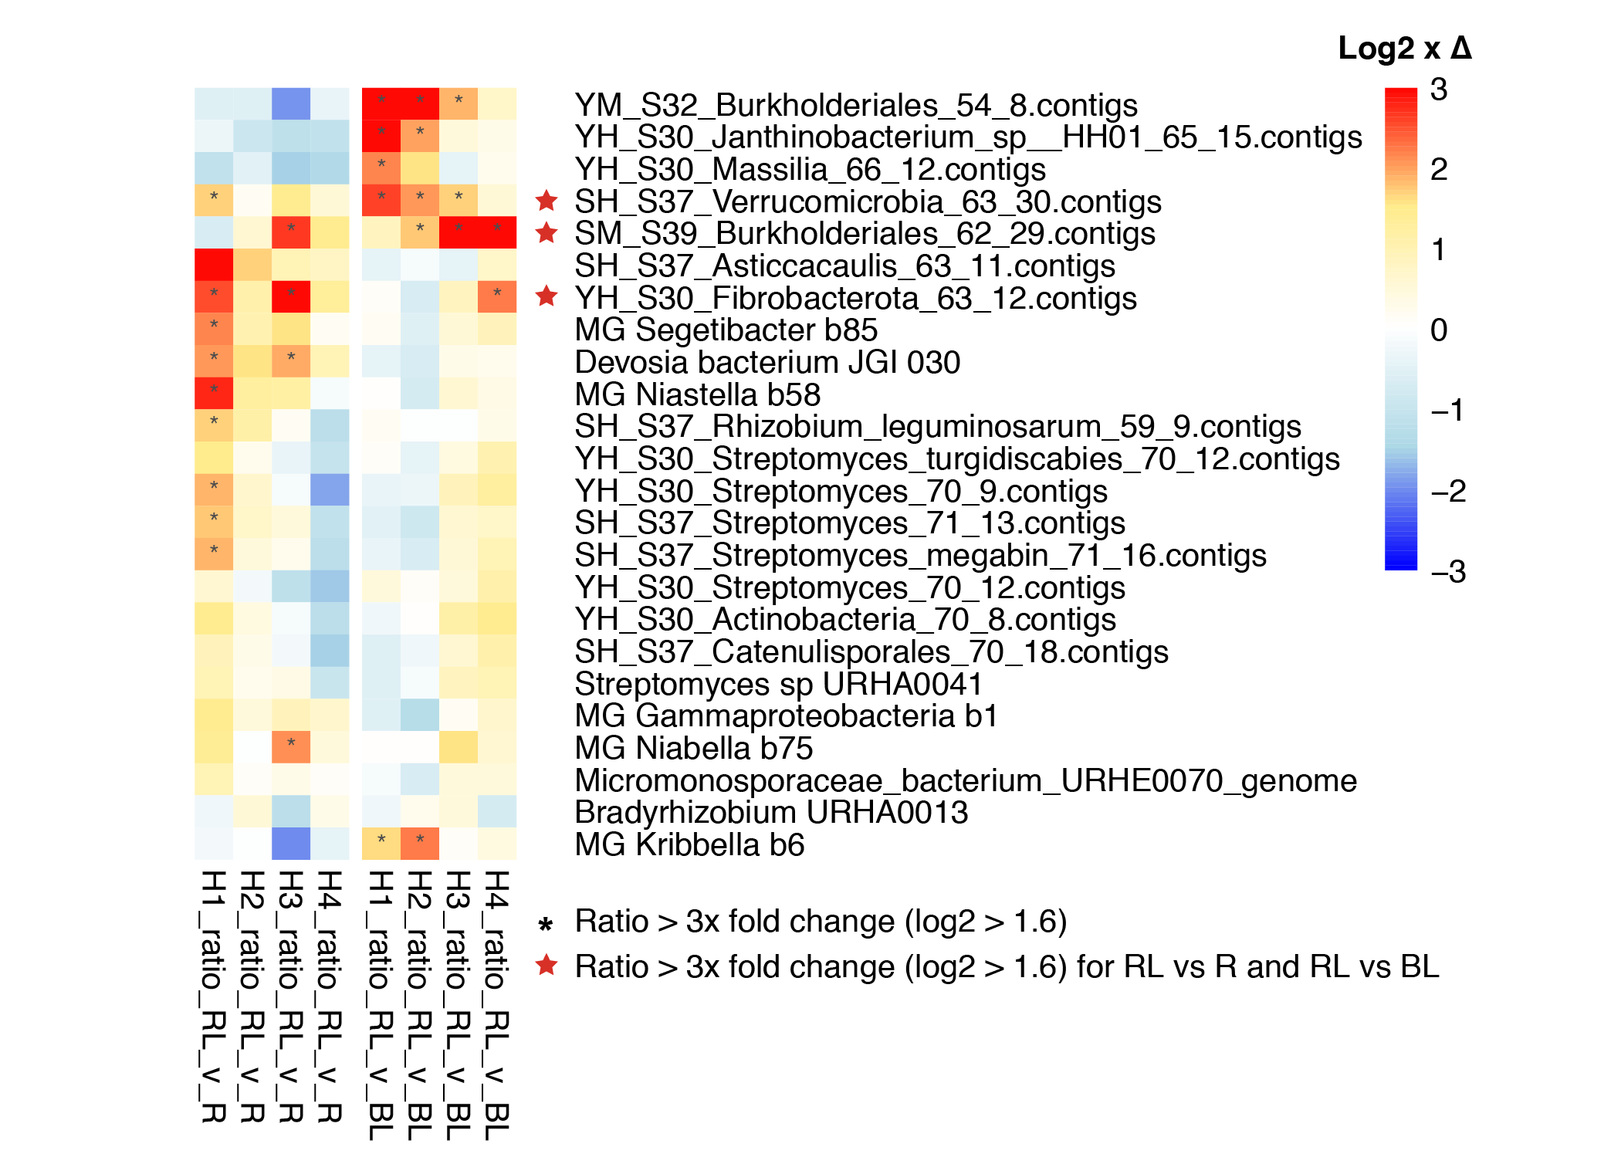Figure S10.** Identification of “Synergist” populations that have highest gene expression in the Rhizosphere + Detritus (RL) treatment relative to both the Rhizosphere (R) and Bulk + Detritus (BL) treatments. Heatmaps colors indicate the log2 fold increase (red) or decrease (blue) over time (3, 6, 12, 22 days). Stars (\*) indicate > 1.6x log2 fold change (i.e., 3-fold change). Red stars indicate synergist populations that had a star (\*) for both the RL vs R comparison and the RL vs BL comparison.

**REFERENCES**

Levy, A., I. Salas Gonzalez, M. Mittelviefhaus, S. Clingenpeel, S. Herrera Paredes, J. Miao, K. Wang, G. Devescovi, K. Stillman, F. Monteiro, B. Rangel Alvarez, D. S. Lundberg, T.-Y. Lu, S. Lebeis, Z. Jin, M. McDonald, A. P. Klein, M. E. Feltcher, T. G. Rio, S. R. Grant, S. L. Doty, R. E. Ley, B. Zhao, V. Venturi, D. A. Pelletier, J. A. Vorholt, S. G. Tringe, T. Woyke, and J. L. Dangl. 2018. Genomic features of bacterial adaptation to plants. Nature Genetics **50**:138-150.

Petersen, T. N., S. Brunak, G. von Heijne, and H. Nielsen. 2011. SignalP 4.0: discriminating signal peptides from transmembrane regions. Nature Methods **8**:785-786.

Rinke, C., J. Lee, N. Nath, D. Goudeau, B. Thompson, N. Poulton, E. Dmitrieff, R. Malmstrom, R. Stepanauskas, and T. Woyke. 2014. Obtaining genomes from uncultivated environmental microorganisms using FACS–based single-cell genomics. Nature Protocols **9**:1038-1048.