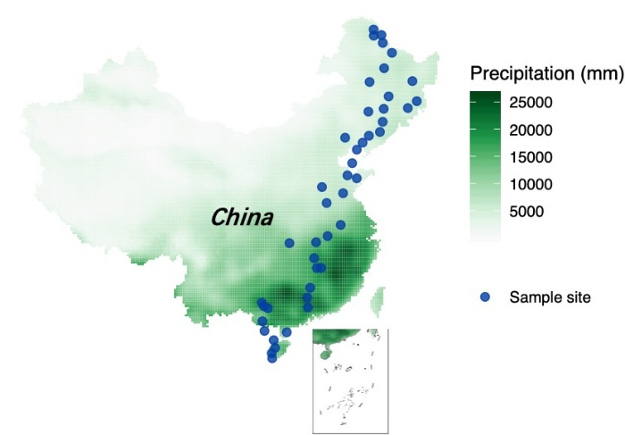
Figure S1. Location of 45 sampling sites.

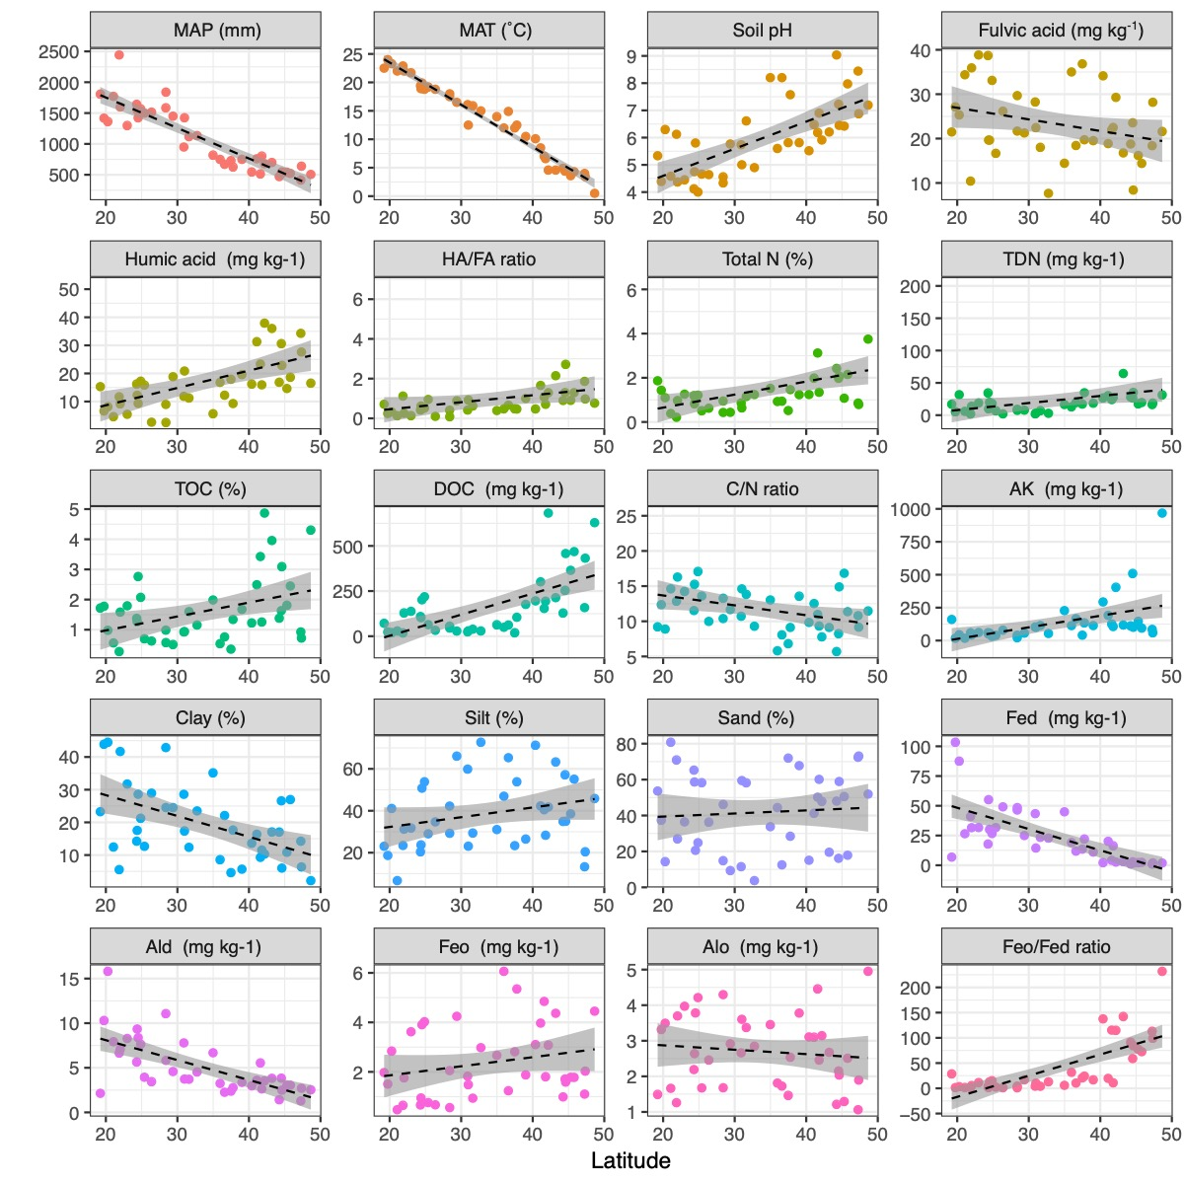
Figure S2. Metadata for sampling sites along the latitudinal transect. HA-humic acid; FA-fulvic acid; Ald-dithionite extractable Al; MAT-mean annual temperature; Fed-dithionite extractable Fe; Feo-amorphous sesquioxides Fe; MAP-mean annual precipitation; TOC-total organic carbon; DOC-dissolved organic carbon; AK-available K; TDN-total dissolved N; Alo- amorphous sesquioxides Al.

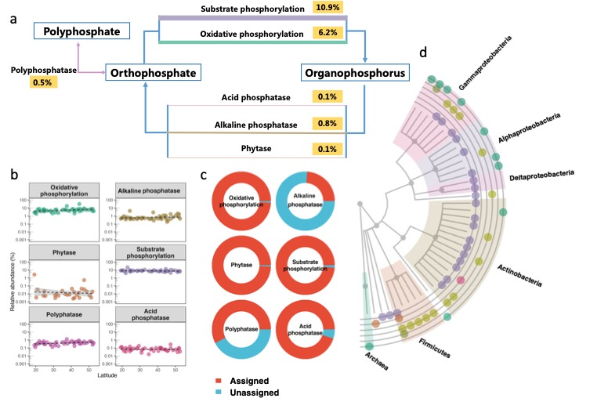
Figure S3. Genes associated with phosphorus biogeochemical cycling in forest soils. (a) Phosphorus biogeochemical cycle pathways; arrow width indicates proportion of biomarker gene contigs for corresponding pathways. (b) Linear relationships between contigs and latitude. (c) Proportion of contigs assigned to known taxa. (d) Distribution of known taxa.

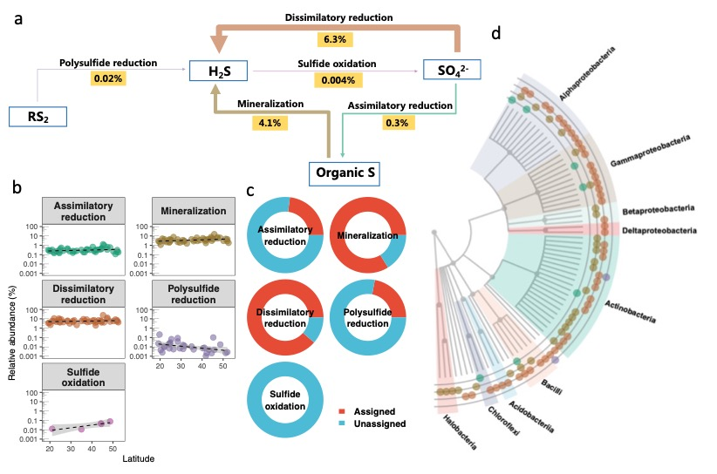
Figure S4. Genes associated with sulfur biogeochemical cycling in forest soils. (a) Sulfur biogeochemical cycle pathways; arrow width indicates proportion of biomarker gene contigs for corresponding pathways. (b) Linear relationships between contigs and latitude. (c) Proportion of contigs assigned to known taxa. (d) Distribution of known taxa.

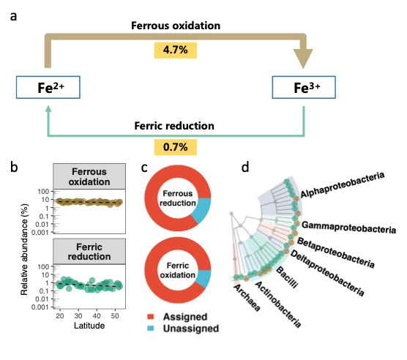
Figure S5. Genes associated with iron biogeochemical cycling in forest soils. (a) Iron biogeochemical cycle pathways; arrow width indicates proportion of biomarker gene contigs for corresponding pathways. (b) Linear relationships between contigs and latitude. (c) Proportion of contigs assigned to known taxa. (d) Distribution of known taxa.

Table S1. GPS coordinates for all sampling sites
Sample | Longitude | Latitude | Sample | Longitude | Latitude
V1 | 126.1247 | 48.6509 | V24 | 112.2898 | 30.9050
V2 | 130.2527 | 47.3398 | V25 | 115.8927 | 29.3888
V3 | 130.8958 | 45.3086 | V26 | 116.9176 | 28.3973
V4 | 124.0023 | 47.2539 | V27 | 116.2927 | 28.3876
V5 | 126.7833 | 45.7893 | V28 | 115.3204 | 26.3879
V6 | 129.5898 | 44.6060 | V29 | 114.9126 | 25.3985
V7 | 126.0660 | 44.5282 | V30 | 114.9936 | 24.3852
V8 | 123.8310 | 44.2441 | V31 | 108.2600 | 24.8700
V9 | 125.5090 | 42.1828 | V32 | 108.5600 | 24.5200
V10 | 125.9139 | 43.2116 | V33 | 109.1500 | 24.3100
V11 | 123.9000 | 41.8000 | V34 | 108.3500 | 22.9900
V12 | 120.4300 | 41.6000 | V35 | 108.6500 | 22.0100
V13 | 122.9800 | 41.1000 | V36 | 111.9000 | 21.8667
V14 | 122.1300 | 40.3900 | V37 | 110.0000 | 21.0667
V15 | 121.4600 | 39.0200 | V38 | 110.2000 | 20.2833
V16 | 120.7663 | 37.7789 | V39 | 109.7064 | 19.7429
V17 | 122.1203 | 37.4890 | V40 | 109.7799 | 19.2315
V18 | 117.0470 | 36.6002 | V41 | 127.2660 | 50.2129
V19 | 117.7290 | 34.9834 | V42 | 125.9296 | 51.2123
V20 | 120.1311 | 35.9731 | V43 | 125.7328 | 52.0126
V21 | 119.7810 | 32.7556 | V44 | 124.5823 | 52.5719
V22 | 117.8717 | 31.6206 | V45 | 124.6095 | 51.9504
V23 | 116.1897 | 30.9966

Table S2. Biomarker genes of biogeochemical processes.
Element | Pathways | Biomarker | Full name | Short name
Carbon | Fermentation | K00016 | L-lactate dehydrogenase | LDH
 | Anaerobic C fixation | K00175 | 2-oxoglutarate/2-oxoacid ferredoxin oxidoreductase subunit beta | KorB
 | Aerobic C fixation | K00855 | Phosphoribulokinase | PRK
 | Aerobic respiration | K02256 | Cytochrome c oxidase subunit 1 | COX1
 | CO oxidation | K03520 | Aerobic carbon-monoxide dehydrogenase large subunit | coxL
 | Aerobic methane oxidation | K10944 | Methane/ammonia monooxygenase subunit A | pmoA
 | Methanogenesis | PF06253 | Trimethylamine methyltransferase | MTTB
Nitrogen | Nitrite oxidation | K00370 | Nitrate reductase / nitrite oxidoreductase, alpha subunit | narG
 | Anammox | K00404 | Cytochrome c oxidase cbb3-type subunit I | ccoN
 | Nitrogen assimilation | K01915 | Glutamine synthetase | glnA
 | Nitrate reduction | K02020 | Molybdate transport system substrate-binding protein | modA
 | Denitrification | K04561 | Nitric oxide reductase subunit B | norB
 | Nitrification | K10946 | Methane/ammonia monooxygenase subunit C | amoC
 | Nitrogen mineralization | K15371 | Glutamate dehydrogenase | GDH2
 | Nitrogen fixation | PF00142 | 4Fe-4S iron sulfur cluster binding proteins | nifH
 | Ammonification | PF01077 | Nitrite and sulfite reductase 4Fe-4S domain | NIR
Phosphorus | Oxidative phosphorylation | K00937 | Polyphosphate kinase | ppk
 | Alkaline phosphatase | K01077 | Alkaline phosphatase | phoA
 | Phytase | K01083 | Phytase | phytase
 | Substrate phosphorylation | K08483 | PTS system enzyme I | Ptsl
 | Polyphatase | PF00719 | Pyrophosphatase | Pyrophosph-atase
 | Acid phosphatase | PF03767 | Acid phosphatases | acid_phosphat
Sulfur | Assimilatory sulfate reduction | K00860 | Adenylylsulfate kinase | cysC
 | Sulfur mineralization | K01011 | 3-mercaptopyruvate sulfurtransferase | sseA
 | Sulfur oxidation | PF08770 | Sulphur oxidation protein | soxZ
 | Dissimilatory sulfate reduction | PF13187 | Ferredoxins | Fer4
 | Polysulfide reduction | PF14589 | Glycoside hydrolase | NrfD
Iron | Ferrous oxidation | PF00210 | Ferritin | Ferritin
 | Ferric reduction | PF01794 | Ferric reductase transmembrane component | Ferric_ reduct

