Fig. S1 Sampling and sequencing of methanogens. Abscissa: the number of sequences randomly selected from the sample; ordinate: the species diversity and the number of OTU that can be represented by the random sampling sequence. Each curve in the figure represents a sample, marked with a different color.

Fig. S2 Linear regression of methanogenic archaea α-diversity and MAT (A) and CH₄ emissions (B). Solid lines denote significant relationship with 95% confidence interval (shadow area). Dotted line denotes P > 0.05.

Fig. S3 The co-occurrence network structure of methanogenic community of 39 plots. Percentage in the top right corner indicates the proportion of 33 key OTUs (Table S4) in total node numbers of each network.

Fig. S4 Contributions of climatic variables and soil properties to the network topological attributes based on correlation and random forest regression model. Circle size represents the variable importance (that is, proportion of explained variability calculated via forest regression analysis analysis). Colors represent Spearman’s correlation coefficients (node: node number; edge: edge number; modularity: modularity; positive: positive correlations; negative: negative correlations; Avg.C.C: average clustering coefficient; N.D: network diameter; C.P.L: characteristic path length).
Fig. S5 Spearman’s correlation analysis of network topological attributes and richness. Blue shaded area is a 95% confidence interval.

Fig. S6 Spearman’s correlation analysis of network topological attributes and CH₄ emissions. Dotted lines denote P > 0.05. Solid lines indicate a significant correlation (P < 0.05), with the blue shaded area showing the 95% confidence interval.

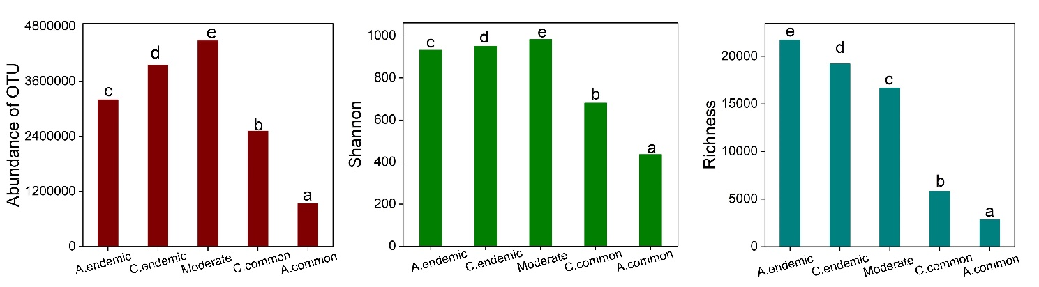
Fig. S7 Relative abundance of OTUs of the five groups of methanogenic archaeal communities. Each column followed by different letters differed significantly at P < 0.05 (ANOVA, Duncan test). (A.endemic: always endemic group; C.endemic: conditionally endemic group; C.common: conditionally common group; A.common: always common group).

Fig. S8 Relative abundance frequency histogram of 33 keystone OTUs in 429 samples. The blue histogram indicates rare OTUs (average relative abundance < 1% in 429 samples). The red histogram indicates abundant OTUs (average relative abundance > 1% in 429 samples), and the inset represents low-frequency OTUs with average relative abundance < 1%.

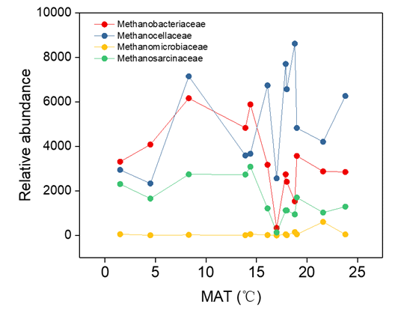
Fig. S9 The relative abundance of keystone taxa (at the family level) changes with temperature. (HL: 1.5℃, CC: 4.5℃, SY:8.3℃, YY: 14.4℃, FQ:13.9℃, LA: 16.1℃, QZ:17.9℃, ZX:17℃, JO:18.8℃, CT:19℃, HY:18℃, QX:21.6℃, HK:23.8℃)

Fig. S10 The relationship between keystone species and microbial functional genes related to methane generation depicted as colored segments in a CIRCOS plot. Ribbons connecting two segments indicate the interaction between the two. The size of the ribbon is proportional to the number of links.

Table S1 Geographic information of 13 sampling regions with 3 plots in each region.
 | Longitude | Latitude | MAT(ºC) | MAP (mm)
HL (Hailun) | 126.97°E | 47.82°N | 1.5 | 556
CC (Changchun) | 125.35°E | 44.74°N | 4.5 | 520
SY (Shenyang) | 123.86°E | 41.57°N | 8.3 | 400
YY (Yuanyang) | 113.36°E | 35.14°N | 14.4 | 550
FQ (Fengqiu) | 114.85°E | 34.89°N | 13.9 | 615
LA (Linan) | 116.52°E | 30.61°N | 16.1 | 1613
QZ (Quzhou) | 118.91°E | 27.24°N | 17.9 | 1971
ZX (Zixi) | 117.92°E | 27.75°N | 17 | 1934
JO (Jian’ou) | 118.72°E | 27.05°N | 18.8 | 1664
CT (Changting) | 116.52°E | 26.61°N | 19 | 1700
HY (Hengyang) | 112.18°E | 25.52°N | 18 | 1500
QX (Qingxin) | 112.72°E | 23.53°N | 21.6 | 2215
HK (Haikou) | 110.01°E | 19.72°N | 23.8 | 1664
MAT, mean annual temperature; MAP, mean annual precipitation; All the soil geochemical data are available in the repository Figshare https://doi.org/10.6084/m9.figshare.11493081.v2.

Table S2 The topological features of the co-occurrence network in each plot.
Sites | Node | Edge | Positive | Negative | Modularity | Average clustering  coefficient | Network  diameter | Characteristic  path length
HLa | 62 | 163 | 150 | 13 | 3 | 0.36 | 6 | 2.38
HLb | 39 | 45 | 40 | 5 | 3 | 0.27 | 9 | 3.19
HLc | 95 | 268 | 221 | 47 | 5 | 0.36 | 11 | 3.88
CCa | 41 | 41 | 34 | 7 | 3 | 0.37 | 5 | 1.94
CCb | 32 | 26 | 22 | 4 | 1 | 0.38 | 5 | 2.24
CCc | 44 | 88 | 18 | 70 | 3 | 0.41 | 10 | 3.68
SYa | 38 | 28 | 22 | 6 | 1 | 0.09 | 4 | 1.68
SYb | 13 | 8 | 8 | 0 | 0 | 0.10 | 3 | 1.42
SYc | 63 | 68 | 58 | 10 | 3 | 0.18 | 10 | 4.71
YYa | 94 | 242 | 221 | 21 | 8 | 0.46 | 11 | 4.61
YYb | 63 | 70 | 60 | 10 | 5 | 0.39 | 9 | 3.20
YYc | 88 | 507 | 437 | 70 | 2 | 0.46 | 6 | 2.62
FQa | 60 | 73 | 67 | 6 | 3 | 0.28 | 7 | 2.23
FQb | 70 | 83 | 70 | 13 | 5 | 0.32 | 12 | 4.38
FQc | 19 | 14 | 13 | 1 | 2 | 0.24 | 2 | 1.22
LAa | 107 | 182 | 157 | 25 | 6 | 0.36 | 15 | 5.86
Lab | 114 | 531 | 365 | 166 | 5 | 0.45 | 9 | 3.32
Lac | 96 | 244 | 172 | 72 | 2 | 0.35 | 10 | 3.43
QZa | 90 | 201 | 137 | 64 | 3 | 0.30 | 8 | 3.50
QZb | 116 | 436 | 379 | 57 | 4 | 0.41 | 8 | 3.43
QZc | 124 | 279 | 260 | 19 | 9 | 0.51 | 12 | 5.58
ZXa | 97 | 330 | 307 | 23 | 7 | 0.48 | 10 | 3.74
ZXb | 107 | 709 | 585 | 124 | 4 | 0.51 | 8 | 2.89
ZXc | 117 | 741 | 571 | 170 | 3 | 0.49 | 6 | 2.60
JOa | 108 | 201 | 185 | 16 | 7 | 0.38 | 13 | 5.78
JOb | 147 | 348 | 313 | 35 | 10 | 0.53 | 13 | 4.79
JOc | 141 | 1039 | 643 | 396 | 4 | 0.49 | 10 | 2.99
CTa | 107 | 250 | 203 | 47 | 7 | 0.47 | 9 | 3.66
CTb | 108 | 220 | 159 | 61 | 10 | 0.50 | 14 | 5.27
CTc | 80 | 127 | 99 | 28 | 6 | 0.29 | 10 | 3.36
HYa | 112 | 263 | 221 | 42 | 7 | 0.41 | 14 | 5.14
HYb | 112 | 456 | 384 | 72 | 5 | 0.40 | 10 | 3.74
HYc | 79 | 122 | 77 | 45 | 3 | 0.53 | 8 | 3.57
QXa | 107 | 245 | 162 | 39 | 7 | 0.39 | 12 | 4.68
QXb | 95 | 235 | 397 | 39 | 6 | 0.46 | 10 | 3.67
QXc | 88 | 224 | 215 | 64 | 2 | 0.33 | 8 | 2.96
HKa | 86 | 153 | 125 | 28 | 6 | 0.33 | 7 | 3.17
HKb | 76 | 88 | 79 | 9 | 4 | 0.19 | 12 | 4.82
HKc | 103 | 344 | 291 | 53 | 5 | 0.33 | 10 | 3.57

Table S3 Partial mantel test between network topology attributes and variables
Parameter | Control for | Network topology properties
 |  | R | P
MAT | Richness index | 0.254 | 0.004
Richness index | MAT | -0.004 | 0.472
Network topology properties: node number; edge number; modularity; positive correlations; negative correlations; average clustering coefficient; network diameter; characteristic path length.

Table S4 Changes of network topology attributes with latitude.
 | Slope | R² | P
Node number | -2.61 | 0.441 | <0.001
Edge number | -10.40 | 0.149 | 0.011
Positive correlations | -8.77 | 0.185 | 0.007
Negative correlations | -2.16 | 0.065 | 0.014
Modularity | -0.140 | 0.222 | 0.002
Network diameter | -0.005 | 0.130 | >0.05
Average clustering coefficient | -0.147 | 0.156 | 0.021
Characteristic path length | -0.057 | 0.161 | 0.015

Table S5 Information of 33 keystone OTUs involved in common co-occurrence relationship.
Name | Class | Order | Family | Genus | Species
OTU1 | Methanomicrobia | Methanomicrobiales | Methanoregulaceae | Methanoregula | /
OTU2 | Methanobacteria | Methanobacteriales | Methanobacteriaceae | Methanobacterium | /
OTU5 | Methanomicrobia | Methanosarcinales | Methanosarcinaceae | Methanosarcina | /
OTU6 | Methanomicrobia | Methanosarcinales | Methanosarcinaceae | Methanosarcina | uncultured_Methanomicrobia_archaeon
OTU12 | Methanomicrobia | Methanosarcinales | Methanotrichaceae | Methanothrix | /
OTU14 | Methanomicrobia | Methanomicrobiales | Methanoregulaceae | Methanoregula | Candidatus_Methanoregula_boonei
OTU17 | Methanomicrobia | Methanocellales | Methanocellaceae | Methanocella | uncultured_Methanomicrobia_archaeon
OTU24 | Methanobacteria | Methanobacteriales | Methanobacteriaceae | Methanobacterium | /
OTU31 | Methanomicrobia | Methanomicrobiales | Methanoregulaceae | Methanoregula | /
OTU37 | Methanomicrobia | Methanosarcinales | Methanotrichaceae | Methanothrix | /
OTU38 | Methanobacteria | Methanobacteriales | Methanobacteriaceae | Methanobacterium | /
OTU47 | Methanobacteria | Methanobacteriales | Methanobacteriaceae | Methanobacterium | Methanobacterium_lacus
OTU64 | Methanomicrobia | Methanosarcinales | Methanotrichaceae | Methanothrix | /
OTU77 | Methanomicrobia | Methanosarcinales | Methanotrichaceae | Methanothrix | uncultured_archaeon_OS-18
OTU89 | Methanomicrobia | Methanomicrobiales | / | / | /
OTU97 | Methanomicrobia | Methanosarcinales | Methanotrichaceae | Methanothrix | uncultured_archaeon_OS-18
OTU165 | Methanomicrobia | Methanosarcinales | / | / | /
OTU174 | Methanomicrobia | Methanosarcinales | / | / | /
OTU256 | Methanomicrobia | Methanomicrobiales | Methanoregulaceae | Methanoregula | uncultured_Methanomicrobia_archaeon
OTU340 | Methanomicrobia | Methanocellales | Methanocellaceae | Methanocella | /
OTU367 | Methanomicrobia | Methanocellales | Methanocellaceae | Methanocella | Methanocella_paludicola_SANAE
OTU442 | Methanomicrobia | Methanosarcinales | / | / | /
OTU448 | Methanomicrobia | Methanomicrobiales | / | / | /
OTU476 | Methanomicrobia | Methanosarcinales | / | / | /
OTU518 | Methanomicrobia | Methanomicrobiales | Methanoregulaceae | Methanoregula | Methanoregula_formicica_SMSP
OTU519 | Methanomicrobia | Methanomicrobiales | Methanoregulaceae | Methanoregula | uncultured_Methanomicrobia_archaeon
OTU593 | Methanomicrobia | Methanocellales | Methanocellaceae | Methanocella | Methanocella_paludicola_SANAE
OTU856 | Methanomicrobia | Methanocellales | Methanocellaceae | Methanocella | /
OTU1100 | Methanomicrobia | Methanosarcinales | / | / | /
OTU1136 | Methanomicrobia | Methanosarcinales | / | / | archaeon_enrichment_culture_clone_LCB_A1C7
OTU1148 | Methanomicrobia | Methanosarcinales | / | / | archaeon_enrichment_culture_clone_LCB_A1C7
OTU1164 | Methanomicrobia | Methanocellales | Methanocellaceae | Methanocella | Methanocella_paludicola_SANAE
OTU1208 | Methanomicrobia | Methanosarcinales | Methanotrichaceae | Methanothrix | /

