Journal of Geophysical Research - Biogeosciences
Supporting Information for
Multi-level nitrogen additions alter chemical composition and turnover of the labile fraction soil organic matter via effects on vegetation and microorganisms
Qiuyu Chen^{1,2}, Bin Niu^{1,3}, Yilun Hu^{1,3}, Jian Wang⁴, Tianzhu Lei⁵, Xu-Ri¹, Jizhong Zhou⁶, Chuanwu Xi⁷ and Gengxin Zhang^{1,2*}
1 Key Laboratory of Alpine Ecology, Institute of Tibetan Plateau Research, China Academy of Sciences, Beijing 100101, China.
2 Key Laboratory of Alpine Ecology, CAS Center for Excellence in Tibetan Plateau Earth Sciences and Institute of Tibetan Plateau Research, Chinese Academy of Sciences, Beijing 100101, China.
3 University of Chinese Academy of Sciences, Beijing 10049, China.
4 Key Laboratory of Mountain Surface Processes and Ecological Regulation of Chinese Academy of Sciences, Institute of Mountain Hazards and Environment, Chinese Academy of Sciences, Chengdu 610041, China
5 Key Laboratory of Petroleum Resources Research, Institute of Geology and Geophysics, Chinese Academy of Sciences, Lanzhou, China
6 Institute for Environmental Genomics, Department of Microbiology and Plant Biology and School of Civil Engineering and Environmental Sciences, University of Oklahoma, Norman, OK, 73019, USA.
7 Department of Environmental Health Sciences, School of Public Health, University of Michigan, Ann Arbor, MI, USA.

*Corresponding author: Dr. Gengxin Zhang; Key Laboratory of Alpine Ecology and Biodiversity, Institute of Tibetan Plateau Research, Chinese Academy of Sciences, Beijing 100101, China; Tel: +86 10 84097071; Fax: +86 10 8409 7079; E-mail: zhangg@itpcas.ac.cn

Contents of this file

Figures S1 to S8
Tables S1 to S5

Introduction
The supplementary information includes: total ion chromatograms for the labile soil samples under N addition (Figure S1). The changes in the aboveground biomass under different levels of N addition (Figure S2). The microbial community (Figure S3) and the microbial functional genes (Figure S4) at six N addition levels. The relative abundance of microbial functional genes (Figure S5 and Figure S6). The structural equation modelling of LF-SOM, soil microorganisms and environmental factors (Figure S7). The percentage change in the carbon content under each treatment compared with N0 (Figure S8). The list of the Py-GC-MS/MS compounds in LF-SOM (Table S1). The soil physicochemical feature under N addition (Table S2). The responses of soil organic compounds in LF-SOM to nitrogen additions (Table S3). The general linear model coefficients of the slopes for the different compound classes (Table S4). The changes in microbial biomass under different N application rates (Table S5).

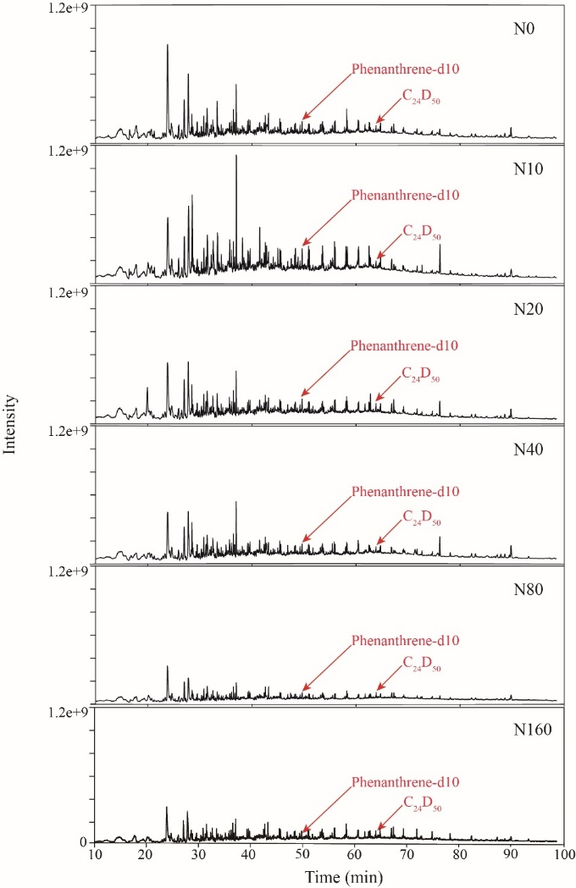

Figure S1. Comparison of total ion chromatograms obtained from labile soil samples under different levels of N addition. The following levels of N addition were investigated: N0 (0 kg N ha⁻¹ yr⁻¹), N10 (10 kg N ha⁻¹ yr⁻¹), N20 (20 kg N ha⁻¹ yr⁻¹), N40 (40 kg N ha⁻¹ yr⁻¹), N80 (80 kg N ha⁻¹ yr⁻¹) and N160 (160 kg N ha⁻¹ yr⁻¹). Phenanthrene-d10 and C₂₄D₅₀ were used as internal standards.

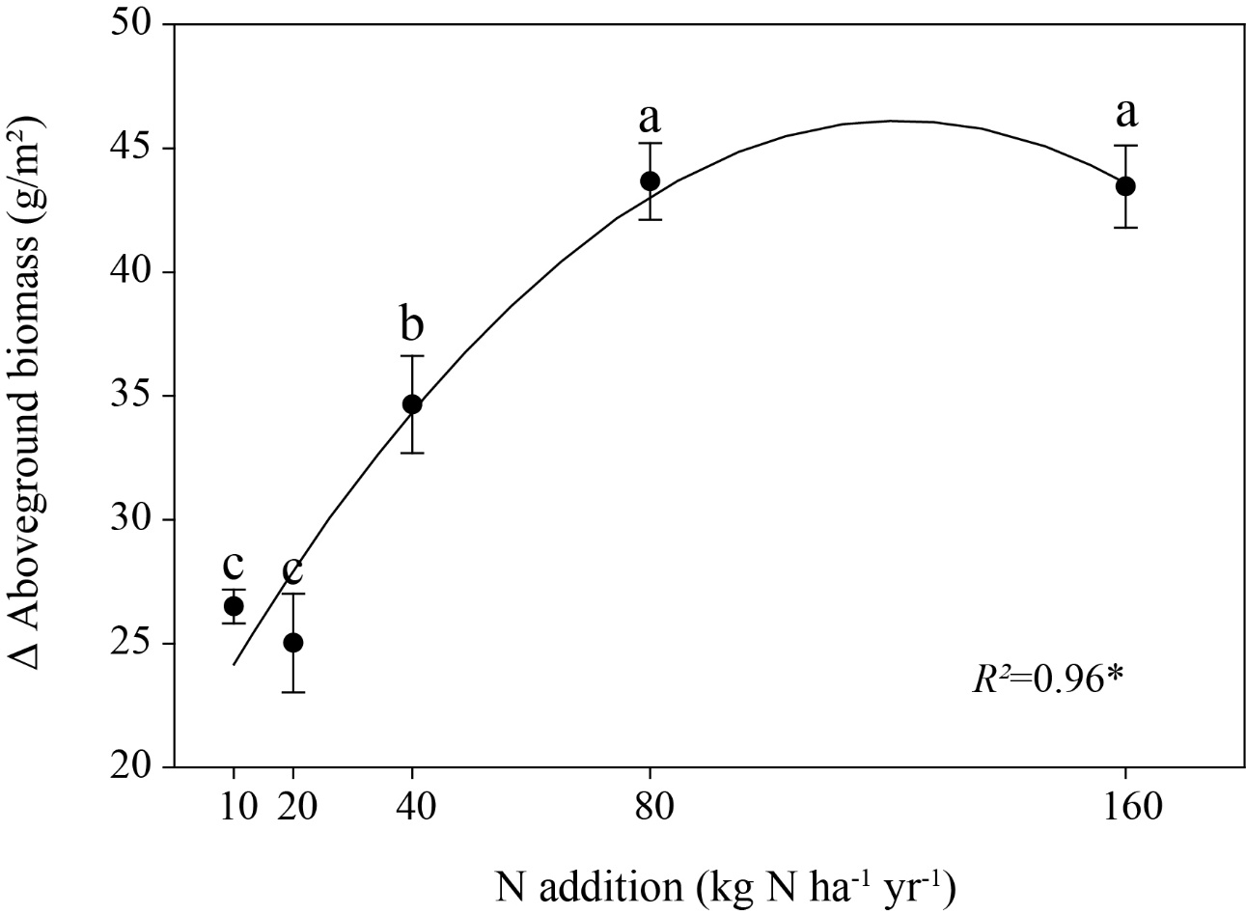

Figure S2. The difference in the aboveground biomass between each treatment and N0. Different lowercase letters (a, b and c) indicate a significant difference (P<0.05) based on ANOVA analysis.

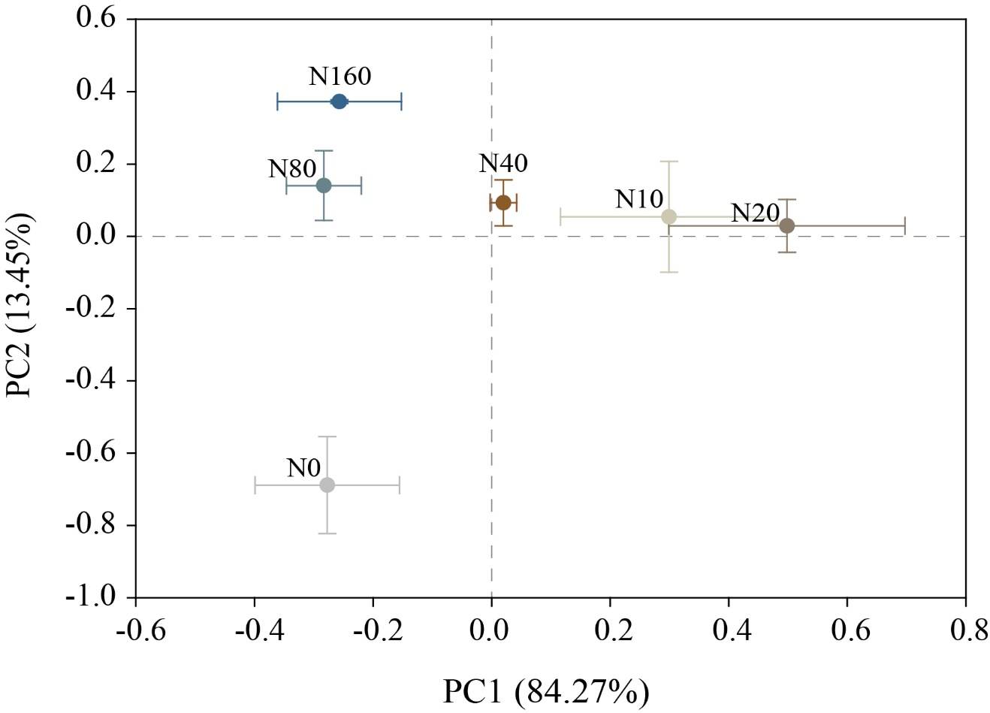

Figure S3. Principal component analysis (PCA) plot of soil microbial community composition under six N addition levels using PLFA fingerprint data. N0 (0 kg N ha⁻¹ yr⁻¹), N10 (10 kg N ha⁻¹ yr⁻¹), N20 (20 kg N ha⁻¹ yr⁻¹), N40 (40 kg N ha⁻¹ yr⁻¹), N80 (80 kg N ha⁻¹ yr⁻¹) and N160 (160 kg N ha⁻¹ yr⁻¹).

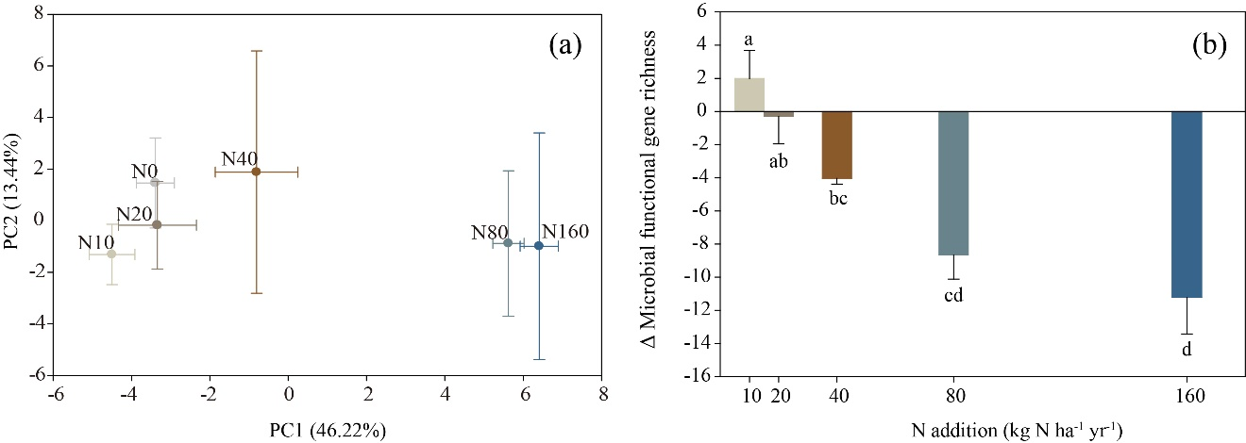

Figure S4. Principal component analysis (PCA) plot of the microbial functional genes structure of six N addition levels (a) and the difference between each treatment and N0 of microbial functional gene richness (b). Different lowercase letters (a, b, c and d) indicate a significant difference (P<0.05) according to ANOVA analysis. N0 (0 kg N ha⁻¹ yr⁻¹), N10 (10 kg N ha⁻¹ yr⁻¹), N20 (20 kg N ha⁻¹ yr⁻¹), N40 (40 kg N ha⁻¹ yr⁻¹), N80 (80 kg N ha⁻¹ yr⁻¹) and N160 (160 kg N ha⁻¹ yr⁻¹).

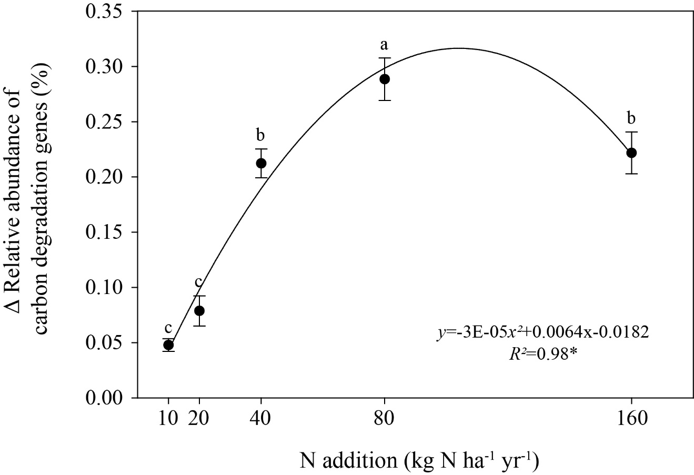

Figure S5. The difference in the relative abundance of carbon degradation genes (%) between each treatment and N0. Different lowercase letters (a, b and c) indicate a significant difference (P<0.05) according to ANOVA analysis. Solid lines are the regression fits. Asterisks represent significant correlations (*P<0.05).

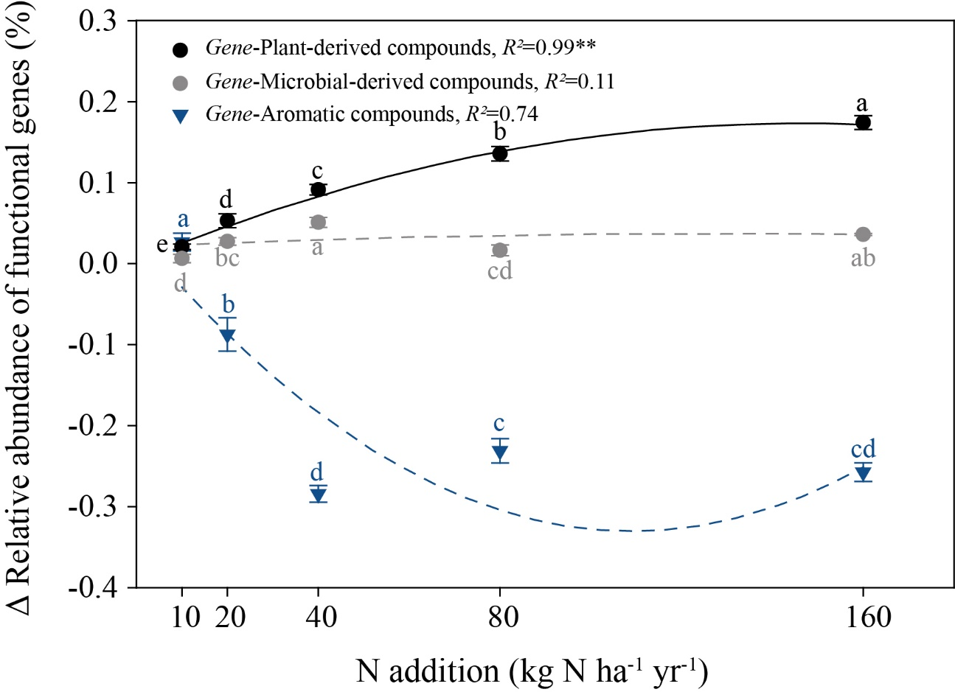

Figure S6. The difference in the relative abundance of microbial functional genes (%) between each treatment and N0. Gene-plant-derived compounds: functional genes involved in plant-derived compound degradation (the sum of relative abundance of lignin genes and cellulose genes); Gene-microbial-derived compounds: functional genes involved in microbial-derived compound degradation (the relative abundance of chitin genes); Gene-Aromatic compounds: functional genes involved in aromatic compound degradation (the sum of the relative abundances of aromatic genes and polyaromatic genes). Different lowercase letters (a, b, c, d and e) indicate significant differences (P<0.05) according to ANOVA analysis. Solid lines are the regression fits. Asterisks represent significant of correlations (*P<0.05, **P<0.01).

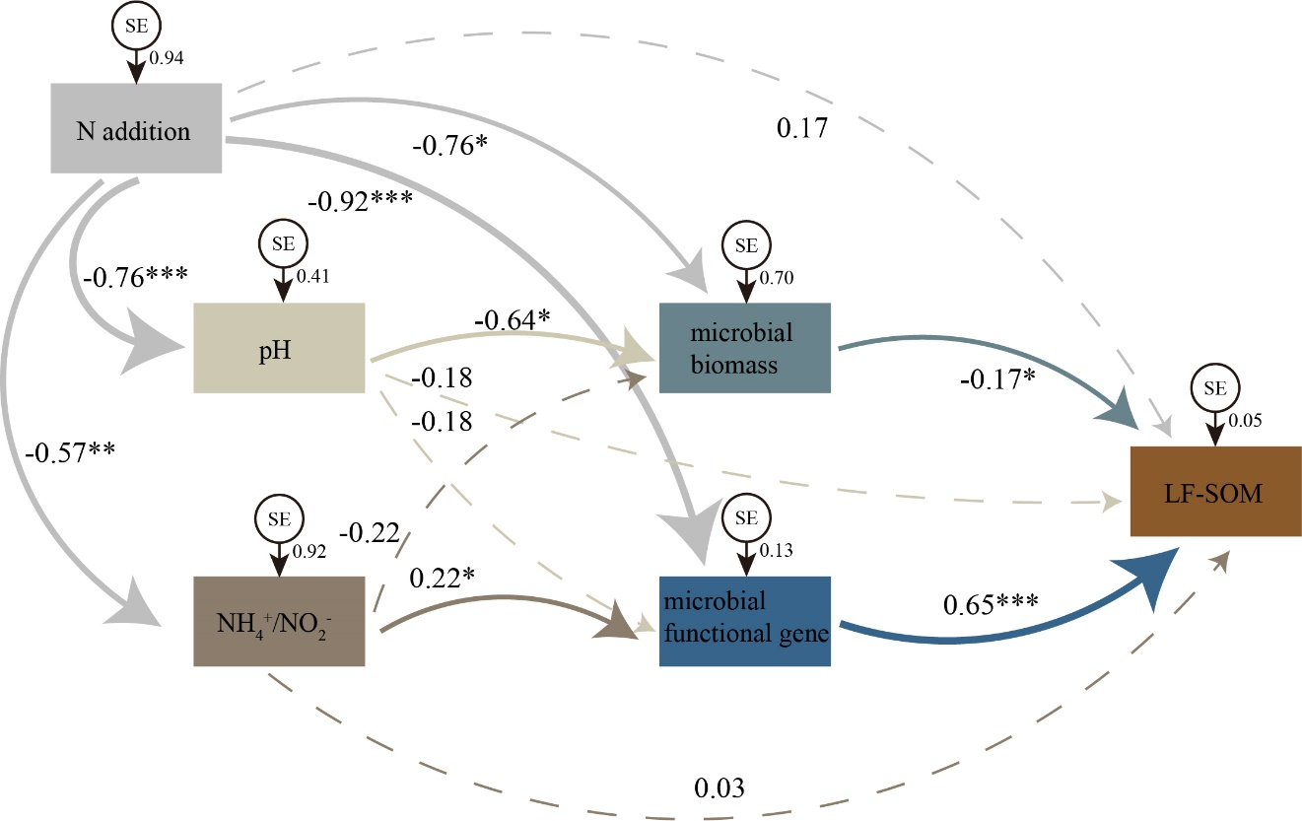

Figure S7. Structural equation modelling (SEM) of LF-SOM, soil microorganisms and environmental factors. The solid lines represent significant correlations, and the dashed lines represent non-significant correlations. N addition was significantly negatively correlated with the soil pH and NH₄⁺/NO₂⁻ value. The soil pH was significantly negatively correlated with the microbial biomass, and the NH₄⁺/NO₂⁻ value was significantly positively correlated with microbial functional genes richness. Microbial biomass was significantly negatively correlated with the molar mass of LF-SOM, and the microbial functional genes richness was significantly positively correlated with the molar mass of LF-SOM. Chi-square (χ2)=0.482; degrees of freedom=2; probability level (P)=0.786; CMIN/DF=0.241, GFI=0.991, RMSEA=0.000, AIC=38.482.

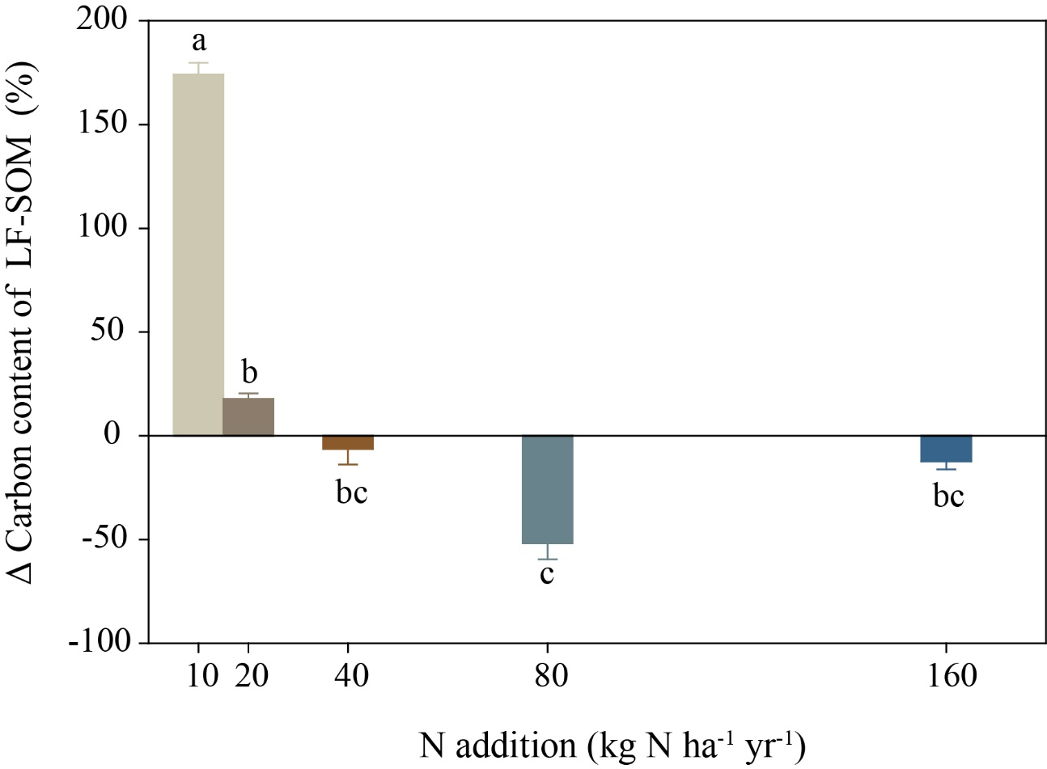

Figure S8. Percentage change in carbon content of each treatment compared with the N0 carbon content (%). Different lowercase letters (a, b and c) indicate a significant difference (P<0.05) based on ANOVA analysis.

Compound names | Code | M+ | m/z | RT
Alkyl compounds
Alkanes, C8-C32 | 8:0-32:0 | 114-450 | 85 | 14.91-89.6
Alkenes, C8-C24 | 8:1-24:1 | 112-350 | 55+69 | 14.01-66.63
Aromatics
Benzene | Ar1 | 78 | 77+78 | 8.2
Toluene | Ar2 | 92 | 91+92 | 12.46
Ethylbenzene | Ar3 | 106 | 91+106 | 17.85
Dimethylbenzene/p-xylene | Ar4 | 106 | 91+106 | 19.66
Styrene | Ar5 | 104 | 78+104 | 19.48
C3-Alkylbenzene | Ar7 | 120 | 91+120 | 33.21
C3-Alkylbenzene | Ar8 | 120 | 105+120 | 22.79
C3-Alkylbenzene | Ar9 | 120 | 105+120 | 23.6
C3-Alkylbenzene | Ar10 | 120 | 105+120 | 24.28
C3-Alkylbenzene | Ar11 | 120 | 105+120 | 26.72
C3-Alkylbenzene | Ar12 | 120 | 105+120 | 27.38
Ethenylmethylbenzene | Ar13 | 118 | 117+118 | 36.25
C4-Alkylbenzene | Ar14 | 134 | 105+134 | 27.43
C6-Benzene to C14-Benzene | B6-B14 | 162-274 | 91+92 | 34.8-58.41
Polyaromatics
Indene | Ps1 | 116 | 115+116 | 26.54
1H-Indene,2,3-dihydro-4-methy 1 | Ps2 | 132 | 117+132 | 35.92
1,1-Methyl-1H-indene | Ps3 | 130 | 115+130 | 30.96
Naphthalene,1,2-dihydro | Ps4 | 130 | 115+130 | 31.18
Naphthalene | Ps5 | 128 | 128 | 32.45
Biphenyl | Ps6 | 154 | 153+154 | 39.29
C1-Alkylnaphthalene | Ps7 | 142 | 141+142 | 36.5
C1-Alkylnaphthalene | Ps8 | 142 | 141+142 | 37.15
1,6-Dimethylnaphthalene | Ps9 | 156 | 141+156 | 40.75
1,7-Dimethylnaphthalene | Ps10 | 156 | 141+156 | 40.9
Fluorene | Ps11 | 166 | 165+166 | 40.38
Lignin-derived compounds
Guaiacol | Lg1 | 124 | 109+124 | 28.23
4-Methylguaiacol | Lg2 | 138 | 123+138 | 32.34
4-Ethylguaiacol | Lg3 | 152 | 137+152 | 35.54
4-Vinylguaiacol | Lg4 | 150 | 135+150 | 36.8
Syringol | Lg5 | 154 | 139+154 | 41.33
4-Formylguaicol | Lg6 | 152 | 152 | 41.63
4-(1-Propenyl) guaiacol | Lg7 | 164 | 149+164 | 46
4-Methylsyringol | Lg8 | 168 | 168 | 44.79
4-(Propan-2-one) syringol | Lg9 | 210 | 167+210 | 43.92
Guaiacol-COOH vanillic acid | Lg10 | 168 | 168 | 38
4-Acetylguaiacol | Lg11 | 166 | 166 | 45.45
4-(prop-1-enyl) syringol | Lg12 | 182 | 181+182 | 47.4
4-Vinlsyringol | Lg13 | 180 | 165+180 | 48.7
4-Acetylsyringol | Lg14 | 196 | 181+196 | 49.96
Phenols
Acetophenone | Ph1 | 120 | 77+105 | 22.74
Phenol | Ph2 | 94 | 66+94 | 23.42
2-Methylphenol | Ph3 | 108 | 107+108 | 26.73
3-Methylphenol | Ph4 | 108 | 107+108 | 27.54
3-Ethylphenol | Ph5 | 122 | 107+122 | 31.23
Methoxytrimethylphenol | Ph6 | 166 | 166 | 45.99
Polysaccharide-derived compounds
2-Propan-2-one tetrahydrofuran | Ps1 | 72 | 57+72 | 4.63
(2H)-Furan-3-one | Ps2 | 84 | 84 | 6.79
2-Methylfuran | Ps3 | 82 | 53+82 | 14.63
2,3-Dihydro-5-methylfuran-2-one | Ps4 | 98 | 55+98 | 15.77
2-Furaldehyde | Ps5 | 96 | 95+96 | 14.38
3-Furaldehyde | Ps6 | 96 | 95+96 | 19.95
2-Acetylfuran | Ps7 | 110 | 95+110 | 20.72
Levoglucosenone | Ps8 | 126 | 126 | 29.27
Methylbenzofuran | Ps9 | 132 | 131+132 | 29.04
Methylbenzofuran | Ps10 | 132 | 131+132 | 29.25
Levoglucosan | Ps11 | 170 | 170 | 34.91
1,4-Dideoxy-D-glycero-hex-1-enopyranos-3-ulose | Ps12 | 144 | 144 | 34.71
Levogalactosan | Ps13 | 162 | 162 | 42.43
Levomannosan | Ps14 | 162 | 162 | 32.29
N-compounds
Pyridine | N1 | 79 | 52+79 | 7.81
(1H)-Pyrrole, dimethyl | N2 | 96 | 95+96 | 15.77
Pyridine, x,x-dimethyl- | N3 | 107 | 106+107 | 27.52
Indole | N4 | 117 | 90+117 | 36.26
1H-Indole-3-ethanamide | N5 | 131 | 131 | 39.48
(Iso)quinoline | N6 | 129 | 102+129 | 32.46
Diketodipyrrole | N7 | 186 | 186 | 49.46
Chitin
Acetamide | Chi1 | 59 | 59 | 5.01
Acetamidofuran | Chi2 | 125 | 83+125 | 33.78
Acetoxypyridine | Chi3 | 137 | 95+137 | 35.61
3-Acetomido-5-methylfuran | Chi4 | 139 | 139 | 37.07
3-Acetomido-2/4-pyrone | Chi5 | 153 | 82+111 | 38.14
3-Acetamido-6-methyl-n-pyrone | Chi6 | 167 | 167 | 43.66
Note: Code, compound code; M+, relative molecular mass; m/z, masses used for quantification; RT, average retention time.

Table S1. List of compounds found in the studied soil samples through Py-GC-MS/MS.

 | Soil moisture | pH | TOC | TN | CN Ratio | WSOC | WSON | WSOC/WSON | NH₄⁺ | NO₃⁻ | NO₂⁻ | NH₄⁺/NO₃⁻
 | （%） |  | (g kg⁻¹) | (g kg⁻¹) |  | (mg kg⁻¹) | (mg kg⁻¹) |  | (mg kg⁻¹) | (mg kg⁻¹) | (mg kg⁻¹)
N0 | 24.28(1.42)a | 7.86(0.00)a | 27.89(1.04)a | 2.28(0.10)b | 12.19(0.10)b | 73.34(9.48)ab | 15.56(2.20)b | 4.73(0.13)a | 3.26(0.48)b | 17.78(1.66)c | 2.22(0.43)c | 0.18(0.01)ab
N10 | 23.32(1.89)a | 7.84(0.01)a | 29.52(1.64)a | 2.58(0.17)ab | 11.48(0.14)c | 83.95(7.16)ab | 18.06(1.44)b | 4.65(0.06)a | 5.17(0.74)a | 18.07(1.36)c | 2.00(0.50)c | 0.28(0.03)a
N20 | 23.12(1.54)a | 7.85(0.03)a | 25.66(1.43)a | 2.23(0.09)b | 11.24(0.16)c | 96.73(11.21)a | 20.05(2.75)b | 3.95(0.30)ab | 5.70(0.68)a | 23.37(4.03)c | 2.51(0.53)bc | 0.27(0.08)a
N40 | 22.97(1.22)a | 7.82(0.02)a | 27.25(2.32)a | 2.38(0.13)ab | 11.72(0.14)bc | 69.89(3.09)ab | 19.68(2.45)b | 3.62(0.28)b | 5.80(0.28)a | 44.87(5.47)b | 2.19(0.52)c | 0.13(0.02)bc
N80 | 23.25(1.78)a | 7.80(0.01)a | 26.06(2.36)a | 2.68(0.25)a | 13.08(0.27)a | 61.05(6.68)b | 24.67(3.23)b | 2.60(0.52)c | 4.23(0.35)ab | 89.92(6.98)a | 3.32(0.72)b | 0.05(0.01)b
N160 | 24.63(2.23)a | 7.70(0.03)b | 29.08(1.85)a | 2.68(0.12)a | 12.81(0.18)a | 68.31(8.86)b | 39.48(7.80)a | 1.79(0.19)c | 4.93(0.43)a | 93.84(7.28)a | 5.20(1.32)a | 0.05(0.00)b
Note: A-Data are the average and standard deviation of three replicates. Different lowercase letters (a, b and c) indicate a significant difference (P<0.05) based on ANOVA analysis. TOC, total organic carbon; TN, total nitrogen; WSOC, water-soluble organic carbon; WSON, water-soluble organic nitrogen.

Table S2. Soil physicochemical features.

 | R² | P | Slope
Plant-derived compounds | 0.4865 | 0.0038 | -0.0110
Microbial-derived compounds | 0.4561 | 0.0057 | -0.0037
Aromatic compounds | 0.5721 | 0.0011 | -0.0038
Note: The data shown in the table are the R² values, P values and slopes obtained from linear regression analyses of the responses of different organic compounds to N addition. The calculated data are the ln-transformed data of compounds in each treatment that differ from those of the corresponding compounds in N0. The black bold font shows the P values that indicate statistical significance (P<0.05), n=15. Plant-derived compounds: the sum of the molar masses of lignin, polysaccharides, plant-derived N compounds, phenols and long-chain alkyl compounds; Microbial-derived compounds: the sum of the molar masses of chitin, microbial-derived N compounds and short-chain alkyl compounds; Aromatic compounds: the sum of the molar masses of aromatics and polyaromatics.

Table S3. Responses of soil organic compounds in LF-SOM to nitrogen addition.

 | Plant-derived compounds | Microbial-derived compounds | Aromatic compounds
Plant-derived compounds | 1.0000
Microbial-derived compounds | 0.0370 | 1.0000
Aromatic compounds | 0.0380 | 0.9200 | 1.0000
Note: The data shown in the table are the P values obtained from general linear model (univariate) analyses of the slopes for different compound classes. Plant-derived compounds: lignin, polysaccharides, plant-derived N compounds, phenols and long-chain alkyl compounds; Microbial-derived compounds: chitin, microbial-derived N compounds and short-chain alkyl compounds; Aromatic compounds: aromatics and polyaromatics.

Table S4. General linear model coefficients of the slopes of different compound classes.

 | Bacteria | Fungi | Actinomycetes | TPLFA | F/B
N10-N0 | -4.28(1.93)c | -5.84(0.63)cd | -0.13(0.82)b | -10.24(3.35)bc | -0.25(0.01)ab
N20-N0 | -5.24(1.66)c | -6.65(0.61)d | -0.92(0.51)b | -12.81(2.77)c | -0.29(0.01)bc
N40-N0 | -0.50(0.27)bc | -4.62(0.30)bc | 0.35(0.04)ab | -4.78(0.08)ab | -0.27(0.03)abc
N80-N0 | 2.53(0.42)ab | -2.59(0.79)a | 1.78(0.09)a | 1.73(1.29)a | -0.22(0.03)a
N160-N0 | 4.97(2.24)a | 3.59(0.63)ab | 1.77(0.29)a | 3.15(3.15)a | -0.32(0.01)c
Note: A-Data are the average and standard deviation of three replicates (the difference between each treatment and N0). Different lowercase letters (a, b, c and d) indicate a significant difference (P<0.05) based on ANOVA analysis.

Table S5. Changes in microbial biomass at different N application rates.

