Supplementary files
Table S1. Short summary for measured variables and their related method/technology
Group | Variable | Method/Techonolgy |  | Reference
Microbes | functional gene abundance | Geochip 4.6 |  | Lu et al., 2012
 | microbial biomass  (based on PLFA analyses) | Single-phase Bligh and Dyer method |  | White et al., 1979; Si et al., 2015
Labile-fraction soil organic matter  (ρ≤2.25 g cm⁻³) | labile C (alkyl compounds, polysaccharides) | Py-GC-MS/MS analysis |  | Chen et al., 2019; Lu et al., 2011
 | recalcitrant C (lignin, phenols, chitin, N compounds, aromatics, and polyaromatics) | EGA/PY-3030D multi-shot pyrolyzer,  Frontier Lab
 |  | Agilent 7890 gas chromatograph
Agilent 7000B triple quadrupole
mass spectrometer
Soil enzymes | hydrolases: invertase, β-glucosidase, urease, and phosphatase; | Colorimetric method and measuring wavelengths: polyphenol oxidase 490 nm, peroxidase 294 nm, β–glucosidase 400 nm, invertase 508 nm, urease 578 nm, alkaline phosphatase 430 nm. |  | Eivazi and Tabatabai 1988; Gopal et al., 2007; Allison and Jastrow 2006; Kandeler and Gerber 1988; Tabatabai, 1982
 | oxidases: phenol oxidase and peroxidase
Plant | Species richness | Field record, include: Stipa purpurea, Kobresia pygmaea, Oxytropis glacialis, Potentillasaundersiana, Poa annua, Saussurea japonica, Androsace tapete and Arenaria pulvinata |  | Liu et al., 2013
 | above ground biomass | Clipped and dried at 75 °C for 48 h,  then weighed
Soil properties | pH | Sartorius PB‐10 digital pH meter.
 | total organic carbon (TOC) | TOC-VCPH, Shimadzu, Japan
 | total nitrogen (TN) | CuSO4 Se powder diffusion method
 | total phosphorous (TP) | NaOH fusion-Mo colorimetric method
 | water-soluble organic carbon/nitrogen (WSOC/N) | TOC-TN analyser, Shimadzu, Japan
 | NH₄⁺,NO₃⁻,NO₂⁻ | Auto Analyser 3, Bran Luebbe, Germany

Table S2. List of compounds found in the studied soil samples through Py-GC-MS/MS.
Compound names | Composition
Alkyl compounds | Alkanes, C8-C32
 | Alkenes, C8-C24
Aromatics | Benzene
 | Toluene
 | Ethylbenzene
 | Dimethylbenzene/p-xylene
 | Styrene
 | C3-Alkylbenzene
 | C3-Alkylbenzene
 | C3-Alkylbenzene
 | C3-Alkylbenzene
 | C3-Alkylbenzene
 | C3-Alkylbenzene
 | Ethenylmethylbenzene
 | C4-Alkylbenzene
 | C6-Benzene to C14-Benzene
Polyaromatics | Indene
 | 1H-Indene,2,3-dihydro-4-methy 1
 | 1,1-Methyl-1H-indene
 | Naphthalene,1,2-dihydro
 | Naphthalene
 | Biphenyl
 | C1-Alkylnaphthalene
 | C1-Alkylnaphthalene
 | 1,6-Dimethylnaphthalene
 | 1,7-Dimethylnaphthalene
 | Fluorene
Lignin-derived compounds | Guaiacol
 | 4-Methylguaiacol
 | 4-Ethylguaiacol
 | 4-Vinylguaiacol
 | Syringol
 | 4-Formylguaicol
 | 4-(1-Propenyl) guaiacol
 | 4-Methylsyringol
 | 4-(Propan-2-one) syringol
 | Guaiacol-COOH vanillic acid
 | 4-Acetylguaiacol
 | 4-(prop-1-enyl) syringol
 | 4-Vinlsyringol
 | 4-Acetylsyringol
Phenols | Acetophenone
 | Phenol
 | 2-Methylphenol
 | 3-Methylphenol
 | 3-Ethylphenol
 | Methoxytrimethylphenol
 | Ph6
Polysaccharide-derived compounds | 2-Propan-2-one tetrahydrofuran
 | (2H)-Furan-3-one
 | 2-Methylfuran
 | 2,3-Dihydro-5-methylfuran-2-one
 | 2-Furaldehyde
 | 3-Furaldehyde
 | 2-Acetylfuran
 | Levoglucosenone
 | Methylbenzofuran
 | Methylbenzofuran
 | Levoglucosan
 | 1,4-Dideoxy-D-glycero-hex-1-enopyranos-3-ulose
 | Levogalactosan
 | Levomannosan
N-compounds | Pyridine
 | (1H)-Pyrrole, dimethyl
 | Pyridine, x,x-dimethyl-
 | Indole
 | 1H-Indole-3-ethanamide
 | (Iso)quinoline
 | Diketodipyrrole
Chitin | Acetamide
 | Acetamidofuran
 | Acetoxypyridine
 | 3-Acetomido-5-methylfuran
 | 3-Acetomido-2/4-pyrone
 | 3-Acetamido-6-methyl-n-pyrone

Table S3. Gene names and the full names of corresponding enzymes
Function | Gene | encoding enzymes
C fixation | PCC/ACC | propionyl-CoA/acetyl-CoA carboxylase
 | Rubisco | ribulose-1,5-bisphosphate carboxylase/oxygenase
 | CODH | carbon monoxide dehydrogenase
 | aclB | ATP citrate lyase
Methane cycle | mcrA | methyl coenzyme M reductase
 | pmoA | methane monooxygenase
 | mmoX | particulate methane monooxygenase
Starch degradation | amyA | amylase
 | nplT | neopullulanase
 | pulA | pullulanase
 | glucoamylase | glucoamylase
Hemicellulose | ara | arabinofuranosidase
degradation | mannanase | mannanase
 | xylanase | 1,4-beta-xylanase
 | xylA | alpha-ketoglutaric semialdehyde dehydrogenase
Cellulose | endoglucanase | beta-glucosidase
degradation | CDH | cellobiose dehydrogenase
 | exoglucanase | exoglucanase
Chitin degradation | acetylglucosaminid | acetylglucosaminidase
 | endochitinase | endochitinase
Lignin degradation | phenol oxidase | phenol oxidase
 | mnp | manganese peroxidase
 | glx | glucosidase
 | lip | lignin peroxidase
Ammonification | gdh | glutamate dehydrogenase
 | ureC | urease
Anammox | hzo | nitrate reductase
Nitrification | hao | hydroxylamine oxidoreductase
Denitrification | norB | nitric oxide reductase
 | nirS | nitrite reductase
 | nirK | nitrite reductase
 | narG | nitrite reductase
 | nosZ | nitrous oxide reductase
Assimilatory N | nasA | nitrate reductase
reduction | nirA | ferredoxin-nitrite reductase
 | NirB | nitrite reductase
 | NiR | nitrite reductase
Dissimilatory N | napA | nitrate reductase
reduction | nrfA | c-type cytochrome nitrite reductase
N fixation | nifH | nitrogenase
P utilization | ppx | exopolyphosphatase
 | ppk | polyphosphate kinase
 | phytase | catalyses the hydrolysis of polyphosphate

Table S4. Soil physical and chemical properties
N addition rate | 0 kg N ha⁻¹ yr⁻¹ | 10 kg N ha⁻¹ yr⁻¹ | 20 kg N ha⁻¹ yr⁻¹ | 40 kg N ha⁻¹ yr⁻¹ | 80 kg N ha⁻¹ yr⁻¹ | 160 kg N ha⁻¹ yr⁻¹
pH | 7.82±0.04a | 7.86±0.03a | 7.85±0.03a | 7.82±0.02a | 7.8±0.01a | 7.67±0.05b
TOC (g·kg⁻¹) | 27.89±1.04a | 29.52±1.64a | 25.66±1.43a | 27.25±2.31a | 26.06±2.35a | 29.08±1.85a
TN (g·kg⁻¹) | 2.28±0.1a | 2.57±0.17a | 2.23±0.09a | 2.38±0.13a | 2.44±0.25a | 2.68±0.12a
TP (g·kg⁻¹) | 0.66±0.02a | 0.71±0.03a | 0.69±0.04a | 0.67±0.04a | 0.71±0.04a | 0.68±0.02a
WSOC(mg·kg⁻¹) | 73.34±9.47ab | 83.95±7.15ab | 96.73±11.2a | 69.89±3.09b | 61.05±6.68b | 68.31±8.85b
WSON(mg·kg⁻¹) | 15.56±2.2b | 18.06±1.44b | 20.05±2.74b | 19.68±2.45b | 24.67±3.23b | 39.48±7.79a
NH₄⁺ (mg·kg⁻¹) | 4.22±1.43a | 5.17±0.72a | 6.93±1.87a | 5.8±0.27a | 3.28±1.01a | 4.7±1.92a
NO₃⁻ (mg·kg⁻¹) | 17.78±1.63b | 18.07±1.33b | 17.62±6.98b | 35.58±9.32b | 63.77±19.8b | 123.3±30.31a
NO₂⁻ (mg·kg⁻¹) | 1.81±0.43b | 1.59±0.5b | 2.16±0.53b | 1.87±0.51b | 2.75±0.72b | 6.39±1.32a
NO₂⁻/NH₄⁺ | 0.47±0.18b | 0.30±0.13b | 0.33±0.12b | 0.33±0.14b | 0.94±0.29b | 1.82±0.8a
TOC/TN | 12.23±0.11a | 11.48±0.14ab | 11.49±0.38ab | 11.41±0.35b | 10.73±0.26b | 10.82±0.2b
TN/TP | 3.46±0.03b | 3.61±0.08ab | 3.22±0.04b | 3.56±0.01ab | 3.41±0.28b | 3.98±0.29a
WSOC/WSON | 4.73±0.13a | 4.65±0.06a | 5.07±1.09a | 3.62±0.27ab | 2.6±0.51bc | 1.79±0.18c
AGB (g·m⁻²) | 29.85±13.94b | 53.38±17.86ab | 47.06±6.97ab | 45.32±13.29ab | 59.91±9.15ab | 75.38±12.64a
PR | 10.99±1.74b | 11.66±1.74b | 12.01±1.19b | 13.99±1.15b | 15.36±-0.91ab | 16.99±-0.55a
MB (nmol·g⁻¹) | 51.73±4.08a | 47.42±3.95ab | 42.86±12.71b | 43.58±9.95b | 44.06±6.23b | 39.51±8.27b
MD | 10.08±0.10a | 10.18±0.06a | 10.16±10.07a | 10.09±0.04ab | 10.04±0.02ab | 9.74±0.12b
Note: pH: 1:2.5 mixture of soil and deionized water; TOC: soil total organic carbon; TN: soil total nitrogen; TP: soil total phosphorous; WSOC: water-soluble organic carbon in soil; WSON: water-soluble organic nitrogen in soil; PR: plant species richness; AGB: above-ground biomass; MB: microbial biomass; MD: microbial diversity. All data are presented as mean ± s.e (n=3). Significant (p<0.05) differences among N gradients are indicated by alphabetic letters above the bars.

Table S5. Diversity indices of all functional genes, carbon cycling genes and nitrogen cycling genes in soil samples
N addition rate  (kg N ha⁻¹ yr⁻¹) | Whole Chip |  |  | Carbon cycling |  |  | Nitrogen cycling
 | Richnessª | Shannon^{b} | Simpson^{c} | Richness | Shannon | Simpson | Richness | Shannon | Simpson
0 | 22448±389a^{d} | 10.02±0.02ab | 1615±38ab | 2174±41ab | 7.85±0.02a | 2542±48ab | 1615±38ab | 7.38±0.02ab | 1605±37ab
10 | 22930±250a | 10.04±0.01a | 1664±19a | 2254±36a | 7.87±0.02a | 2622±40a | 1664±19a | 7.41±0.01a | 1653±18a
20 | 22600±277a | 10.02±0.01ab | 1619±20a | 2197±25a | 7.86±0.01a | 2576±29a | 1619±20a | 7.39±0.01ab | 1610±19a
40 | 20792±473b | 9.94±0.02b | 1492±33b | 2021±51b | 7.77±0.02a | 2372±54b | 1492±33b | 7.31±0.02b | 1486±33b
80 | 17656±351c | 9.78±0.02c | 1255±27c | 1730±41c | 7.62±0.02b | 2024±44c | 1255±27c | 7.13±0.02c | 1250±27c
160 | 15696±1005d | 9.66±0.07d | 1111±76d | 1504±107d | 7.48±0.07c | 1772±120d | 1111±76d | 7.01±0.07d | 1107±75d
Note: All data are presented as mean ± s.e (n=3). Significant (p<0.05) differences among N gradients are indicated by alphabetic letters above the bars.
ª Detected gene number.
^{b} Shannon-Weiner index. Higher number represents higher diversity.
^{c} Simpson’s index. Higher number represents higher diversity.
^{d} Significant differences among N gradients are indicated by alphabetic letters.

Table S6. Permutation test results of canonical correlation analysis (CCA).
 | Df | Chi-square | F | p
pH | 1 | 0.00066 | 1.497 | 0.145
TP | 1 | 0.00044 | 0.989 | 0.393
NO₃⁻ | 1 | 0.00054 | 1.222 | 0.245
NO₂⁻/NH₄⁺ | 1 | 0.00070 | 1.583 | 0.121
Plant richness | 1 | 0.00273 | 6.214 | 0.001
TOC/TN | 1 | 0.00035 | 0.800 | 0.569
TN/TP | 1 | 0.00061 | 1.389 | 0.154
WSOC/WSON | 1 | 0.00048 | 1.096 | 0.270
Constrained |  | 0.00651 |  | 0.003
Residual | 9 | 0.00396

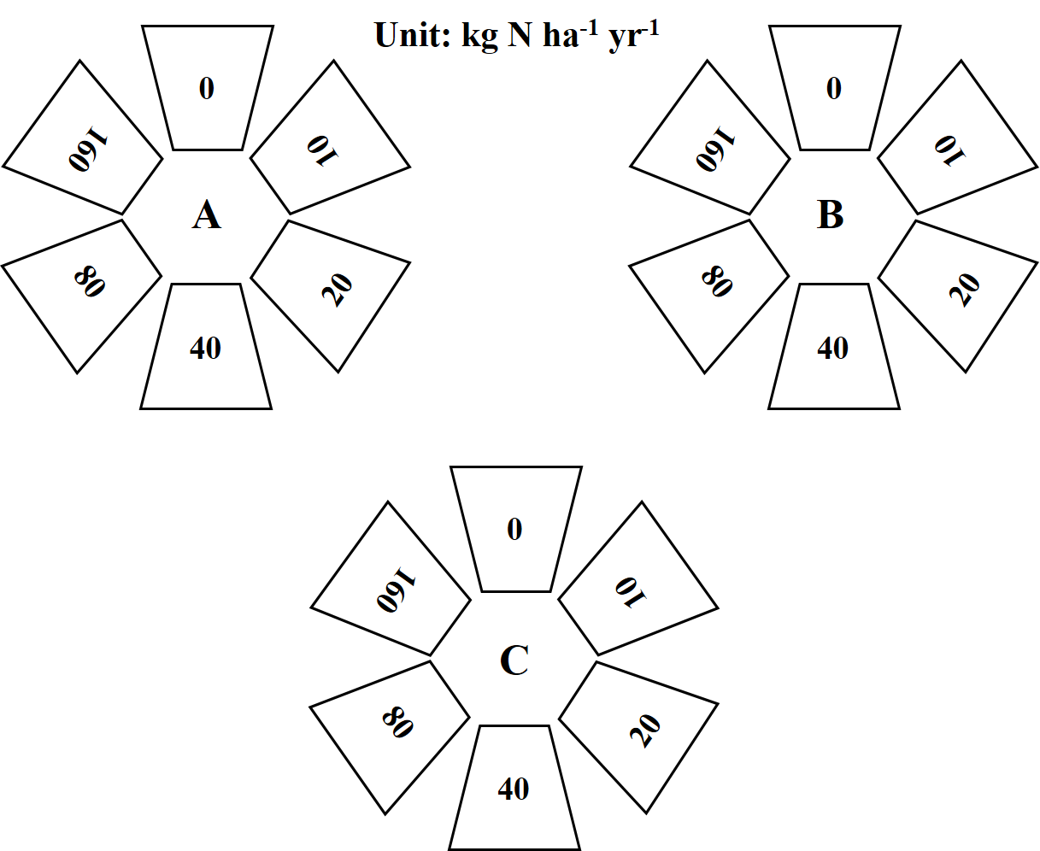
Fig. S1 The experimental design in the Nam Co Station. In May 2009, three homogenous plots were randomly assigned as replicates in an alpine steppe. In each plot, six subplots (~13 m²) were arranged in a circle, with a buffer zone of at least 2 m between adjacent subplots.

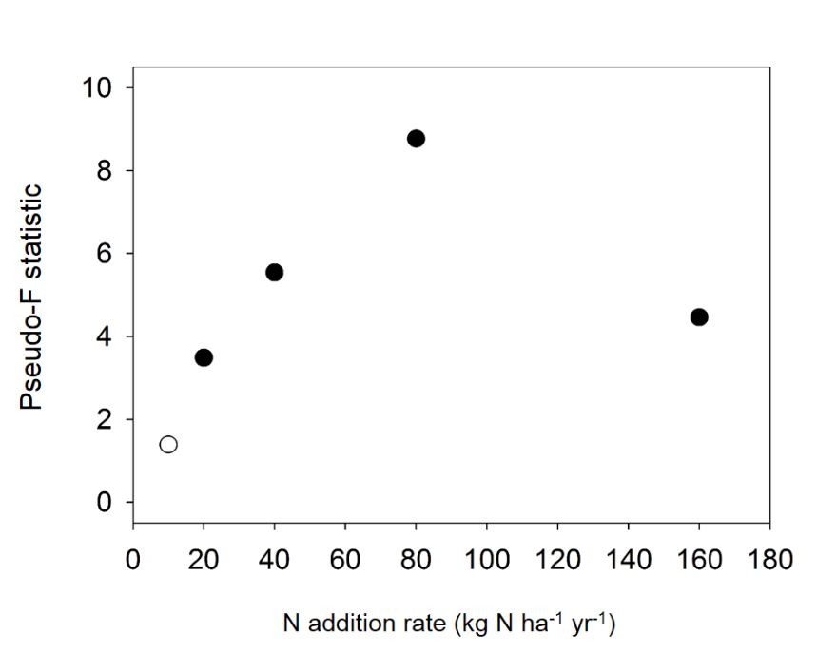
Fig. S2 Compositional differences of Geochip data between low and high nitrogen addition rates. For each site, the low and high nitrogen addition treatments were defined as the treatments below and above(include include current rate) current nitrogen addition rate, respectively. The significant differences between the Geochip data of low and high N addition treatments were tested by a permutational multivariate analysis of variance (PERMANOVA) with pseudo-F statistic and were shown as solid and open circles for significance (p<0.05) or non-significance (p>0.05), respectively.

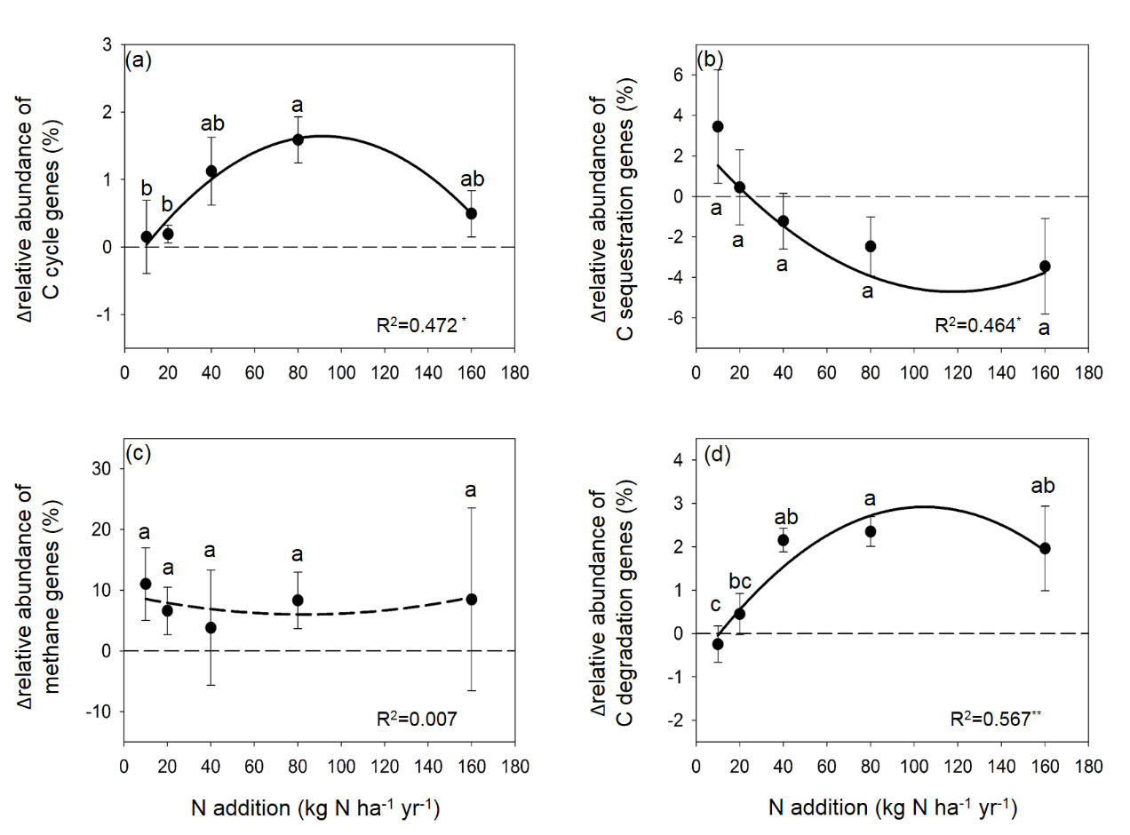
Fig. S3 The difference in the abundance of C-cycle genes (%) between each treatment and control. (a) Total C cycle genes; (b) C sequestration genes; (c) Methane cycling genes; (d) C degradation genes. Different lowercase letters indicate a significant difference (p<0.05) according to ANOVA analysis. Asterisks represent significant correlations (* p<0.05, ** p<0.01, ***p<0.001).

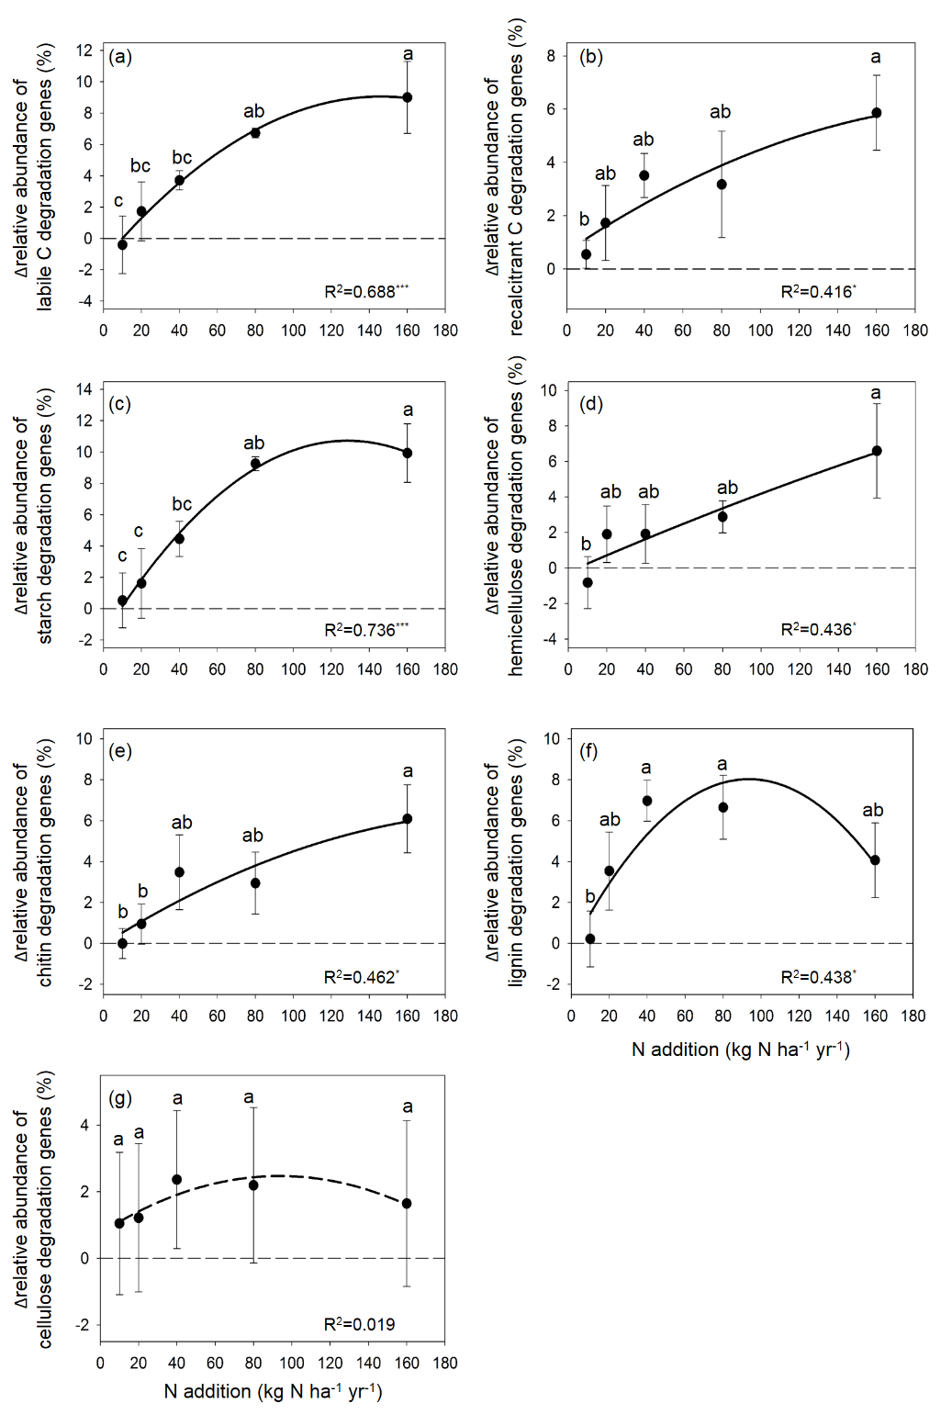
Fig. S4 The difference in the abundance of C degradation genes (%) between each treatment and control. (a) Labile C degradation; (b) Recalcitrant C degradation; (c) Starch degradation; (d) Hemicellulose degradation; (e) Chitin degradation; (f) Lignin degradation; (g) Cellulose degradation. Different lowercase letters indicate a significant difference (p<0.05) according to ANOVA analysis. Asterisks represent significant correlations (* p<0.05, ** p<0.01, ***p<0.001).
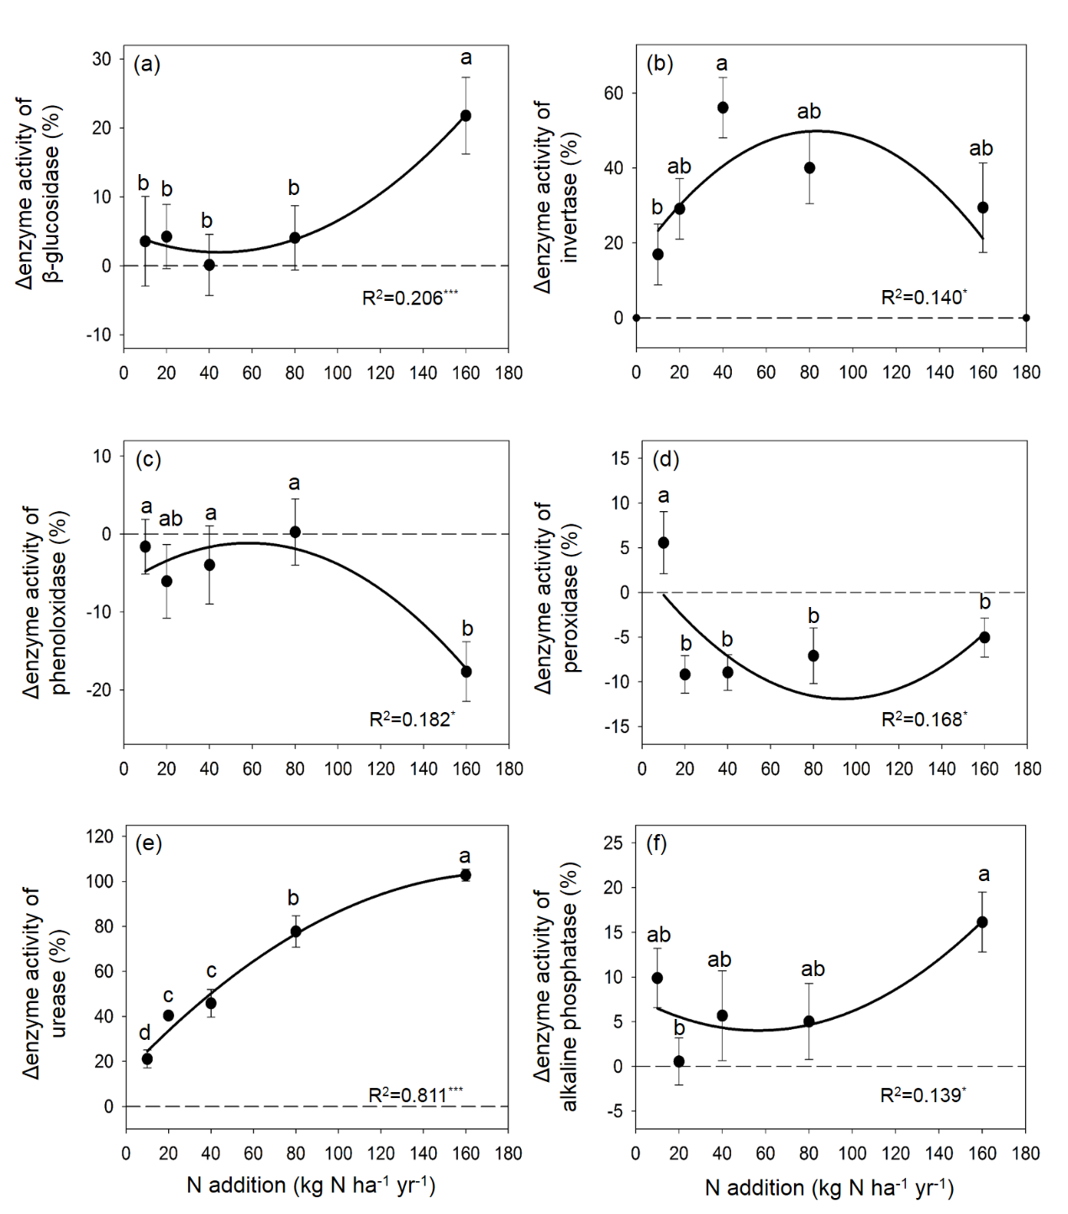
Fig. S5 The difference in the enzyme activity (%) between each treatment and control. (a) Invertase; (b) β-glucosidase; (c) Phenoloxidase; (d) Peroxidase; (e) Urease; (f) Alkaline phosphatase. Different lowercase letters indicate a significant difference (p<0.05) according to ANOVA analysis. Asterisks represent significant correlations (* p<0.05, ** p<0.01, ***p<0.001).
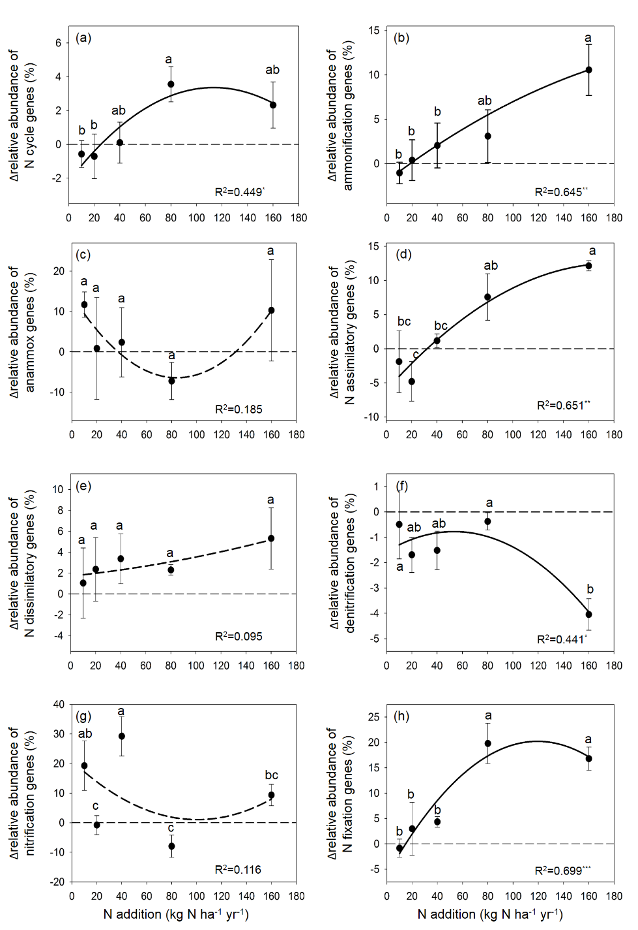
Fig. S6 The difference in the abundance of N-cycle genes (%) between each treatment and control. (a) Total N cycle genes; (b) Ammonification genes; (c) Assimilatory N reduction genes; (d) Nitrogen fixation genes; (e) Anammox genes; (f) Nitrification genes; (g) Dissimilatory N reduction genes; (h) Denitrification genes. Different lowercase letters indicate a significant difference (p<0.05) according to ANOVA analysis. Asterisks represent significant correlations (* p<0.05, ** p<0.01, ***p<0.001).
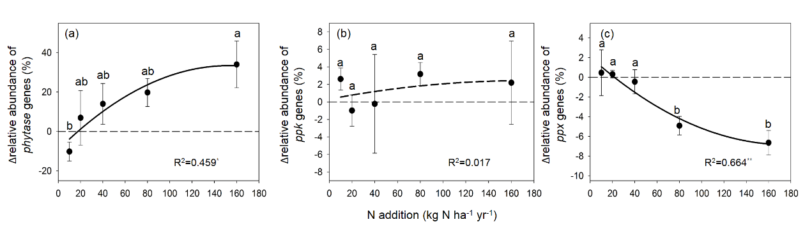
Fig. S7 The difference in the abundance of P utilization genes (%) between each treatment and control. (a) phytase genes; (b) ppk genes; (c) ppx genes. Different lowercase letters indicate a significant difference (p<0.05) according to ANOVA analysis. Asterisks represent significant correlations (* p<0.05, ** p<0.01, ***p<0.001).

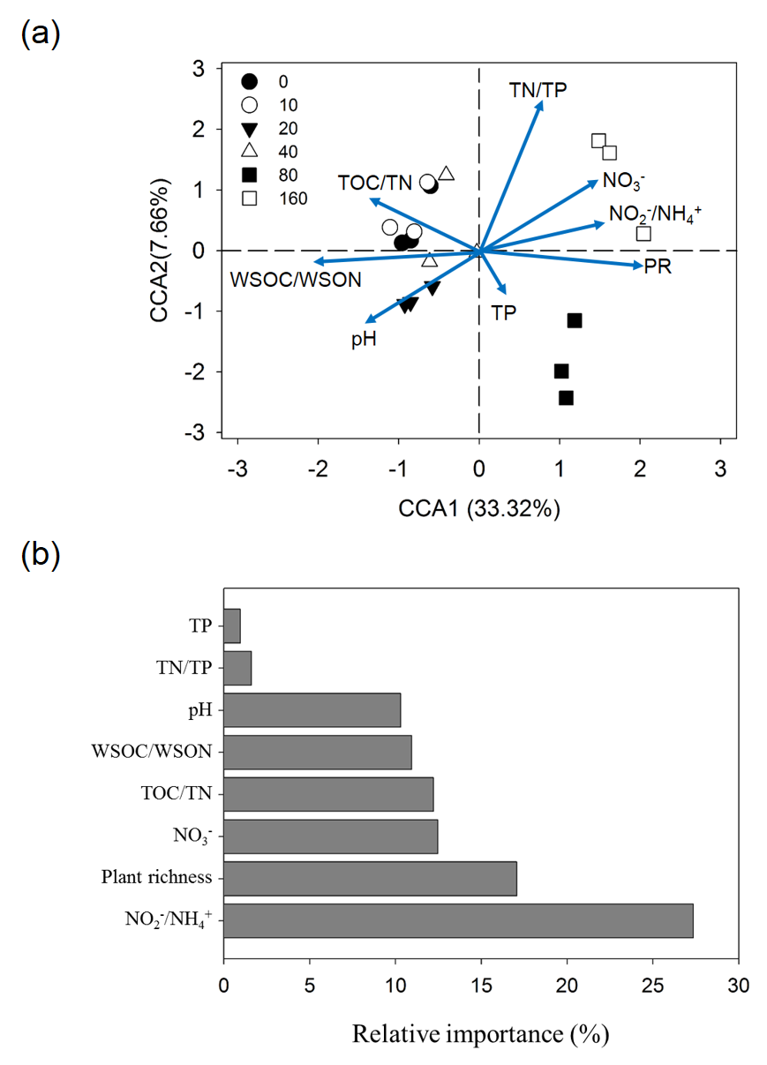
Fig. S8 Canonical correlation analysis (CCA) and multiple regression analysis of the microbial function genes and environmental variables. (a) pH, TP, NO₂⁻, NO₃⁻, NH₄⁺,TOC/TN,TN/TP, WSOC/WSON and Plant richness. The percentage of variation explained by each axis is shown. (b) The relative importance (%) of each variable for functional genes is shown as bar plots. The functional genes composition were indicated by first axis of detrended correspondence analyses (DCA).

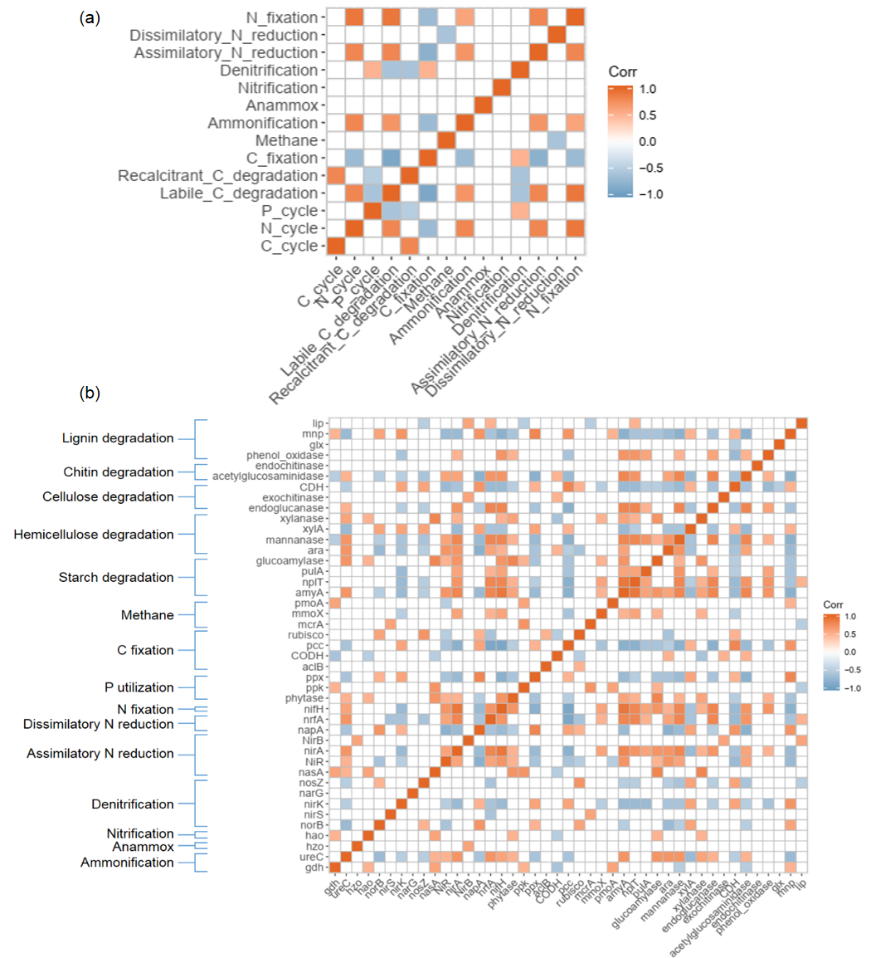
Fig. S9 Correlations between C, N, and P cycle genes. (a) Correlations between the sums of functional gene abundance; (b) Correlations between individual C, N, and P-cycle related gene abundance.
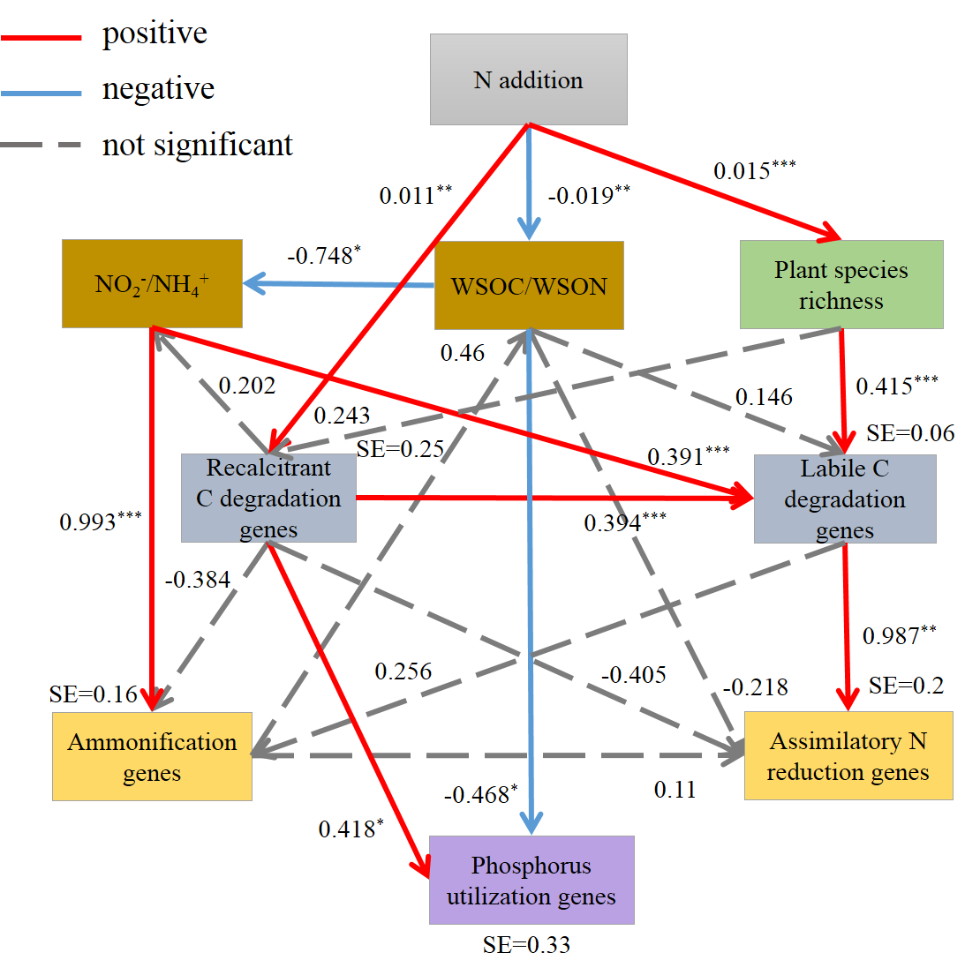
Fig. S10 Structural equation modelling (SEM) of function genes and environmental factors. The red solid lines represent significant positive correlations, blue solid lines represent significant negative correlations, and the dashed black lines represent non-significant correlations. Chi-square (χ²) =14.165; p=0.586; CMIN/DF=0.885, GFI=0.846, RMSEA<0.001, AIC=72.165.

